SERBIA
SAVA AND DRINA RIVER CORRIDORS INTEGRATED DEVELOPMENT PROGRAM P168862

Draft
ENVIRONMENTAL and SOCIAL
COMMITMENT PLAN (ESCP)

December 5, 2019

ENVIRONMENTAL AND SOCIAL COMMITMENT PLAN

- The Government of Serbia will implement the Sava and Drina River Corridors Integrated Development Program (the Project), with the involvement of the following Ministries: Ministry of Finance, Ministry of Agriculture, Forestry and Water Management (MAFWM) , Ministry of Construction, Transport and Infrastructure (MCTI) and Project Management Unit (PMU) housed by the MAFWM and Project Management Unit (PMU) housed by the Ministry MCTI responsible for implementation of subproject 1.3.1 Enhancement and modernization of Port of Sremska Mitrovica. The International Bank for Reconstruction and Development (hereinafter the Bank) has agreed to provide financing for the Project.
- The Government of Serbia will implement material measures and actions so that the Project is implemented in accordance with the Environmental and Social Standards (ESSs). This Environmental and Social Commitment Plan (ESCP) sets out material measures and actions, any specific documents or plans, as well as the timing for each of these.
- The Government of Serbia will also comply with the provisions of any other E&S documents required under the ESF and referred to in this ESCP, such as Environmental and Social Management Plans (ESMP), Resettlement Plans (RP), Labor Management Program (LMP), and Stakeholder Engagement Plan (SEP), and the timelines specified in those E&S documents.
- The Government of Serbia is responsible for compliance with all requirements of the ESCP even when implementation of specific measures and actions is conducted by the Ministry, agency or unit referenced in 1. above.
- Implementation of the material measures and actions set out in this ESCP will be monitored and reported to the Bank by the Government of Serbia as required by the ESCP and the conditions of the legal agreement, and the Bank will monitor and assess progress and completion of the material measures and actions throughout implementation of the Project.
- As agreed by the Bank and the Government of Serbia, this ESCP may be revised from time to time during Project implementation, to reflect adaptive management of Project changes and unforeseen circumstances or in response to assessment of Project performance conducted under the ESCP itself. In such circumstances, the Government of Serbia will agree to the changes with the Bank and will update the ESCP to reflect such changes. Agreement on changes to the ESCP will be documented through the exchange of letters signed between the Bank and the Government of Serbia. The Government of Serbia will promptly disclose the updated ESCP.
- Where Project changes, unforeseen circumstances, or Project performance result in changes to the risks and impacts during Project implementation, the Government of Serbia shall provide additional funds, if needed, to implement actions and measures to address such risks and impacts, which may include environmental, health, and safety impacts or labor risks.

MATERIAL MEASURES AND ACTIONS |  | TIMEFRAME | RESPONSIBILE ENTITY/AUTHORITY
MONITORING AND REPORTING
A | REGULAR REPORTING  Prepare and submit to the Bank regular monitoring reports on the environmental, social, health and safety (ESHS) performance of the Project, including but not limited to the implementation of the ESCP, status of preparation and implementation of E&S documents required under the ESCP, stakeholder engagement activities, functioning of the grievance mechanism(s). | Semi-annually throughout Project implementation. | PMU of the Ministry of Agriculture, Forestry and Water Management  PMU yet to be formed  PMU of the Ministry Construction, Transport and Infrastructure ( MCTI) related to subproject 1.3.1 Expansion and modernization of port of Sremska Mitrovica  PMU yet to be formed
B | INCIDENTS AND ACCIDENTS  Promptly notify the Bank of any incident or accident related to the Project which has, or is likely to have, a significant adverse effect on the environment, the affected communities, the public or workers including any incidental spillage that can cause pollution of land/water, expropriation issues, accidents involving workers or members of affected communities, labor issues, etc. Provide sufficient detail regarding the incident or accident, indicating immediate measures taken or that are planned to be taken to address it, and any information provided by any contractor and supervising entity, as appropriate. Subsequently, as per the Bank’s request, prepare a report on the incident or accident and propose any measures to prevent its recurrence. | Notify the Bank within 48 hours after learning of the incident or accident.  A report to be provided within a timeframe acceptable to the Bank, as requested. | PMU of the Ministry of Agriculture, Forestry and Water Management.  PMU yet to be formed  PMU of the Ministry Construction, Transport and Infrastructure (MCTI) related to subproject 1.3.1 Expansion and modernization of port of Sremska Mitrovica  PMU yet to be formed
C | CONTRACTORS REPORTS  Ensure through the Employer’s Requirements that Contractors provide quarterly progress reports to the Project Implementing Unit on the ESHS performance, as set in the site specific ESMPs. Such reports would be submitted to the Bank by the Borrower upon request. | The Contractors shall submit reports to the PMUs on a quarterly basis.  The Borrower shall submit to the Bank upon request. | PMU of the Ministry of Agriculture, Forestry and Water Management.  PMU yet to be formed  PMU of the Ministry Construction, Transport and Infrastructure (MCTI) related to subproject 1.3.1 Expansion and modernization of port of Sremska Mitrovica  PMU yet to be formed
ESS 1: ASSESSMENT AND MANAGEMENT OF ENVIRONMENTAL AND SOCIAL RISKS AND IMPACTS
1.1 | ORGANIZATIONAL STRUCTURE  Establish an organizational structure (PMU) with qualified staff to support management of environmental and social risks of the Project. One Environmental and one Social Specialist are required to be engaged by the PMU. | Prior to Project effectiveness.  The organizational structure, including the specialist, should be maintained throughout Project implementation. | PMU of the Ministry of Agriculture, Forestry and Water Management.  PMU yet to be formed  PMU of the Ministry Construction, Transport and Infrastructure (MCTI) related to subproject 1.3.1 Expansion and modernization of port of Sremska Mitrovica  PMU yet to be formed
1.2 | ENVIRONMENTAL AND SOCIAL ASSESSMENT  Implement the Environmental and Social Management Framework (ESMF), Resettlement Framework (RPF), Stakeholder Engagement Plan (SEP) and Labor Management Procedure (LMP) that has been prepared for the Project, in a manner acceptable to the Bank. Update the documents if and when necessary. | The ESMF, RPF, SEP and LMP will be implemented throughout the Project timeframe and will be updated if and when necessary. | PMU of the Ministry of Agriculture, Forestry and Water Management.  PMU yet to be formed  PMU of the Ministry Construction, Transport and Infrastructure (MCTI) related to subproject 1.3.1 Expansion and modernization of port of Sremska Mitrovica  PMU yet to be formed
1.3 | MANAGEMENT TOOLS AND INSTRUMENTS  Prepare an ESMF to identify and assess the environmental and social risks and impacts of the Project and appropriate mitigation measures. This includes stakeholder engagement and public consultation on the draft ESMF. | Prior to Project Appraisal. | MAFWM i.e. PMU supported by the external Environmental and Social Specialist
1.3 | MANAGEMENT TOOLS AND INSTRUMENTS  Screen any proposed subproject in accordance with the ESMF prepared for the Project, and, thereafter, draft, adopt, and implement the subproject Environmental and Social Impact Assessment Study (ESIA Study) or Environmental and Social Management Plan (ESMP), as required, in a manner acceptable to the Bank. | ESIA Studies or site-specific ESMPs will be prepared prior to launching of the bidding process for construction of a specific subproject.  The site-specific ESIAs will be prepared in accordance with both Serbian law on EIA and lender requirements. Subject of ESIAs will be each subproject screened as “High Risk” Projects during Project screening phase and/or recognized by Relevant Institution (Ministry, Provincial Secretariat or Local Municipality) as Project for which ESIA Study is mandatory.  The site-specific ESMPs will be an integral part of bidding documents. The documents will require the Bank’s prior review and approval before launching the bidding process for the respective subproject. Once approved, the instruments must be applied throughout subproject implementation. | PMU of the Ministry of Agriculture, Forestry and Water Management.  PMU yet to be formed  Ministry of Environmental Protection.  Provincial Secretariat for Environmental Protection.  PMU of the Ministry Construction, Transport and Infrastructure (MCTI) related to subproject 1.3.1 Expansion and modernization of port of Sremska Mitrovica  PMU yet to be formed
1.4 | MANAGEMENT OF CONTRACTORS  Incorporate the relevant aspects of the ESCP, including the relevant E&S documents and/or plans (e.g. generic or site-specific ESMP), and the Labor Management Procedures, into the ESHS specifications of the procurement documents with contractors. Thereafter ensure that the contractors comply with the ESHS specifications of their respective contracts. | Prior to the preparation of procurement documents.  Supervise contractors throughout Project implementation. | PMU of the Ministry of Agriculture, Forestry and Water Management.  PMU yet to be formed  and  PMU of the Ministry Construction, Transport and Infrastructure (MCTI) related to subproject 1.3.1 Expansion and modernization of port of Sremska Mitrovica  PMU yet to be formed  CFU
ESS 2: LABOR AND WORKING CONDITIONS
2.1 | LABOR MANAGEMENT PROCEDURES  Implement the Labor Management Procedures (LMP) that have been developed for the Project. Update the document when and if necessary. | The LMP has been prepared, disclosed and adopted prior to Project appraisal. The document will be updated if and when necessary, and implemented throughout the Project timeframe. | MAFWM i.e. PMU supported by the external Environmental and Social Specialist  PMU of the Ministry Construction, Transport and Infrastructure (MCTI) related to subproject 1.3.1 Expansion and modernization of port of Sremska Mitrovica  PMU yet to be formed
2.2 | GRIEVANCE MECHANISM FOR PROJECT WORKERS  Establish, maintain, and operate a grievance mechanism for Project workers, as described in the LMP and consistent with ESS2. | Grievance mechanism operational prior to engaging Project workers and maintained throughout Project implementation. | PMU of the Ministry of Agriculture, Forestry and Water Management.  PMU yet to be formed  PMU of the Ministry Construction, Transport and Infrastructure (MCTI) related to subproject 1.3.1 Expansion and modernization of port of Sremska Mitrovica  PMU yet to be formed
2.3 | OCCUPATIONAL HEALTH AND SAFETY (OHS) MEASURES  Implement occupational, health and safety (OHS) measures specified in  (a) the generic ESMP annexed to ESMF prepared for this Project  or  (b) the site-specific ESMP to be prepared for some subprojects,  as required. | Same timeframe as for the implementation of the ESMP. | PMU of the Ministry of Agriculture, Forestry and Water Management.  PMU yet to be formed  PMU of the Ministry Construction, Transport and Infrastructure (MCTI) related to subproject 1.3.1 Expansion and modernization of port of Sremska Mitrovica  PMU yet to be formed
ESS 3: RESOURCE EFFICIENCY AND POLLUTION PREVENTION AND MANAGEMENT
3.1 | RESOURCE EFFICIENCY AND POLLUTION PREVENTION AND MANAGEMENT:  Implement resource efficiency and pollution prevention and management measures specified in  (a) the generic ESMP annexed to ESMF prepared for this Project  or  (b) the site-specific ESMP to be prepared for some subprojects, as required. | Same timeframe as for the implementation of the ESMP. | PMU of the Ministry of Agriculture, Forestry and Water Management.  PMU yet to be formed  PMU of the Ministry Construction, Transport and Infrastructure (MCTI) related to subproject 1.3.1 Expansion and modernization of port of Sremska Mitrovica  PMU yet to be formed

ESS 4: COMMUNITY HEALTH AND SAFETY
4.1 | COMMUNITY HEALTH AND SAFETY:  Implement community health and safety measures specified in  (a) the generic ESMP annexed to the ESMF prepared for this Project  or  (b) the site-specific ESMP to be prepared for some subprojects,  as required and integrating the community health and safety measures, as specified in the ESMF.  Carry out consultations according to SEP prepared for this Project. | Same timeframe as for the implementation of the ESMP. | PMU of the Ministry of Agriculture, Forestry and Water Management.  PMU yet to be formed  PMU of the Ministry Construction, Transport and Infrastructure (MCTI) related to subproject 1.3.1 Expansion and modernization of port of Sremska Mitrovica  PMU yet to be formed
ESS 5: LAND ACQUISITION, RESTRICTIONS ON LAND USE AND INVOLUNTARY RESETTLEMENT
5.1 | RESETTLEMENT PLANS: Prepare, adopt, and implement resettlement plans (RPs) in accordance with ESS 5 and consistent with the requirements of the Resettlement Framework (RPF) that has been prepared for the Project, and thereafter adopt and implement the respective RPs before carrying out the associated activities, in a manner acceptable to the Bank. | RPs submitted for the Bank’s approval and, once approved, implemented prior to commencing Project activities that involve land acquisition and resettlement. | PMU of the Ministry of Agriculture, Forestry and Water Management.  PMU yet to be formed  PMU of the Ministry Construction, Transport and Infrastructure (MCTI) related to subproject 1.3.1 Expansion and modernization of port of Sremska Mitrovica  PMU yet to be formed
5.2 | GRIEVANCE MECHANISM  Implement the grievance mechanism (GM) to address resettlement related complaints as described in RPF and SEP prepared for this Project. | GM to be established prior to commencement of resettlement activities, and implemented throughout the Project | PMU of the Ministry of Agriculture, Forestry and Water Management.  PMU yet to be formed  PMU of the Ministry Construction, Transport and Infrastructure (MCTI) related to subproject 1.3.1 Expansion and modernization of port of Sremska Mitrovica  PMU yet to be formed
ESS 6: BIODIVERSITY CONSERVATION AND SUSTAINABLE MANAGEMENT OF LIVING NATURAL RESOURCES
6.1 | BIODIVERSITY RISKS AND IMPACTS:  Screen any proposed subproject in accordance with ESMF prepared for the Project, and, as relevant, draft, adopt, and implement a stand-alone Biodiversity Management Plan, or specific measures to be included in site-specific ESMPs, in a manner acceptable to the Bank. | Submit for the Bank’s prior approval prior to construction of any structures that may affect biodiversity.  Once approved, the measures and/or plan must be implemented for the specific subproject, and for any other subprojects as relevant throughout Project implementation. | PMU of the Ministry of Agriculture, Forestry and Water Management.  PMU yet to be formed  PMU of the Ministry Construction, Transport and Infrastructure (MCTI) related to subproject 1.3.1 Expansion and modernization of port of Sremska Mitrovica  PMU yet to be formed
ESS 7: INDIGENOUS PEOPLES/SUB-SAHARAN AFRICAN HISTORICALLY UNDERSERVED TRADITIONAL LOCAL COMMUNITIES
7.1 | Currently not relevant to the project
ESS 8: CULTURAL HERITAGE
8.1 | CHANCE FINDS:  Implement chance find mitigation measure as defined in the (a) the generic ESMP annexed to ESMF prepared for this Project  or (b) the site-specific ESMP to be prepared for some subprojects,  as required. | Throughout subproject implementation | Contractor
ESS 9: FINANCIAL INTERMEDIARIES
9.1 | Currently not relevant to the project
ESS 10: STAKEHOLDER ENGAGEMENT AND INFORMATION DISCLOSURE
10.1 | STAKEHOLDER ENGAGEMENT PLAN PREPARATION AND IMPLEMENTATION  Implement Stakeholder Engagement Plan (SEP) prepared for this project. Update SEP if and when necessary. | Throughout Project implementation | PMU of the Ministry of Agriculture, Forestry and Water Management.  PMU yet to be formed  PMU of the Ministry Construction, Transport and Infrastructure (MCTI) related to subproject 1.3.1 Expansion and modernization of port of Sremska Mitrovica  PMU yet to be formed
10.2 | PROJECT GRIEVANCE MECHANISM:  Prepare, adopt, maintain and operate a grievance mechanism, as described in SEP prepared for this project. | Throughout Project implementation | PMU of the Ministry of Agriculture, Forestry and Water Management.  PMU yet to be formed  PMU of the Ministry Construction, Transport and Infrastructure (MCTI) related to subproject 1.3.1 Expansion and modernization of port of Sremska Mitrovica  PMU yet to be formed
CAPACITY SUPPORT (TRAINING)
CS1 | Training for PMU staff on implementation of ESMF, RPF, SEP, LMP prepared for this project. | Beginning of the project | Consultant

Annex 1 – Report on Public consultations
Republic of Serbia
Ministry of Agriculture, Forestry
and Water Management
Nemanjina 22-26, 11000 Belgrade

SAVA AND DRINA RIVER CORRIDORS INTEGRATED DEVELOPMENT PROGRAM (SDIP)

REPORT ON PUBLIC CONSULTATIONS
held for:
Environmental and Social Management Framework (ESMF)
Environmental and Social Commitment Plan (ESCP)
Resettlement Policy Framework (RPF)
Stakeholder Engagement Plan (SEP) and
Labor Management Plan (LMP)

FINAL DOCUMENT
B E L G R A D E, January 2020

Table of contents

1. REPORT ON PUBLIC DISCLOSURE AND PUBLIC CONSULTATION 3
2. LIST OF PARTICIPANTS - PRELIMINARY CONSULTATIONS WITH KEY STAKEHOLDERS, 30 DEC 2019 8
3. DOCUMENTATION 11

REPORT ON PUBLIC DISCLOSURE AND PUBLIC CONSULTATION

As required by WB Environmental and Social Standard 10 (ESS10) – Stakeholder Engagement and Information disclosure, during preparation of Draft ESMF, ESCP, RPF, SEP and LMP documents the Borrower carried out public consultations with relevant stakeholders.
Starting from 19 December 2019, MAFWM disclosed the Draft ESMF, ESCP, RPF, SEP and LMP documents on its web site and announced invitation for Public Consultations for the public, bodies and organizations interested in subject documents prepared for SDIP Project. Same announcement was published in the daily newspaper with national coverage “Politika” on 26 December 2019. Public and other interested parties and organizations were invited to participate in process of public consultation on draft ESMF, ESCP, RPF, SEP and LMP documents.
Draft documents and invitation to the Public Consultations were also available on the web site of the MAFWM: http://www.rdvode.gov.rs/aktuelno.php.
On 30 December 2019, at 12:00 AM (local time), public consultations and presentation of the Draft ESMF, ESCP, RPF, SEP and LMP documents were organized at the premises of the Ministry of Agriculture, Forestry and Water Management - Serbian Directorate for Water Management, Room 301, III floor, Bulevar umetnosti 2a, 11000 Belgrade. The meeting was attended by a diverse group of 21 stakeholders, namely representatives of MAFWM – Directorate for water management, Public Water Management Company “Srbijavode”, Citizen Association “Akademija inzenjerskih nauka Srbije - The Academy of Engineering Sciences of Serbia”, non-formal Citizen Group “Pravo na vodu – Right2water” and NGO Coalition “Save the Blue Heart of Europe” and Association “Jugo Cikling Kampanja – Yugo Cycling Campaign”.
The attendees were:
- Mr. Milan Boric Citizen Association “Jugo Cikling Kampanja”
- Ms. Ana Petrovic Serbian Directorate for Water Management
- Mr. Branislav Djordjevic Citizen Association “Akademija inzenjerskih nauka Srbije”
- Ms. Aleksandra Smiljanic Citizen Association “Akademija inzenjerskih nauka Srbije”
- Mr. Zoran Bukvic UZB
- Mr. Dmitar Zakula Serbian Directorate for Water Management
- Mr. Zoran Kresojevic Serbian Directorate for Water Management - PIU
- Ms. Milica Pavlovic Serbian Directorate for Water Management
- Ms. Jasmina Pejcic Serbian Directorate for Water Management
- Ms. Mila Udarevic Serbian Directorate for Water Management
- Ms. Maja Jeremic Serbian Directorate for Water Management
- Mr. Uros Suberic Serbian Directorate for Water Management
- Ms. Zorica Jankovic Serbian Directorate for Water Management
- Ms. Milica Mrenkolic Serbian Directorate for Water Management
- Ms. Dijana Ivanov Serbian Directorate for Water Management
- Mr. Milan Njegovan Serbian Directorate for Water Management
- Ms. Biljana Vasic Public Water Management Company “Srbijavode”
- Mr. Oliver Ilic Non-formal Citizen Group “Savski Nasip”
- Mr. Sasa Petrovic Citizen Group “Pravo na vodu”
- Mr. Sasa Kulic Serbian Directorate for Water Management
- Ms. Iva Markovic NGO Coalition “Save the Blue Heart of Europe”

The consultation consisted of two parts. The first presentational were participants were informed in general of the ESF and the purpose of ESMF, ESCP, RPF, SEP and LMP documents during implementation. In addition, it was emphasized that all activities supported under the Project shall be environmentally and socially sound, sustainable, and consistent with WB ESS and Serbian national legislation.
Project screening procedure and risk classification are explained, as well as legal and administrative framework for Project.
The meeting started according to schedule at 12:00 AM. The Social Specialist Ms. Nina Valcic presented all project documents in details to the interested attendees.

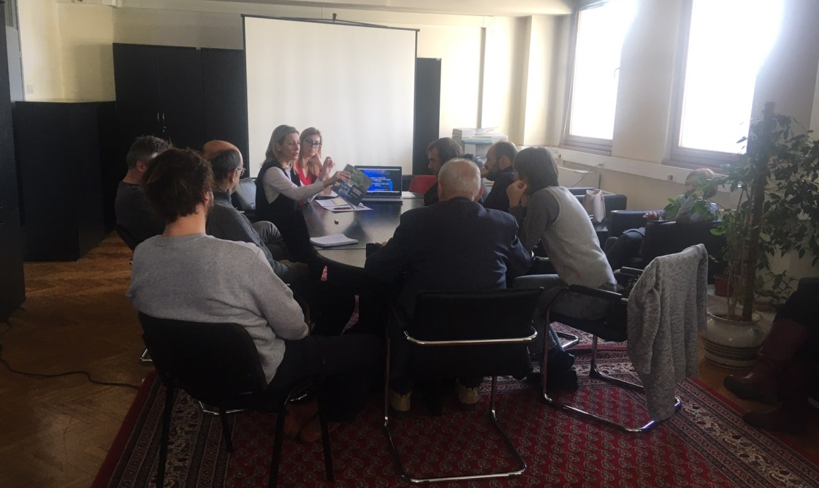
Picture 1: Public consultation in Belgrade, 30 December 2019
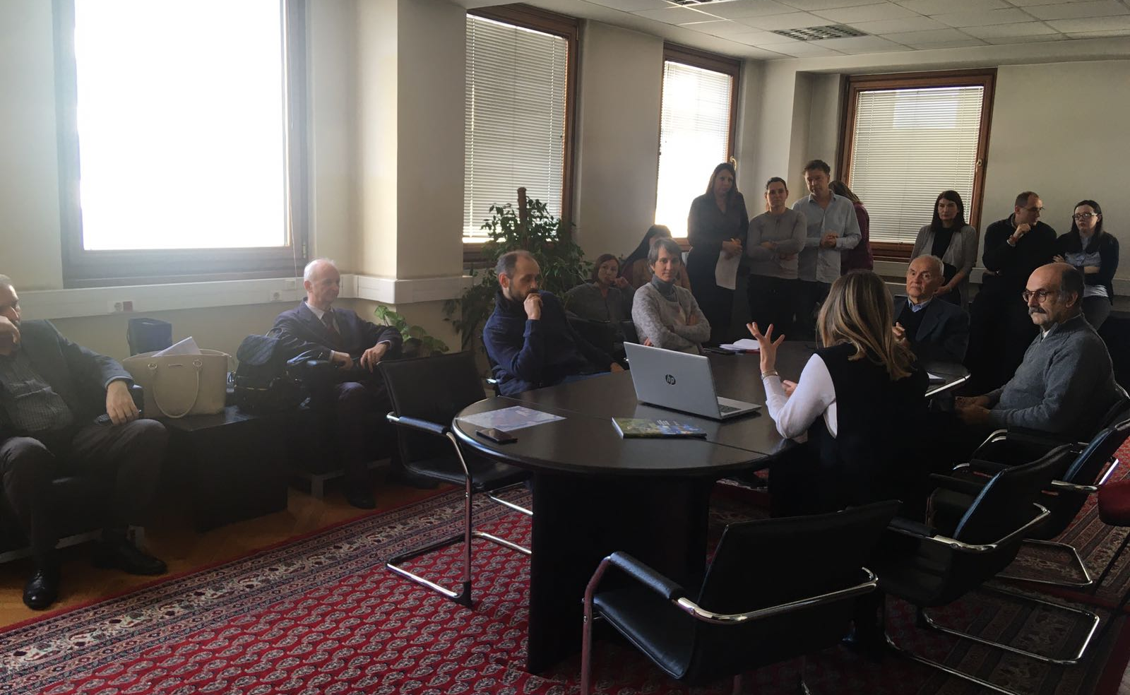
Picture 2: Public consultation in Belgrade, 30 December 2019
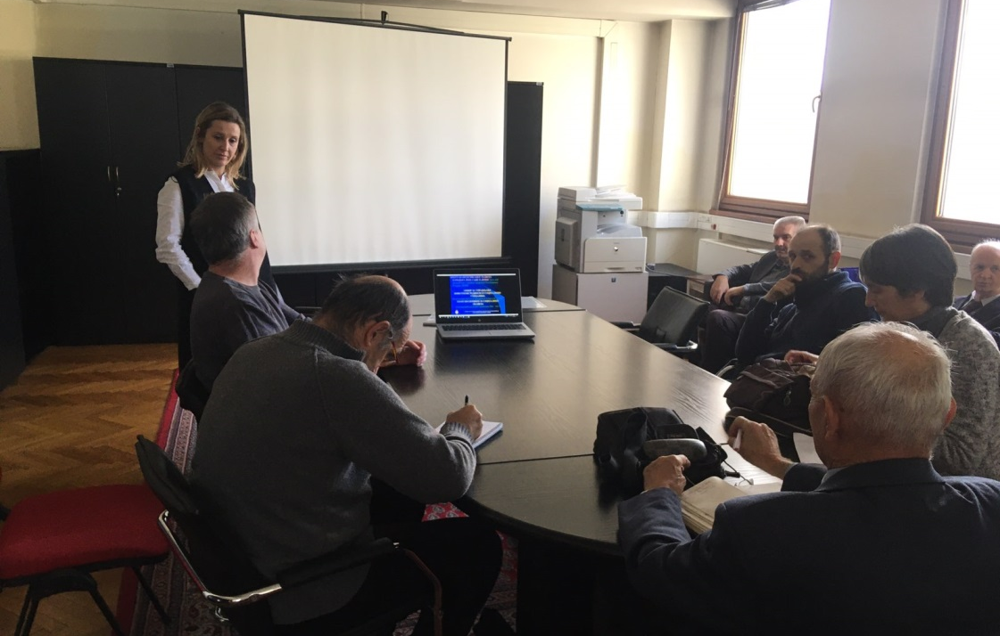
Picture 3: Public consultation in Belgrade, 30 December 2019
Special focus was given to project description, implementation arrangements, potential environmental and social impacts, grievance redress procedures, labor management, screening forms and development of environmental and social management plans during Project implementation.
The importance of Labor management and most important provisions of WB Environmental and Social Standard ESS2 (Labor and Working Conditions) are also explained to the public during presentation of ESMF document.
Before starting with questions of participants, institutional responsibilities and monitoring and reporting procedure on Project were presented and explained. However, the whole consultation have taken a participatory form and turned into a very interactive discussion with participation of all present Stakeholders very early before the moderator handed over the floor to the participants. This
Consultation started at 12:00 AM and ended at 3:30 PM, local time.

Questions and Answers during public presentation and consultations:

Q1: Has the MAFWM and/or the Government defined all subprojects at this stage?
A1 Nina Valcic, Social Specialist: Only a couple of subproject were identified at the preparation stage. These are subprojects Jarak, Popova Bara and Surcin Warehouse. One of the aims of these public consultations and the whole Stakeholder engagement activities relate inter alia to better understand the needs and provide the Stakeholders with an opportunity to directly contribute to the project architecture.
.................................................
Q2: What is the rationale of the World Bank to support compensation even for informal structures constructed without valid permits on land designated as river protection belt?
A1 Nina Valcic, Social Specialist: Any Project developed with financial support of the World Bank, here and anywhere in the World are subjected to the Banks social standards. As already highlighted as of October 2018 any new Project is subject to the Environmental and Social Framework =. Adverse impacts attributable to the Project stemming from Land acquisition are in detailed covered by the ESS 5 on Land Acquisition, Restrictions on Land Use and Involuntary Resettlement. The requirements of these standards are very specific when it comes to informal owners and users and formal and informal economic activities and between these two categories there are no differences in their eligibility. In the aim to prevent opportunistic claims, which indeed, are not eligible the Borrow is requested to announce the Cut-off date.
.................................................
Q3: How are the specific Stakeholder engagement activities designed? What will the methods of engagement be and what frequency will they take?
A1 Nina Valcic, Social Specialist: .As presented today this Project has a standalone Stakeholder Engagement Plan (SEP) applicable throughout the Project lifecycle, to be updated as needed following the procedure set out in the plan itself. The method of engagement is phase sensitive and will be continued and ongoing carefully following the development of the Project and the need to consult and inform the identified Stakeholders. Stakeholders are encouraged to follow announcements on the website of the MAFWM and newspapers as the Project information will be available there. Following these consultations and the Appraisal by the World Bank the engagement shall be intensified as outlined in the plan. For more details please again refer to the disclosed Stakeholder Engagement plan.
.................................................
Q4: Will the Project have a specific Grievance Mechanism? As we understand this is a requirement of many IFIs?
A1 Nina Valcic, Social Specialist: This as all other Projects financially supported by the World bank will have a Project Specific Grievance Mechanism to serve both persons directly affected by land acquisition and persons affected by other Project`s activities ( throughout the cycle). At this moment given the preparation phase of the project the Central mechanism within the MAFWM is operational to be followed by local entry points. Subsequently as the selection of subprojects continues and progresses. This points and function of the GM shall be locally publicized and information material distributed.

Opinions and remarks provided in written form:

O1 Branislav Djordjevic, Citizen Association “Akademija inzenjerskih nauka Srbije”, by his letter dated 03 January 2020:
- All hydro technical project activities on the rivers and in the Sava and Drina corridors should be done exclusively with new hydrological studies and with new hydrological analyzes, since the previously prepared studies are obsolete. Recommended experts to be involved in the new design team.
- Detailed environmental impact analysis is required. The Ramsar Convention on the Protection of Wetlands should also be kept in mind.
- In the case of construction of a new embankment on the left bank of the Sava River in the New Belgrade area, a Spatial Plan of Detailed Regulation with clearly defined Land use should be developed.
- The planned settlements in the remaining Sava river bank areas of New Belgrade, in the hinterland of the regulated part of the river banks, should be carefully reviewed in sense of the population density of that particular city zone (density of buildings, floors), as it is already extremely densely populated, which is reflected in very difficult traffic, as well as to air pollution resulting from excessive occupancy of remaining land.
- Since the Program also includes the Drina corridor, regardless of which facilities will be financed in that corridor, the integral solution of the water management system on that river, which is now official, should be mentioned, as it is in the Water Management Base of Serbia and the Spatial Plan of the Republic of Serbia, as well as in the Republika Srpska Water Management Strategy.
- During the consultation, I and several other attendees were unpleasantly surprised by the explanation of the World Bank's position that all facilities for which displacement and demolition are needed - are in the same legal position in terms of compensation, regardless of when and how investors built the property to be removed. Therefore, in view of the legal regulations relating to water land, as well as the zone of protection of springs, the World Bank in Serbia must use the only possible - selective approach. He implies that the position on the legal position of those whose property will be expropriated and compensated for the construction of shorelines does not apply to those owners who have committed the crime of building in prohibited zones.
- It would be completely illogical and dangerous to require a high degree of flood protection in the new coastal zones regulated under this Program, while allowing the already existing embankment upstream of the settlement in block 45 to be physically destroyed by unintended use as a road, even for the heaviest traffic. Such loads have a very unfavorable effect on the deformations of the foundation zone of the embankment, which therefore becomes unsafe and prone to collapse. The World Bank should therefore explicitly restrict its loan for the construction of new fortifications on the left bank of the Sava by requiring that physical barriers be completely prevented from accessing motor vehicles on the embankment, in all places where it occurs, and preventing the opening of some new approaches.
- In order to re-design the New Belgrade embankment project, it should be borne in mind that the owners of illegally constructed houses in the river side area have constructed transverse embankments to block the large water (river inundation) trough so that they can reach their homes, not only by cars, but by heavy construction machines. These transverse structures during periods of high Sava waters completely impede the flow in the high water trough and drastically aggravate the modes of propagation of large water waves, drastically increasing the risk of breakage of the embankment. Therefore, it is necessary for the World Bank to make the loan for new works in the Sava Corridor conditional on the removal of these transverse structures (access roads to residential buildings, rem.aut.), as well as all other facilities in the large water basin and to enable unhindered mode of transmission of large-water waves. Here, too, the principle must be that these works should be done at the expense of those persons who performed those dangerous works.
- Raft owners cut deep embankments through deep trenches to push plumbing to their rafts. The embankment is thus damaged in several places, which compromises its safety. Therefore, as one of the priorities of this Program, the World Bank should require the rehabilitation of an already existing embankment and prevent its further damage by enforcing a traffic ban on it, except for the official purpose of maintaining the embankment.
- The World Bank should also be aware of the very serious endangering of Belgrade Water Supply springs by illegal construction in the protection zones of the springs.

O2 Aleksandra Smiljanic, Citizen Association “Akademija inzenjerskih nauka Srbije”, by her letter dated 03 January 2020, related to SDIP Project Potential Procurement Packages - : Nr. 1.1.14 Design and Raising dykes in Novi Beograd to protect Belgrade City from flood:
- Several hundred illegal cottages between the embankment and the water were built on the Sava embankment. They threaten the embankment itself, which protects New Belgrade with over 200,000 inhabitants from flooding, as well as Belgrade's water supply, because they are located in the middle of Belgrade's water source
- The owners of illegal cottages drive cars along an embankment that is not designed for traffic but only for service vehicles
- The owners of illegal rafts along the Sava Quay have drilled the embankment in several places with water pipes to bring water to their rafts.
- Although no funds have been allocated for specific projects, investment is being considered for coastal fortification along the planned settlement in New Belgrade, downstream of Block 70a, on land owned by the private companies Comtrade and Zepter. The owners of these companies benefit most from such a project, which is not in line with the World Bank policy that everyone has equal access to World Bank funds
- New planned settlements along the Sava River in New Belgrade do not need to be built, because New Belgrade is already too densely populated and traffic congestion is unbearable.
- If the World Bank wants to provide embankments on the Sava River, it must first start with the existing, already built part of the embankment, which is most vulnerable to the misuse of infrastructure by irresponsible citizens.
- I request that my statement and the accompanying articles be forwarded to the World Bank:
- http://savskinasip.com/analize/group-of-irresponsible-people-endanger-belgrade/1469/
- http://savskinasip.com/analize/stance-of-serbian-academy-of-engineering-sciences/1463/
- http://savskinasip.com/analize/story-about-insolent-people-and-powerless-system/1439/

- LIST OF PARTICIPANTS - PRELIMINARY CONSULTATIONS WITH KEY STAKEHOLDERS, 30 DEC 2019

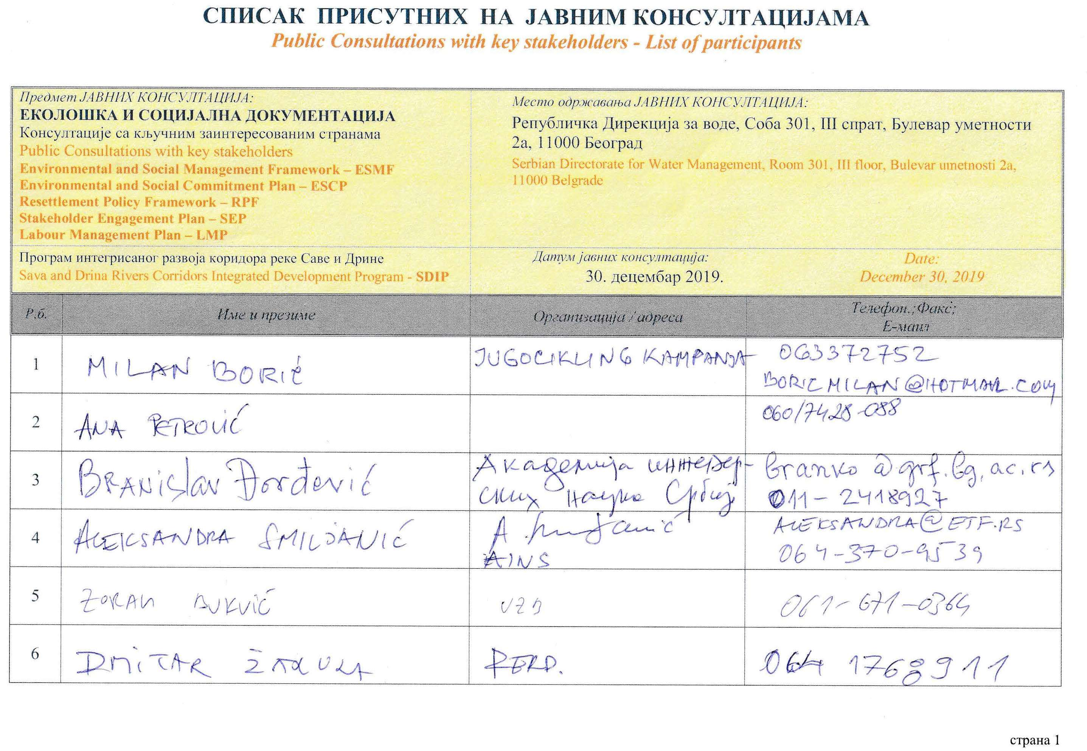
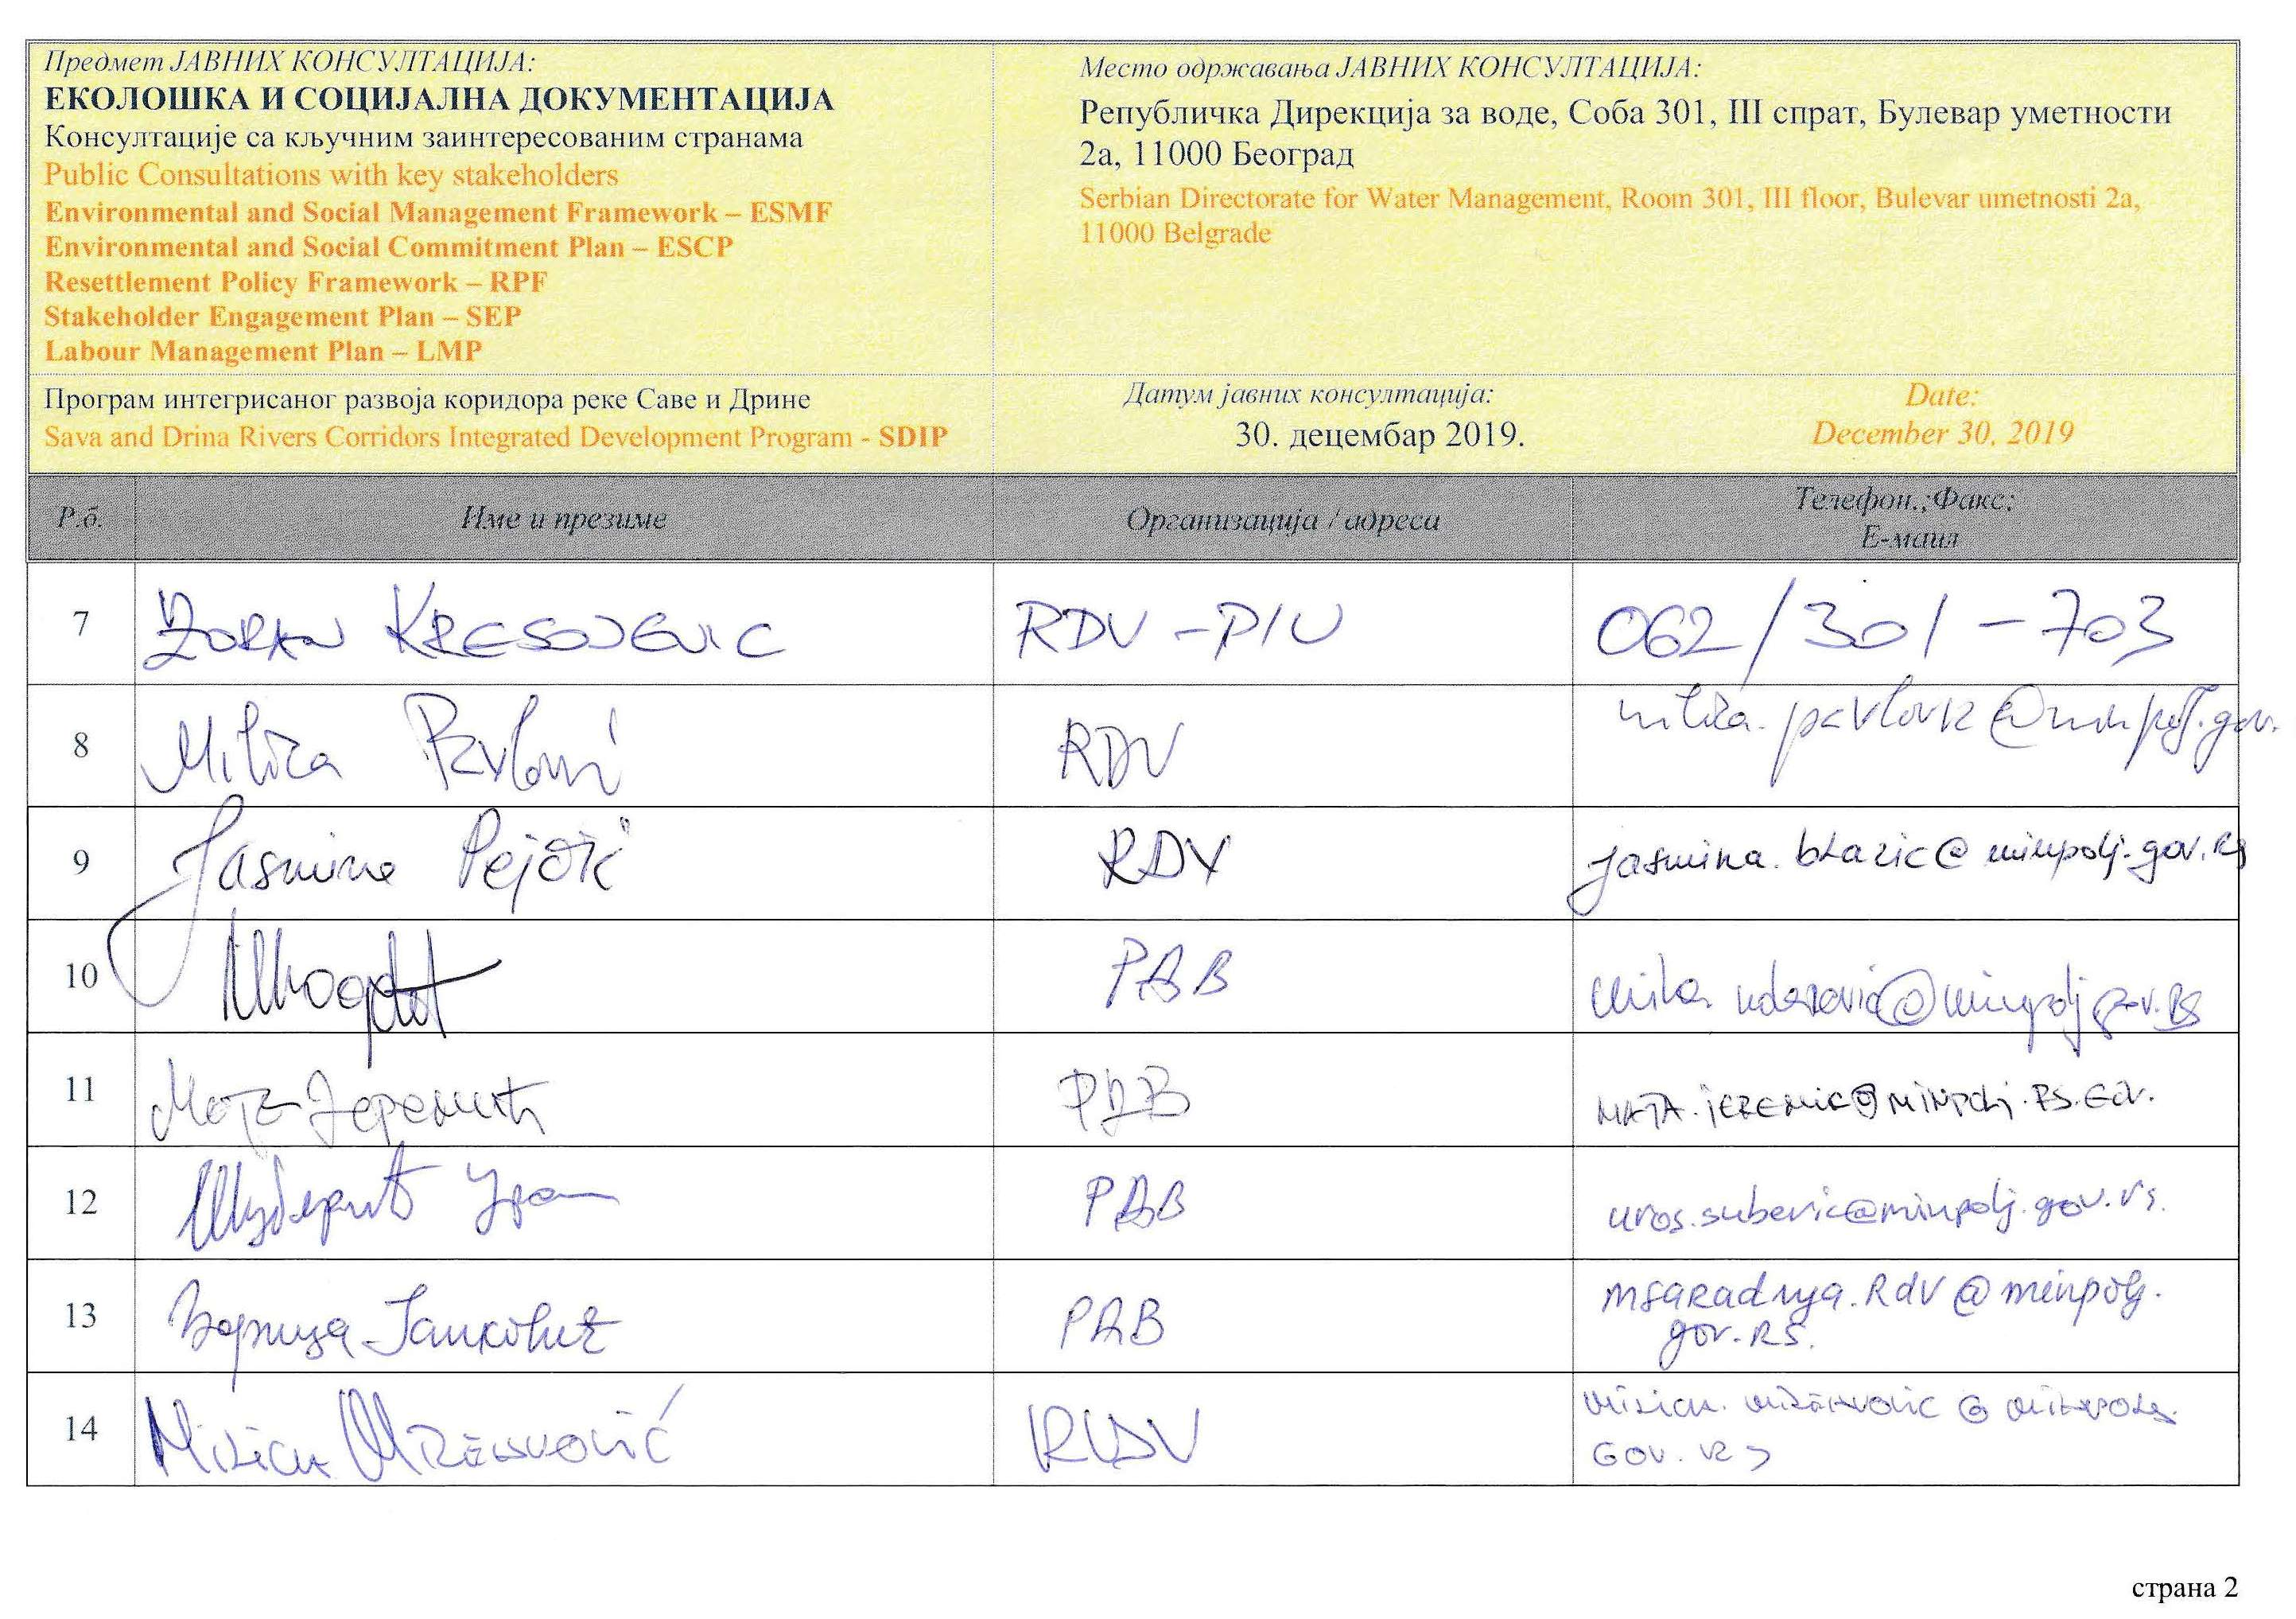
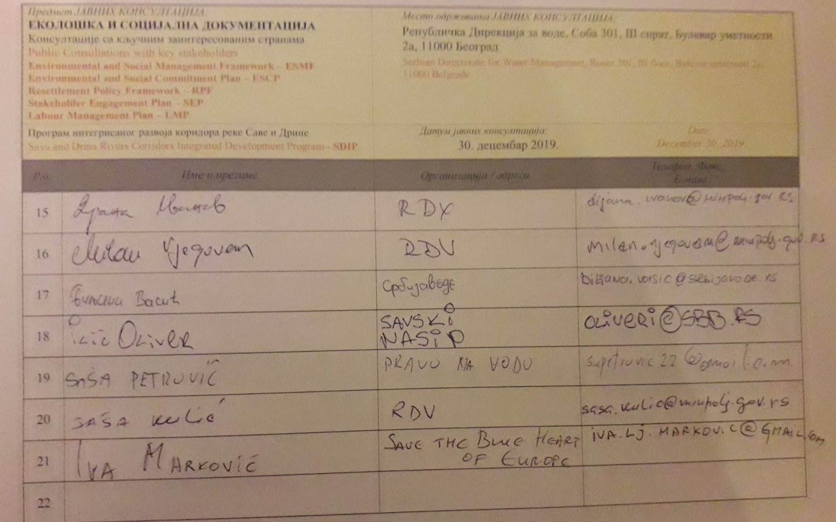

- DOCUMENTATION

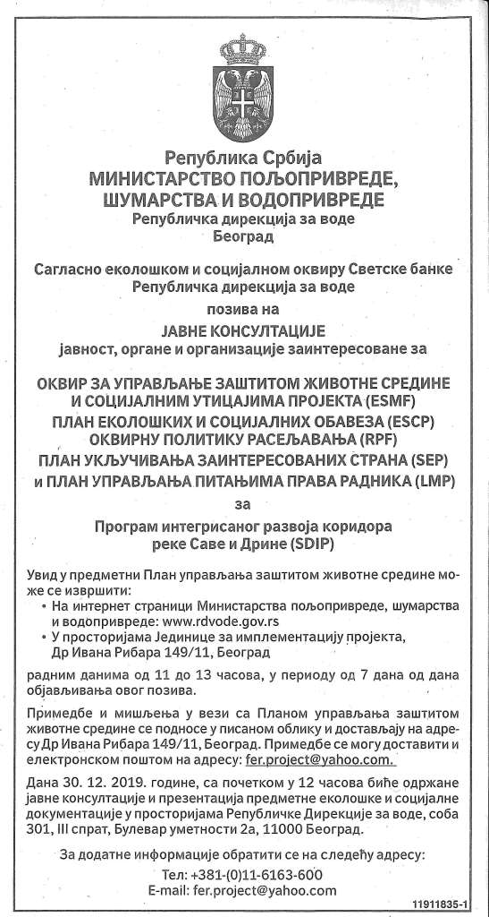
Picture 4: Announcement of public consultation in daily newspaper, (“Politika”, 26 Dec 2019)

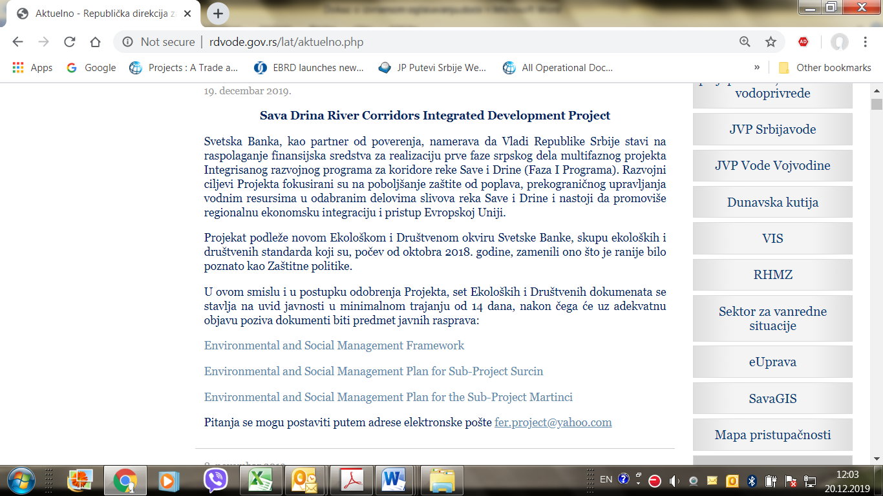
Picture 5: Announcement of public consultation on SDIP Environmental documents on Ministry web site

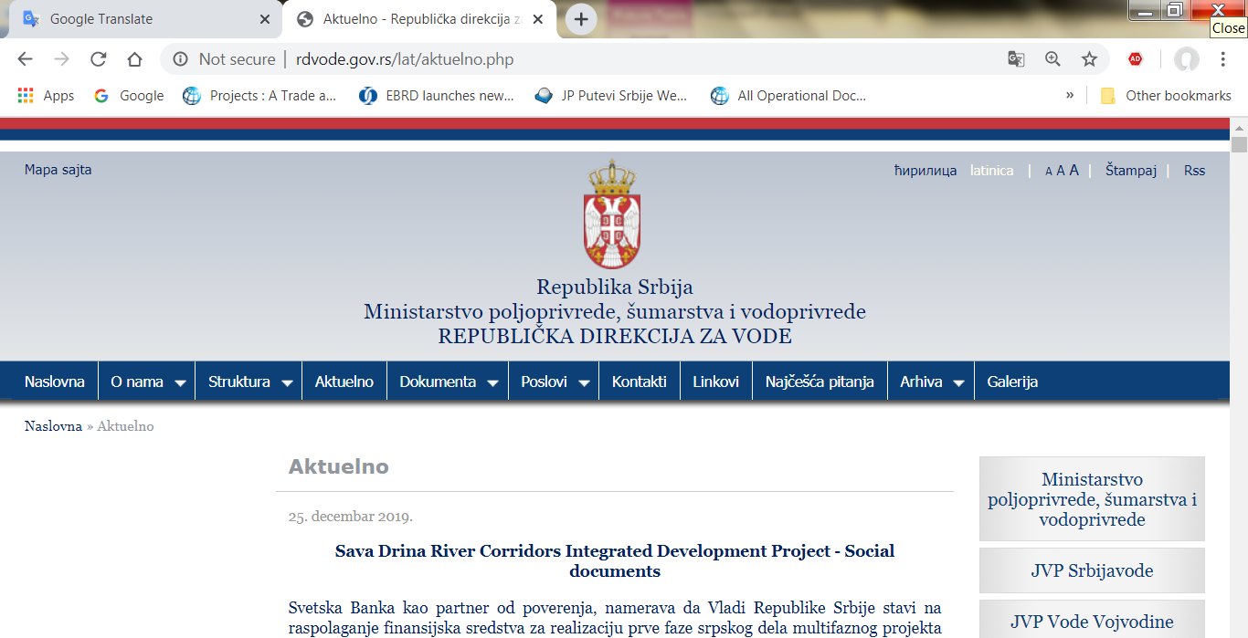
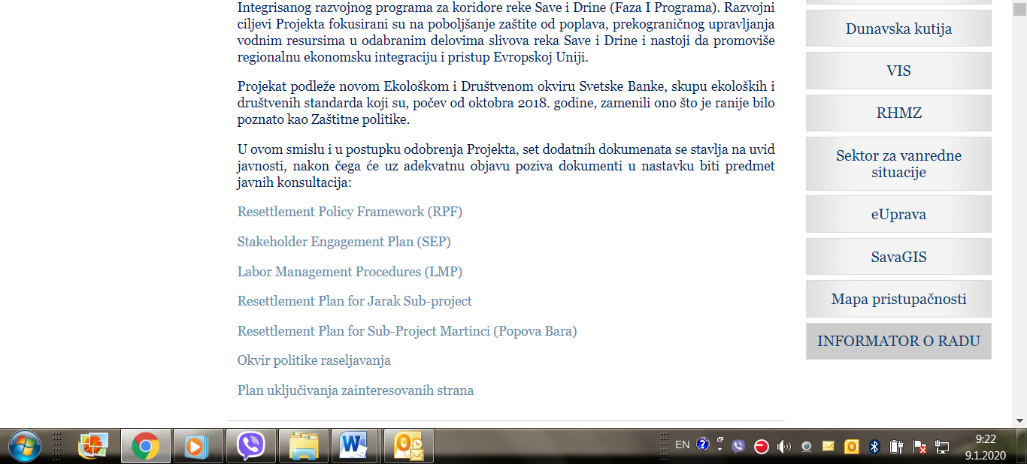
Picture 6: Announcement of public consultation on SDIP Social documents on Ministry web site

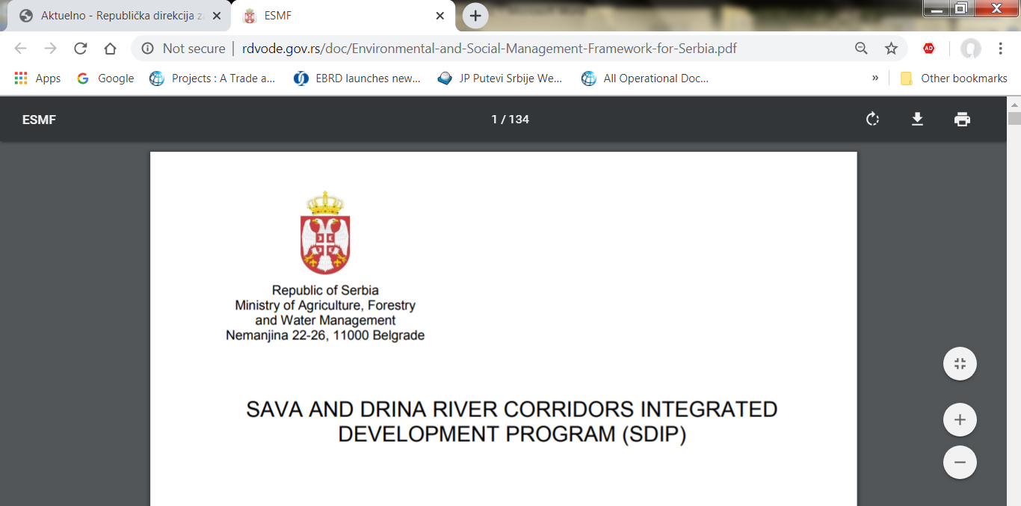
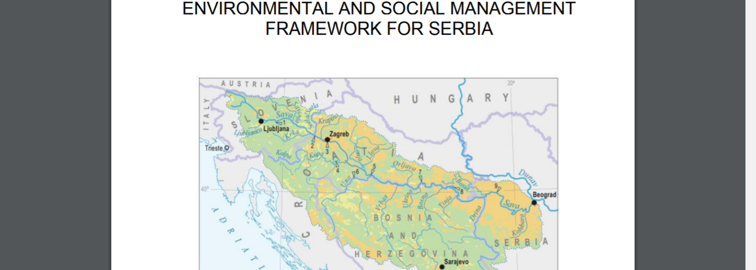
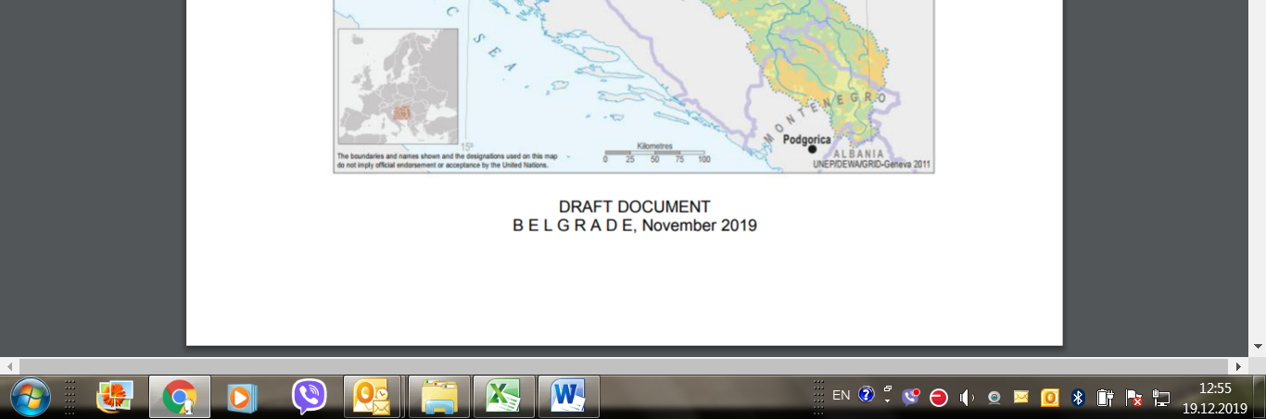
Picture 7: Public disclosure of DRAFT ESMF document, English language, Ministry web site

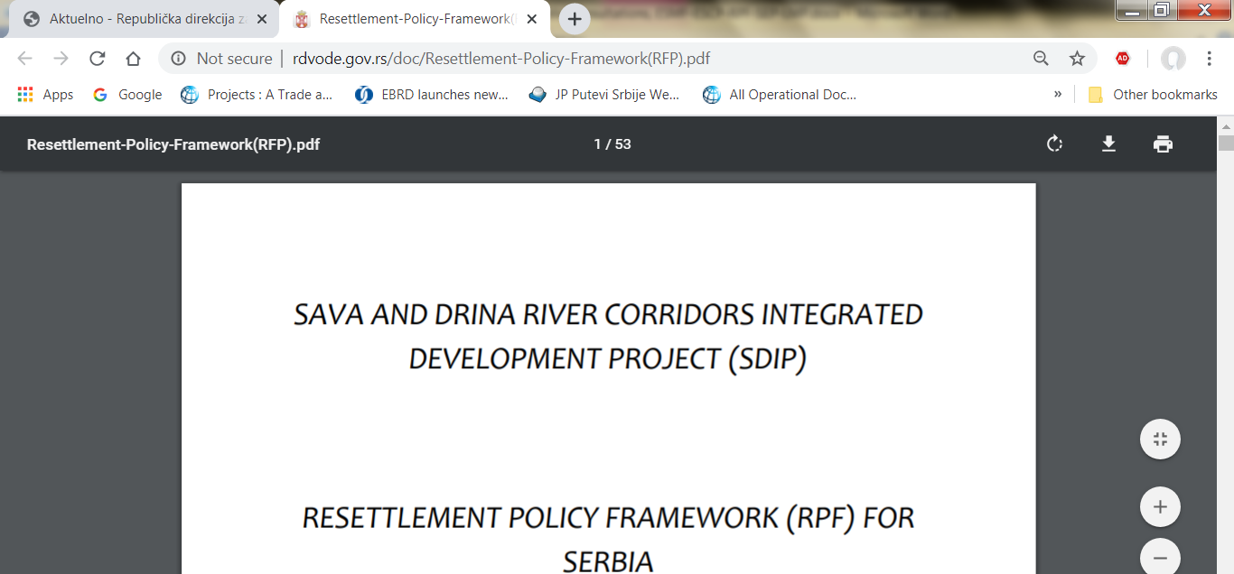
Picture 8: Public disclosure of DRAFT RPF document, English language, Ministry web site

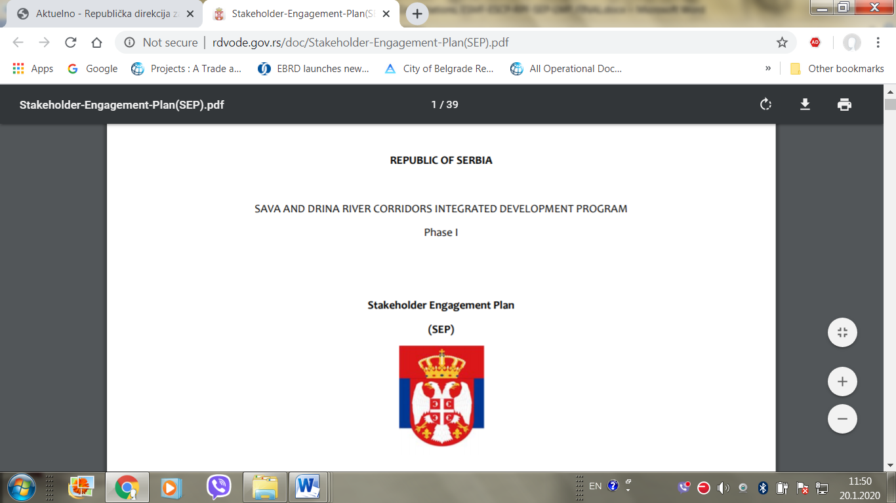
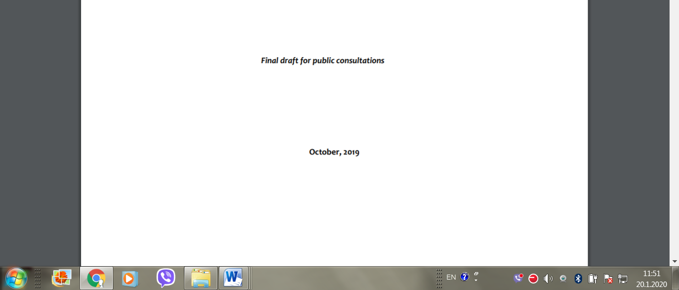
Picture 9: Public disclosure of DRAFT SEP document, English language, Ministry web site

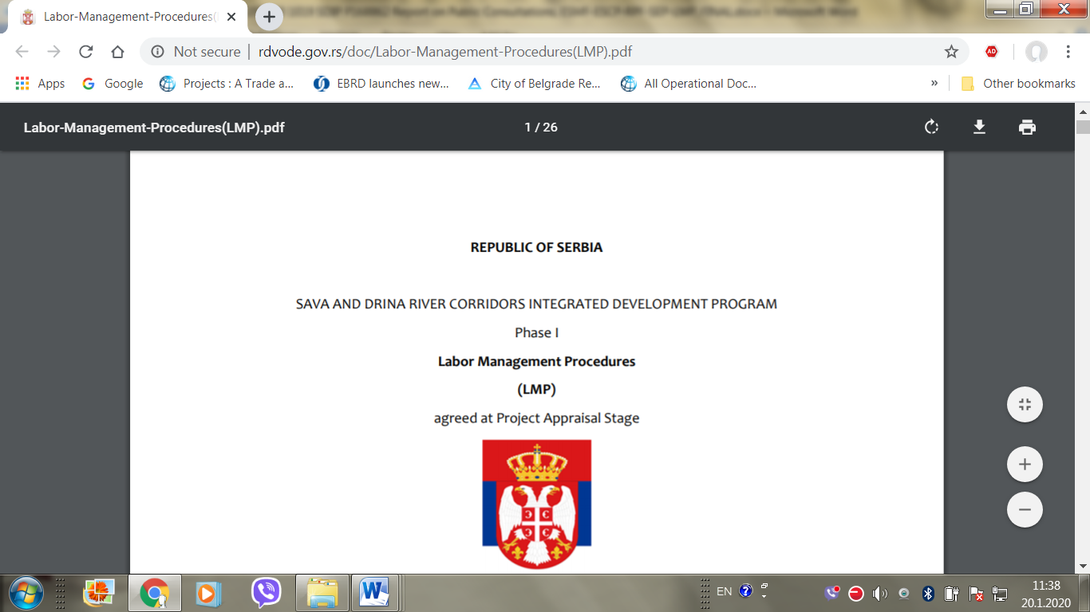
Picture 10: Public disclosure of DRAFT LMP document, English language, Ministry web site

The Public Consultation were conducted prior to the decision on two PMUs was taken and subproject 1.3.1 moved to the first Phase

