**REPUBLIC OF GHANA**



**MINISTRY OF EDUCATION**

**GHANA ACCOUNTABILITY FOR LEARNING OUTCOMES PROJECT**

**(GALOP)**

**STAKEHOLDER ENGAGEMENT PLAN**

**(SEP)**

**APRIL 2019**

# 

# **EXECUTIVE SUMMARY**

The current Stakeholder Engagement Plan (SEP) is designed to establish an effective platform for productive interaction with potentially affected parties and persons with interest in the implementation and outcomes of the Ghana Accountability for Learning Outcomes project (GALOP). Effective stakeholder engagement is a necessary aspect of any good project and the GALOP SEP will help solicit feedback to inform project design and implementation while simultaneously managing expectations of beneficiaries and interested parties about project outcomes.

The GALOP will support implementation of the Government’s Education Strategic Plan (ESP) focusing on about half of basic schools (KG1 to JHS3) in Ghana comprising about 10,000 schools. The Project Development Objective is to improve the quality of low performing basic schools and to strengthen education sector equity and accountability in Ghana.

Project environmental and social risk is assessed as moderate given that the learning grants under Component 2 of the GALOP could be used to finance school rehabilitation works which are likely to occur while school is in session. As a result, strict supervision and adherence to the Ghana Environmental and Protection Agency and World Bank E&S Standards, including the health and safety guidelines is required during implementation of the project. There is also a likely labor risk from civil works contracting which may include risks to health and safety of workers during the construction and operationalization of civil works structures.

The SEP outlines previews stakeholder engagement activities categorizing various groups, their interests and topics of consultations. The identification and analysis of stakeholder groups include government agencies, development partners, Civil Society and Non-Governmental Organizations, Academia, and at the school level, teachers and students. These stakeholder groups also cover affected and other interested parties, key characteristics of vulnerable groups and their specific needs. A stakeholder engagement program also sets out details of the purpose, timing and methods of stakeholder engagement and the GALOP strategy for information disclosure which incorporates the view of vulnerable groups.

Resources and implementation arrangements for SEP activities will be included in Component 4.1 of the GALOP and will be included in mainstreamed activities of the Ministry of Education and the Ghana Education Service. A summary of key institutions and focal persons has been included in the SEP to allow for easy identification of roles and responsibilities. A Grievance Redress Mechanism (GRM) will be incorporated in an already existing GRM within the Ministry of Education. Follow up on grievances and actions taken will form part of the overall monitoring of the project implementation team.

The GALOP SEP is among the first of its kind in IDA funded projects and will offer great opportunities for lessons which can be applied to future projects in the education sector.

# **TABLE OF CONTENT**

EXECUTIVE SUMMARY i

TABLE OF CONTENTS ii

LIST OF TABLES iii

LIST OF ABBREVIATIONS AND ACRONYMS iv

1.0 INTRODUCTION AND PROJECT DESCRIPTION 1

1.1 Introduction 1

1.2 Project Description 1

2.0 NATIONAL REQUIREMENT FOR CITIZEN ENGAGEMENT 2

3.0 BRIEF SUMMARY OF CITIZEN ENGAGEMENT 2

4.0 STAKEHOLDER IDENTIFICATION AND ANALYSIS 5

5.0 STAKEHOLDER ENGAGEMENT PROGRAM 9

5.1 Purpose and Timing of Stakeholder Engagement Program 9

5.2 Proposed GALOP Strategy for Information Disclosure 9

5.3 Proposed Strategy to incorporate the views of Vulnerable Groups 14

6.0 RESOURCES AND RESPONSIBILITIES FOR IMPLEMENTING SEP ACTIVITIES 14

6.1 Resources 14

6.2 Management Functions and Responsibilities 12

7.0 GRIEVANCE MECHANISM 16

8.0 MONITORING AND REPORTING 17

8.1 Involvement of Stakeholders in Monitoring Activities 18

8.2 Reporting back to Stakeholder Groups 18

APPENDICES 19

Appendix 1: Stakeholder Consultations Workshops at Regional Level 19

Appendix 2: Stakeholder Prioritization 24

# **LIST OF TABLES**

Table 1: Previous Stakeholder Engagement Activities …………………………………………………..3

Table 2: List of Stakeholders………………………………………………………………………………………….5

Table 3: Characteristics of Vulnerable Groups……………………………………………………………….6

Table 4: GALOP Stakeholder Engagement Methods………………………………………………………8

Table 5: GALOP Strategy for Information Disclosure……………………………………………………10

Table 6: Summary of Key Institutions/Focal Persons and their Responsibilities…………..14

# **LIST OF ABBREVIATIONS AND ACRONYMS**

ADEOP Annual District Education Operational Plan

CE Citizen Engagement

CS Circuit Supervisors

CBO Community Based Organization

CHRAJ Commission on Human Rights and Administrative Justice

CSO Civil Society Organisation

CSU Client Service Unit

DCE District Chief Executive

DEOC District Education Oversight Committee

DE District Engineer

DLI Disbursement Linked Indicators

DTST District Training Support Teams

EA1 Environmental Assessment Form 1

EA2 Environmental Assessment Form 2

EIA Environmental Impact Assessment

EIS Environmental Impact Statement

EPA Environmental Protection Agency

EGMA Early Grade Mathematics Assessment

EGRA Early Grade Reading Assessment

EMIS Education Management Information System

ESCP Environmental and Social Commitment Plan

E&S Environmental and Social

ESF Environmental and Social Framework

ESMF Environmental and Social Management Framework

ESMP Environmental and Social Management Plan

ESMTDP Education Sector Medium Term Development Plan

ESP Education Sector Plan

ESS Environmental and Social Standards

FBO Faith Based Organization

GALOP Ghana Accountability for Learning Outcomes Project

GBV Gender Based Violence

GES Ghana Education Service

GETFund Ghana Education Trust Fund

GNECC Ghana National Education Campaign Coalition

GPE Global Partnership for Education

GRM Grievance Redress Mechanism

ICT Information and Communication Technology

IDA International Development Association

IE Inclusive Education

KG Kindergarten

LEG Local Education Group

MCA Maximum Country Allocation

MCE Metropolitan or Municipal Chief Executive

MMDA Metropolitan Municipal District Assembly

MLGRD Ministry of Local Government and Rural Development

MOE Ministry of Education

MoGCSP Ministry of Gender, Children and Social Protection

MOF Ministry of Finance

MCA Maximum Country Allocation

NACCA National Council for Curriculum and Assessment

NCCP National Climate Change Policy

NEA National Education Assessment

NGO Non-Governmental Organization

NIB National Inspectorate Board

NTC National Teaching Council

P4 Primary 4

PC Project Coordinator

PAPs Project Affected Persons

PASEL Program for Analysis of Education Systems

PDO Proposed Development Objective

PER Preliminary Environmental Report

PO Planning Officer

PIM Project Implementation Manual

PISA Program for International Students Assessments

PIT Project Implementation Team

PST Project Steering Team

RAP Resettlement Action Plan

RPF Resettlement Policy Framework

SEIP Secondary Education Improvement Project

SEP Stakeholder Engagement Plan

SCD Systematic Country Diagnostic

SHEP School Health Education Programme

SMC School Management Committee

SPED Special Education Division

SORT Systematic Operations Risks Rating Tool

SPIP School Performance Improvement Plans

SRC School Report Card

TA Technical Assistance

TLM Teaching and Learning Material

UNICEF United Nations International Children’s Emergency Fund

WB World Bank

# **INTRODUCTION AND PROJECT DESCRIPTION**

* 1. **INTRODUCTION**

Stakeholders are defined as persons or groups who are directly or indirectly affected by a project as well as those who may have interest in a project and/or the ability to influence its outcome, either positively or negatively. The current Stakeholder Engagement Plan (SEP) is designed to establish an effective platform for productive interaction with the potentially affected parties and others with interest in the implementation and outcomes of the Ghana Accountability for Learning Outcomes Project (GALOP). Meaningful stakeholder engagement throughout the project cycle is an essential aspect of good project management and provides opportunities for the GALOP to solicit feedback to inform the project design, assess environmental and social risks as well as mitigation measures, and clarify the project scope and impacts to manage expectations.

The objective and purpose of the present SEP is to inform how Stakeholder Engagement will be practiced throughout the course of the project, how previous engagements have already informed project design or how they have been integrated into planning and mitigation, and outline the responsibilities of the relevant body and contractors in the implementation of upcoming engagement activities etc.

This SEP identifies the major stakeholders affected by the project either directly or indirectly (including vulnerable groups) as well as those with other interests that can influence decisions about the project. It outlines the engagement approach undertaken and planned, and articulates a range of strategies for timely, relevant and accessible stakeholder engagement throughout the project life cycle. The SEP is also prepared in compliance and with the application of the World Bank Performance Standard 10 on stakeholder engagement and information disclosure.

* 1. **PROJECT DESCRIPTION**

The proposed Ghana Accountability for Learning Outcomes Project (GALOP) will support the implementation of the Government’s Education Strategic Plan (ESP) with a focus on basic education. It will support investments aimed at improving the quality of low performing basic education schools and strengthen education sector equity and accountability in Ghana. Activities towards achieving these objectives would include strengthening teacher capacity, school support and supervision, and strengthening accountability systems. The project would target grades from KG 1 to P6 for the support to teachers and schools, and provision of teaching and learning materials and will impact systems strengthening for basic education from KG1 to JHS3. The project’s focus on early years is equity enhancing because of the long-term benefits in terms of readiness to learn and improved future learning outcomes. The learning interventions are expected to reach approximately 10,000 low performing public basic schools, which represents approximately one half of all basic schools in Ghana. The GALOP will provide learning grants for beneficiary schools to stimulate school level management accountability for results. These learning grants are expected to improve literacy and numeracy, through a menu of activities from which the schools can select and implement for the desired outcomes. Schools may also have the option of choosing additional activities which they expect to improve learning outcomes given their context.

The project environmental and social risk has been assessed as moderate. Specifically, the learning grant could be used to finance school rehabilitation works. The nature of the anticipated civil works is not complex given that these will take place in existing school compounds and it is not envisaged that any natural or sensitive habitats will be affected by the works. However, since the works may occur during school hours when lessons are taking place, young children may be exposed to construction hazards, and strict supervision and adherence to the Ghana EPA and World Bank E & S Standards, including the health and safety guidelines for construction is required during implementation of the project.

While the project is expected to use school or government lands, in many cases, unused or underused state land is subject to occupation, sometimes by “squatters”. The utilization of state land may therefore impact on livelihoods. It is also frequently the case that government acquisition is not properly done or properly documented which can result in disputes over ownership and boundary demarcation that will need to be identified through due diligence and appropriate mitigation measures in accordance with the World Bank E&S standards.

Labor Risk: The contracting structure of the project is to use mainly local labor residing within the communities, it is not expected that there would be need for the establishment of workers camps and international migrants. The likely labor risk may include health and safety of workers during the construction and operational phases, general labor working conditions, community grievances over recruitment process and selection and protection of female workers. Attention will also be paid to GBV risk mitigation particularly possible interaction between workers and school children, and the possibility of sexual harassment and exploitation of girls and women as they search for jobs on civil works sites or seek for procurement opportunities from the Project.

1. **NATIONAL REQUIREMENT FOR CITIZEN ENGAGEMENT**

The 1992 Constitution of Ghana acknowledges the right to information under Article 21(1) (f) as a fundamental human right of all citizens. This right will be properly enjoyed where the public is efficiently engaged in the processes and procedures of public institutions.

The Environmental Assessment Regulations 1999, (LI 1652) provides the regulatory framework for the administration of Environmental Assessment (EA) in Ghana. The regulation provides for the participation of stakeholders at all levels of the EIA process in order to ensure that their concerns and inputs are considered as part of the design, planning, project implementation and decommissioning

Section 16 (1) (3) makes provision the general public to make comments and provide suggestions on any project

Section 17 (1) makes provisions for public hearing

Section 27 (1) provides the platform for complaints by aggrieved persons

Strategic goal 4 of the National Environmental Policy which focuses on Participation and Coordination in Environmental Governance charges the lead institutions in environmental governance to ensure active participation in all environmental matters.

**3.0 BRIEF SUMMARY OF PREVIOUS ENGAGEMENET ACTIVITIEIS**

Stakeholder Engagement under GALOP began early from the project identification to allow stakeholders’ views and concerns to be considered in the project design, and to provide inputs to the project environmental and social assessment and mitigation plan. The engagement also sought to disseminate and disclose project related information and to plan project implementation, monitoring and evaluation arrangements. Engagements included both formal and several informal methods. Stakeholders span government institutions, Development Partners, CSO/ NGOs, academia and across the geographic spread of the country. Below is a summary stakeholder engagement undertaken so far:

Table 1: Previous Stakeholder Engagement Activities

|  |  |  |  |  |
| --- | --- | --- | --- | --- |
| **Stakeholder Group** | **Institutions** | **Interest** | **Method of engagement** | **Topic of consultations** |
| **Government agencies** | * Ministry of Education (MOE) * Ghana Education Service (GES) * National Council for Curriculum and Assessment (NACCA) * National Inspectorate Board (NIB) * National Teaching Council (NTC) * Reform Secretariat | Project Implementing partners, technical implementing agencies, beneficiaries | Team meetings  Workshops | Project objective, scope, implementation arrangement, costing and budgeting, etc. |
| * Ministry of Gender, Children and Social Protection (MoGCSP) * Commission of Human Rights and Administrative Justice (CHRAJ) | Gender parity in education and respect for the rights of the child | One-on-one interviews | Gender and GBV assessment |
| District Education officials   * Regional and District Directors of Education, Statisticians, Circuit Supervisors, M&E and Planning Officers | Implementing Partners/Beneficiaries at sub-national levels | 3 Zonal Workshops | Project scope, environmental and social risk and mitigation planning |
| District Education offices   * Abokobi Municipal * Assin South * Nsawam Adoagyir Municipal * Asante Akim Central |  | Semi-structured Interviews | Social assessment |
| **Development Partners** | UNICEF  DFID  USAID  JICA  UNESCO  Innovations for Poverty Action (IPA) | Project design/ scale up partners | Sector Working Group Meetings  Monthly Education Partners Meeting  Workshops including 2-day Appraisal Workshop | Project objective, scope, identification of pilots to be scaled under GALOP |
| **CSO/ NGO** | * Ghana Federation of Disability Organizations * SWEB Foundation * The Ark Foundation * Ghana National Education Campaign Coalition (GNECC) * APEX Consult * World Reader * Discovery Learning Alliance | Disability inclusion/ scalable education technology and evaluation results | Formal one-on one interviews  Workshops |  |
| **Academia** | University of Cape Coast | Disability inclusion | Formal one-on-one interviews | Inclusive Education |
| **Schools, teachers and Pupils** | Atomic Hills Estates Basic School: A&B  Haatso Presbyterian Basic School  Papao Community Presbyterian Basic School  Rev. Father Wieggers RC Basic School  Konongo Roman Catholic Basic School: A,B &C  Odumase M/A Basic cluster of schools  Assin Adubiase Methodist Basic School  Assin Nsuta M/A  Tamale Fouta Methodist Primary  Tamale St Paul’s RC Primary  Tamale Al-saqasat Islamic Primary | Potential project beneficiaries | Semi-structured interviews, Focus Group Discussion | Social risks and mitigation planning |

1. **STAKEHOLDER IDENTIFICATION AND ANALYSIS**

This section identifies key stakeholders who will be informed and consulted about the project, including individuals, groups, or communities. It also identifies and assesses the needs of some disadvantaged or vulnerable individuals or groups, who may have limitations in participating and/or in understanding the project information or in participating in the consultation process. Based on this assessment and considering other aspects including stakeholder requirements/needs and interests, the stakeholder list below are categorised as (i) affected parties; (ii) other interested parties; and (iii) disadvantaged/ vulnerable individuals or groups. The Stakeholder list is a “living document” which will be updated regularly throughout the Project life as appropriate.

Table 2a: List of Affected and Level of Impact

|  |  |  |  |
| --- | --- | --- | --- |
| **Type of Stakeholder/ Level of Impact** | **High Impact** | **Medium Impact** | **Low Impact** |
| **Affected** | * Ministry of Education * Ghana Education Service (GES) * National Council for Curriculum and Accreditation (NACCA) * National Inspectorate Board (NIB) * National Teaching Council (NTC) * Project Technical Implementation Team (including safeguards) * District Directors of Education * Circuit supervisors * District Education Oversight Committee * Teachers/ Head teachers * Pupils (Students) * Contractors | * Regional Directors of Education * Parent Teacher Associations (PTAs) * School Management Committees (SMCs) * Parents * Communities and Community Leaders/ members - (peer groups women, children, vulnerable groups and persons etc.) * Sub-contractors | * Artisans |

Table 2a: List of other Interested Persons and Level of Impact; Vulnerable Groups

|  |  |  |  |
| --- | --- | --- | --- |
| **Type of Stakeholder/ Level of Impact** | **High Impact** | **Medium Impact** | **Low Impact** |
| **Other Interested** | * Special Education Division, GES * Development Partners * Office of the President (Cabinet) * Ministry of Finance * Special Education Unit, GES | * Ministry Gender, Children and Social Protection * Environmental Protection Agency (EPA) * Ministry of Local Government and Rural Development * Ghana National Association of Teachers (GNAT) * Parliament * Parliamentary Select Committee on Education * Ministry of Justice and Attorney-General’s Department * Regional Coordinating Council * District Assemblies * Department of Social Welfare * Community Based Organisations (CBOs) * Ghana Police Service * Media * Health centers | * Civil Society Organizations (CSOs)/ Non-Governmental Organizations (NGOs) * Ghana Education Trust Fund (GETFund) * Land Valuation Division * Faith Based Organizations (FBOs) |
| **Vulnerable** | * Persons with Disabilities * Children with special needs * Women/ girls * Orphans | | |

The table below also identifies and assesses the needs of some disadvantaged or vulnerable individuals or groups to help determine suitable engagement strategies.

Table 3: Characterization of Vulnerable Groups

|  |  |  |  |  |
| --- | --- | --- | --- | --- |
| Stakeholder group | Key Characteristics | Language needs | Preferred notification | Specific needs |
| Pupils (students) with disabilities | Hearing impairment (Hearing loss)  Visual impairment  (Low vision or blindness)  Physical impairment (Mobility disabilities) | Braille, audio, sign language | Written information | Accessible venues, sign-language translators/interpreters |
| Teachers with disabilities | Hearing impairment (Hearing loss)  Visual impairment  (Low vision or blindness)  Physical impairment (Mobility disabilities) | Braille, audio, sign language | Written information | Accessible venues, sign language translators/intepreters |
| Children with special needs | Learning disabilities, such as Attention-Deficit Disorder,  Hyperactivity Disorder, dyslexia, or dyscalculia  epilepsy | Additional person support | Through care givers | Special needs textbooks and materials  Limited assistive devices may be required |
| Women and girls | Consultation times will have to align with the needs of women, girls. Women may have limitations about time of day or location for public consultation; they may need child care for meetings or other additional support and resources to enable them participate in consultations. | Local language as appropriate | Verbal, community announcement, focused group meetings etc | Gender sensitive Teaching and Learning Materials  Meetings in close by locations within the communities |
| Orphans | limited voice  low representation, lack of access to information | - | Focused group meetings | Reach out to orphanages to ensure that opportunities under the Project are available |

1. **STAKEHOLDER ENGAGEMENT PROGRAM**
   1. **Purpose and timing of stakeholder engagement program**

This Stakeholder Engagement Plan (SEP) is designed to establish an effective platform for productive interaction with the potentially affected parties and others with interest in the implementation outcome of GALOP. Meaningful stakeholder engagement throughout the project cycle is an essential aspect of good project management and provides opportunities for GALOP to:

* Solicit feedback to inform project design, implementation, monitoring and evaluation
* Clarify project objectives, scope and manage expectations
* Assess and mitigate project environmental and social risks
* Enhance Project outcomes and benefits
* Build constituencies and collaboration
* Disseminate project information/ materials
* Address project grievances

To ensure adequate representation and participation of the different groups, GALOP will rely on different methods and techniques based on the assessment of the stakeholder needs. Some of the engagement methods are listed below in Table 4.

* 1. **Proposed GALOP strategy for information disclosure**

Timing and advanced planning of engagement is one key element that ensures that consultations are relevant, information is readily accessible to the affected public, and that facilitates informed participation. It is envisaged that the roll out of stakeholder engagement will align to the project cycle i.e., Preparation and Design Phase, Implementation Phase, Monitoring Phase, Completion and Evaluation Phase. These phases do not necessarily occur in a linear way for all stakeholders as indicated in Table 5.

Section on Proposed strategy for consultation

Table 4: GALOP Stakeholder Engagement Methods:

|  |  |  |
| --- | --- | --- |
| Engagement Technique | Description and use | Target audience |
| MOE, GES websites | The GALOP PAD and PIM, as well as the ESMF, RPF, ESCP and SEP will be published on the MOE website | All stakeholders |
| Information Centre and Information Boards | Advance announcements of commencement of major Project activities, project Grievance Redress Mechanism, advertisement for local artisans and labor etc. | Local communities within the project areas |
| Community durbars/ public meetings | Will be used to convey general information on the Project, detailed discussions on sub-project activity that is planned by the project, project environmental and social risks and mitigation measures and to provide regular updates on implementation progress to local, regional and national stakeholders. Interactive Questions & Answers session with the audience | Project affected communities |
| Correspondence by phone/ email/ written letters | Distribute project information to government officials, organizations, agencies and companies  Invite stakeholders to meetings | Government officials, NGO’s, CSOs, CBOs, FBOs, Development Partners |
| Printed advertisement media | Will be used to disseminate and disclose project documents intended for general readers and audience (e.g. ESMF, RPF, ESCP)  Advertise some project procurement | General public |
| Distribution of printed public materials: Project information leaflets, brochures, fact sheets | Will be used to convey general information on the Project and to provide regular updates on its progress to local, regional and national stakeholders. |  |
| Internet/Digital Media | Use of the Ministry of Education’s official website to promote various information and updates on the overall Project, impact assessment and impact management process, procurement, employment opportunities, as well as on Project’s engagement activities with the public | Project stakeholders and other interested parties that have access to the internet resources. |
| One-on-one interviews | Will be used to solicit views and opinions on project impacts and solutions | Vulnerable individuals, CSO/NGOs/ FBOs, DPs etc. |
| Dedicated hotline | A designated and manned telephone line will be set up that can be used by the public to make complaints and grievances, obtain information, make enquiries, or provide feedback on the Project. | Project affected persons, and any other stakeholders and interested parties |
| Workshops | * Present project information to a group of stakeholders * Allow the group of stakeholders to provide their views and opinions * Use participatory exercises to facilitate group discussions, brainstorm issues, analyse information, and develop recommendations and strategies * Recording of responses | Government, NGOs, CSOs, FBOs |
| Focus group meetings | Facilitate discussion on Project’s specific issues (eg GBV, disability inclusion), that merit collective examination with various groups of stakeholders using Focus Group Meetings. | Vulnerable groups, |
| Surveys | Use to gather beneficiary opinions and views about project interventions. Engagement with CSOs to support citizen feedback surveys is being explored | Project beneficiaries |

Table 5: GALOP Strategy for Information Disclosure

|  |  |  |  |  |  |  |  |
| --- | --- | --- | --- | --- | --- | --- | --- |
| **Project stage** | **List of information to be disclosed** | **Method proposed** | **Time table: Location/dates** | **Target Stakeholders** | **Topic of consultation** | **% reached** | **Responsibility** |
| Preparation or design phase | Project Appraisal Document (PAD)  ESMF, RPF, ESCP, SEP | Newspaper publication  workshops  website  Community durbars and Consultation with affected parties  Distribution of printed documents in relevant institution | Once in 2 national dailies  3 workshop – South, middle and Northern sectors  MOE, GES WB, Min. of Local Gov. EPA,  Community Information Centers  MOE, GES, DAs.  Community Information Centers | National, Regional and district stakeholders  Regional, District and community level  International, National, Regional and district stakeholders  Community level  National, Regional and district stakeholders | Project concepts, benefits and impacts  Mode of selection of subprojects, benefits, impacts | 60%  75%  75% | MOE, GES and Project Management unit  MOE, GES and Project Management unit  MOE, GES and Project Management unit |
| Implementation Phase | ESMP, RAP, ARAP, Labor Management Procedure, Occupational Health and Safety Plan  Emergency preparedness and response  Project Monitoring and safeguard compliance report | website | MOE, GES WB, Min. of Local Gov. EPA | International, National, Regional and district stakeholders | Subprojects benefits, impacts (Community health and Safety, Occupational health and Safety, Labor Management Procedures, Traffic Safety, Security, GRM, GBV issues and mitigation) |  | MOE, GES and Project Management unit, Safeguard Team |
| Operational Phase | Annual Education Sector Performance report  Environmental and Social Audit report  Updates on project activities | Regional and District level offices of GES  MOE/GES national office and website | GES Regional and District offices | Regional and district stakeholders | Performance of the schools, GRM, maintenance of facilities, Security, GBV education | 100%  80% | MOE, GES and Project Management unit |
| Completion Phase | Project completion report |  |  |  |  |  |  |

**5.3 Proposed strategy to incorporate the view of vulnerable groups**

The consultation activities will be based on the principle of inclusiveness, i.e. engaging all segments of the local society, including disabled persons and other vulnerable individuals as specified above. If necessary, logistical assistance would be provided to enable representatives from the remote areas, persons with limited physical abilities and those with insufficient financial and transportation means to attend public meetings scheduled by the Project. In cases where vulnerable status may lead to people’s reluctance or physical incapacity to participate in large-scale community meetings, the project will hold separate small group discussions with them at an easily accessible venue is a way for the Project to reach out to the groups who, under standard circumstances, may be insufficiently represented at general community gatherings. The following can be some of the options to reach out to vulnerable groups:

* Identify leaders of vulnerable and marginalized groups to reach-out to these groups
* Engage community leader and CSOs, NGOs
* Organize face-to-face and focus group discussions

1. **RESOURCES AND RESPONSIBILITIES FOR IMPLEMENTING SEP ACTIVITIES**

**6.1 Resources**

Funding for the SEP implementation will be included as part of project cost under sub-component 4.1. which would fund all Technical Assistance (TA) and communication strategies conducted at the headquarters, regional and district levels.

**6.2 Management functions and responsibilities**

The implementation of the GALOP will be mainstreamed in the Ministry of Education (MOE) and the Ghana Education Service (GES).  A Technical Team comprising MOE and GES teams (Project Implementation Team-PIT) will be set up to drive implementation including oversight of the SEP implementation. The Environment and Social consultants within the PIT will directly facilitate implementation of the SEP. The Project will also include the District Education Oversight Committees (DEOCs) and School Management Committee (SMCs) who will ensure SEP implementation at the sub-national level. Below is summary of GALOP’s management functions and responsibilities.

Summary of key Institutions/Focal Persons and their Responsibilities

|  |  |
| --- | --- |
| Institutions/Focal persons/Unit | Responsibilities |
| Project Steering Team | * Oversight responsibility for entire implementation team |
| Project Implementation Team (MOE &GES) | * Coordination |
| NACCA  SPED/SHEP | * Development of new standard based curriculum to be used by teachers * Support the development of curriculum for PWD. |
| NTC | * Teacher licensing/design of teacher training |
| NIB | * School supervision/provide support for the design of inspection tools * Coordinate harmonization of inspection tools |
| Environmental and Social Consultants | * Facilitate implementation of SEP * Incorporate SEP guidelines in contractors’ agreement * Organize and conduct national and district level training * Develop manuals and modules for capacity building and awareness creation * Facilitate monitoring and coordinate monitoring activities * Develop and ensure effective implementation of GRM * Liaise with relevant institutions on environmental and social issues |
| DEOC | * Oversight responsibility at the district level * Ensure effective implementation of the SEP at the district level * Coordinate district level capacity building and training activities * Carry out periodic and surprise inspection in schools * Work to resolve conflicts at the district level |
| SMC | * Management of GALOP activities at the sub-project level * Design of SPIP, financial management and accountability * Ensure strict adherence to E&S guidelines are complied with by contractors * Liaise between contractor and community/schools * Create awareness on the project at the sub project level * Liaise with other focal persons with regards to emerging issues |
| Contractor/Artisan | * Follow and comply with all, E&S guidelines * Keep records of all E&S issues on site |

1. **GRIEVANCE MECHANISM**

The main objective of a GRM is to assist an entity to resolve complaints and grievances in a timely, effective and efficient manner to satisfy all parties involved. Specifically, it provides a transparent and credible process resulting in outcomes that are fair, effective and lasting. It also builds trust and cooperation as an integral component of broader community consultation that facilitates corrective actions.

The MOE through the implementation of the Secondary Education Improvement Project (SEIP) has established a GRM which is currently being tested to ensure functionality. The GALOP will strengthen and harness the existing GRM. The project will support a GRM system that would have three toll free numbers which complainants or PAPs can directly call. These toll-free numbers can also be used to text or Whatsapp complaints to the Center. Complaints can also be received via written letters, emails an in person. The numbers and addresses will be disclosed at the schools, district assemblies, district education offices, regional education offices, and community centers. The number will also be publicised through community information centers, advertisement and jingles on radio and television. The GRM may be used by all stakeholder groups. In addition, complaints may also be registered with SMC members or Circuit Supervisors at the local level, who will document the complaints in a complaints Sheet and then register the call with the central system. The GRM system will track the school with which the complainant is associated to ensure that feedback can be directed to them if the grievance cannot be resolved immediately and requires further action. Once a complaint is received, it should be responded to within 24 hours and resolved within 10 working days. Once a complaint is received, it should be responded to within 24 hours and resolved within 10 working days.

that the toll-free numbers will terminate at the Client Services Unit (CSU) of the Ghana Education Service (GES). The Client Services Unit is an existing unit of the GES, with professional personnel manning dedicated telephone lines. The personnel have also been given orientation on how to receive calls from PAPs, document relayed information and pass on to the Project Coordinator’s office. In addition, staff at the CSU will also fill in a form (Grievance Register) as they interact on phone with the complainants for record purposes and further processing. Upon receipt, complaints will be directed to the appropriate units for resolution. Complainants who cannot communicate in English would have the liberty to use their local language as the unit would find an interpreter for ease of communication. Complainants would also be assured of receiving feedback within ten working days. The District Assemblies are important stakeholders in addressing issues therefore complaints received from PAPs at the CSU would be relayed to them by the Project Coordinator (PC) through email or a WHATSAPP platform developed for this purpose. On monthly basis all complaints will be vetted and be reported at the project management team level. On a quarterly basis, the safeguards specialists at the MOE will randomly survey complainants to follow-up on satisfactory resolution. A summary of implementation of the grievance mechanism will be provided to the public on a regular basis, after removing identifying information on individuals to protect their identities. In handling GRM matters, client confidentiality will be paramount.

If a complainant is not satisfied after exhausting all the grievance structures of the project, s/he may appeal to the Minister for Education as set out in the Environmental Assessment Regulations 1999, (LI 1652). In all cases, complainants will be reassured that they still have all their legal rights under their national judicial process to go to court.

To enhance the system, SMS and coding of grievances have been incorporated into system to widen its scope. The enhanced GRM would require categorization of grievances to be channelled to the appropriate location of the Ministry and the GES for redress. Figure 1 indicates the GRM log and process under the GALOP.

Figure 1: Grievance Log Process and Feedback



1. **MONITORING AND REPORTING**

Monitoring and Tracking of Stakeholder Engagement is important as it:

* Ensures effective continuous engagement and follow-up.
* Minimizes slippages and oversight of important engagements.

GALOP PIT will maintain a Stakeholder Engagement Log that chronicles all stakeholder engagement undertaken or planned. The Engagement Log includes location and dates of meetings, workshops, and discussions, and a description of the project-affected parties and other stakeholders consulted. Monitoring reports presented to the GALOP Management Team will include Stakeholder Engagement Logs as well as feedback from the GRM. It may also include for instance, how the project implementation agency responded to the concerns raised, how these responses were conveyed back to those consulted, details of outstanding issues and any planned follow up. There will be annual reporting of the SEP as part of the project monitoring report.

GALOP PIT will also develop an evaluation form to assess the effectiveness of every formal engagement process. The questions will be designed as appropriate for the relevant audience.

* 1. **Involvement of stakeholders in monitoring activities**

As indicated earlier, the Project Implementation Team will have oversight over the SEP implementation. The Environmental and Social consultants in the PIT will monitor the Stakeholder Engagement Plan (SEP) in accordance with the requirements of the legal agreement, including the Environmental and Social Commitment Plan (ESCP). The team will monitor and document any commitments or actions agreed during consultations, including changes resulting from changes in the design of the project or the SEP.

Involvement of stakeholders at the district and local level is fostered directly under GALOP’s component 2 through the Regional and District Education officers and the school management committees (SMCs). The SMCs consist of community members who are involved in improving school management in order to increase accountability for resource use to improve learning.  Sub-component 2.3 is aimed at Strengthening the SMCs for enhanced citizen engagement. The proposed activities among others would also include training for SMCs in monitoring implementation of SPIPs and SEP.

There are discussions with the umbrella group for NGOs engaged in education, the Ghana National Education Campaign Coalition (GNECC) to track citizen engagement and impact of the GALOP. These discussions will be firmed up in collaboration with the MOE and GES.

**8.2 Reporting back to stakeholder groups**

Reports back to stakeholder groups will be done through various means key among which will be during the National Education Week held annually to report on the performance of the education sector in meeting goals and objectives set in the Education Strategic Plan. Other means will be through the Sector Working Group (SWG) meetings made up of education stakeholders at the national level. For sub-national level reporting back, it is important to utilize the several fora for training, orientation, and information sharing which will become available as the project is implemented.

# 

# **APPENDICES**

## Appendix 3: Stakeholder Consultations Workshops at Regional Level

**Sample Sign-in Sheets during Consultative Workshop**

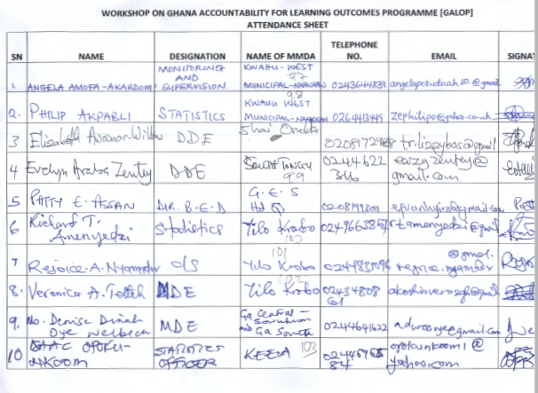

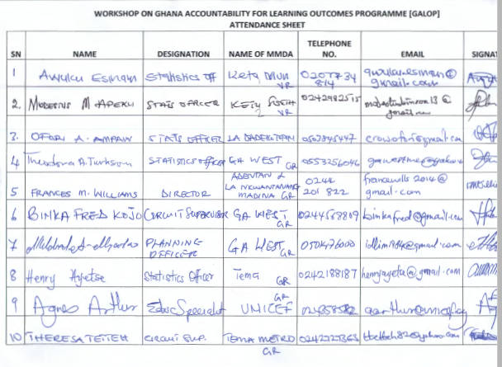

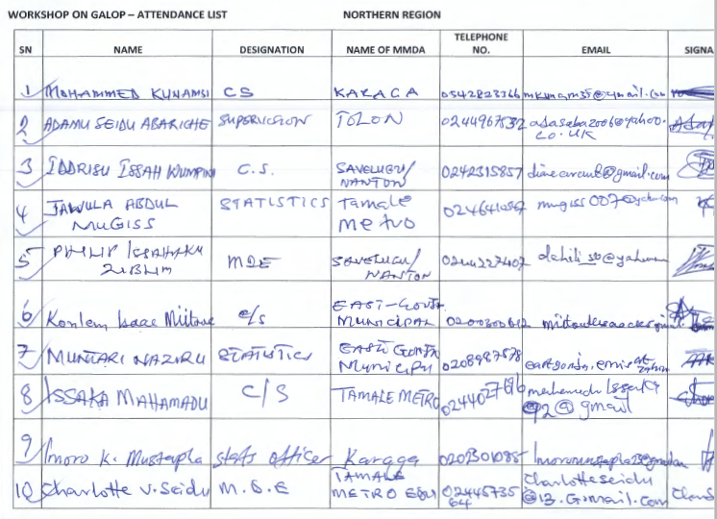

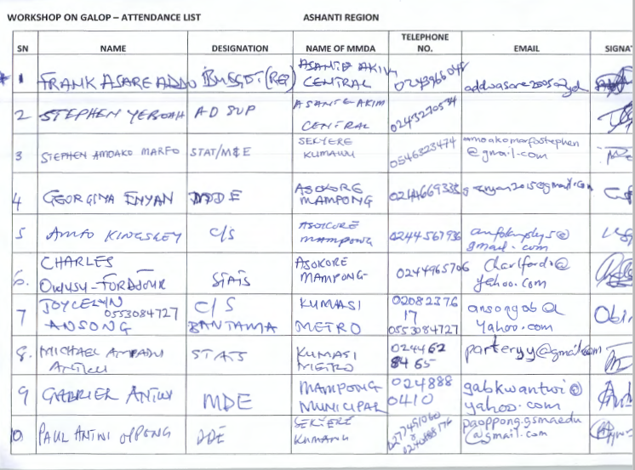

|  |  |
| --- | --- |
| C:\Users\user1\Desktop\Consultation 2.jpg | C:\Users\user1\Desktop\Consultation 1.jpg |
|  |  |
| C:\Users\user1\Desktop\Consultation 3.jpg | C:\Users\user1\Desktop\Consultation 4.jpg |
| Photos of stakeholder consultation workshops | |

**Annex 4: Stakeholder Prioritization**

|  |  |  |  |
| --- | --- | --- | --- |
|  | | **Level of impact of issue on stakeholder** | |
| **Stakeholder influence issue** |  | Low | High |
| High | Medium-High | Highest priority |
| Low | Low priority | High |
| **Vulnerable** | |  |  |