Document of
The World Bank
Report No: ICR123774

IMPLEMENTATION COMPLETION AND RESULTS REPORT

ON A

SIGNED PURCHASE OF CERTIFIED CARBON EMISSIONS REDUCTIONS

BY THE SPANISH CARBON FUND (TF093336)

AND A

SIGNED PURCHASE OF CERTIFIED CARBON EMISSIONS REDUCTIONS

BY THE CARBON FUND OF THE CARBON PARTNERSHIP FACILITY (TF 011237)

FROM

BRAZIL

ITAOCA AND CANDEIAS LANDFILL GAS PROJECTS (P105389, P12466)

February 12, 2018

Social, Urban, Rural and Resilience Global Practice
Brazil Country Management Unit
Latin America and the Caribbean Region
CURRENCY EQUIVALENTS
(Exchange Rate Effective January 31, 2018)
Currency Unit = Real (BRL)
BRL1.00 = US$0.317
US$1.00 = BRL3.152
FISCAL YEAR 2018

ABBREVIATIONS AND ACRONYMS
CAIXA | Caixa Econômica Federal (Federal Savings Bank)
CDM | Clean Development Mechanism
CER | Certified Emissions Reductions
CPF | Carbon Partnership Facility
CPRH | Agência Estadual de Meio Ambiente de Pernambuco
CTR | Centro de Tratamento de Residuos (Waste treatment center)
ER | Emissions Reduction
ERPA | Emissions Reductions Purchase Agreement
ESMP | Environmental and Social Management Plan
GHG | Greenhouse Gases
IBRD | International Bank for Reconstruction and Development
ICR | Implementation Completion and Results Report
ISR | Implementation Status Report
JSDF | Japanese Social Development Fund
LAC | Latin America and the Caribbean Region
LFG | Landfill gas
PDD | Project Design Document (UNFCCC, CDM)
PDO | Project Development Objective
PGSA | Plano de Gestão Socioambiental (Environmental and Social Management Plan)
PISCA | Waste Picker Social Inclusion Plan
POA | Programme of Activities (in the context of CDM)
SCF | Spanish Carbon Fund
SW | Solid Waste
SWM | Solid Waste Management
tCO₂e | Tons of carbon dioxide equivalent (greenhouse gases)
UNFCCC | United Nations Framework Convention on Climate Change

Senior Global Practice Director: | Ede Jorge Ijjasz-Vasquez
Practice Manager: | Ming Zhang
Project Team Leader: | Beatriz Eraso Puig
ICR Team Leader: | Beatriz Eraso Puig

1. DATA SHEET iii
A. Basic Information iii
B. Key dates iii
C. Ratings summary iii
D. Sector and theme codes iv
E. Bank staff iv
F. Emission reductions delivery to date iv
G. Supervision of Carbon Finance Operations Guidelines iv
2. ACHIEVEMENT OF IMPLEMENTATION OBJECTIVES AND OUTCOMES 1
2.1 Basic Project description and summary of significant changes since ERPA signature 1
2.2 Project implementation and commissioning 6
2.3 Monitoring, reporting, verification and issuance of ERs 9
3. BANK AND PROJECT ENTITY PERFORMANCE 10
3.1 Assessment and rating of overall Bank performance 10
3.2 Assessment and rating of overall project entity performance 11
4. COMMENTS FROM PROJECT ENTITY AND OTHER PARTNERS 12
5. BENEFITS, TARGET POPULATION AND RATE OF SUCCESS 12
6. SAFEGUARDS COMPLIANCE 13
7. LESSONS LEARNED 14
8. JUSTIFICATION FOR MOVING TO THE SECOND PHASE 15

IMPLEMENTATION COMPLETION AND RESULTS REPORT (ICR)

1. DATA SHEET

Basic Information
Country: | Brazil
Project Name: | Itaoca and Candeias Landfill Gas Projects
Project ID: | P105389, P124663
ICR Date: | February 12, 2018
Bank/IFC lending or grant: | N/A
Environmental Category: | B
Project Entity (PE): | Caixa Econômica Federal, Haztec and Ecopesa
Cofinanciers and Other External Partners: | N/A
ICR prepared by: | Beatriz Eraso Puig
Approved by CD: | Martin Raiser
Approved by PM: | Ming Zhang

Key dates
 | ERPA with Spanish Carbon Fund | ERPA with Carbon Fund of Carbon Partnership Facility
ERPA signing date | November 19, 2008 | December 5, 2011
ERPA effectiveness date | February 22, 2011 | December 5, 2011
ERPA amendment date | January 6, 2011  November 29, 2011 | May 23, 2013
ERPA termination date | May 23, 2014 | May 25, 2017
Project commissioning date | December 14, 2012 | December 14, 2012

Ratings summary
Outcomes (project performance) | MS
Bank performance | MS
Project entity performance | S

Sector and theme codes
Sector Codes (in %)
Solid waste management | 100

Theme Codes (in %)
Climate change | 50
Pollution management and env. Health | 50

Bank staff
Position | at ICR | at 1st ERPA signing
Task Team Leader | Beatriz Eraso Puig | Paul Procee
Legal Counsel | Julius Martin Thaler | Flavia Rosembuj
Deal Manager | Javier Freire Coloma | Werner Kornexl
Environmental Specialist | Clarisse Dall´Acqua | Paul Procee

Emission reductions delivery to date
Emission reductions in the amount of 546,581 tCO2e were certified and delivered under CDM Project 3958: CTR Candeias Landfill Gas Project. None were delivered under CDM Project 4657: Itaoca Landfill Gas Project.

Monitoring Period | CERs (tCO₂e) | Issuance
09/29/2011 – 12/31/2012 | 1,181 | September 9, 2014
01/01/2013 – 12/31/2013 | 103,451 | September 9, 2014
01/01/2014 – 12/31/2014 | 138,170 | July 10, 2015
01/01/2015 – 12/31/2015 | 145,393 | September 29, 2016
01/01/2016 – 08/31/2016 | 158,386 | April 18, 2017
TOTAL | 546,581

Supervision of Carbon Finance Operations Guidelines
With all contracted Emissions Reductions (500,000 tCO₂e) having been delivered, the ERPA has been closed. No further monitoring by the Climate Funds Management Unit (GCCFM) is required for this Project.

2. ACHIEVEMENT OF IMPLEMENTATION OBJECTIVES AND OUTCOMES

2.1 Basic Project description and summary of significant changes since ERPA signature
Context at Appraisal
- At the time of appraisal, the 251 municipalities in Brazil with over 100,000 inhabitants were generating over 100,000 tons of solid waste (SW) per day. Large disparities existed across the country with regards to solid waste management (SWM) practices. In 2007, it was estimated that while 141,000 tons of waste were collected daily in Brazil, only 39% of the 5,564 municipalities disposed their waste at the sanitary landfills. Approximately 32% of municipalities deposited waste in so called “controlled landfills” (which lack lining and capture of leachate), and the remaining 30% did it in open dumps. 65% of generated SW in the South region and 70% in the South-East region were disposed of in sanitary landfills. In contrast, in the North and Center West regions, less than 30% of SW was adequately disposed. Sophisticated technologies and adequate levels of service were typical in the larger south-eastern urban areas, while in other regions of the country service provision (e.g., collection, transportation and treatment, and disposal) had large gaps, and even more so in the smaller municipalities.
- The Brazilian Constitution stipulates that urban cleaning and SWM services are the responsibility of municipalities. Yet, by 2010 financial resources had been generally inadequate, and municipalities spent little of their budgets on SWM. Roughly half of the municipalities collected fees for the services they provided, which were insufficient to recover costs. Fees varied by region: in the North, and particularly the Northeast, a small fraction of the services provided were charged to final beneficiaries.
- While the government had made efforts to attract private sector investment, the participation of private operators in SWM was often in its nascent stage. Private SWM concessions were not yet able to generate profits, primarily due to the low tipping fees paid by municipalities. However, additional businesses – such as recycling and treatment of medical waste – were showing potential to make waste disposal financially attractive and were starting to attract private sector providers.
- In 2009, it was estimated that 59% of the municipalities in Brazil had recycling programs in place, although public recycling programs were not profitable and accounted for only a small fraction of the recycling in the country (estimates of quantities recycled were as low as 1% of total waste generated). Most of the recycling was undertaken by the informal sector, which included between 500,000 and 800,000 people both in organized groups and individuals that worked throughout the country collecting recyclables from households, in dumpsites and in other informal ways, and making a profit from the sale of collected recyclables.
- At the time of appraisal, the National Solid Waste Policy Bill, a comprehensive document covering rules and responsibilities along the entire solid waste value chain, had been debated by the National Congress for over a decade but had not yet been approved. The Bill proposed to use the 3Rs (reduce, reuse and recycle) as its basic principle and provides guidelines for managing waste from source to final disposal. It was expected that once approved, the bill would provide important regulatory incentives for the implementation of comprehensive waste management plans and reduction of environmental impacts related to open dumping. The legislation has since been enacted (Law 12305 of August 2010) and the SW sector is regulated by Decree 7404 of December 2010.
- With the Kyoto Protocol under the United Nations Framework Convention on Climate Change (UNFCCC) and its Clean Development Mechanism (CDM), the private sector had begun to recognize the opportunity of contributing to mitigation of climate change and of earning additional revenues from the sale of certified reductions of emissions (CER) of greenhouse gases. As Trustee of the Prototype Carbon Fund, the Bank had worked with the private firm NovaGerar in Rio de Janeiro State to take advantage of the CDM through an Emissions Reductions Purchase Agreement (ERPA) for the NovaGerar Landfill Gas Rio de Janeiro Project (P079182), which in 2004 became the very first CDM project approved worldwide by the UNFCCC.
NovaGerar Carbon Finance and Solid Waste Management Project II
- This ICR covers two of the five proposed sub-projects of the Second NovaGerar Carbon Finance and Solid Waste Management Project (P105389) (referred to as NovaGerar II), an umbrella project approved in 2008 for the purchase of CERs through an ERPA (TF093336) with the Spanish Carbon Fund (SCF), for which the Bank acted as Trustee. The two sub-projects are the Candeias Landfill Gas Project and the Itaoca Landfill Gas Project.
- The project development objective was to mitigate greenhouse gas (GHG) emissions and to reduce environmental and social impacts of SW disposal. The Project included rehabilitation and closing of old dumpsites, opening of sanitary landfills, and exploring alternative waste treatment options such as composting. The Project’s goal (depending on the quality/quantity of gas collected from disposal sites) was either to flare (burn) gas or to use it for electricity generation.
- The Project sought to expand the scope of the approach of the NovaGerar Landfill Rio de Janeiro Project (P079182) and take into account its lessons, namely: (i) technology can and must be improved to increase gas collection efficiency and reduce leachate, among other improvements; (ii) gas recovery estimates must be more realistic, so as not to inflate revenue estimates and projected financial viability; and (iii) NovaGerar’ s best practices on environmental management should be further improved with a view to replicating them at a larger scale. CERs were to be purchased by the Bank as Trustee of the Spanish Carbon Fund (SCF).
- Key performance indicators for the Project results were:
- Improvement of SW final disposal practices: Construction and operation of the landfill gas capture and flaring facility or implementation of composting facilities.
- Fulfillment of the Clean Development Mechanism (CDM) project cycle: The emission reductions (ERs) attained during 2008–2012 comply with CDM rules.
- Timely delivery of Emission Reductions (ERs) in accordance with the Emission Reductions Purchase Agreement (ERPA): The expected ER schedule would be outlined for each individual sub-project.
- The Bank, as trustee of the Spanish Carbon Fund (SCF), was to purchase CERs through an ERPA signed on November 19, 2008 from the following, but not limited to, sub-projects:
- Itaoca. The existing landfill in the Itaoca district of São Gonçalo municipality, located on Guanabara Bay in Rio de Janeiro state, had already been contracted as a municipal concession and was scheduled to close in 2008. About 200 waste-pickers were living in the project location, organized in a cooperative after the rehabilitation of Itaoca from a dumpsite into a proper landfill.
- Candeias. A new privately-operated landfill in the Jaboatão dos Guarapes municipality of Pernambuco state, known as the Candeias Solid Waste Treatment Site, was operating since 2007 and serving nearby municipalities. At the time of project start, the landfill had been processing an estimated 900 tons/day of municipal waste and was prepared to accept an additional 2,700 tons/day from Recife municipality.
- São Gonçalo. Opening of a new sanitary landfill in São Gonçalo municipality, in Rio de Janeiro state (successor to Itaoca).
- Santa Rosa. A new landfill in the Seropédica municipality, within the metropolitan area of Rio de Janeiro.
- Initially, all sub-projects involved NovaGerar Ecoenergia S.A (NovaGerar) as the entrepreneur. NovaGerar was bought in 2008 by Haztec Tecnologia e Planejamento Ambiental S.A (Haztec), which assumed the commitments of NovaGerar under the ERPA with the SCF. A second ERPA (TF 011237) only for Itaoca and Candeias was signed on December 2011 between Caixa Econômica Federal (CAIXA), as intermediary, and the Carbon Partnership Facility (CPF), another carbon fund administered by the Bank, to purchase emissions generated after the full delivery of contract volumes under the first ERPA with the SCF. It turned out six years later that no CERs were ever delivered from the first ERPA and it was cancelled in May 2014. Therefore, this ICR concerns the results achieved with the second ERPA only.
- Emission reductions were to be achieved by capturing methane from anaerobic decomposition of organic matter in the landfills (biogas), burning it, and releasing carbon dioxide (CO₂) into the atmosphere (rather than methane), generating electricity in the process. The generated electricity was to be fed to the national grid and generate revenues for the operating entity. Excess methane not used for electricity generation was to be flared (burnt). Emission reductions result from the higher global warming potential of methane, as well as from the displacement of fossil fuels in case of electricity generation.
- The overall risk was rated low at appraisal. The social risk was rated medium: the main social issue was the closing of the open dump in São Gonçalo (Itaoca) which had about 200 waste pickers (most of whom were already organized). ER non-delivery risk was also rated medium.
- Only the first two sub-projects, Candeias and Itaoca, are considered in this ICR (see paragraph 12). The Sao Goncalo and Santa Rosa Landfills were registered as part of the Caixa Econômica Federal Solid Waste Management and Carbon Finance Programme of Activities (PoA 6573); emission reductions, originally under the SCF ERPA, are now purchased under a separate ERPA with the CPF that is still effective (TF-11236).
Candeias Landfill Gas Project
- The Candeias landfill was built and is operated by Ecopesa Ambiental S.A. (Ecopesa), currently controlled by Haztec. Candeias landfill is located within the Recife Metropolitan Area, 16 km south of the center of the city of Recife and was the first sanitary landfill in the State of Pernambuco. It started operations in 2007 and was designed to operate over a 16 year-period. It is receiving SW from the cities of Recife, Jaboatão dos Guararapes, Cabo de Santo Agostinho, Moreno and São Lourenço da Mata. The landfill covers an area of over 170,000 m² and was expected to receive about eleven million tons of SW during the period of 2007-2022. Candeias is a privately owned sanitary landfill and there has never been a presence of waste pickers.
- The planned technology and installations involved a landfill gas (LFG) collection system, a LFG pre-treatment system, an enclosed flaring system, an electricity generation system, and connection to the electric grid. Gas extraction and flaring was to begin in 2011, while electricity production was scheduled to begin in 2012. Electricity was to be fed into the national grid. The installed capacity was to increase from 4.245 MW in 2012 to 8.490 MW in 2017. LFG extracted but not used to generate electricity was to be flared. The CDM Project Design Document (PDD) estimated the ERs as 1,085,783 tCO2e over the seven-year crediting period (i.e., August 2011-July 2018) with an annual average of 155,112 tCO₂e.
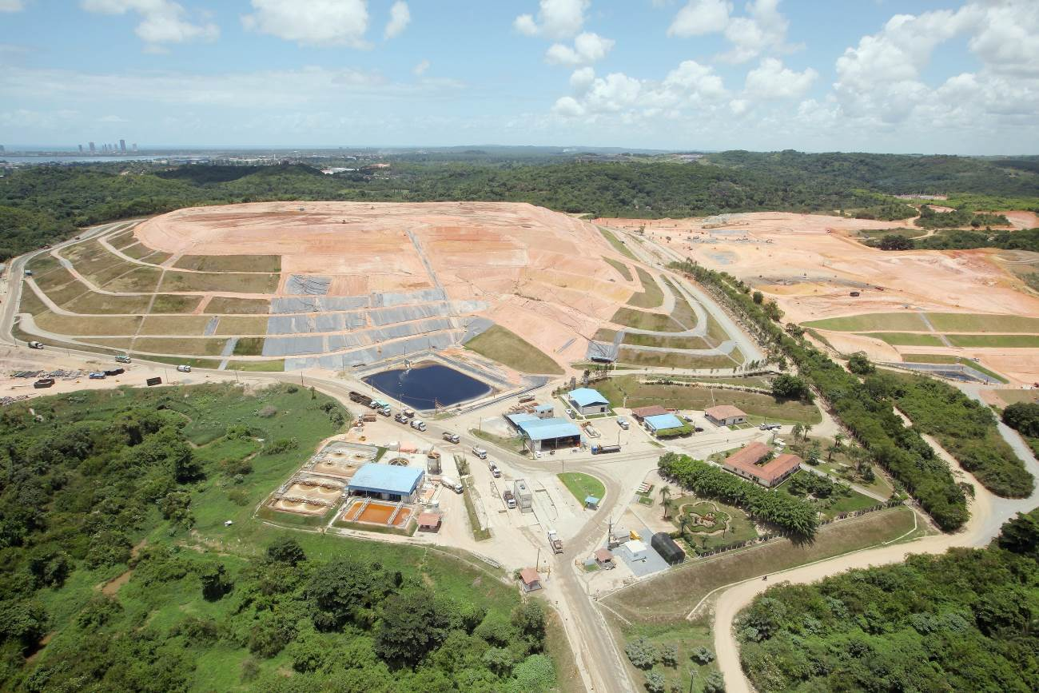
Figure 1 Aerial photo of Candeias landfill 2016
Itaoca Landfill Gas Project
- The Itaoca dumpsite, owned by the São Gonçalo municipality in Rio de Janeiro state, opened in 1980 and operated without appropriate design or construction and under poor oversight of disposal. In 2004, NovaGerar was granted a 15-year license by the municipality to manage the site and explore its landfill gas potential. Thereafter, waste was deposited in a controlled manner, cover was applied daily, and the leachate collection and treatment system was improved. In 2008, NovaGerar merged with Haztec, which assumed all rights and obligations of NovaGerar. Haztec was contractually obliged to decommission and rehabilitate the Itaoca dumpsite and to open a new waste treatment center in São Gonçalo municipality. Waste picker families at the site would lose their source of income when it was closed.

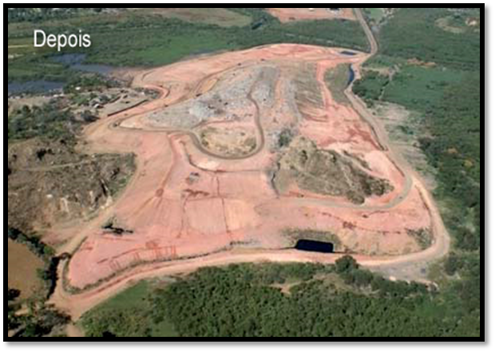
Figure 2 Itaoca after covering

- Before the project, and as baseline scenario, Itaoca dumpsite emitted greenhouse gases into the atmosphere. The project foresaw an LFG collection and flaring system, releasing CO₂ into the atmosphere rather than methane, but had no provision for the generation of electricity. The Itaoca Landfill Gas Project was expected to reduce GHG emissions by 258,869 tCO₂e over a ten-year period (i.e., 2011 – 2020) or 25,870 tCO₂e on average per year.

2.2 Project implementation and commissioning
- Project implementation started late due to delays in completing the validation process under CDM and completing registration under the UNFCCC (October and December 2011 respectively for Itaoca and Candeias). The CDM audit firm contracted for the validation had limited experience in Brazil at the time. In addition, it was also a period when CDM rules and methodologies changed relatively often, and it was a peak period in terms of a large number of project validations. As a result, there were significant implementation and registration delays. It was therefore decided to terminate the SCF contract, thus accelerating the start date of the junior ERPA under the CPF.

Candeias Landfill Gas Project
- The Letter of Approval from the Government of Brazil to UNFCCC was signed on June 30, 2011. After CDM project registration with UNFCCC on September 29, 2011, Ecopesa initiated procurement of equipment and started construction of the landfill gas capture and flaring project, including gas wells, pipelines, flaring system and monitoring equipment, but not the electricity generation system. Initially, Ecopesa wanted to operate the flaring system for six months to monitor the gas volume and to confirm the parameters of the gas-electric turbine to be installed.
- All licenses needed for the operation of the gas collection and flaring systems had been obtained from the environmental agency (“Agência Estadual de Meio Ambiente”, known as CPRH) of the State of Pernambuco. An operating license for the flare was issued on December 7, 2012. The monitoring equipment was installed on December 12, 2012. Flaring started on December 15, 2012 (the project commissioning date); electricity generation was never implemented.
- Candeias landfill has been receiving SW beyond initial expectations, leading to higher volumes of methane gas flared and to much higher ER than estimated in the PDD. During 2012-2016 Candeias CTR received on average about 1,550,000 tons of SW per year, compared to the original estimate of 766,500 tons from 2010 onwards. In May 2014 Candeias CTR received about 5,237 tons of SW per day, whereas in May 2017 it received only 3,736 tons per day. By May 2017, 11.1 million tons had been received, leaving room for another 15 million tons. At the rate of waste arrivals in 2017, the facility could thus be used almost to the end of 2027.
- Ecopesa has not found the generation of electricity to be cost-effective, because of regulatory risks (i.e., approvals required for injecting electricity into the grid) as well as the lack of a power purchase agreement (PPA) at an acceptable price. Nevertheless, the landfill gas flaring activity has had a positive impact of GHG mitigation on its own, given that methane has a global warming potential 25 times larger than CO₂.
Itaoca Landfill Gas Project
- The PDD for the Itaoca landfill gas project was submitted to UNFCCC in 2010. The validation report was submitted in August 2011, and the project was registered in October 2011.
- Haztec was able to close and cover the dump and to install the basic drainage. It also monitored the environmental impact parameters. The dump is located on the border of territories occupied by two rival criminal factions. This has created serious social and public safety problems, which the state and local governments have been unable to control. Security of administration buildings, equipment, and Haztec personnel at the site was compromised. The equipment for gas collection and flaring could not be installed. The situation deteriorated further to the extent that Haztec staff could not safely visit the site. The closed dump has not received any SW since February 2012 and the landfill gas project was not implemented.
- The Bank´s safeguard policy BP/OP 4.12 (Involuntary Resettlement) was triggered at appraisal and resulted in preparation of the Waste Picker Social Inclusion Plan (PISCA). The PISCA included: the opening and operation of a Social Assistance Referral Center in the community; the registration of waste pickers; the provision of assistance grants during the reintegration of waste pickers into the labor market; formation of a cooperative of collectors of recyclable materials; and training for professional qualifications in other activities. Children of registered waste pickers received and continue to receive social assistance and are included in courses and colleges in the region.
- Due to the low level of social cohesion and community organization, and a weak local leadership with low capacity for mobilization and agglutination, many of the actions carried out by under PISCA were not successful. Equipment purchased for the waste pickers' cooperative was stolen, facilities were destroyed, and the cooperative itself dissolved. Training and professional qualification activities for inclusion in other activities - also supported by PISCA - were more successful; 19 former waste pickers work at the São Gonçalo sanitary landfill as Haztec employees. The outcomes of the professional training courses are probably underestimated, as it became difficult for Haztec to keep track of the whereabouts of the people taking these classes. Finally, due to the difficult social situation, activities to alleviate the situation of waste pickers under the Brazil Solid Waste Picker Social Inclusion Initiative Project (TF 097192), supported by a Japanese Social Development Fund (JSDF) grant, were indefinitely postponed.
ERPA with Spanish Carbon Fund and transfer to Carbon Partnership Facility
- The ERPA with the Spanish Carbon Fund (SCF) was signed by Haztec on November 19, 2008. The Project comprised, but was not limited to, four sub-projects: Candeias, Itaoca, São Gonçalo and Santa Rosa. The CER delivery schedule provided a total amount per period without defining specific CERs from each sub-project. As indicated earlier, the ERPA was amended on November 8, 2010 to align it with the expected volume over the contract period, which focused on ERs generated by 2012 (the first commitment period under the Kyoto Protocol). The second ERPA was signed on December 5, 2011 between CAIXA, as the intermediary, and the Carbon Partnership Facility (CPF) to purchase ERs generated post-2012 from Itaoca and Candeias.
- As it became clear that delivery of ERs under the Candeias and Itaoca projects might be significantly delayed, the Bank, Haztec, CAIXA, the CPF and the SCF signed an agreement in May 2014 to cancel the SCF ERPA, freeing up the ERs from Candeias and Itaoca for the ERPA between CAIXA and CPF. No ERs were delivered under the SCF ERPA, as the first CER issuance only started in September 2014.
- The CPF ERPA also specified only the total amount to be delivered by the two sub-projects, without a breakdown by sub-project. The Candeias landfill gas project generated 546,581 tCO₂e between 2012 and 2016, due to the higher than expected waste received. Accordingly, the CPF ERPA was completed as of May 2017 with the delivery of the contracted 500,000 tCO₂e.
- The signing of the CPF ERPA was also reflected in the Bank’s supervision reporting. The SCF ERPA was linked to the NovaGerar Carbon Finance and Solid Waste Management Project II (P105389). The CPF ERPA was however linked to the Caixa Solid Waste Management Project (P124663), which also covers another CPF ERPA with CAIXA for the purchase of ERs from the Caixa Econômica Federal Solid Waste Management and Carbon Finance Programme of Activities (PoA 6573).

2.3 Monitoring, reporting, verification and issuance of ERs
- ERs at Candeias were monitored by the site operator, Ecopesa, in accordance with the Monitoring Plan in the PDD and subsequent revisions, and in accordance with CDM Methodology ACM0001 Version 11: “Consolidated baseline and monitoring methodology for landfill gas project activities.” and its associated tools. Ecopesa installed the monitoring system and state-of-the-art equipment at the flare facility for measuring physical and chemical parameters. ERs for Candeias were issued as shown in the table below. All four monitoring reports are available at the CDM website.
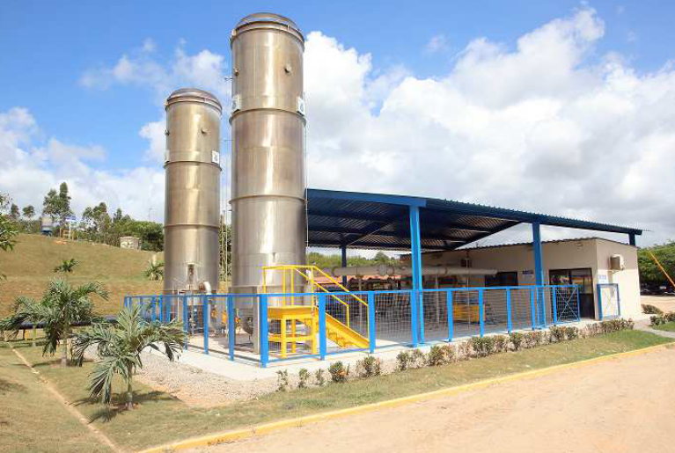
Figure 3 Flaring Facility at CTR Candeias
Monitoring Period | CERs (tCO₂e) | Issuance
09/29/2011 – 12/31/2012 | 1,181 | September 9, 2014
01/01/2013 – 12/31/2013 | 103,451 | September 9, 2014
01/01/2014 – 12/31/2014 | 138,170 | July 10, 2015
01/01/2015 – 12/31/2015 | 145,393 | September 29, 2016
01/01/2016 – 08/31/2016 | 158,386 | April 18, 2017
TOTAL | 546,581

Objective and Indicators
- The table below presents the assessment of the key performance indicators by sub-project.
Indicator | Candeias | Itaoca
- Improvement of SW final disposal practices | Fully achieved. LFG capture and flaring facility was constructed and continues to be operated. | Not achieved, except for environmental recovery of the landfill (cover).
- Fulfillment of the CDM project cycle | Fully achieved. ERs generated complied with CDM rules. | Partly achieved. The sub-project was registered under the CDM rules; however, no ERs were generated as the sub-project was not implemented.
- Timely delivery of emission reductions (ER) as per ERPA | ERs from Candeias exceeded the overall target for both projects together. | Not achieved, as the sub-project was not implemented.

- The Candeias landfill achieved the three indicators and delivered all ERs, albeit with delays; however, the Itaoca landfill gas Project was ultimately not implemented. As such, the overall project development outcome is rated Moderately Satisfactory.

3. BANK AND PROJECT ENTITY PERFORMANCE

3.1 Assessment and rating of overall Bank performance
Performance during preparation, appraisal, negotiation and signing
- Bank performance during preparation, appraisal and negotiation is rated Moderately Satisfactory. It identified a pipeline of sub-projects to be implemented, estimated the emissions reductions to be achieved, carried out a technical evaluation to ensure that the sub-projects complied with the corresponding CDM methodology for validation, and conducted a financial analysis. The project design incorporated lessons learned from an earlier project. The Bank ensured the preparation of safeguard documents and educated the Project Entity on CDM guidelines and implementation requirements. However, the Bank did not foresee the severity of the social problems at Itaoca, which went beyond the problems expected from the closing of the site and the consequent loss of income and occupation of waste pickers. While appropriate measures were foreseen to attend to the needs of the waste pickers, the potential threats to security of staff and assets of the operating company were not foreseen. These limited the implementation of the Itaoca landfill gas sub-project to merely the closure of the dumpsite.
Performance during supervision and management of trust funds
- The performance of the Bank during supervision of project implementation is rated Satisfactory. The Bank supervised this project together with the Integrated Solid Waste & Carbon Finance Project (P106702), carrying out on average two supervision missions per year between 2011 and 2015, and fielded yearly missions thereafter until the ERPA was completed. Missions included urban and carbon finance specialists as well as social and environmental safeguards specialists. Over the lifetime of the project, there were three task team leaders.
- The Bank helped with the process of CDM project proposal, validation and registration. It supervised the implementation of social and environmental safeguards at both sites with care, including the challenging developments at the Itaoca dump site, and helped with obtaining a JSDF grant to alleviate the loss of livelihoods from closing Itaoca and transition to other means of livelihood for waste pickers. The Bank conducted timely visits to Itaoca to address the social and environmental concerns, and to the Candeias site to supervise the application of environmental safeguards. It reviewed and approved the social and environmental plan drawn up by CTR Candeias in a timely manner.
- The Bank prepared and arranged for the transition of CER purchases from one carbon fund to another (SCF to CPF), giving preference to the readiest projects (Itaoca and Candeias), in view of the delays experienced with validation and registration of the CDM project and given the time limits for CER purchases by the SCF. This transition included contracting the new ERPA with CAIXA as financial and technical intermediary, rather than with landfill operators directly. The project could have been restructured to drop Itaoca once it was clear that implementation was not possible. The task team did not pursue this option due to two main reasons. First, the CPF ERPA did not specify the volumes to be delivered by each individual subproject and Candeias was on track to deliver 100% of contracted volume, so no breach of contract was expected. Second, a restructuring would have required the signing of a new ERPA, opening the door for renegotiation of the commercial terms, which was not attractive to Caixa given the decreasing market prices.
- Considering the ratings of Bank performance in ensuring quality at entry and quality of supervision, Bank performance overall is rated Moderately Satisfactory.

3.2 Assessment and rating of overall project entity performance
Landfill operators Haztec and Ecopesa as implementing project entities
- The performance of Haztec (at Itaoca) and Ecopesa (at Candeias) is rated Satisfactory, despite the failure of Itaoca to generate emission reductions.
- Haztec addressed the social and economic needs of the economically displaced waste picker population diligently. It made strong efforts to communicate with the surrounding communities, despite the adverse social situation, and find solutions to the problems faced by people living nearby. Haztec restored the Itaoca dump site to the extent feasible under the difficult local circumstances.
- Ecopesa was outstanding in implementing an environmentally safe sanitary landfill, including protection of the groundwater aquifer, capture and processing of leachate, capture and flaring of methane, pre-sorting of SW for recyclable materials and their appropriate disposal. It applied state-of-the-art technology and established and cultivated excellent public relations with the surrounding communities, the existing waste picker/recycling cooperative, schools and other stakeholder groups; conducted environmental education projects and programs; took care of labor safety and health; and initiated replanting in certain areas of the landfill. It also carried out the mandatory environmental monitoring of the landfill to high technical standards, and reported the results on a monthly basis.
Caixa Econômica Federal as intermediary project entity
- CAIXA entered the Project through the 2011 ERPA as the purchaser of CERs generated by the projects and as a partner of the CPF. CAIXA carried out its role as intermediary between the operating companies and the Bank, as well as its partner role under the ERPA with the CPF, in a satisfactory manner. CAIXA prepared, and satisfactorily implemented, a comprehensive Environmental and Social Management Framework (2009). CAIXA’s Pernambuco and Rio de Janeiro teams carefully supervised the implementation of environmental and social safeguards in both projects, including through monthly visits to the landfill sites. The ESMF is now being applied by CAIXA as standard reference in all its SWM projects, including in projects without any Bank involvement. CAIXA also has a small team of highly dedicated carbon finance specialists that have helped the CDM process.
- The overall performance of project entities is rated Satisfactory.

4. COMMENTS FROM PROJECT ENTITY AND OTHER PARTNERS
- Caixa Econômica Federal highlighted that their participation in the follow-up of Projects carried out by technical staff was important to guarantee the identification and timely correction of possible deviations from the plans. These actions helped the fulfillment of the project ERPA by the Candeias landfill two years earlier than established, even without the implementation of the Itaoca landfill gas project.
- Haztec expressed its appreciation for support from CAIXA and the Bank, and acknowledged the benefits from the social and environmental restoration of the Itaoca dump. The company highlighted that its regular dialogue with and assistance to waste pickers has facilitated their income generation, as well as child protection and promotion of sports and leisure activities. The company emphasized the importance of increased professional qualifications and the strengthened capacity of recycling cooperatives for inclusion in the local job market.
- Ecopesa expressed its recognition of the support from CAIXA and the Bank during the development of the contract. The company acknowledged the substantial learning from the project. Ecopesa considers that the objectives of the socio-environmental plan to benefit the various actors that interact with Candeias landfill were satisfactorily achieved. The socio-environmental activities carried out in the Candeias landfill during the project had a positive impact on the company and the surrounding population. Candeias landfill enabled Ecopesa to grow as a company and acquire social and environmental principals that benefited its employees and the community.

5. BENEFITS, TARGET POPULATION AND RATE OF SUCCESS
- Solid waste from municipalities in the Recife metropolitan area is being properly disposed of in a well-managed sanitary landfill. Inhabitants of the surrounding cities, towns and neighborhoods have benefited significantly and support the landfill. School children receive environmental education. GHG emissions were reduced at Candeias landfill at a much faster rate than originally foreseen. The operator, Ecopesa, has enhanced its operating revenues through the sale of CERs. Remedial measures to help “economically displaced” waste pickers at Itaoca have benefited several families.
- Haztec, Ecopesa and CAIXA have accumulated know-how that can be used elsewhere in Brazil.

6. SAFEGUARDS COMPLIANCE
- Project investments did not impose significant impacts and most of them were of local and reversible nature. Therefore, the Project was rated as environmental Category B. The Project triggered the following safeguard policies:
- OP 4.01 – Environmental Assessment. NovaGerar had prepared two social and environmental management frameworks: one specific to existing dumpsites, and the other for new sites, to be applied to individual sub-projects. An environmental assessment was conducted for the CTR Candeias and an Environmental and Social Management Plan (ESMP) was prepared prior to ERPA signing. An ESMP, based on the Environmental and Social Framework, was prepared for the Itaoca dumpsite. The Candeias ESMP was implemented satisfactorily.
- OP 4.04 – Natural Habitats. The Itaoca dumpsite was located in a sensitive mangrove area. The project entity implemented appropriate measures to reduce and minimize impacts and conducted adequate environmental monitoring in and around the site.
- OP 4.12 – Involuntary Resettlement. The policy was triggered by the closing of the existing dumpsite at Itaoca where waste pickers were already earning a livelihood, even though no physical relocation was necessary ("economic displacement”). A social analysis, consultation and accompaniment process had by appraisal already resulted in the formation of a waste pickers’ recycling cooperative, the construction of a waste sorting facility, and other measures. NovaGerar, in coordination with the São Gonçalo municipality, developed and implemented a comprehensive waste picker inclusion strategy.
- NovaGerar/Haztec implemented public consultation and outreach programs in all sub-project areas to improve public understanding of the need for landfills and their basic principles of operation. The Project was linked to a series of initiatives aimed at strengthening social inclusion in SWM in Brazil, specifically, the Integrated Solid Waste Management and Carbon Finance Project (P106702) and the JSDF-supported Brazil Solid Waste Picker Social Inclusion Initiative Project (TF 097192).
- CAIXA’s Social and Environmental Framework (2009), developed with support from the Bank, is now applied to all its projects and sub-projects, irrespective of the source of financing.
- Adequate efforts were made to address the needs of displaced waste pickers at the Itaoca dump site, including implementation of the PISCA and assistance through the JSDF grant. However, despite being beneficial to many waste pickers and their families, these efforts had only limited impact due to the social and political circumstances around the dump site.
- Operating licenses of the Candeias landfill have been renewed periodically. CPRH receives monthly environmental monitoring reports from Ecopesa, and conducts monthly inspections at the site. Ecopesa has been in compliance with license conditions.
- The Bank reviewed the Environmental and Social Management Plan for CTR Candeias (Plano de Gestão Socio Ambiental - PGSA) prepared by Ecopesa and provided no-objection in 2014. Ecopesa has issued detailed reports on the implementation and results of the PGSA for 2014-2017. The report documents Ecopesa’ s efforts on communicating with the surrounding communities and schools on: the purpose, importance and benefits of the landfill; educational activities directed to children and students; monitoring crucial environmental parameters (as required by CPRH); caring for the safety and health of its own employees; and on restoring tree cover in selected parts of the facility.
- Overall, potential environmental and social impacts and risks have been handled satisfactorily by Haztec, Ecopesa, CAIXA and the Bank.

7. LESSONS LEARNED
- A financial intermediary can help in implementing carbon finance projects. CAIXA acted as a financial intermediary between the Carbon Fund and the companies generating the CERs, and accumulated valuable knowledge on: (i) the process of registering CERs at the UNFCCC/CDM; and (ii) the application of environmental and social safeguards in all its projects. It was easier for the carbon funds (the Bank) to deal with a single partner in multiple ERPAs, as part of the supervision was handled by CAIXA. The participation of CAIXA in project follow-up enabled the timely identification and correction of deviations from plans.
- The Bank has a critical role in the design and implementation of carbon finance projects. The Bank helped the Project Entity to navigate the CDM process and create the local capacity for the continuation of the Project.
- Unforeseen local obstacles might impede project implementation. At appraisal, the social assessment focused mostly on waste pickers whose livelihoods would be impacted by the project at Itaoca. In retrospect, the assessment should have been expanded to identify potential risks to the proposed operation from the situation in the surrounding vulnerable communities. In addition, the social assessment should have been updated during project implementation to identify and address the significant risk that the proposed activities to benefit waste pickers may yield poorer outcomes and results than expected compared to similar projects.
- Landfill gas to electricity generation might not always be feasible. LFG electricity generation depends on the local regulatory framework and market conditions in the electricity sector. The Candeias project entity did not find electricity generation to be cost effective during the life of the ERPA. The analysis should be revisited periodically as market conditions change over time and may eventually justify the investment.

8. JUSTIFICATION FOR MOVING TO THE SECOND PHASE
- Not applicable, as the contract is fully delivered and the project is closed.

Dates refer to both the ERPA between the Spanish Carbon Fund and Haztech Tecnologia e Planejamento Ambiental S.A., which was later replaced by the ERPA between the Carbon Partnership Facility (CPF) and Caixa Econômica Federal (Caixa). The CPF ERPA was initially set up as a junior ERPA to the SCF agreement after full delivery of its contract volume.
Commissioning date of the CTR Candeias Landfill Gas Project.
This date is the project registration date. Actual first day of ER accrual was Dec. 15, 2012, after project implementation
Under CDM the following conversion applies: 1 tCH4 = 25 tCO₂equivalent
Data provided by Ecopesa on June 2017.
The CPF focused more on ERs generated under the second commitment of the Kyoto Protocol (2013-2020).
Revisions are documented in detail in the last verification report by TÜV Nord.
Actual first day of ER accrual was Dec. 15, 2012

