Environmental and Social Management Framework (ESMF)

(Draft)

KOSOVO FINANCIAL SECTOR STRENGTHENING PROJECT

February 2019
Table of Contents
1 Introduction 5
2 Description of the Investment support project 6
3 Lines of Financial Support 6
3.1 Line of financial support for investment 6
3.2 Line of financial support for capacity building 8
4 WB Policies that Apply to the Project 9
5 Stakeholders 10
6 National Legislation Overview 11
7 Eligible and Non-Eligible Investment 13
7.1 Activities that have been excluded by KCGF 13
7.2 WB policies exclusion 14
7.3 Other types of ineligible projects 14
8 Environmental assessment and Screening Categories 14
8.1 Kosovo EIA Regulation Requirements 14
8.2 WB Environmental Screening Categories 16
8.3 Environmental due diligence documentation 19
8.4 Environmental Audit (Report) 19
9 Screening Procedures 19
9.1 Social Assessment 20
9.2 Grievance Redress Mechanism 20
10 Due diligence documents, Public Consultation and Disclosure 21
11 Environmental Review Process (RFIs, KCGF and WB) 21
11.1 Monitoring and Reporting 23
Annex 1 – MAIN RESPONSIBILITIES OF KEY PARTICIPANTS 24
Annex 2 – ENVIRONMENTAL Management Plan checklist 25
Annex 3 – Environmental and Social Management Plan template 33
Annex 4 – Minutes of the ESMF Consultation Meeting(s) 36
Annex 5 - Projects listed in Annex I of the EIA law which requires an EIA 37
Annex 6- Projects listed in Annex II of national EIA Law 41
Annex 7 – List of the activities that are subject to the Municipal Environmental Permit 44
Annex 8 – Commercial Banks’ (RFIs) existing Environmental Screening and Management Systems 46
ProCredit Bank Environmental and Social Management Procedures 46
Raiffeisen Bank Kosovo Environmental and Social Management Procedures 47
TEB Kosovo Bank Environmental and Social Management Procedures 48

Acronyms
EA - Environmental Assessment
ESMF - Environmental Social and Management Framework
ESMP - Environmental and Social Management Plan
ESMS – Environmental and Social Management System
FI – Financial Institution
RFI – Registered FI
KCGF - The Kosovo Credit Guarantee Fund
H&S - Health and Safety
OHS - Occupational Health and Safety
MED - Ministry of Economic Development
MESP – Ministry of Environment and Spatial Planning
MEP – Municipal Environmental Permit
MSME - Micro, Small and Medium Size Enterprises
AI – Administrative Instruction

Introduction
With the population of around 1.8 million, Kosovo is one of Europe’s poorest countries, with almost a third of the population living below the national poverty line. At the same time, with its new statehood and the average age of its population (26 years) Kosovo is the youngest country on the continent, with emerging opportunities and challenges. Unemployment rates are also stubbornly high – in 2015 almost a third of the labor force was unemployed; among youth the unemployment rate was more than 57 percent.

Micro, Small and Medium Size Enterprises (MSMEs) play a critical role in job creation. According to World Bank Job Diagnostic Report (2017), Kosovo stands out in international comparisons in terms of the greater contribution of micro firms to employment. MSMEs account for 65 percent of employment while micro enterprises alone provide 36 percent of total employment. One of the key constraints to growth for MSMEs is access to finance because that the lenders (Financial Institutions) are conservative and interest rates and collateral requirements remain high.

The Government of Kosovo has submitted a request to the World Bank (WB) for strengthening financial sector intermediation through increasing the capital of the Kosovo Credit Guarantee Fund (KCGF).
MSMEs in Kosovo are faced with constraints in accessing financing due to high informality, unclear property rights and weak judicial system which also caused conservative lending practices and the risk aversion of banks. The same reasons also discouraged the investors to establish a private guarantee scheme as it is the case in most of the developing countries. This situation required a public-sector intervention and the KCGF was established in 2016 as an independent, legal institution.

The objective of the Project is to improve access to finance for MSMEs, which in the same time are the main beneficiaries together with the lenders.

Due to the scope of the project the only safeguard policy triggered is OP 4.01 Environmental Assessment, and overall Project category according to WB Safeguards Policies is B. This means no high-risk activities, A category sub-projects, or those triggering other WB Safeguards Policies will be eligible for support under the Project. Since the specific investments for which the guarantees will be issued, under the Project, will not be identified until project implementation, this Environmental and Social Management Framework (ESMF) was prepared.

Environmental assessments will be carried out in accordance with the national environmental regulation enforced mostly by Ministry of Environment and Spatial Planning and WB Safeguards policies, as defined in this ESMF.
The environmental assessment process is carried out to determine the possible positive or negative impacts of proposed sub-projects; to evaluate the precautions to be taken in order to avoid, prevent, mitigate or minimize negative impacts which may damage the environment (for example by construction and mitigation measures); and for supervision and inspection of sub-project implementation.
The sub-projects should be subjected to an environmental and social review process by RFIs and KCGF incorporating procedures described in the chapter 13. However, KCGF will be responsible for successful implementation of the Project, including overall environmental compliance. The RFIs will be responsible for environmental categorization (screening) of Applicants/sub-projects, and for ensuring that each guaranteed sub-project (and sub-project proposal) includes an assessment of its environmental impact appropriate for the category, mitigation measures adequate to the assessment results and clearance documentation from the local authorities, and that the sub-project complies with the national environmental regulation and WB Safeguard policies.
The purpose of the ESMF is to ensure that sub-projects which may be implemented identify and address measures to avoid and minimize environmental and social impacts following relevant Kosovo environmental and social legislation and the World Bank’s safeguards policies. The ESMF defines how safeguards will be taken into account and applied for all project activities that may have safeguards requirements. This ESMF is a KCGF document that applies to all activities under the Kosovo Financial Sector Strengthening Project and will be an indispensable part of the project’s operational manual and into the loan agreement between KCGF and RFIs.

Description of the Investment support project
The objective of the Project is to improve access to finance for MSMEs and consists from two components:

Component 1: Enhancing the Credit Guarantee Framework (EUR19 million). Under this component the Project will increase the capital base of the KCGF, expand the range of products offered. Accordingly, the component consists of two subcomponents:

Subcomponent 1: Increasing the capital base of KCGF. Under this subcomponent, the WB will lend to the Republic of Kosovo USD16 million to expand the capital base of the KCGF. MoF confirmed that they will be the borrowing party on behalf of KCGF and the funds will be channeled as a grant to KCGF. The additional capital will allow an increase in usage of the Fund and allow the KCGF to address a larger portion of the financing gap for SMEs. Financing gap estimates and the team consultations with financial institutions and other donors indicated that there is enough room in the financial sector to absorb the expansion. The CBK’s planned revision of the risk weightings for guaranteed portfolio in the coming months is expected to have a positive impact on guarantee demand.

Subcomponent 2: Establishing a window for underserved and strategic segments. Under this subcomponent, the WB will lend to the Republic of Kosovo EUR3 to 3.5 million to be used for the capitalization of the KCGF to provide partial credit guarantees and if necessary other financial products for specific themes/segments/sectors that have strategic importance for supporting the sustainable growth of the economy. These are expected to include young entrepreneurs, women business owners, renewable energy, waste management, agriculture and movable collateral. Increasing the guarantee coverage is at most importance for the successful implementation of this component as it will give flexibility to the KCGF to develop tailor-made products.

Component 2: Project implementation and institutional strengthening of the KCGF (USD 1 million). Under this component approximately USD500,000 to USD1,000,000 will be provided to the KCGF for project implementation and institutional strengthening which will be essential to efficiently use the proposed additional capital.

Lines of Financial Support

Line of financial support for investment
The Kosovo Credit Guarantee Fund with the donated capital in amount of USD20 million will:
- increase the capital base of the KCGF (in amount of USD16 million),
- expand the range of products/windows for specific segments/sectors (in amount of USD3 to 3.5 million), and
- Project implementation and institutional strengthening of the KCGF (in amount of USD 500,000 to USD 1,000,000).
The Kosovo Credit Guarantee Fund (KCGF) is a local, independent, sustainable credit guarantee facility issuing portfolio loan guarantees to financial institutions to cover up to 50% of the risk for loans to micro, small, and medium enterprises (MSMEs).
For a MSME to qualify for a Credit Guarantee, the following minimal conditions must be satisfied:
- Privately owned micro, small, and medium-sized enterprise (MSMEs), as defined in the LKCGF, should be duly registered with the Kosovo Business Registration Agency (KBRA), shall have obtained its fiscal number, have less than two hundred and fifty (250) employees,
- It’s business activities must not be prohibited by applicable legislation, regulatory provisions, or international treaties to which Kosovo is a party,
- A Qualifying MSME must be one hundred percent (100%) owned by private citizens or permanent residents of Kosovo, with no Government ownership during the period the loan is covered by the guarantee,
- A Qualifying Borrower includes any Related Party of that borrower. Related Parties should be interpreted in compliance with the CBK Regulation on Large Exposures, respectively Article 1 paragraph g) of this Regulation.
For a Credit to qualify for a Credit Guarantee, the following minimal conditions must be satisfied:
- Guarantees will be up to 50% of the principal of loans to MSMEs (the lender could take a guarantee for a lower percentage).
- The Credit cannot exceed the maximum principal value specified in the Guarantee Agreement.

The maximum size of a guarantee exposure that the fund can have to any one borrower or group of related borrowers will be €250,000. In other words, the maximum sized loan exposure that a lender can have to any one borrower or group of related borrowers when participating in the guarantee scheme will be €1,000,000.
- Guarantees will be issued for principal only. They will not cover interest or other amounts owed to or other costs incurred by the lender.
- The maximum maturity of loans being guaranteed will be 84 months.
- The lender may take collateral from the Borrower, but it is expected that the amount of collateral will be lower than for loans without guarantees.

Guarantee Acceptance Process
Each RFI shall source, analyze, perform due diligence, structure, disburse, manage and enforce all Qualifying Credit Facilities in the same manner as it does its non-guaranteed loans in full compliance with all laws, regulations and policies in force, including those of the CBK.
The RFIs will decide which loans to submit to KCGF to be covered by the guarantee up to a maximum of 50% coverage. The RFIs will perform credit underwriting, determine the terms and conditions of the loans, and will submit loans to KCGF that meet the criteria in the Guarantee Agreement.

Submission process
The RFI shall input the new loans under guarantee within five (5) business day of the initial disbursement of the loan, with information such as: Financial Institution, Loan Details, Customer Business Information, Customer Demographic Information, Collateral Information, Guarantor information, Related Party Information, Environmental information, etc. The complete set of data that must be provided by RFIs is given in the KCGF MIS Operational Manual.

Approval/Acceptance Process
As soon as a RFI user submits the details for loans to be covered by the guarantee, those loans appear in the MIS as submitted.
The appointed KCGF staff shall ensure that the information processed by the RFI user is sound. In case of technical mistakes, the appointed KCGF staff shall contact the respective RFI in order to correct the technical mistakes. As soon as the appointed KCGF staff considers that the given information is reliable, the case shall be accepted in the MIS, and the loan shall be covered by the KCGF.
Environmental and social due diligence procedures described in the Chapter 13 supplement the guaranteeing process on equal grounds.

Line of financial support for capacity building

Under the Component 2 of the Project, funds will be provided to the KCGF for project implementation and institutional strengthening which will be essential to efficiently use the proposed additional capital. Under this subcomponent the KCGF will hire experts to (i) carry out procurement and financial management activities for the project implementation, (ii) to review and reform the legislative framework, (ii) improve information technology, (iii) enhance the risk assessment, (iv) improve monitoring and evaluation framework, (v) design and develop new products tailored for underserved and strategic segments, (vi) enhance environmental management and supervision capacity, and (vii) support marketing and public awareness campaign.

Environmental management capacity building
Involved RFIs have various capacities. Three international banks: TEB, Raiffeisen and Procredit Bank have elaborated environmental and social management systems – ESMSs (presented in the Annex 8) and/or mechanisms for screening the loans and/or loan Applicants and ensuring the national environmental (and other relevant) regulation compliance while other, mostly local, have none. The aforementioned three banks with functioning ESMS in place will use their systems in addition to this ESMF for screening the projects and management. Other banks which are lacking the ESMSs might after initial training start by supporting capacity C projects, but will be assisted by the KCGF and WB to build and enhance the systems during the project implementation and eventually more to supporting environmentally riskier projects.

In order to ensure that the Environmental Assessment (EA) procedures, Project and implementation of sub-projects are fully in compliance with the WB safeguard policies, it is of critical importance that the KCGF and RFIs have the necessary capacities and resources to properly carry out these policies. In that sense, KCGF will contract Environmental Expert (as a Project effectiveness condition), a Project Implementation team (PIU) member, on part or full-time bases to ensure ESMF implementation and Project’s adherence to national environmental regulation and WB Safeguards policies. The Environmental Expert will be experienced in environmental management, environmental and risk assessment and will be additionally trained in WB Safeguard Policies and procedures (by the WB Environmental Specialist). He/She will be expected to provide training (supported by the WB when necessary) to the RFIs, and supervise their environmental performance during implementation.

Any shortcomings identified on the part of RFIs will be addressed and overcame through (i) training sessions, the content of which will be prepared by KCGF Environmental Expert and approved by WB Environmental Specialist, (ii) guidelines, (iii) building EMS and (vi) other corrective measures. The training program will be optimized based on the existing capacity of RFI, feedback from the RFIs on later stages, and will be presented by KCGF engaged Environmental Expert, supported by WB safeguard specialist as necessary. The Environmental Expert will regularly report to the WB on capacity and performance of RFIs in regular progress reports.

WB Policies that Apply to the Project
The WB environmental and social safeguard policies are indispensable to WB twin goals of fighting extreme poverty and boosting shared prosperity. The objective of these policies is to prevent and mitigate undue harm inflicted during the development process on to populations, their livelihood, and habitat. These policies provide social and environmental protection and compliance requirements and guidelines for WB and Borrowers/Clients in the identification, preparation, and implementation of programs and projects.
During the Project environmental screening and assessment only one World Bank safeguards policy was triggered, per below:
- OP/BP 4.01 (Environmental Assessment) has been triggered. The policy is triggered for eligible activities possibly supported under the Component 1 which, amongst other, may include potentially polluting sectors such as renewable energy, waste management and agriculture. The environmental aspects include wastewaters, waste generation, emissions, earthworks, occupational health and safety, community health, and more. Since the specific features of the projects and the location are not known in advance, KCGF has prepared this ESMF to ensure their adequate and efficient environmental management. ESMF document will provide guidelines and procedures for environmental due diligence of all project activities implemented by KCGF, RFIs and final users of guaranteed loans. ESMF also differentiates and defines eligible and non-eligible activities/guaranteed sub-projects under the Project through KCGF and WB general exclusion risk (Chapter 7) as well as ruling out category A sub-projects, and those activities subjects to specific Safeguard policies.
- The subprojects supported so far by KCGF mainly belong to the sectors like Wholesale & Retail trade, Services, Manufacturing products, Agriculture, Forestry and Fishing and Construction. KCGF will continue along these lines and pose no restriction on the supported sectors, however, as specific legal, social and environmental Safeguard policies were not triggered, including: OP 4.04 (Natural Habitats), OP/BP 4.36 (Forests), OP/ BP 4.09 (Pest Management), OP/BP 4.11 (Physical Cultural Resources), OP/BP 4.37 Safety of Dams, OP/BP 7.50 Projects on International Waterways, Social Safeguards meaning that sub-projects with activities demanding application of these policies will not be supported/guaranteed under this Project (more detail in Chapter 9 Screening Procedures).

OP/BP 4.04 (Natural Habitats) - This policy strictly limits the circumstances under which any Bank-supported project can affect or alter natural habitats (land and water areas where most of the native plant and animal species are still present) as well as parks, natural areas, or other declared protected areas. The policy is not triggered meaning that activities and sub-projects that are taking place in or may potentially affect natural habitat, protected or sensitive areas, or forest resources or their management are not eligible for funding.

OP/BP 4.36 (Forests) - The policy is not triggered, therefore, sub-projects that involve forest management, logging or harvesting would not be eligible for funding.

OP 4.09 (Pest Management) - This policy is not triggered. The project would not support (i) any procurement of pesticides or pesticide application equipment (agricultural use, vector control, weed control, etc.), either directly by the project, or indirectly through on-lending, co-financing, or government counterpart funding; (ii) projects that are expected to introduce new pest management practices, or expand or alter existing pest management practices; (iii) any other project or program that may lead to substantially increased pesticide use and subsequent environmental and health risks.
OP/BP 4.11(Physical Cultural Resources) - This policy is not triggered. Any works or other activities that could impact cultural resources (movable or immovable objects, sites, structures, groups of structures, and natural features and landscapes that have archaeological, paleontological, historical, architectural, religious, aesthetic, or other cultural significance) cannot be financed under the project. For projects with earth-moving activities (excavation, trenching, grading, etc.) a chance-find procedure is required including stopping works and notifying competent authorities (Ministry of Culture), etc. The chance finding clause in the Environmental Assessments will follow the national procedures.

OP/BP 4.37 (Safety of Dams) - The policy is not triggered. The nature and capacity of the project does not allow the implementation of projects involving dams.

OP/BP 7.50 Projects on International Waterways - The policy is not triggered. It applies to the following types of projects:
(a) Hydroelectric, irrigation, flood control, navigation, drainage, water and sewerage, industrial, and similar projects that involve the use or potential pollution of international waterways.
(b) Detailed design and engineering studies of projects.

All the main Kosovo rivers (therefore also their tributaries) are transboundary but taking into the consideration the nature of the potentially sub-projects, it is not expected that this policy will apply. Screening will exclude any projects that could potentially trigger this policy.
OP/BP 4.12 (Involuntary Resettlement) - Involuntary land acquisition and/or resettlement will not be eligible under the proposed project. During the screening procedures, if the sub-project is found to include involuntary land acquisition and/or resettlement, including involuntary removal of persons who have no recognizable legal right or claim to the affected land/property, the proposed sub-project will not be eligible for financing under the project. Voluntary selling (willing buyer willing seller transactions) of the land and properties required to realize MSME plans does not fall under involuntary land acquisition

- Only B and C category activities will be supported (guaranteed) under the Project.

Stakeholders
In the context of implementation of this project there are three main stakeholders: (i) KCGF who is implementing the project using these funds; (ii) RFIs – International and local banks, the recipients of KCGF Guarantees, (iii) final users (MSMEs/Applicants) as direct beneficiaries.
The Kosovo Credit Guarantee Fund (KCGF) was established in January 2016 to provide guarantees to eligible businesses residing in Kosovo. The KCGF was established to help meet the need for increased access to finance for MSME in Kosovo, in order to create jobs, increase local production and value-added services, and improve trade balance and enhance financing opportunities for MSME. KCGF issues guarantee to financial institutions to cover the risk for MSME loans. So, KCGF helps the financial institutions lend to MSMEs that are viable but do not have enough collateral and/or credit history; MSMEs needing long-term financing; MSMEs that can increase local production and reduce imports and/or increase exports; women-owned MSMEs; and MSMEs that will create new jobs. KCGF has 5 employees and none experienced or trained in environmental issues, thus environmental management capacity of KCGF is assessed as limited.

Environmental stakeholders

Two main institutions draft, enforce, and oversee implementation of environmental legislature and regulations in Kosovo: The Ministry of Environment and Spatial Planning (MESP) and Kosovo Environmental Protection Agency (KEPA).

MESP is a central executive body tasked with the creation and implementation of general management legislation in the field of environment, water, housing spatial planning and construction.
KEPA is a government institution that engages, through integrated environmental monitoring, efficient system of environmental information and continuous reporting on the environmental situation, to maintain quality of air, water, soil and biodiversity, promote use of renewable energy sources and sustainable use of natural resources.

MESP issues waste management permits, permits for export, import, and transit of waste, and manages hazardous waste. As far as licenses for waste landfill management are concerned, one or more municipalities, by agreement, may determine and use the location on their territory for the construction of waste management facilities and equipment. If municipalities cannot reach agreement for setting a common site for waste management, the decision will be taken by the MESP on the basis that conditions have been fulfilled, according to this Law.

Local government (municipalities) are responsible for issuance of local plans on waste management, determination of location for the municipal waste management needs etc., according to the spatial plan, and determination of fees for collection and disposal of municipal waste. By the Law, they are also responsible for selecting licensed persons (through the application of procurement procedures) for collection, gathering, storage and transportation of solid waste, municipal, voluminous wastes, from construction and demolition of buildings and commercial buildings within their territory. Kosovo Landfill Management Company (KLMC) manages sanitary landfills of municipal waste.

National Legislation Overview
The Law on Environmental Protection 03/L-025 is a centerpiece of Kosovo’s legal and regulatory environmental framework. The fundamental purpose of the present law is to establish a basic legal framework that will promote an increasingly healthy environment for the people of Kosovo through the gradual introduction of the Environmental Standards of the European Union. The law addresses the prevention and reduction of pollution, environmental monitoring and highlights, among others, the principles of rational use of natural resources.
This law stipulates that the environmental impact assessment shall be done for the projects planned and realized in the place, including changes in technology, reconstruction, and extension of facilities or interruption of operations, which may result in major environmental pollution or which constitute the risk to human health.

The Law NO.03/L-214 On Environmental Impact Assessment regulates procedures for identification, assessment, reporting and administration of the environmental impacts of a proposed project, in order that during decision making process by the MESP for issuing the Environmental Consent, to provide all relevant information regarding the environment.
EIA mandatory activities are listed in the Annex I of the Law while Annex II list the activities for which the MESP decides on the EIA requirement. None such projects, that require EIA under the national legislation, will be supported under this Project.
The natural protected areas are governed by directorates, according to the Law on Nature Protection (2010/03-L-233). Directorates for management of national parks, natural parks, natural monuments of special importance are established by the MESP, while other categories of protected areas are run by municipality founded authorities. Authorization for interventions and activities in the strict reserve, special areas, national park, nature park, monument of nature, shall be issued by the Ministry. Authorization for works and interventions in the landscape and protected monument of architecture of the parks, issues administrative authority or competent municipal authority. Authorization shall be issued by the decision. Appeals on decision of the administrative authority or competent municipal authority may be submitted to the Ministry.

The Law on the Inspectorate of Environment, Waters, Nature, Spatial Planning and Construction (04/L-175) regulates the principles, organization and inspection supervision, coordination of surveillance inspection, rights, duties, powers of inspectors, rights, obligations and supervision entities, the procedure for performing inspection and other important issues dealing with inspection supervision. The scope of this Law deals with the duties and powers of inspectors under the supervision of environmental fields, water, nature, urban planning and construction within the bodies of local and central level including Municipal Inspectorate for Construction and Municipal Inspectorate for Environmental Protection.

The Law on Construction No. 2004/2015 determines the main requirements for design, construction, and use of construction materials, professional supervision, as well as procedures for construction permits, use permits and building inspection. The provisions of this Law regulate the design and building conditions regarding the public safety and protection of environment in Kosovo, and they are also applicable to other building objects, unless provided otherwise by this Law or by administrative instruction.
Law no. 04/l-161 on safety and health at work, Purpose of this Law is to set measures for improving the level of safety and health of employees at work. It regulates working conditions at a workplace, rights of employees and employer obligations, in general. According to this law , employer employing up to fifty (50) employees, if competent, can personally take over the responsibility for implementing measures determined by this law; Employer employing over fifty (50) employees and less than two hundred and fifty (250) employees, is obliged to appoint an expert, for carrying out tasks related to safety and health at work; Employer employing over two hundred and fifty (250) employees should engage one (1) or more experts to carry out activities related to safety and health at work. According to this law all MSME employing more than 50 and less than 200 employees are obliged to appoint a health and safety expert.

The Law on Waste (2012), a National Strategy on Waste Management and a Five-Year Plan on Waste Management (2013-2017) with actions based on the Strategy form the core of the solid waste management (SWM) legislature. Per this legislature, Kosovo has established a regionalized waste collection and disposal system. Most recently, it has initiated changes to the system of billing and collection that are intended to improve the financial performance of the sector.
Hazardous waste is managed according to the provisions of the Law on Waste and respective AI (like: AI no. 22/2015 for management of wastes containing asbestos, AI no. 10/2015 for waste treatment of medical products, AI no. 15/2015 on waste management of fluorescent tubes containing mercury, AI no. 07/2014 for powers of waste holder, manufacturers and product importers, etc.), i.e. MESP is mandated to manage the hazardous waste, in cooperation with respective Ministry. Measures to be taken on hazardous waste are elaborated by a 5-year National Strategy on Waste Management.

The purpose of the Law on Noise Protection No. 02/L-102 is to avoid, prevent or reduce on prioritized bases, the harmful effects, including annoyance, due to exposure to noise, in the environment.

According to the Law on Cultural Heritage and what concerns the Project, any intervention that may affect the integrity or values of the cultural heritage requires written permission from the Competent Institution. The Competent Institution shall order an immediate stop for an unspecified period of time to any kind of unauthorized work on the Cultural Heritage. If during construction works an archaeological discovery is made, the discoverer or investor shall inform the Competent Institution immediately, but not later than the following day from the time of discovery. The Competent Institution has the right to immediately stop the initiated development works and will undertake an evaluated study and rescue archaeology on site for a limited period of time to be determined by a sublegal act based on this Law. Development works can only recommence following the express permission in writing by the Competent Institution.

Eligible and Non-Eligible Investment

Activities that have been excluded by KCGF
KCGF internal Credit Risk Guarantee Policy defines prohibited sectors and loan purposes which cannot be supported under the Project:
- Forced labor or child labor.
- Activities or materials deemed illegal under the laws or regulations of the host country or international conventions and agreements, or those subject to international phase-outs or bans, such as:
  - Ozone depleting substances, PCB's (Polychlorinated Biphenyls) and other specific, hazardous pharmaceuticals, pesticides/herbicides or chemicals;
  - Wildlife or products regulated under the Convention on International Trade in Endangered Species or Wild Fauna and Flora (CITES); or
  - Unsustainable fishing methods (e.g., blast fishing and drift net fishing in the marine environment using nets in excess of 2.5 km in length).
  - Cross-border trade in waste and waste products, unless compliant with the Basel Convention and the underlying regulations.
  - Destruction of High Conservation Value areas
  - Radioactive materials and unbound asbestos fibers.
  - Pornography and/or prostitution. 10. Racist and/or anti-democratic media.
  - In case any of the following products constitute an essential part of the primary business activities of the project:
    - Alcoholic beverages (except beer and wine);
    - Tobacco;
    - Weapons and munitions; or
    - Gambling, casinos and equivalent enterprises

WB policies exclusion
From the WB loan it is not possible to finance, A category and high-risk projects, projects triggering specific WB safeguard policies as well as following activities, as defined in WB general exclusion list:
- Trade in wildlife and wildlife products prohibited under the CITES convention,
- Release of genetically altered organisms into the natural environment,
- Manufacturing, distribution and sale of banned pesticides and herbicides,
- Drift seine netting in the marine environment,
- Manufacturing, handling and disposal of radioactive products,
- Hazardous waste storage, treatment and disposal,
- Manufacturing of equipment and appliances containing CFCs, halons and other substances regulated under the Montreal Protocol,
- Manufacturing of electrical equipment containing polychlorinated biphenyls (PCBs) in excess of 0,005 % by weight,
- Manufacturing of asbestos containing products,
- Nuclear reactors and parts thereof,
- Tobacco, unmanufactured or manufactured,
- Tobacco processing machinery, and
- Manufacturing of firearms.

Other types of ineligible projects
- Other than WB OP/WB 4.01 Environmental Assessment policy can be triggered by the sub-project. In the case any other WB Safeguard policy is triggered, it will be excluded form funding. In practical terms this means all sub-projects with potential impact to: forests, cultural heritage, use of pesticides, waters and safety of dams will be rejected under the Project.
- High risk project categorized by RFIs that require any type of construction or extending capacity
- All activities listed under the Annex 1 of The Law NO.03/L-214 On Environmental Impact Assessment for which EIA is mandatory under the national regulation.
- All activities listed under the Annex 2 of The Law NO.03/L-214 On Environmental Impact Assessment for which EIA is required/requested by the competent authority.

Environmental assessment and Screening Categories

Kosovo EIA Regulation Requirements

According to the Law on Environmental Impact Assessment (Law No. 03/L-214), an Environmental Consent is required for every public or private project listed in Annex I or Annex II of this Law (see Annex 6 and Annex 7 of the ESMF), which is likely to have significant effects on the environment by virtue, inter alia, of its nature, size or location. All projects listed in Annex I are required to undergo an EIA, whereas Projects listed in Annex II are examined on a case by case and in accordance with the criteria set out in Annex III of the EIA law, in order to determine whether they are required to undergo EIA. According to this Law, the EIA procedure includes the following phases: (1) selection; (2) scoping; (3) review of EIA Report. Only sub-projects that do not require EIA under this legislation can be guaranteed.

Selection (Screening)
Based on the obtained information (a completed questionnaire, determined by the Ministry of Environment and Spatial Planning (MESP), covering the description of the proposed project, description of the location, and description of the potential impacts of the proposed project on the environment), presented together with the application and on the basis of the criteria set out in Annex III, MESP determines whether the proposed project is likely to have significant effects on the environment and, within ten (10) days from the day of receipt of the application, informs the applicant in writing of its decision whether an EIA Report is required or not. If an EIA report is not required, the relevant Municipality assesses the project against the requirements of a municipal permit and may initiate the procedure for issuing a Municipal Environmental Permit.

Municipal Environmental Permit

Projects and activities that are subject to Municipal Environmental Permits (MEP) are listed in the Annex of the Administrative Instruction No. 01/2017 (see Annex 7 of ESMF) as well as the projects and activities that have passed the selection phase in MESP and are assessed to be subject to Municipal Environmental Permit and not EIA.
To obtain a Municipal Environmental Permit, that is a condition for obtaining construction permit and development of specific activities, the applicant shall submit a request to the Municipality to which is attached the Report on MEP. The MEP will be issued after review and approval of the Report.

The Report on MEP contains:
- Description of the project;
- Description of the technology process, updated equipment;
- Identification and description of environmental impacts;
- Description of measures to reduce negative impacts on the environment;
- Investment values of the project;
- Measures for the rehabilitation of the surface after completion of the activity

The Report can be drafted by a natural or legal person, which together with the applicant of MEP Report is responsible for the accuracy of data contained in the Report.
The Administrative Instruction for the release of MEP is in force since 2017, so the existing subjects, that do not have MEP, are obliged to be equipped with MEP.
Environmental Authorization
The competent authority for application of procedures for issuing this authorization is MESP. Environmental Authorization is required for:
- Temporary proposed activities and projects, which may cause environmental impacts.
- Temporary proposed projects that are not subject of Environmental Consent and Municipal Environmental Consent (e.g. transport of hazardous materials).

To obtain an Environmental Authorization the applicant must submit an Application to the MESP attaching an Environmental Report. This Report, which shell be drafted by the applicant, contains:
- Description of the project or activity,
- Description of the equipment and process of project or activities,
- Identification and description of environmental impacts.

WB Environmental Screening Categories
Depending on the type, location, sensitivity, and scale of the project and the nature and magnitude of its potential environmental impacts, the sub-project can be classified into one of four categories:

Category A

Category A activities will not be financed through the sub-lending scheme
A proposed sub-project is classified in this category, if it is likely to have highly significant, diverse, and/or long-term adverse impacts on human health and natural environment the magnitude of which is difficult to determine at the sub-project identification stage. These impacts may also affect an area broader than the sub-project sites. Measures for mitigating such environmental risks may be complex and costly.

An Environmental Impact Assessment (EIA) is therefore required to identify and assess the future environmental impacts associated with the proposed project, identify potential environmental improvement opportunities and recommended any measures needed to prevent, minimize and mitigate adverse impacts.
The Applicant is responsible for preparing a report, normally an EIA. The Applicant would in parallel provide the techno economic feasibility study of the sub-project. The costs of the mitigation measures would be included in the EIA and incorporated in the feasibility study.

For the category A projects environmental impact study is prescribed by the EIA law of the Republic of Kosovo. The EIA law identifies projects for which according to the Kosovo regulation EIA is mandatory (Annex I of the EIA Law).

Category A projects (Annex I of the EIA Law) and high-risk projects (sub-projects from Annex II of the EIA Law from which MESP requires EIA) are not going to be supported (financed or guaranteed) under this Project.

Category B

A proposed project is classified as Category B if its potential adverse environmental impacts on humans or environment are less adverse than those of Category A projects. These impacts are site-specific; few if any of them are irreversible; and in most cases mitigation measures can be designed more readily than for Category A projects. The scope of EA for a Category B project may vary from sub project to sub project. Like Category A EA, it examines the project's potential negative and positive environmental impacts and recommends any measures needed to prevent, minimize, mitigate, or compensate for adverse impacts and improve environmental performance. Environmental assessments for these projects are carried out by Applicants and reviewed and approved by RFIs, ex-ante. No works and project activities that can cause negative environmental effects are allowed before Environmental Assessment report (containing management and monitoring plan) is finalized.

For the purposes of this Project, taking into consideration its specificities, two B sub-categories are differentiated:

Category B-
B- Category includes sub-projects involving simple upgrades, small civil works, small construction (e.g. small annexes to existing buildings, and small supporting facilities, simple constructions, but not new large greenfield projects), as well as reconstruction, rehabilitation or adaptation of the existing buildings. For such projects a ESMP Checklist for B- category (see Annex 2) is prepared and publicly consulted as a part of this ESMF. ESMP Checklist for B- category will be distributed by RFIs to sub-project Applicants/Contractors of B1 categorized sub-projects and applied in the course of implementation. The Applicant is responsible for ESMP Checklist implementation and adherence to national regulation. ESMP Checklist will be a part of bidding and contracting documents with works Contractors if applicable. The Applicant and or Applicant’s Contractor are responsible for implementation of ESMP Checklist. Those will be randomly checked by RFI, KCGF and possibly WB. On an exceptional terms other projects might fall under cat B+.

Category B+
B+ Category includes sub-projects that are listed under Annex II of the Kosovo EIA Law that do not require full EIA by the opinion of MESP. For these sub-projects, a Screening Report which includes ESMP (annex 3) will be prepared based on the written opinion/decision of MESP that EIA is not needed. For this type of works ESMP will be publicly disclosed and consulted either on the Ministry or Municipality website or website and information board of the applicant. If required, Municipal Environmental Permit will be disclosed as well. On an exceptional terms other projects might fall under cat A.

Category C
A proposed project is classified as Category C if:
      - It is likely to have minimal or no adverse environmental impacts and therefore requires neither an Environmental Assessment;
      - All other sub-projects. In these cases, Banks (RFI) environmental system would be used to manage environmental and OHS risks. These projects might include the need for environmental authorization.

Beyond screening, no further EA action is required for a Category C project.

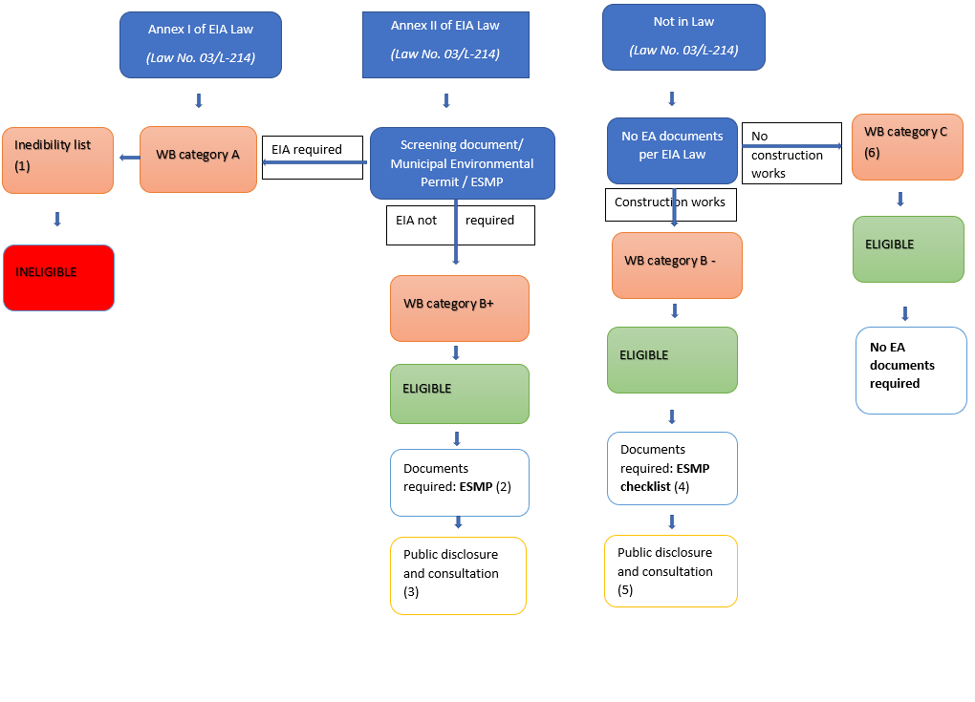
Figure 1 Eligibility and due diligence

Examples of correct categorizations based on the most common MSMEs’ sub-projects applying for the loans in the three selected RFIs is presented in the table:
Loan destination | Category
Automobiles | C
Commercial Vehicles | C
Other Equipment | C
Production or Farming Equipment | C
Working Capital | C
Construction or Renovation | C or B -
Purchase of land and buildings | C
Other | C, B- or B+
Total

Environmental due diligence documentation

The RFIs need to include the following environmental documentation guarantee packages (Table 1):
Table 1: Environmental Documentation
Environmental Category | Environmental Documentation to be included in Sub-loan Application Package
Category C | Environmental Questionnaire
Category B- | Environmental Questionnaire  Any official approval/permits (if applicable)  ESMP Checklist for B- category
Category B+ | Environmental Screening Form and Environmental Questionnaire  MESP decision on EIA  Any official approval/permits (if applicable)  ESMP for B+ category

Environmental Audit (Report)
Environmental audit will be carried out as part of regular KCGF audit procedures in the case a guarantee is triggered. Auditing will be carried out against national environmental regulation, WB Safeguard Policies and environmental due diligence documentation for the sub-project (ESMF and EA appropriate for the sub-project category). The results will be communicated in the detailed Environmental Audit Report. For all category B sub-projects, established significant non-compliance during audit might lead, as per RFI environmental expert (in agreement with KCGF expert), to canceling of the guarantee.

Screening Procedures
Environmental assessments will be carried out in accordance with both the Kosovo Environmental Impact Assessment regulation and WB environmental assessment (OP 4.01).

As a first screening step, the RFIs should identify and reject the following types of sub-project proposals, as NOT eligible for financing under this project:

- if it is a Category A project, according to the WB categorization (OP 4.01) and Annex I, or Annex II listed activity for which MESP requested EIA under of the Kosovo Law on Environmental Impact Assessment;
- if the sub-project is in the WB or KCGF exclusion list (see chapter 7 of this ESMF);
- if the sub-project triggers WB policy on Natural Habitats (OP/BP 4.04, i.e. the project location is in a nature protected site, or the project activities will result in impacts on natural habitats (critical and non-critical habitats);
- if the sub-project triggers the WB policy on Pest management (OP 4.09), if it causes any changes in pest management, e.g. expanding agricultural production, change in crops or agricultural techniques, introducing new pest control, in some cases construction or expansion of food production or storage (which requires pest management, e.g. wheat);
- if the sub-projects trigger the WB policy on Physical Cultural Resources (OP 4.11) causing an effect on monuments, archeological sites, protected buildings, and other physical cultural resources;
- if the sub-project triggers the WB policy on Projects on International Waterways (OP/BP 7.50) i.e. the investment can involve the use or pollution of, or otherwise affect the quality or quantity of an international waterway, as defined in OP/BP 7.50. Most of Kosovo rivers and lakes, at least the major ones and their tributaries, can be classified as international waters;
- if the sub-project supports any involuntary land acquisition or associated involuntary resettlement that would trigger the WB’s policy on Involuntary Resettlement OP/BP 4.12;
- OP/BP 4.36 (Forests) if activities involve logging, expansion of forests, reforestation, commercial planting or can impact health of a forest;
- OP/BP 4.37 Safety of Dams, if involves construction, rehabilitation, maintenance and other activities related to dams;
- Projects that fall under RFI exclusion list.

After ascertaining that all Kosovo requirements have been met and clearances obtained, RFIs should screen the project according to WB categorization (Category A, B-, B+ or C) based on Environmental Questionnaire and other documentation and according to OP 4.01 as well as eligibility conditions set in this ESMF. Upon that screening, if the sub-project is categorized as a Category A or high risk according to WB and ESMF criteria then it should be stated to the sub-beneficiary that it is not eligible for financing. Only projects falling within Category B or Category C may be considered for financing under this project.

Social Assessment
Taking into consideration the nature of potentially sub-projects, those by now are dominated by Wholesale & Retail trade and service sector, the possible negative social impacts are expected to be very limited. Any potential negative impacts on the community health and safety, and on private property and assets will be excluded by means of the screening process explained in this framework. Any other social risks will be addressed in the framework of the necessary documentation for obtaining an environmental permit according to Kosovo legal requirements, as presented above.

Grievance Redress Mechanism
Project will establish a Grievance Redress Mechanism (GRM) within 6 months of Project effectiveness to address any concerns related the project that anyone can bring, including beneficiary MSMEs and their host communities. The project will utilize the existing KCGF website to provide relevant project information, such as progress reports, safeguard reports, events, activities, etc. The KCGF website will have contact information for submitting grievances through multiple channels (website, e-mail, phone, mail) as well as a description on GRM procedures. The possibility to submit a grievance through the website will be also communicated through the Project’s information sessions, public consultations, and workshops and printed materials produced under the Project.

A KCGF staff will be assigned to receive and respond to the grievances/feedback. It is envisaged that the grievance would warrant a response, as long as the following two criteria have been met: (i) concerns any of the Project activities; (ii) contains a sufficient amount of details to indicate a malignant action has occurred or is likely to take place, affecting individual or collective well-being or posing a risk to the environment. If the grievance could be addressed, the assigned KCGF staff will follow up with the actions to be taken to address the grievance. In the case the second criteria is not fully met, the relevant KCGF staff will still make further inquiries (with or without contacting the complainant) as well as corrective measures and provide feedback to the complainant. In the case the complaint is anonymous, the feedback will be provided on the Project web-site.

Due diligence documents, Public Consultation and Disclosure
ESMF with well elaborated ESMP Checklists for B- sub-projects (small construction) will be disclosed for 14 days at least, on KCGF website in English, Albanian and Serbian. Hard copy of the document must be available to the public at the reception. At the same time, a call for consultations will be issued through KCGF webpage and date and venue set for consultation meeting. KCGF will also launch a call for submission of comments and will provide both postal and email address for sending comments and suggestions. All relevant comments and questions raised in/during the public consultations will be addressed, then summarized and will be enclosed to ESMF as Annex 4. Only when the minutes of the consultations are included to the ESMF and it is re-disclosed, it will be considered final. Final ESMF will be redisclosed.
RFIs will publish ESMF on their web site to make ESMF and ESMP Checklists for B- sub-categories available to Applicants and public only after the signing of the agreement for the participation in the project.
EAs (ESMP) prepared for individual B+ sub-projects will have to be disclosed in Albanian, Serbian and if needed English and publicly consulted (disclosed for at least 14 days) by applicant, relevant Ministry or Municipality web-site with a call for comments. Hard copy of the document must be available to the public as well. Comments will be requested on the documents disclosed (the call will provide both postal and email address for sending comments and suggestions). Local newspaper advertisements may be used as a mean for calling the public to comment on the same documents. All relevant comments and questions raised in/during the public consultations will be addressed, then summarized and enclosed to the EA. Only when the minutes of the consultations are included to the document, it will be considered final.
As consulted within ESMF public consultations, ESMP Checklist for B- individual sub-projects do not have to be publicly reconsented/ redisclosed (as it was disclosed as part of the ESMF), but it is recommended to do so as a sign of good practice.

Environmental Review Process (RFIs, KCGF and WB)
All Applicants (final users of funds)/sub-projects, KCGF and RFIs will follow the environmental review process presented below:

STEP 1: The Applicant prepares an initial sub-project concept. Following informal discussion with the RFI, in which the RFI alerts the Applicant of environmental assessment requirements, the RFI distributes Environmental Protection Questionnaire form (to be agreed with RFI before the signing of the agreement). Moreover, Environmental Protection Questionnaire form will be built on existing environmental RFI forms adding additional information required by the WB safeguards policies. The Applicant provides requested information and submits the filled in Environmental Protection Questionnaire and other requested documentation to the RFI. It is the responsibility of the Applicant to initiate discussions with the MESP or relevant Municipality in order to fulfill any local and national environmental review requirements (such as opinion on EIA procedure and/or other official approval/permits). It will be the responsibility of the Applicant to obtain the appropriate permits and licenses as required by national law in order to facilitate the clearance process with the MESP or relevant Municipality. By the time the Applicant contacts RFI, all the permits and opinions/consents/approvals must be obtained. These requirements are considered separate, but parallel, to those presented here and satisfying them is the responsibility of the Applicant. The Applicant is responsible for validity and truthfulness of the provided information in Environmental Protection Questionnaire and other documents.
STEP 2: Based on the submitted Environmental Protection Questionnaire the RFI categorizes the sub-project (as A or otherwise non-eligible, B-, B+, C).
2.1: For category C sub-projects, no further actions are required other than following RFIs internal environmental management procedures.
2.2: For B+ category sub-projects RFIs draft Environmental Screening Report and submits it (accompanied by the Env. Questionnaire and project description) to the KCGF (Environmental Expert) for review. KCGF confirms or corrects the screening result. RFI informs the Applicant on (i) category, (ii) required EA process and reports
2.3: For B- category sub-projects, the RFI distributes the ESMP Checklist (Annex 2) to the Applicant who makes it a part of bidding and contracting documentation. Contractor and Applicant are responsible for its implementation.

STEP 3: If the sub-project is B+ category the RFI sends the Applicant ESMP template in case ESMP is not part of the screening report (Annex 3). The Applicant prepares the ESMP and sends it the RFI (and KCGF and WB if required) for review and approval or comments. At this stage the Applicant has already obtained Municipal Environmental Permit or Environmental Authorization and other permits if required by the national legislation. When RFI is satisfied with environmental documentation, it approves it and disburses a loan and request the guarantee. Approved ESMP for B+ category is a part of (a) loan application package, (b) guarantee request package, (c) bidding and contracting documentation for Contractors (if applicable). The Applicant (and its Contractors) implements ESMP mitigation and monitoring measures. RFI is performing supervision and proposes corrective actions if needed. At least first 3 ESMPs of each RFI will be a subject of KCGF review and approval. First 5 ESMPs will be a subject of WB approval.

STEP 4: RFI reports the environmental compliance to KCGF in regular progress reports, minimum once in six months. KCGF carries out supervision of selected B+ sub-projects.

STEP 5: KCGF will carry out Environmental Audit for each category B sub-project for which the guarantee is triggered. Auditing will be carried out against national environmental regulation, WB Safeguard Policies and environmental due diligence documentation for the sub-project (ESMF and EA appropriate for the sub-project category – ESMP for B+ and ESMP Checklist for B- sub-projects). For all category B sub-projects, established significant non-compliance during audit might lead, as per RFI environmental expert, to canceling of the guarantee. The results will be reported in the Environmental Audit Report.
RFI must keep records of EAs (ESMP Checklists for B- and ESMP for B+ category), and relevant associated documents (e.g. waste manifests and records, complaints, inspection findings, and similar). In addition to the supervision, Environmental Audits in the case a guarantee is triggered will be assessed against these documents.

Monitoring and Reporting
Environmental screening, assessment, and approval procedures described above are part of the procedures for selecting and approving the sub-loan applications. Once a loan and guarantee agreement is signed and sub-projects enter the implementation stage, the environmental work also moves to a new phase. In the course of a sub-project implementation the Applicants are responsible for carrying out their daily activities and applying mitigation measures in compliance with the requirements of the Environmental Assessment Reports (ESMP and ESMP Checklists). RFIs will be expected to monitor sub-borrower’s compliance with EAs (ESMPs) and report to the KCGF on the environmental performance of their clients as an integral part of their regular reporting on the status of portfolio (at least on semiannual basis). Environmental performance of RFIs will be subject to evaluation by the KFGF and the WB supervision missions. KCGF carries out supervision of selected B sub-projects.
The WB will carry out prior review of first five B+ sub-projects and will endorse them before a decision is taken on their guarantee. The KCGF will also check a sample of sub-loan packages of Category B- and B+ as well as Category C sub-projects to ensure that RFIs carried out screening and categorization of sub-projects in a correct way; that Environmental Assessments for Category B sub-projects were carried out adequately and the produced ESMPs are of acceptable quality. The supervision evaluations will ensure that: the work was of satisfactory quality, community participation took place when appropriate, the appropriate recommendations were made, all documentation was properly filed and recorded, and that the conditions of approval by the MESP or the relevant Municipality were met.

The KCGF will inform the WB on the environmental due diligence applied by RFI through the general reporting on the project progress. The WB will track environmental performance of the KCGF and the RFIs by regular review of their reports as well as by supervision of the overall screening process and implementation of environmental recommendations for the selected sub-projects, including random visits to the subproject sites and desk (reports) review. Such practice of supervision is aimed at ensuring that: the work was of satisfactory quality, community participation took place when appropriate, the appropriate recommendations were made, all documentation was properly filed and recorded, and that the conditions of approval by the authorized bodies were met. Therefore, RFIs shall properly keep all sub-project documentation on file and make it available for the KCGF and the WB as needed as well as secure B+ subprojects access to files and enable site visits.

Annex 1 – MAIN RESPONSIBILITIES OF KEY PARTICIPANTS

Participant | Activity | Supporting Documentation
KCGF | - Distribution of Operational manual to RFIs  - Assist to the RFIs about environmental requirements  - Reporting of RFI environmental Performance  - Environmental Audit in the case of triggering  - B+ category supervision  - Together with WB organizes the training for RFIs | - Progress reports
RFI | - Finalize the environmental screening form  - Review of sub-loan application package for required environmental documentation and licenses/permits from the State authorities  - Proposing environmental category  - Distribution of ESMP Checklist and ESMP  - Maintain complete files of environmental documentation for review by the KCGF and WB  - Checking the compliance with mitigation plans (B+ category)  - Continuous improvement of ESMS | - Include environmental information with sub-loan application  - Include environmental monitoring information in regular portfolio reporting to KCGF  - Include environmental documentation in normal RFI records.
Beneficiaries  Sub-borrowers | - Filling in environmental Questionnaire  - Submission of sub-project concept to RFI  - Arrangement and financing of ESMP, if applicable  - Obtain clearance from MESP/Municipality authority if required  - Obtain required permits/licenses  - Implementing ESMP  - Reporting | - Copies of permits, licenses  - Clearance statement  - Decision on the need for EIA  from the MESP  - Environmental Screening Report (if relevant)  - ESMP (if relevant See annex 3)
WB (IBRD) | - Organize training for RFI and KCGF staff regarding environmental review procedures and ESMS enhancement  - Carry out post reviews (for first Category B+ projects)  - Identification of problems/ issues and proposal of solution  - Projects requiring the WB safeguard policies other than OP 4.01 requirements will be prior reviewed by the World Bank Environmental expert. | - Document status of project implementation in Implementation Status and Results reports and the mission Aide-Memoires

Annex 2 – ENVIRONMENTAL Management Plan checklist
Introduction
The objective of the KSFF Project is to improve access to finance for MSMEs. Component 1 of the project Enhancing the Credit Guarantee Framework aims to increase the capital base of the KCGF, expand the range of products offered.
The expected results will be improved access to finance for MSMEs and enhanced payments infrastructure. On the PDO level, these results will be measured by the amount of funding leveraged through the KCGF and the ratio of cashless payments per capita. The Project entails following two components in addition to the project coordination and implementation support:
• Enhancing the credit guarantee framework: The expected results for this component are a sustainable increase in the volume of partial credit guarantees, improved institutional capacity and expanded range of products.

• Establishing a payments card switch: The expected results for this component are operationalized switch center with improved interoperability and lower transactions costs.

Environmental Category
In line with the WB OPs, the project design requires FI category. The KCGF, Implementing Agency for the Component 1, is established with the sole purpose to issue guarantees to target businesses - SMEs and does not operate in any other area. As such, and with credit limited to 500.000 Euros, project activities are not expected to produce significant and lasting environmental impacts. The Project will provide general capital injection to KCGF under the sub-component 1.1, however, the guarantee issuance will be issued on loan-to-loan basis. The sub-component 1.2 targeted sectors include some potentially polluting ones such as, but not limited to: agriculture, energy efficiency and waste management. The guarantees can be issued for infrastructure and production deployment loans, but not retroactively. Environmental and Social Management Framework (ESMF) was developed guiding establishment of screening, EA and environmental review procedures for all sub-projects supported by loans guaranteed during the project implementation as well as those supported from the new piloting schemes.
ESMF screens out all high-risk and category A activities. It also defines capacity building requirements and Grievance Redress Mechanisms as part of the environmental and social due diligence procedures.
Project will support cat B sub projects. These are sun projects with potential adverse environmental impacts on humans or environment are less adverse than those of Category A projects. These impacts are site-specific; few if any of them are irreversible; and in most cases mitigation measures can be designed more readily than for Category A projects. The scope of EA for a Category B project may vary from sub project to sub project.
For the purposes of this Project, taking into consideration its specificities, two B sub-categories are differentiated:
- Category B- to which this ESMP checklist applies. B- Category includes sub-projects involving simple upgrades, small civil works, small construction (e.g. small annexes to existing buildings, and small supporting facilities, simple constructions, but not new large greenfield projects), as well as reconstruction, rehabilitation or adaptation of the existing buildings. For such projects this ESMP Checklist is prepared and publicly consulted as a part of this ESMF. ESMP Checklist will be distributed by RFIs to sub-project Applicants/Contractors of B1 categorized sub-projects and applied in the course of implementation. The Applicant is responsible for ESMP Checklist implementation and adherence to national regulation. ESMP Checklist will be a part of bidding and contracting documents with works Contractors if applicable. The Applicant and or Applicant’s Contractor are responsible for implementation of ESMP Checklist. Those will be randomly checked by RFI, KCGF and possibly WB. On an exceptional terms other projects might fall under cat B+.
- Category B+ to which this EMP checklist does not apply. B+ Category includes sub-projects that are listed under Annex II of the Kosovo EIA Law that do not require full EIA by the opinion of MESP. For these sub-projects, a Screening Report which includes ESMP will be prepared based on the written opinion/decision of MESP that EIA is not needed. For this type of works ESMP will be publicly disclosed and consulted either on the Ministry or Municipality website or website and information board of the applicant. If required, Municipal Environmental Permit will be disclosed as well. On an exceptional terms other projects might fall under cat A.

Potential Environmental Impacts
The environmental impacts of the project are expected to be of manageable, temporary and of local impact as they are related to the general construction activities on already known and previously used locations. These impacts most commonly include: a) dust and noise due to excavation, demolition and construction; b) management of demolition construction wastes and accidental spillage of machine oil, lubricants, etc., c) encroachment to a private property; d) damage to historical or cultural property or unknown archaeological sites; e) traffic disturbance; f) surface or ground water; and g) soil pollution or erosion.

CHECKLIST ESMP

PART 1: INSTITUTIONAL & ADMINISTRATIVE
Country | Kosovo
Project title | KOSOVO FINANCIAL SECTOR STRENGTHENING
Project activity
Institutional arrangements  (Name and contacts) | Project management
 | Who is in charge for the project (contact person) | Which bank guarantees it
LEGISLATION AND PERMITS
Identify national & local legislation & permits that apply to project activity | - Environmental Consent/Permit - required ( ); issues ( ); n/a ( )  - Municipal Environmental Permit - required ( ); issues ( ); n/a ( )  - Environmental Authorization- required ( ); issues ( ); n/a ( )  - Water use permit- required ( ); issues ( ); n/a ( )  - Wastewater discharge permit- required ( ); issues ( ); n/a ( )  - Construction permit - required ( ); issues ( ); n/a ( )  - Licenses or Permit to use natural/mineral resources- required ( ); issues ( ); n/a ( )  - Other: ________________________________________________________
PUBLIC CONSULTATION
Identify when / where the public consultation process took place | The information about the place and date of public discloser will be put on:  - Company website  - Company info board  - Other: __________________________  Date:

PART 2: ENVIRONMENTAL /SOCIAL SCREENING

Will the site activity include/involve any of the following: | Activity | Status | Additional references
 | - Building rehabilitation | [ ] Yes [] No | See Section B below
 | - New construction | [ ] Yes [ ] No | See Section B below
 | - Individual wastewater treatment system | [ ] Yes [ ] No | See Section C below
 | - Historic building(s) and districts | [ ] Yes [ ] No [ ] Possible | See Section D below
 | - Acquisition of land | [ ] Yes [] No | See Section E below
 | - Hazardous or toxic materials | [ ] Yes [ ] No | See Section F below
 | - Impacts on forests and/or protected areas | [ ] Yes [ ] No | See Section G below
 | - Handling / management of medical waste | [ ] Yes [ ] No | See Section H below
 | - Traffic and Pedestrian Safety | [ ] Yes [ ] No | See Section I below
 | - Other applicable | [ ] Yes [ ] No | See Section J below

ACTIVITY | PARAMETER | MITIGATION MEASURES CHECKLIST
A. General Conditions | Notification and Worker Safety | - All legally required permits have been acquired for construction and/or rehabilitation  - The public has been notified of the works through appropriate notification in the media and/or at publicly accessible sites (including the site of the works)  - All work will be carried out in a safe and disciplined manner designed to minimize impacts on neighboring residents and environment.  - Workers’ PPE will comply with international good practice (always hardhats, as needed masks and safety glasses, harnesses and safety boots)  - Appropriate signposting of the sites will inform workers of key rules and regulations to follow.
B. General Rehabilitation and /or Construction Activities | Air Quality | - During interior demolition use debris-chutes above the first floor  - Keep demolition debris in controlled area and spray with water mist to reduce debris dust  - Suppress dust during pneumatic drilling/wall destruction by ongoing water spraying and/or installing dust screen enclosures at site  - Keep surrounding environment (sidewalks, roads) free of debris to minimize dust  - There will be no open burning of construction / waste material at the site  - There will be no excessive idling of construction vehicles at sites
 | Noise | - Construction noise will be limited to restricted times according to the law on noise  - During operations the engine covers of generators, air compressors and other powered mechanical equipment should be closed, and equipment placed as far away from residential areas as possible
 | Water Quality | - The site will establish appropriate erosion and sediment control measures such as e.g. hay bales and / or silt fences to prevent sediment from moving off site and causing excessive turbidity in nearby streams and rivers.
 | Waste management | - Waste collection and disposal pathways and sites will be identified for all major waste types expected from demolition and construction activities.  - Mineral construction and demolition wastes will be separated from general refuse, organic, liquid and chemical wastes by on-site sorting and stored in appropriate containers.  - Construction waste will be collected and disposed properly by licensed collectors  - The records of waste disposal will be maintained as proof for proper management as designed.  - Whenever feasible the contractor will reuse and recycle appropriate and viable materials (except asbestos)
C. Individual wastewater treatment system | Water Quality | - The approach to handling sanitary wastes and wastewater from building sites (installation or reconstruction) must be approved by the local authorities  - Before being discharged into receiving waters, effluents from individual wastewater systems must be treated in order to meet the minimal quality criteria set out by national guidelines on effluent quality and wastewater treatment  - Monitoring of new wastewater systems (before/after) will be carried out
D. Historic building(s) | Cultural Heritage | - If the building is a designated historic structure, very close to such a structure, or located in a designated historic district, notify and obtain approval/permits from competent authorities (Ministry of Culture, Youth and Sport) and address all construction activities in line with local and national legislation  - Ensure that provisions are put in place so that artifacts or other possible “chance finds” encountered in excavation or construction are noted, officials contacted, and works activities delayed or modified to account for such finds.
E. Acquisition of land | Land Acquisition Plan/Framework | - If expropriation of land was not expected and is required, or if loss of access to income of legal or illegal users of land was not expected but may occur, the proposed sub-project will not be eligible for financing.
F. Toxic Materials | Asbestos management | - If asbestos is located on the project site, mark clearly as hazardous material  - When possible the asbestos will be appropriately contained and sealed to minimize exposure  - The asbestos prior to removal (if removal is necessary) will be treated with a wetting agent to minimize asbestos dust  - Asbestos will be handled and disposed by skilled & experienced professionals  - If asbestos material is to be stored temporarily, the wastes should be securely enclosed inside closed containments and marked appropriately  - The removed asbestos will not be reused
 | Toxic / hazardous waste management | - Temporarily storage on site of all hazardous or toxic substances will be in safe containers labeled with details of composition, properties and handling information  - The containers of hazardous substances should be placed in an leak-proof container to prevent spillage and leaching  - The wastes are transported by specially licensed carriers and disposed in a licensed facility.  - Paints with toxic ingredients or solvents or lead-based paints will not be used
G. Affects forests and/or protected areas | Protection | - All recognized natural habitats and protected areas in the immediate vicinity of the activity will not be damaged or exploited, all staff will be strictly prohibited from hunting, foraging, logging or other damaging activities.  - For large trees in the vicinity of the activity, mark and cordon off with a fence large tress and protect root system and avoid any damage to the trees  - Adjacent wetlands and streams will be protected, from construction site run-off, with appropriate erosion and sediment control feature to include by not limited to hay bales, silt fences  - There will be no unlicensed borrow pits, quarries or waste dumps in adjacent areas, especially not in protected areas.
H. Disposal of medical waste (not applicable) | Infrastructure for medical waste management | - In compliance with national regulations the contractor will insure that newly constructed and/or rehabilitated health care facilities include sufficient infrastructure for medical waste handling and disposal; this includes and not limited to:  - Special facilities for segregated healthcare waste (including soiled instruments “sharps”, and human tissue or fluids) from other waste disposal; and  - Appropriate storage facilities for medical waste are in place; and  - If the activity includes facility-based treatment, appropriate disposal options are in place and operational
I Traffic and Pedestrian Safety | Direct or indirect hazards to public traffic and pedestrians by construction activities | - In compliance with best international practices the contractor will insure that the construction site is properly secured and construction related traffic regulated. This includes but is not limited to  - Signposting, warning signs, barriers and traffic diversions: site will be clearly visible and the public warned of all potential hazards  - Traffic management system and staff training, especially for site access and near-site heavy traffic. Provision of safe passages and crossings for pedestrians where construction traffic interferes.  - Adjustment of working hours to local traffic patterns, e.g. avoiding major transport activities during rush hours or times of livestock movement  - Active traffic management by trained and visible staff at the site, if required for safe and convenient passage for the public.  - Ensuring safe and continuous access to office facilities, shops and residences during renovation activities, if the buildings stay open for the public.
J Other | Additional impacts  _________________ | Additional mitigation measures______________________

PART 3: MONITORING PLAN

The RFI and KCGF will on monitor the implementation of the mitigation measures during their site visit.

Annex 3 – Environmental and Social Management Plan template
A project's Environmental and Social Management Plan (ESMP) consists of the set of mitigation, monitoring, and institutional measures to be taken during implementation and operation to eliminate adverse environmental and social impacts, offset them, or reduce them to acceptable levels. The plan also includes the actions needed to implement these measures.
1. Management plans are essential elements of EA reports for Category A projects; for many Category B projects the EA may result in a management plan only. To prepare a management plan, the recipient and its EA design team (a) identify the set of responses to potentially adverse impacts; (b) determine requirements for ensuring that those responses are made effectively and in a timely manner; and (c) describe the means for meeting those requirements.
More specifically, the ESMP includes the following components:
Mitigation
2. The ESMP identifies feasible and cost-effective measures that may reduce potentially significant adverse environmental impacts to acceptable levels. The plan includes compensatory measures if mitigation measures are not feasible, cost-effective, or sufficient. Specifically, the ESMP;
(a) Identifies and summarizes all anticipated significant adverse environmental impacts (including those involving indigenous people or involuntary resettlement);
(b) Describes with technical details each mitigation measure, including the type of impact to which it relates and the conditions under which it is required (e.g., continuously or in the event of contingencies), together with designs, equipment descriptions, and operating procedures, as appropriate;
(c) Estimates any potential environmental impacts of these measures; and
(d) Provides linkage with any other mitigation plans (e.g., , indigenous peoples, or cultural property) required for the project.
Monitoring
3. Environmental monitoring during project implementation provides information about key environmental aspects of the project, particularly the environmental impacts of the project and the effectiveness of mitigation measures. Such information enables the recipient and the Bank to evaluate the success of mitigation as part of project supervision, and allows corrective action to be taken when needed. Therefore, the ESMP identifies monitoring objectives and specifies the type of monitoring, with linkages to the impacts assessed in the EA report and the mitigation measures described in the ESMP. Specifically, the monitoring section of the ESMP provides(a) a specific description, and technical details, of monitoring measures, including the parameters to be measured, methods to be used, sampling locations, frequency of measurements, detection limits (where appropriate), and definition of thresholds that will signal the need for corrective actions; and (b) monitoring and reporting procedures to (i) ensure early detection of conditions that necessitate particular mitigation measures, and (ii) furnish information on the progress and results of mitigation.

Implementation Schedule and Cost Estimates
4. For all three aspects (mitigation, monitoring, and capacity development), the ESMP provides (a) an implementation schedule for measures that must be carried out as part of the project, showing phasing and coordination with overall project implementation plans; and (b) the capital and recurrent cost estimates and sources of funds for implementing the ESMP. These figures are also integrated into the total project cost tables.

Mitigation Plan
Construction Phase
Activity | Expected Environmental Impact | Proposed Measure for Mitigation | Responsibility for Implementing Mitigation Measure | Period of Implementing Mitigation Measure | Cost associated with implementation of mitigation measure
1.
2.
…
Operation Phase
1.
2.
…

Monitoring Plan
Construction Phase
What  Parameter is to be monitored? | Where  Is the parameter to be monitored? | How  Is the parameter to be monitored (what should be measured and how)? | When  Is the parameter to be monitored (timing and frequency)? | By Whom  Is the parameter to be monitored– (responsibility)? | How much  is the cost associated with implementation of monitoring
1.
2.
…
Operation Phase

Annex 4 – Minutes of the ESMF Consultation Meeting(s)
Consultations for the ESMF, took place in the KCGF premises in Pristina on February 22, 2019. The document was previously published on the KCGF web site (on Feb 12, 2019) and was available in hard copies at its premises for 14 days. Information on its disclosure, followed by public consultations was posted on the KCGF web site. Both, the document and the announcement, was provided in Albanian, Serbian, and English languages. In addition the invitations to stakeholders were sent by email.

Figure 1. Public announcement in the Albanian language
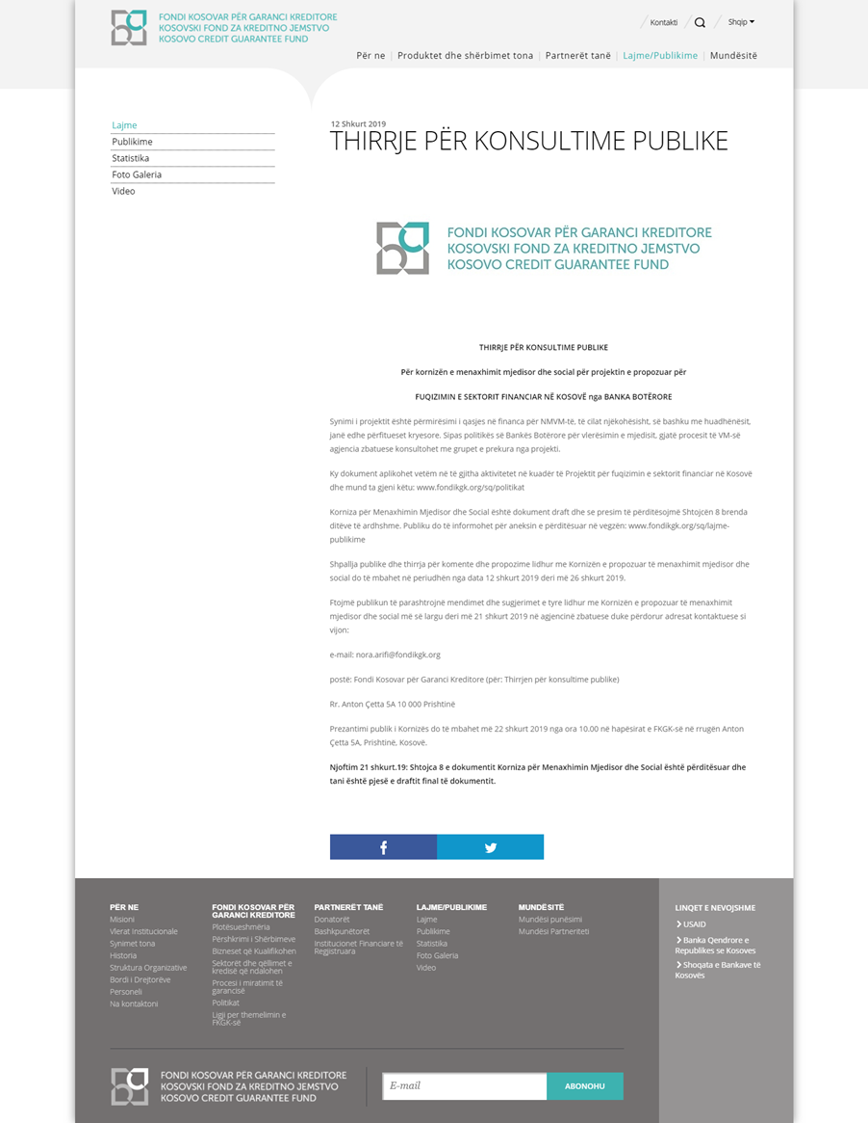

Figure 2. Public announcement in the Serbian language
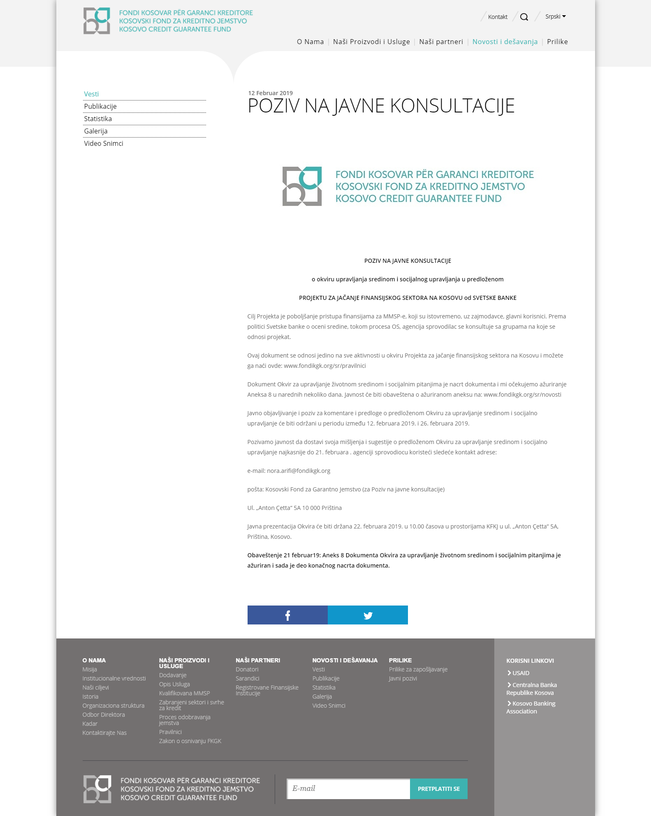

Figure 3. Public announcement in the English language

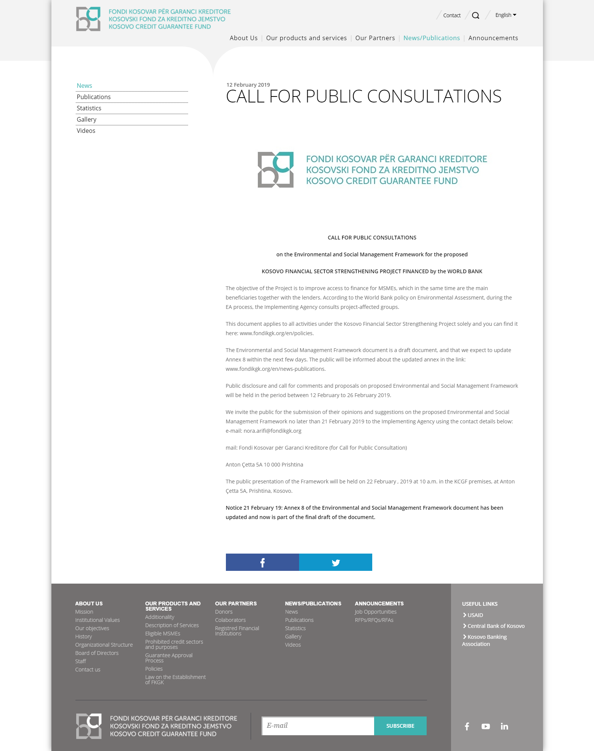

The meeting started at 10:30 a.m. Present were: representatives of the KCGF, Ms. Nora Arifi - Senior Guarantee Manager, Mr. Partin Pruthi - Senior Legal Officer, Mr. Kastriot Këpuska - Agro Expert, a representative of BKT: Mr. Mentor Berisha - Manager-Corporate & Business Department, a representative of BPB: Mr. Bujar Statovci, a representative of NLB: Mr. Viktor Halili - Senior Compliance Officer, a representative of PCB: Mr. Gëzim Tropoja - Head of Environmental Unit, and a representative of RBKO Mr. Blerim Terziqi - Acting Portfolio and Risk Controlling Manager.
No other stakeholders expressed interest to take part in this public consultation and there was no feedback received during the consultation period.

Picture 1 Public Consultation KCGF Building
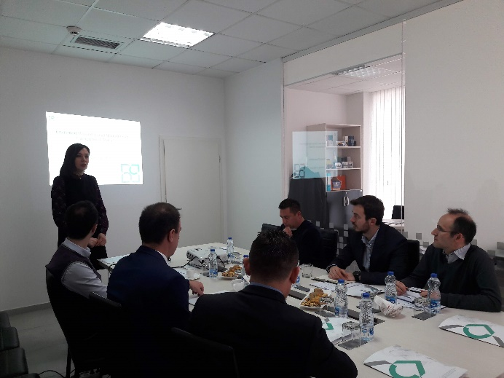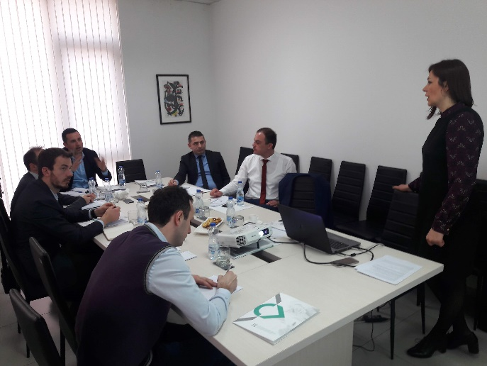

The public discussion meeting was chaired by Ms. Arifi. Ms. Arifi started with a brief introduction of the Kosovo financial sector strengthening project, the objective of the Project and its importance towards improving the access to finance for MSMEs.
Further, the Environmental and Social Management Framework (ESMF) document was introduced starting with a brief introduction of the importance of the ESMF for the Project. Different parts of the ESMF were presented focusing on the Environmental review process and on mitigation measures checklist for the sub-project investments. It was agreed that there is very challenging requirement of the Financial Institutions to modify the internal policies and procedures, and the involvement of and KCGF on evaluation of B+ category.

Picture 2 Hard copies of ESMF at KCGF Offices
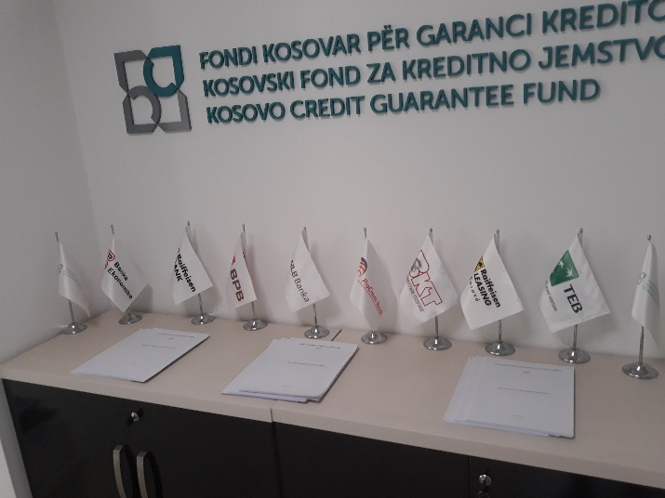
There are two distinct conclusions from the public consultation:
- the challenge of the requirement of the ESMP preparation by the client (category B+) and approval from RFI and KCGF.
Feedback on conclusion: The issue has been considered and discussed with the World Bank. The requirement presented in the ESMF have been adopted to the minimum requirements of the OP/BP 4.01 (Environmental Assessment) Policy. Although this requirement is under the requirements of the MESP as a part of the procedures for the Environmental Permit or Authorization it is expected that with enhancement of the stakeholder’s capacity building, the project might rely more on country procedures.

- KCGF should prepare an operational manual to make the environmental evaluation easier for banks.
Feedback on conclusion: The KCGF will define the operational manual in cooperation with Banks in order to fit the procedures as much as possible.

At the end of the meeting it was concluded that there were great efforts from the KCGF to inform different stakeholders and citizens who will be able to send their comments till February 26, 2019.

Figure 4. Participants List
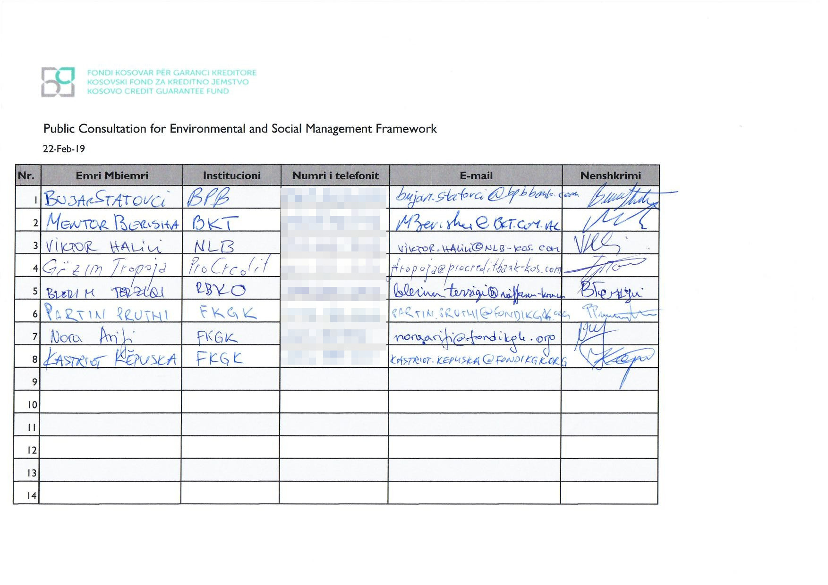

Annex 5 - Projects listed in Annex I of the EIA law which requires an EIA
1. Production and Processing of Metals
1. Metal ore (including sulphide ore) roasting or sintering installations.
2. Factories for cast iron and steel influx (primary or secondary fusion), including continuous casting.
3. Factories/foundries for processing of ferrous metals:
3.1.hammer smitheries with an energy output exceeding fifty (50) KJ per hammer, while the power input exceeds twenty (20) KW;
3.2. application of protective fused mixed metal coats with an input which exceeds one (1) tones/hour of steel gross;
3.3. foundries for production of ferrous metals with capacity higher than one hundred (100) tonnes/day.
4. Factories/foundries for:
4.1.non-ferrous metal production and production of non-ferrous crude metals from ore; concentrates or secondary raw materials by metallurgical, chemical or electrolytic processes;
4.2.smelting, including production of alloys, including reclaimed products (refining, casting in foundries, etc.) with production that exceeds one (1) tone/day for lead and cadmium or ten (10) tones/day for other metals.
5. Factories for surface treatment of metals and plastic materials, using electrolytic or chemical processes where the volume of treatment vats exceeds ten (10) m3.
6. Installations for surface treatment of substances or products which use organic solvents especially for coating, painting, degreasing, protection against water and colour infiltration, cleaning or pressing where the amount of solvents used exceeds one hundred (100) tonnes/year.
7. Production and processing of alloys from non-ferrous metals which contain arsenic, mercury and lead, with a capacity higher than one thousand (1,000) tonnes/year.

2. Mineral Industry
8.Cement factories containing rotating kilns (baking and drying) with production capacity higher than three hundred (300) ton/day or lime producing factories with rotating limekilns with a production capacity of thirty (30) tones/day or more, or containing other types of kilns with production capacity of thirty (30) tones/day or more.
9. Factories for production of materials using processes such as calcification and baking of minerals which contain toxic elements like, mercury, arsenic and cadmium.
10. Glass producing factories, including production of glass fibre, with a production capacity of ten (10) tonnes/day or more.
11. Foundries for smelting of mineral substances, including production of mineral fibres, with a production capacity of ten (10) tonnes/day or more.
12. Factories for production of ceramic products, by firing, especially production of bricks, tiles, refractory bricks, stoneware and porcelain, with a production capacity of thirty (30) tones/day or more.
13. Installations for extraction of asbestos and for the processing and transformation of asbestos and other asbestos containing products, such as: asbestos-cement products, with an annual production of more than five thousand (5,000) tones of finished products; for friction material, with annual production of more than fifty (50) tones of finished products; and for other uses of asbestos, utilization of more than two hundred (200) tones/year.
14. Factories for roasting and sintering of non-metallic minerals with a production capacity of thirty (30) tonnes/day or more.

3. Extractive Industry
15.Quarries and open-cast mining of clay where the surface of the site exceeds five (5) ha, or peat extraction, where the surface of the site exceeds ten (10) ha or involves the extraction of fifteen thousand (15,000) tones or more/annum.
16. Extraction and processing (except liquefaction and gasification) of coal, lignite and bituminous minerals with a production capacity of fifty thousand (50,000) tones/year or more.

4. Chemical Industry
17. Integrated activities for industrial production, through chemical processes, of single substances or groups of substances, listed in the sub-paragraphs 17.1 to 17.7:
17.1. Production of basic organic chemicals, such as:
17.1.1. simple hydrocarbons (linear or cyclic, saturated or not saturated, aliphatic or aromatic);
17.1.2. hydrocarbons which contain oxygen such as: alcohols, carboxylic acids, ethers, acetone, peroxide, epoxy resin;
17.1.3. sulphate hydrocarbons;
17.1.4. nitrogen hydrocarbons, such as amines, amides, nitrogen compounds, nitrate compounds, nitrites, cyanide, isocyanides;
17.1.5. phosphor-containing hydrocarbons;
17.1.6. halogen hydrocarbons;
17.1.7. organometallic components;
17.1.8. base plastic materials (polymers synthetic fibres and fibres with a cellulose base);
17.1.9. synthetic rubber;
17.1.10. colourings and pigments;
17.1.11. active-surface agents.
17.2. Production of basic inorganic chemicals, such as:
17.2.1. gases, like ammonia, chlorine, or hydrogen chloride, fluorine or hydrogen fluoride, carbon dioxide, sulphur compounds, hydrogen, sulphur dioxide, carbonyl fluoride;
17.2.2. acids, such as: chromic acid, hydrofluoric acid, phosphoric acid, nitric acid, hydrochloric acid, sulphuric acid, sulphurous acid;
17.2.3. bases, such as ammonium hydroxide, potassium hydroxide, sodium hydroxide;
17.2.4. salts, such as potassium carbonate, sodium carbonate, bleaches based on sodium or potassium borates, silver nitrate;
17.2.5. non metals, metal oxides and other inorganic combinations, such as: calcium carbide, silicon, silicon carbide;
17.3. Production of chemical fertilizers with a phosphate, nitrogen, or potassium base (simple or compound fertilizers);
17.4. Production of basic plant health products and biocides;
17.5. Production of basic pharmaceutical products, colours and pesticides, using a chemical or biological process;
17.6. Production of explosive substances;
17.7. Production of protein nutrition additives, ferments and other protein substances using chemical and biological processes.

5. Energy Industry
18. Thermal power stations and other combustion installations with a heat output of fifty (50) MW or more.
19. Centrals of Nuclear Energy.
20. Installation of electric lines of high voltage with minimum of two hundred and twenty (220) kV and with length longer than ten (10) km.
21. Crude oil refineries and installations for gasification and liquefaction of coal and bituminous shale and installations for reclaiming of used oils involving amounts of one hundred thousand (100,000) tonnes/year or more.
22. Installations for storage of petroleum, petrochemical, or chemical products with a capacity of one hundred thousand (100,000) tones or more.
23. Installations for storage of radioactive materials.

6. Transport Infrastructure
24. Construction of lines for long-distance railway traffic and of airports with a basic runway length of two thousand one hundred (2100) m or more.
25. Construction of a new road of two or more lanes, or realignment and/or widening of an existing road to provide two or more lanes, where such new road, or realignment and/or widened section would be five (5) km or more in continuous length.
26. Pipelines with a diameter of five hundred (500) mm or more and a length of ten (10) km or more for the transport of:
26.1. natural gas, oil or chemicals, and
26.2. carbon dioxide (CO2) streams for the purposes of geological storage, including associated booster stations.
27. Pipelines with a diameter of eight hundred (800) mm or more and a length of forty (40) km for the transport carbon dioxide (CO2) streams for the purposes of geological storage, including associated booster stations.

7. Food Industry
28. Manufacture and processing of food products from:
28.1. raw materials of animal origin (excluding milk) where production capacity of final product, exceeds thirty (30) tonnes/day;
28.2. raw materials of plant origin where production capacity of final product, exceeds two hundred fifty (250) tones/day (average based on the quarterly value);
28.3. milk products, where the amount of treated milk exceeds one hundred (100) tones/day (average based on annual amount);

8. Waste and Wastewater Treatment and Disposal
29. Installations for incineration, recovery, chemical treatment, or land filling of hazardous waste.
30. Facilities for municipal waste incineration, with an input of 1 tone/hour or more.
31. Landfills for non-hazardous waste, with an input of thirty (30) tonnes/day or more.
32. Plants for treatment of municipal wastewater with a capacity exceeding one hundred thousand (100,000) population equivalents.
33. Plants for treatment of industrial wastewater.

9. Water Storage, Transfer and Supply Projects
34. Groundwater abstraction or artificial groundwater recharge schemes where the annual volume of water abstracted or recharged is equivalent to or exceeds five (5) million cubic meters.
35. 1. Works for the transfer of water resources between river basins where the transfer aims at preventing possible shortages of water and where the amount of water transferred exceeds thirty
(30) million m3/year.
35. 2. In all other cases, works for the transfer of water resources between river basins where the multi-annual average flow of the basin of abstraction exceeds six hundred (600) million m3/year and where the amount transferred exceeds 5% of this flow. In both cases transfers of piped drinking water are excluded.
36. Dams and other installations designed for the holding back or permanent storage of water, where a new or additional amount of water held back or stored exceeds five (5) million m3.

10. Paper, Wood, Textile and Leather Industries
37. Installations for production of paper and board exceeding one hundred thousand (100,000)m2/year.
38. Industrial plants for the:
38.1.production of pulp from timber or similar fibrous materials;
38.2.production of paper and board with a production capacity exceeding fifty (50) tonnes/day.
39. Furniture production with an input of wood or other basic material greater than ten thousand (10.000) m3/year.
40. Plants for the pre-treatment (operations such as washing, bleaching, mercerisation) or dyeing of fibresor textiles.
41. Factories for tanning of hides and skins.

11. Intensive Agriculture
42. Installations for intensive rearing of poultry, pigs or livestock with more than:
42.1. ten thousand (10 000) poultry;
42.2. five hundred (500) pigs;
42.3. one hundred (100) cattle; and
42.4. one thousand (1000) small livestock;

12. Other Projects
43. Installations for rendering or disposal of dead animals.
44. Storage sites for the geological storage of carbon dioxide.
45. Installations for the capture of CO2 streams for the purposes of geological storage from installations covered by this Annex or where the total yearly capture of CO2 is 1,5 megatons or more.
46. Any change or extension to projects listed in this Annex where such a change or extension in itself meets the thresholds, if any, set out in this Annex.

Annex 6- Projects listed in Annex II of national EIA Law
1. Agriculture, forestry and fishing:
1.1. Projects for the use of uncultivated land or semi-natural areas for intensive agricultural purposes;
1.2. Water management projects for agriculture, including irrigation and land drainage projects;
1.3. Initial afforestation and deforestation, for the purposes of conversation to another type of land use;
1.4. Intensive fish farming.

2. Extractive industry
2.1. Quarries, stone crushers, open-cast mining and peat extraction including sites identifies for municipally managed artisan mining (projects which are not included in Annex 1);
2.2. Underground mining;
2.3. Extraction, crumbling and other minerals by dredging of river beds;
2.4. Deep drillings, in particular:
2.4.1. Geothermal drilling; and
2.4.2. Drilling for water supplies, with the exception of drillings investigating the stability of the soil;
2.5. Surface installations for extraction of coal, lignite and bituminous minerals (projects which are not included in Annex 1);

3. Energy Industry
3.1. Industrial installations for the production of electricity, steam and hot water (projects not included in Annex 1);
3.2. Industrial installations for carrying gas, steam and hot water; transmission of electrical energy by overhead cables (projects not included in Annex 1);
3.3. Surface storage of natural gas;
3.4. Underground storage of combustible gases;
3.5. Surface and underground storage of fluid combustible materials (projects not included in Annex 1) and storage in land surface of fossil carburants;
3.6. Industrial briquetting of coal and lignite;
3.7 installations for the processing and storage of radioactive waste (unless included in Annex I);
3.8. Installations for hydroelectric energy production (projects not included in Annex 1);
3.9. Installations for harnessing of wind power for energy production; 3.9.continuous radiate resources (ionizing and non-ionizing).
3.10. Installations for the capture of CO2 streams for the purposes of geological storage (installations not covered by Annex I);

4. Production and processing of metals
4.1. Installations for the production of pig iron or steel with continuous casting;
4.2. Installations for the processing of ferrous metals (projects not included in Annex 1);
4.3. Ferrous metal foundries (projects not included in Annex 1);
4.4. Installations for the smelting, including the alloyage, of non-ferrous metals, including reclaimed products (refining, foundry casting etc.), (projects not included in Annex 1);
4.5. Installations for surface treatment of metals and plastic materials (projects not included in Annex 1);
4.6. Manufacture and assembly of motor vehicles and manufacture of motor-vehicle engines;
4.7. Installations for the roasting and sintering of metallic ores;
4.8. Installations for building and repairing airplanes;
4.9. Production of railway equipment;
4.10. Disintegration with explosive

5. Mineral industry
5.1. Coke ovens (dry coal distillation);
5.2. Installations for the manufacture of cement (projects not included in Annex 1);
5.3. Installations for the production of asbestos and the manufacture of asbestos- products (projects not included in Annex 1);
5.4. Installations for production of glass including glass fibre (projects not included in Annex 1);
5.5. Installation for smelting mineral substances including production of mineral fibres (projects not included in Annex 1);
5.6. Manufacture of ceramic products by firing, in particular roofing tiles, bricks, refractory bricks, tiles, stoneware or porcelain (projects not included in Annex 1);
5.7. Factories for asphalt production;
5.8. Factories for beton production.

6. Chemical industry
6.1. Treatment of intermediate products and production of chemicals;
6.2. Production of pesticides and pharmaceutical products, paint and varnishes, elastomers and peroxides (projects not included in Annex 1);
6.3. Storage facilities for petroleum, petrochemical and chemical products.

7. Food industry
7.1. Manufacture of vegetable and animal oils and fats (projects not included in Annex1);
7.2. Packing and canning of animal and vegetables products;
7.3. Manufacture of dairy products (projects not included in Annex 1);
7.4. Brewing of beer (projects not included in Annex 1);
7.5. Confectionery and syrup manufacture (projects not included in Annex 1);
7.6. Installations for the slaughter of animals;
7.7. Industrial installations for production of farina;
7.8. Sugar factories (projects not included in Annex 1).

8. Textile, leather, wood and paper industry
8.1. Factories for the production of paper and board (projects not included in Annex 1);
8.2. Plants for pre-treatment (washing, bleaching, mercerization) or dying of fibres or textiles (projects not included in Annex 1);
8.3. Plants for the tanning of hides and skins.
8.4. Cellulose-processing and production installations.

9. Rubber Industry
9.1. Manufacture and treatment of elastomer-based products.

10. Infrastructure projects
10.1. industrial estate development projects;
10.2. urban development projects, including the construction of shopping centres and car parks;
10.3. construction of railways and intermodal transshipment facilities, and of intermodal terminals (projects not included in Annex 1);
10.4. constructions for airports and airfields (projects not included in Annex 1);
10.5. construction of roads (projects not included in Annex 1);
10.6. inland waterway construction or modification;
10.7. flood prevention projects including modifications to river channels (projects not included in Annex 1);
10.8. dams or other installations designed to hold water or store it on long-term basis (projects not included in Annex 1);
10.9. Construction or modification of tramways, elevated or underground railways, suspended lines or similar lines of a particular type, used exclusively or mainly for passenger transport;
10.10. Oil and gas pipeline installations and pipelines for the transport of CO2 streams for the purposes of geological storage (projects not included in Annex I).
10.11. Groundwater abstractions and artificial groundwater recharge schemes (projects not included in Annex 1;
10.12. Works for the transfer of water resources between river basins (projects not included in Annex 1).

11. Tourism and leisure
11.1. Ski-runs, ski-lifts, and cable cars and associated activities;
11.2. Holiday villages and hotel complexes outside urban areas and associated developments;
11.3. Permanent camp and caravan sites;
11.4. Theme parks;
11.5. Infrastructure installations in protected zones, not included in spatial plans.

12. Other projects
12.1. Permanent racing and test tracks for motorized vehicles;
12.2. Installations for the disposal of waste (projects not included in Annex 1);
12.3. Waste- water treatment plants (projects not included in Annex 1);
12.4. Sludge deposition sites (projects not included in Annex 1);
12.5. Storage of scrap iron and other metals, including scrap vehicles;
12.6. Installations for the manufacture of artificial mineral fibres (projects not included in Annex 1);
12.7. Installations for the recovery or destruction of explosive substances;
12.8. Sites for disposal of industrial non-hazardous waste;
12.9. Sites for storage and processing of dead and unwanted animals (projects not included in Annex 1);
12.10. Food industries (projects not included in Annex 1 or under section 7 above).
12.11. Any change or extension of projects given in Annex I or Annex II already authorized, executed or in the process of being executed, which may have significant adverse effects on the environment (change or extension not included in Annex I);
12.12. Projects in Annex I, undertaken exclusively or mainly for development and testing of new methods or products and not used for more than two (2) years.

Annex 7 – List of the activities that are subject to the Municipal Environmental Permit

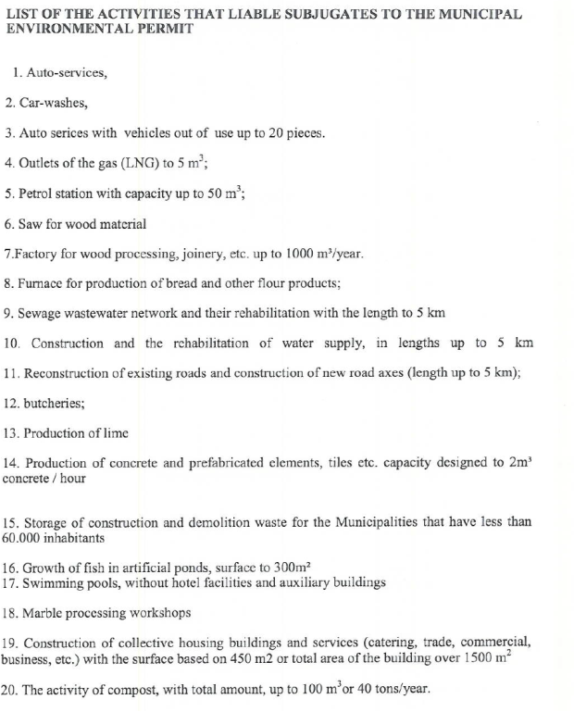

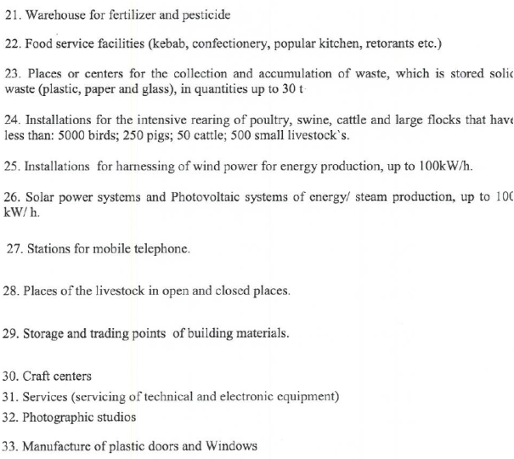

Annex 8 – Commercial Banks’ (RFIs) existing Environmental Screening and Management Systems
(to be determined)

Regulation on Large Exposures approved by the Board of the Central Bank of the Republic of Kosovo on April 26, 2013
http://www.ammk-rks.net/?page=2,46
http://www.unmikonline.org/regulations/unmikgazette/02english/E2004regs/RE2004_37_ALE2004_15.pdf
http://documents.worldbank.org/curated/en/282091494340650708/pdf/Kosovo-SCD-FINAL-May-5-C-05052017.pdf
Forced labor means all work or service, not performed voluntarily, obtained by an individual under threat of force or penalty as defined by ILO conventions
Persons may only be employed if they are at least 14 years old, as defined in the ILO Fundamental Human Rights Conventions (Minimum Age Convention C138, Art. 2), unless local legislation explicitly specifies compulsory school attendance or the minimum working age. In those cases, the upper limit applies.
Destruction means the (1) elimination or severe diminution of the integrity of an area caused by a major, long-term change in land or water use or (2) modification of a habitat in such a way that the area’s ability to maintain its role is lost. High Conservation Value (HCV) areas are defined as natural habitats where these values are considered to be of outstanding significance or critical importance (see http://www.hcvnetwork.org).
This does not apply to the purchase of medical equipment, quality control (measurement) equipment or any other equipment where the radioactive source is understood to be trivial and/or adequately shielded
For companies, “substantial” means more than 10% of their consolidated balance sheets or earnings. For financial institutions and investment funds, “substantial” means more than 10% of their underlying portfolio volumes.
- a) Trade in wildlife and wildlife products prohibited under the CITES convention; b) Release of genetically altered organisms into the natural environment, c) Manufacturing, distribution and sale of banned pesticides and herbicides, d) Drift seine netting in the marine environment, e) Manufacturing, handling and disposal of radioactive products, f) Hazardous waste storage, treatment and disposal, g) Manufacturing of equipment and appliances containing CFCs, halons and other substances regulated under the Montreal Protocol, h) Manufacturing of electrical equipment containing polychlorinated biphenyls (PCBs) in excess of 0,005 % by weight, i) Manufacturing of asbestos containing products, j) Nuclear reactors and parts thereof, k) Tobacco, unmanufactured or manufactured, l) Tobacco processing machinery, and m) Manufacturing of firearms. In addition, no purchasing of pesticides; no works on cultural heritage sites and high-risk projects classified by RFIs (construction and extending the capacity) - ESMP – Environmental and social management plan is part of the Screening document prepared for the opinion on the need for EIA - Public disclosure and consultation would be done based on the screening document / ESMP as per national legislation, if fails it would be done by investor - ESMP checklist is a general ESMP checklist for small construction woks prepared as part of the project Environmental and Social Framework (ESMF) - ESMP checklist id disclosed and consulted as part of the ESMF document. If larger company, they can disclose on their website or information board - Category C project include: a) Automobiles; b) Commercial Vehicles; c) Other Equipment; d) Production or Farming Equipment; e) working capital; f) Renovation (inside of the premises); g) purchasing of Land and Buildings. Environmental Authorization might be required
EMP checklists are generic for small constructions yet allow addressing additional project specificities
Land acquisitions includes involuntary taking of land (expropriation) that results in displacement of people, loss of assets or access to assets and loss of income sources or means of livelihood as defined in the World Bank’s OP/BP 4.12. This involves land which was purchased/handed over and impact on persons who have no recognizable legal right or claim to the land, but are living and/or unlawfully exist and or/performing business activities (booths) on the land already purchased.
Toxic / hazardous material includes and is not limited to asbestos, toxic paints, removal of lead paint, etc.

