37967

Rural Water Supply, Sanitation, and Hygiene
A Review of 25 Years of Lending: 1978 – 2003

This report was prepared by Param Iyer, Jennifer Davis, Elif Yavuz

The views and opinions expressed in this report are those of the author(s) and do not necessarily reflect those of the World Bank, its Executive Directors, or the countries they represent. Any references provided in this document to a specific product, process, or service is not intended as, and does not constitute or imply an endorsement by the World Bank of that product, process, service, or its producer or provider.

Energy and Water Department
April, 2006
Table of Contents

1. Introduction: Taking stock of World Bank support to water supply, sanitation and hygiene in rural areas 3
2. Methodology 5
3. Findings 7
3.1 Regional lending patterns and the Millennium Development Goals (MDGs) 7
3.2 Stand-alone and multi-sector operations 8
3.3 Sustainability 10
3.3.1 Cost sharing 12
3.3.2 Institutional roles 13
3.4 Scalability 16
3.5 Sanitation and hygiene 18
4. Conclusions 21
Annex 1: General references 23
Annex 2: World Bank project documents reviewed 24
Annex 2: Interviews completed 29
Annex 3: Sample frame 30
Annex 4: Stratified sample 38
Annex 4: Population and sample profiles 40
Annex 5: Historical overview of RWSSH at the World Bank 42
Annex 6: Timeline of major international conventions and agreements related to rural water supply and sanitation 46
Annex 7: The first World Bank-supported rural water supply and sanitation projects 48
Annex 8: The World Bank’s RWSSH assistance program in Paraguay 49
Annex 9: Summaries of previous reviews of Bank-supported RWSSH projects 50

1. Introduction: Taking stock of World Bank support to water supply, sanitation and hygiene in rural areas

Background
Access to adequate water supply and sanitation, coupled with hygienic practices, have a significant, direct and positive impact on health and dignity, educational attainment, and economic productivity in rural areas. Similarly, lack of access to safe water and sanitation has been shown to severely constrain the impact of other interventions in the health and education sectors. For all of these reasons, improving access to rural water supply, sanitation and hygiene (RWSSH) is central in the effort to reach the Millennium Development Goals (MDGs) for poverty alleviation.

Achieving sustained access to clean water and sanitation facilities in rural areas is a daunting challenge, however. RWSSH operations need to be technically, financially, and socially sustainable—a particular challenge in rural areas, which are home to three-quarters of the world’s poor. Moreover, accelerating the rate of coverage expansion envisioned within the MDGs implies working effectively at the regional or national level.

The World Bank has been a major supporter of rural and small town water supply and sanitation since the first projects in Paraguay and Nicaragua were approved in 1978. During the 25-year period of 1978-2003, the Bank has implemented approximately 53 stand-alone (single-sector or “dedicated”) rural water and sanitation projects, with a total value of about US$2 billion. Over the same period, rural, water, sanitation, and hygiene components have also been included in at least 340 multi-sector projects—including rural development projects, water sector reform projects, and social funds—at an estimated US$3.6 billion. As such, the Bank has a tremendous amount of experience on which to draw for operational learning and strategic planning in the sector.

Purpose and structure of the Review
Whereas the Bank has undertaken assessments of its RWSSH portfolio in the past, such reviews have been limited in their coverage regionally, temporally, and/or substantively. This review, which represents the only known effort to investigate the full universe of Bank-supported projects in the sector, was spurred in part by the Millennium Development Goal (MDG) initiative. Recognizing that improving access to water and sanitation services in rural areas can play a major role in the poverty reduction agenda embodied by the MDGs, the Bank’s Energy and Water Department launched this review to provide the Sector Board with (i) an overview of historical trends, as well as the current scope and direction, of the RWSSH portfolio; (ii) key insights regarding the alignment of the Bank’s RWSSH activities with its commitment to attaining the MDGs; and (iii) a proposed agenda to address gaps in knowledge and to help maximize the impact of the Bank’s RWSSH lending.

The review was carried out using data from 397 Bank-supported projects that had identifiable RWSSH components. Summary information about each of these almost 400 projects was collected from existing reports, and was used for analysis of broad trends in the Bank’s RWSHH portfolio. Next, a stratified sample of 60 projects was drawn that mirrored the full dataset in terms of regional distribution, size of projects (in US$ terms), and period of execution. To supplement the available secondary data for this sub-sample, in-person or telephone interviews with World Bank task managers were carried out whenever possible. This additional data-collection effort allowed for the more in-depth analyses included in the review.

Further information on the methodological approach employed for the review is provided in Section 2. Section 3 lays out the key findings of the Review, grouped into four thematic sub-sections: regional lending patterns and alignment with the Bank’s MDG agenda; institutional and financial performance of RWSSH projects; the consideration of “scalability” in project design; and sanitation and hygiene. Section 4 summarizes the outcomes of the Review and provides concluding observations.

The primary audience for this work is World Bank management through the Water and Sanitation Sector Board. A second audience comprises Task Team Leaders who, it is hoped, will be able to use the review to inform both sector strategy development and project design.

2. Methodology

Data collection and analysis for the Review were carried out in five steps:
1: Review of existing literature, including previous RWSSH evaluations;
2: Collection of secondary data (project documents and database queries) for all Bank-supported projects with substantial RWSSH elements; compilation of a database;
3: Sampling of projects from database;
4: Primary data collection (via in-person and telephone interviews and email exchanges) for selected projects; and
5: Data analysis and write-up of findings.

Identifying the full population of Bank-supported RWSSH projects was limited by the structure and classification approaches used within the Bank’s project database, the Business Warehouse (BW). For example, the BW does not clearly distinguish between rural and urban water sector operations, which complicated the identification of stand-alone projects. Nor does the BW allow queries for individual components of multi-sector operations, e.g., one cannot easily discern whether a particular rural development project included water supply, sanitation, and/or hygiene. In such cases, the research team attempted to contact each project’s task manager or team leader to determine whether the project should be included in the review sample. A complete list of the projects included in the review is provided in Annex 3.

Accurate monetary values for multi-sector projects in particular were also difficult to obtain. Available lending figures are often inaccurate because they are based on an initial budget allocation estimates made early in the project stage (not on actual disbursements, which can often differ substantially). Moreover, in many multi-sector projects—particularly social fund interventions—project components (and thus budgetary allocations) are not determined until participating communities have expressed their preference for particular interventions. In order to obtain reliable figures for the review, the research team thus pursued a lengthy investigation of several sector portfolios, e.g., rural development, social funds, etc.

All of the Bank’s lending projects are subject to an Implementation Completion Report (ICR) carried out by Bank staff, usually within twelve months of the closing of the project. In addition, the Bank has reviewed its rural water sector portfolio at various points since the first stand-alone projects in the late 1970s. In general, however, these reviews have been limited to a small number of projects or have focused on a particular project approach. The most recent study focusing specifically on Bank support to the rural water supply sector was published by the Bank’s Operations Evaluation Department (OED) in 2000. The review is based on the evaluation results of 15 stand-alone rural water and sanitation projects. Whereas the authors recognize that these “free-standing” projects are “just part of the story” and identify additional multi-sector projects with rural water subcomponents, such projects are not included in their actual analysis (Parker & Skytta, p.49).

A more recent review by OED in 2003 assesses performance of both the rural and urban water sectors. Although favoring an urban/utility focus, the review tries to extend its analysis to multi-sector projects. This was limited because the authors found that “outcome, IDI [institutional development impact] and sustainability ratings were not readily available for water supply and sanitation investments financed under non-dedicated projects” (OED, 2003, p.9). In general OED reviews tend to rely strongly on Bank internal documents alone although over the years there have been two or three analytical pieces that have incorporated primary data collection. For example, in 1998 Sara and Katz authored a global study on the sustainability of rural water projects which uses data collected from 125 community water systems in six countries.

From the complete set of 397 projects with identifiable RWSSH components, a stratified sample of 60 projects was drawn that mirrored the full dataset in terms of regional distribution, size of projects (in US$ terms), and period of execution. Only projects with Implementation Completion Reports (ICRs) were eligible for inclusion in the sample. Detailed information on these sampled projects was collected from available project documents, including Staff Appraisal Reports/Project Appraisal Documents, Implementation Completion Reports, Project Performance Audits Reports, and other OED evaluations where available. Complementary information was obtained through in-person or telephone interviews with World Bank task managers. A total of 22 such interviews were completed.

The data compiled for the review are thus substantially more complete than those for any other evaluation or study regarding RWSSH operations of which the research team is aware; however, serious limitations persist. Information on RWSSH operations at the Bank is incomplete, dispersed and inconsistent. Very few previous rigorous evaluations were found that could inform the review (although a more thorough search at country level might yield better results). Data which are available are heavily skewed toward inputs (project design) as opposed to outcomes and impacts, which severely limited analysis of issues related to the sustainability and scalability of the Bank’s RWSSH operations. As discussed in the following section, alternative analytical approaches were employed where possible to compensate for shortcomings in data quality.

3. Findings

3.1 Regional lending patterns and the Millennium Development Goals (MDGs)
This review provides an opportunity to assess the extent to which Bank lending for RWSSH is aligned with those actions identified by the international community as being critical for attainment of the Millennium Development Goals. Recent (1996-2003) client RWSSH investments do not appear to be well aligned with MDG priorities. The Millennium Development Project, for example, has noted that the key regions requiring support and resources in order to meet the 2015 water supply and sanitation targets are sub-Saharan Africa (where progress to date has been slowest) and East Asia (where the numbers of unserved are highest). These are not the regions to which the majority of Bank RWSSH lending has been channeled in recent years (Figure 1).

Figure 1: Regional distribution of World Bank RWSSH lending
and rural populations lacking access to improved water supply
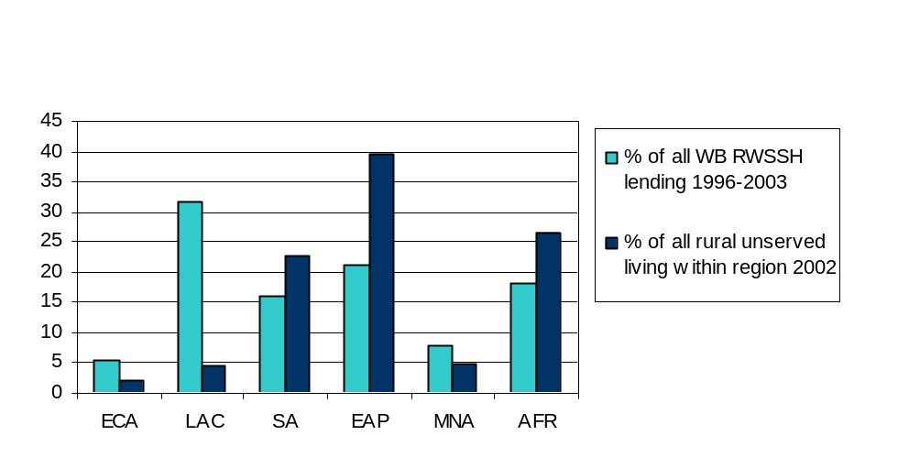
Sources: Review team analysis of WB data (lending), and
WHO-UNICEF Joint Monitoring Programme (access to water supply)

Bank staff and sector experts interviewed for the review cited a number of institutional and technical factors that have likely contributed to this finding. Some emphasized the low absorptive capacity in the rural water supply and sanitation sector in most African and some South and East Asian countries; others noted that the often stringent reform programs imposed by the Bank and other donors as prerequisites for aid have likely limited lending flows to those regions. In addition, lending to the East Asia and Pacific region dropped off during this period, most likely because of the regional macroeconomic crisis that began in 1997 (Figure 2).

Figure 2: Allocation of World Bank RWSSH Lending by time period and region (% )
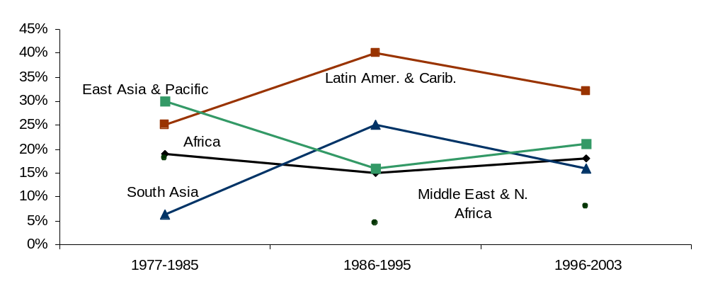

By contrast, respondents felt that the generally strong economic base and institutional framework found in many Latin American countries have facilitated lending from both a “demand” and a “supply” perspective. Bank lending for RWSSH in Latin America has also been comparatively more costly on a per-capita basis—the result of both higher unit costs and effective demand for higher levels of service—which also contributes to higher aggregate lending levels in that region.

Finally, several respondents noted that the relative allocation of Bank resources through loan (IBRD) versus IDA (credit) channels has also shaped the regional distribution of funding for RWSSH. Whereas a substantial proportion of rural populations that lack access to water supply and sanitation services live in large middle income countries that receive IBRD loans, the majority of rural unserved live in poorer, IDA countries.

3.2 Stand-alone and multi-sector operations
Bank lending for RWSSH is delivered through both stand-alone projects implemented under the Water Supply and Sanitation Sector Board, as well as through multi-sector operations mainly within agriculture, social funds, and rural development. Following a period of predominantly stand-alone RWSSH projects in the early 1980s, multi-sector approaches have claimed a steadily increasing share of Bank lending owing mainly to the introduction of Social Development Funds. Indeed, multi-sector operations currently account for two thirds of RWSSH lending (Figure 3).

Figure 3: World Bank lending in RWSSH by project type and period
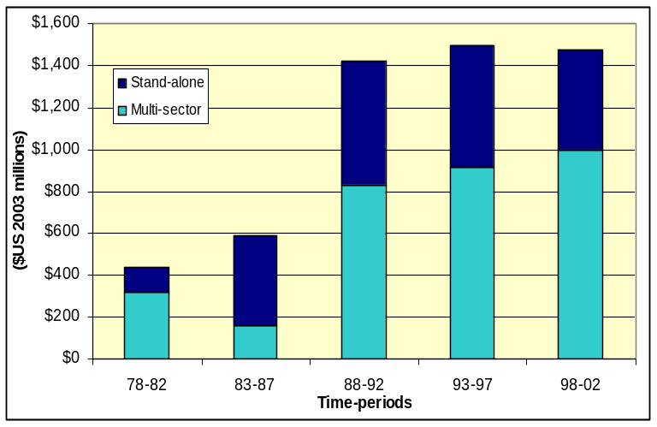

The first Bank projects in RWSSH were two stand-alone (“dedicated”) operations approved in 1978 for Paraguay and Nicaragua. Lending to stand-alone RWSSH projects grew throughout the 1980s from an average of one project per year to three projects by the 1990s.

Available data suggest regional preferences for stand-alone versus multi-sector approaches (Figures 4 and 5). The South Asia and East Asia regions of the Bank have been more likely to implement stand-alone projects, whereas RWSSH has been supported with multi-sector funds to a greater extent in the Bank’s Latin American region. Differences are most apparent during the late 1980s and early 1990s.

Figures 4 & 5: WB support to RWSSH, 1978-2003, by time period, region, and project type
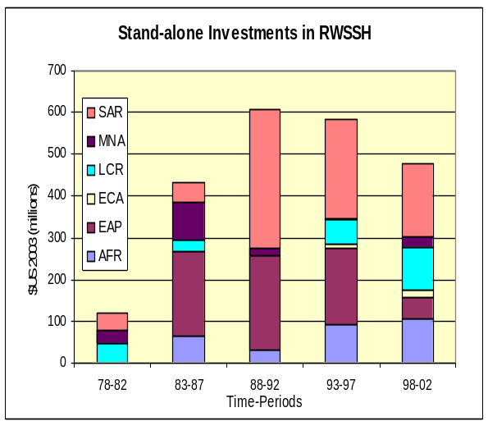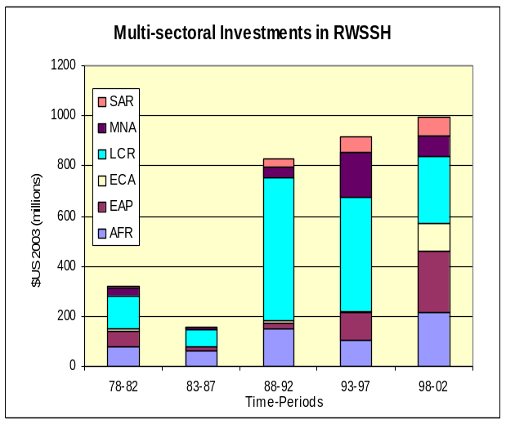

Whether multi-sector or stand-alone approaches to RWSSH lending have systematically better outcomes is a question that has been subject to periodic debate. One 2003 evaluation completed by the Bank’s Operations Evaluation Department (OED), for example, concluded that stand-alone rural and urban water and sanitation projects receive higher performance ratings because they “include objectives such as cost recovery, policy reform, private sector participation, and regulatory reform more frequently than non-dedicated projects do.” The findings of this current review, which are drawn from a larger sample of projects as compared to the OED study, do not corroborate these conclusions. For example, median values for the percentage of capital cost-sharing for water infrastructure are consistent at 15% across all three project types although the mean value is higher at just over 20% for stand-alone projects (Table 1). Cost sharing for operations and maintenance of installed infrastructure is also consistent across project types and is close to 100%.

Table 1: Capital cost sharing for water infrastructure (% of total cost), by project type
% capital cost sharing by users/ community | Stand-alone projects (n=14) | Social funds  (n=14) | Rural development projects (n=10) | All non-dedicated  (n=24)
Median  Mean  St. Dev. | 15  20  16 | 15  15  5 | 15  15  9 | 15  15  7

Additional discussion of the project elements for stand-alone and multi-sector projects is included in the sections on sustainability and scalability below. However, given the continuing debate within the donor community about the effectiveness and efficiency of various strategies for implementing RWSSH projects—as well as the continuing trend within Bank lending away from stand-alone toward multi-sector approaches—this topic would also seem to be an important element of future research into the conditions under which different RWSSH investment strategies are successful.

3.3 Sustainability
Target 10 of the Millennium Development Goals explicitly identifies the expansion of sustainable access to water supply and sanitation services, implicitly recognizing the persistent challenge of maintaining installed infrastructure that has plagued the water and sanitation sector, particularly in rural communities. Assessing the Bank’s experience with sustainability of rural water and sanitation projects over its 25 years of lending, however, is difficult because:
- RWSSH components of multisector projects are rarely evaluated individually, despite the fact that these operations represent more than two-thirds of total Bank lending in the sector;
- Only a small percentage of stand-alone RWSSH projects have been evaluated by the Operations Evaluation Department (OED);
- OED’s approach to assessing sustainability has changed during the period under review (Box 1), making analysis of trends questionable;
Box 1: OED sustainability ratings
The Operations Evaluation Department (OED) currently uses the following indicators to generate project sustainability ratings:
- Technical resilience
- Financial resilience (including cost recovery)
- Economic resilience
- Social support (including “safeguard policies”)
- Environmental resilience
- Government ownership (including by central governments/agencies, and availability of O&M funds)
- Other stakeholder ownership (including local participation, beneficiary incentives, civil society/NGOs, private sector)
- Institutional support (including legal/regulatory framework, organizational/management effectiveness)
- Resilience to exogenous influences (including terms of trade, economic shocks, regional political and security situations)
For more information, see http://oed.worldbank.org
- Available data is heavily skewed toward inputs (project design) as opposed to outcomes and impacts; and
- Attention to sustainability evaluations amongst Bank staff has increased over the period under review.

OED defines sustainability as “the resilience to risk of net benefits flows over time,” and sustainability ratings are meant to answer the questions: “At the time of evaluation, what is the resilience to risks of future net benefit flows? How sensitive is the project to changes in the operating environment? Will the project continue to produce net benefits, as long as intended or even longer? How well will the project weather shocks and changing circumstances?” Sustainability is evaluated by assessing the risks and uncertainties faced by a project and by ascertaining whether adequate arrangements are in place to help avoid known operational risks or to mitigate their impacts.

Analysis of sustainability for the Bank’s complete 25-year RWSSH portfolio using OED ratings is not formally possible, because the RWSSH component(s) of multi-sector projects are not evaluated independently. Each project, which could comprise lending for activities across a variety of sectors, receives a single set of sustainability scores. Moreover, in order to accurately assess sustainability of Bank-supported interventions, data collection—preferably through site visits of independent evaluators—at various points over the entire life of a project would be required. At present, many Implementation Completion Reports (ICRs) are completed within 12 months of project closing. Given Bank staff’s time and resource constraints, not every project can be evaluated directly, although period field-visits and assessments of projects do exist.

In sum, it is difficult to obtain comparable data on sustainability for stand-alone and multi-sector Bank-supported projects, and those (OED) data which are available provide only limited insight regarding long-term sustainability of RWSSH projects. The review effort did not include primary data collection in field and was thus limited to information available through desk reviews and a modes number of in-person interviews. The research team was thus limited in its assessment of portfolio sustainability to investigating the likely determinants of sustainability, rather than on direct assessments of whether the systems remained in place with adequate operation and maintenance. In particular, financial performance and institutional arrangements are two factors widely stressed to be of crucial importance for the sustainability of RWSSH interventions, and for which data were available for most projects in the review sample. The following sections thus provide a summary of such data for RWSSH projects in different time periods, across regions, and for all types of projects.

3.3.1 Cost sharing
It has been widely asserted that without adequate cost recovery, rural water supply and sanitation services will not be sustainable or replicable. Full cost recovery comprises funds for both the initial capital costs of facilities construction, as well as the costs of ongoing operation and maintenance (O&M). Irrespective of the source of funds, without adequate money, schemes are often not completed or fall into disrepair, thus negating any potential benefits to the community. In addition, many sector professionals consider that financial contributions by community members (for both capital and O&M costs) helps to create a sense of ownership that itself increases the chances of installed infrastructure being sustained in the long run.

At the World Bank, the concept of greater cost-recovery through user fees, together with granting communities greater voice in planning decisions and the choice of technologies and level of water supply and sanitation (W&S) services, has been termed the “demand-responsive approach” to W&S planning. The approach gained currency in the 1990s, with many other donors in the W&S sector adopting variations of the approach in their own W&S operations.

Interestingly, however, despite the relatively recent attention to “demand-oriented” project design in the water and sanitation sector, the review found that cost-sharing by users and communities for both capital and operation and maintenance costs (O&M) of installed infrastructure has actually been a consistent feature of Bank-supported RWSSH projects since the first operations in Ecuador and Paraguay in 1978 (Table 2). Over time the form of such cost-sharing has changed somewhat, with non-cash (e.g., labor and land) contributions becoming more common over time.

Table 2: User/community cost sharing in Bank-supported RWSSH projects
 |  | Period 1  77-85 | Period 2  86-95 | Period 3  96-03 | Over all time periods
 |  | Median % of capital costs contributed by users/communities
 |  | 15  (n=6) | 15  (n=16) | 15  (n=16) | 15  (n=38)
 | % of projects including capital cost contributions of indicated type
 | Cash | 100 | 100 | 94 | 98
 | Labor | 80 | 83 | 92 | 86
 | Materials | 60 | 78 | 85 | 78
 | Land | 40 | 61 | 69 | 61
 |  | Median % of operation and maintenance cost borne by users/communities
 |  | 100  (n=10) | 100  (n=23) | 100  (n=18) | 100  (n=51)

The pattern of capital cost sharing across different regions is generally consistent, with a few exceptions. Recognizing that the cell sizes for Table 3 are very small, the median cost-sharing rate for South Asian projects is 30%, whereas the median values for all other regions range between 10 and 15% of total capital costs.

Table 3: Cost sharing by communities (% of total costs), per project
Sub-Saharan Africa (AFR)  (n=12) | East Asia / Pacific (EAP)  (n=3) | East / Central Asia (ECA)  (n=3) | Latin Amer. / Caribbean (LAC)  (n=16) | Middle East / North Africa (MNA)  (n=6) | South Asia (SA)  (n=7)
Mean: 14.5  St. dev.: 8.2  Median: 12.5 | Mean: 26.3  St. dev.: 14.8  Median: 30.0 | Mean: 9.7  St. dev.: 0.6  Median: 10.0 | Mean: 21.8  St. dev.: 14.9  Median: 15.0 | Mean: 14.0  St. dev.: 6.5  Median: 10.0 | Mean: 15.7  St. dev.: 13.5  Median: 15.0

With respect to cost-sharing by communities for O&M of installed infrastructure, the data from sampled projects suggest that Bank-supported RWSSH have consistently called for a high level of recurrent cost sharing throughout the 25-year period under study (Table 4). It appears that right from the start of the first rural water and sanitation intervention; virtually all O&M expenses were expected to be borne by users or communities. Similarly, regional values for cost sharing in O&M are all close to 100% (data not shown).

Table 4: Cost sharing (percentage) for O&M by users/the community
Period 1:77-85  (n=10) | Period 2: 86-95  (n=23) | Period 3: 96-03  (n=18)
Mean: 100  St. Dev.: 0  Median: 100 | Mean: 97.8  St. Dev.: 13.4  Median: 100 | Mean: 100  St. Dev.: 0  Median: 100

3.3.2 Institutional roles
Analysis of the Bank’s RWSSH portfolio reveals an evolution in institutional arrangements for planning, financing, and managing rural water and sanitation services that mirrors changing attitudes throughout the sector. An increase in the diversity of institutional actors, as well as increasing reliance on community associations and private sector actors and a reduced role for central government, was documented (Figure 6).

Figure 6: Key actors in project design and planning, by time period (% of projects)
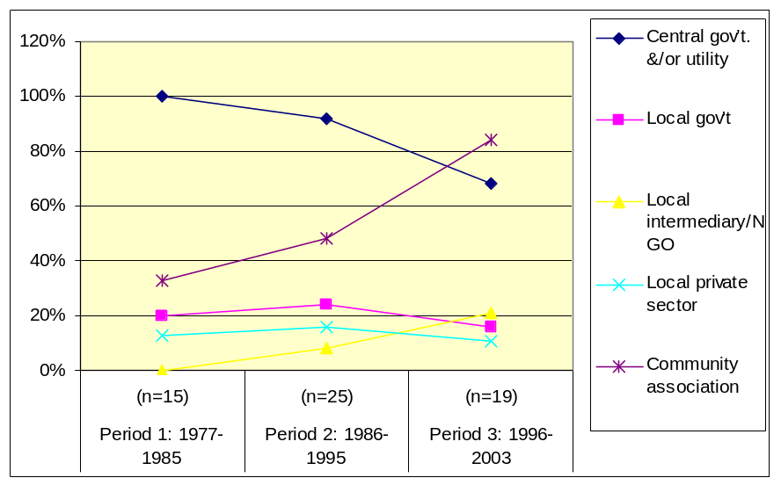
Similar trends over time are suggested when analyzing institutional roles during the post-construction phase of RWSSH projects (Table 5). Governments and utilities are less frequently considered “key actors” with responsibilities for operations and maintenance of infrastructure. Community associations and, to a lesser extent, local private sector and paid operators are playing an increasingly important role in O&M.

Table 5: Key actors in operations and maintenance of installed water infrastructure (% of projects)
 | Period 1: 77-85  (n=14) | Period 2: 86-95  (n=25) | Period 3: 96-03  (n=19) | All time periods  (n=58)
Government utility/board | 79% | 64% | 47% | 62%
Local intermediary/NGO | 7% | 12% | 5% | 9%
Local private sector | 0% | 8% | 11% | 7%
Paid operator | 14% | 24% | 26% | 22%
Community association | 57% | 68% | 74% | 67%
Note: Columns may sum to more than 100% because categories are not mutually exclusive.

Finally, the data suggest that ownership of installed RWSSH assets has increasingly moved into the hands of community associations, largely at the expense of ownership by central government (Figure 7).

Figure 7: Ownership of completed water supply assets (% of projects)
Govt utility
Local government
Community association
0%
10%
20%
30%
40%
50%
60%
70%
80%
Period 1:77-85
(n=12)
Period 2: 86-95
(n=25)
Period 3: 96-03
(n=19)
Regional trends
Some regional variation in the allocation of institutional responsibilities is observed (Table 6). For example, central governments have a somewhat less central role, and community organizations a more significant role, in projects implemented within the South Asia region. By contrast, no local private sector participation was reported among the SA projects included in the review sample, as compared to one third of ECA and MNA projects. Local government appeared as a key actor more frequently in the MNA, LAC, and SA regions, and less so in Africa and Eastern/Central Asia.

Table 6: Key actors in project design and planning (% of projects) by region: 1978-2003
 | Central gov’t./ utility | Local government | NGO/local intermediary | Local private sector | Comm. association
AFR (n=22) | 82 | 9 | 14 | 9 | 59
EAP (n=5) | 100 | 20 | 0 | 20 | 40
ECA (n=3) | 100 | 0 | 0 | 33 | 33
MNA (n=7) | 100 | 33 | 17 | 33 | 50
LAC (n=16) | 88 | 31 | 6 | 13 | 56
SA (n=7) | 71 | 29 | 14 | 0 | 71
Note: Rows may sum to more than 100% because categories are not mutually exclusive.

Regionally, considerable variation in the allocation of responsibility for operations and maintenance was documented (Table 7). Projects in the LAC, MNA, and SA regions have particularly high reliance on community involvement for O&M. More than half of projects in all regions except East Asia/Pacific include a principal role in operations and maintenance for the government utility or water board.

Table 7: Key actors in operation and maintenance of installed water infrastructure (% of projects)
 | AFR (n=22) | EAP (n=5) | ECA (n=3) | LAC (n=3) | MNA (n=6) | SA (n=7)
Gov’t utility/board | 59 | 40 | 100 | 67 | 67 | 57
NGO/local intermediary | 9 | 20 | 0 | 0 | 17 | 14
Local private sector | 5 | 20 | 0 | 0 | 33 | 0
Community Association | 55 | 60 | 33 | 87 | 83 | 71
Paid operator | 27 | 0 | 0 | 7 | 33 | 57
Note: Rows may sum to more than 100% because categories are not mutually exclusive.

Regarding ownership of assets, MNA, ECA and the Africa regions have a comparatively high rate of ownership by central governments (Figure 8). Legal ownership by local government was documented in projects within only four of the six regions. At least one half of projects in all regions except MENA report community ownership of installed systems.

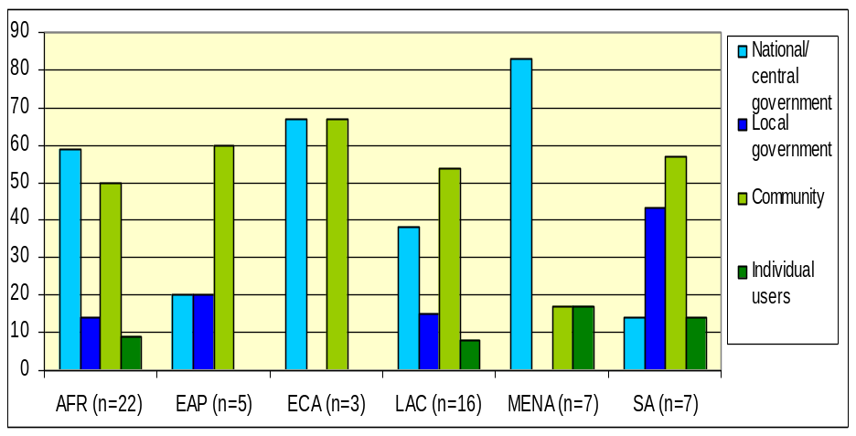
Figure 8: Ownership of water infrastructure assets per region (% of projects): 1978-2003

Stand-alone versus multi-sector projects
A comparison of different types of project instruments reveals a consistent pattern of central government/utility involvement in design and planning (Table 8). Stand-alone projects, however, appear to have greater local government involvement in planning; social funds report a higher rate of involvement by community groups. Rural development projects, by contrast, have predominantly limited participation in project design and planning to central governments and utilities.

Table 8: Key actors in project design and planning:
Percentage of projects by type of project, 1978-2003
 | Stand-alone projects (n=20) | Social funds (n=20) | Rural dev. projects (n=20) | All  multi-sector
Central government &/or utility | 90 | 80 | 90 | 85
Local government | 35 | 10 | 16 | 13
Local intermediary/NGO | 15 | 15 | 0 | 8
Local private sector | 20 | 15 | 5 | 10
Community association | 55 | 75 | 37 | 56
Note: Columns may sum to more than 100% because categories are not mutually exclusive.

Central governments and/or utilities play a more limited role in ongoing operations and maintenance of installed infrastructure across all project types (Table 9), but these institutions are still viewed as ‘key actors’ in more than half of the sampled projects in each category. A high percentage of stand-alone projects and social funds also identify community groups as key actors in O&M, compared with 44% of rural development projects. Indeed, the comparison in Table 9 highlights the potential, when analyzing all types of multi-sector project approaches in a single category, of overlooking substantial differences among them. In this example regarding institutional roles for O&M, for instances, social funds appear to have much more in common with stand-alone projects as compared to rural development projects.

Table 9: Key actors in O&M: Percentage of projects by type of project, 1978-2003
 | Stand-alone projects (n=20) | Social funds (n=20) | Rural dev. projects (n=20) | All  multi-sector
Central government &/or utility | 60 | 70 | 56 | 63
Local government | 5 | 5 | 17 | 11
Local intermediary/NGO | 15 | 0 | 6 | 3
Local private sector | 20 | 15 | 33 | 24
Community association | 70 | 85 | 44 | 66
Note: Columns may sum to more than 100% because categories are not mutually exclusive.

Summary
In sum, the frequency of both favorable evaluations for sustainability, as well as the inclusion of project design elements that are widely considered to be prerequisites for sustainability, have increased in Bank-supported RWSSH projects over time. For the reasons cited above, however, no causal relationship between these observations should be inferred. Indeed, the paucity of rigorous analysis into sustainability represents both a challenge and an opportunity for the Bank. In the absence of a solid understanding regarding how project design factors have influenced sustainability over time, on what basis can the Bank justify shifts in its approach to RWSSH lending (such as the current trend toward multi-sector, as opposed to stand-alone, projects)? From a broader perspective, the persistent challenges related to sustainability of donor operations in RWSSH suggest that this is an important puzzle that deserves attention within the Bank’s research agenda.

3.4 Scalability
Many of the task managers and team leaders interviewed by the research team emphasized the need to capitalize on the Bank’s 25 years of experience in RWSSH lending with more systematic and operationally linked research into the determinants of sustainability and other elements of project success. Several also mentioned the need to examine rigorously the issue of scaling up successful projects to regional and national levels. It has been estimated, for example, that achieving the Millennium Development Goals for water supply would require providing 280,000 individuals—most of whom live in rural areas—with access to improved water services every day for the next twelve years. Given this immense challenge, the extent to which a project can expand and/or influence future operations (e.g., by introducing new policy tools) at regional or national scale has become a topic of increasing importance to multi and bi-lateral donors, NGOs, and other national stakeholders.

The term “scaling up” is used with a variety of meanings. A recent discussion paper by the World Bank defines the concept as having two basic elements:
- Inclusion: the vast majority of the target population is provided with sustainable, improved services within a reasonable time frame. Inclusion should not necessarily be equated with full coverage, and
- Institutionalization: a system of actors and institutions (public, private, and/or civic) is in place with the necessary capacity and resources to deliver sustainable RWS services indefinitely’

Despite the relatively recent emergence of a sector dialogue on “scalability,” Bank project data do not suggest major shifts in the extent to which scaling up has been considered in project design over the past 25 years (Table 10). Although the percentage of projects in which scaling up was reported to be a “major project objective” does appear to have increased over time, the share of projects in which it was “not at all considered” in planning and design shows a similar increase.

Table 10: Extent to which ‘scalability’ was considered in project design (% of projects)
 | Period 1: 77-85  (n=13) | Period 2: 86-95  (n=24) | Period 3: 96-03  (n=18) | All periods  (n=55)
Not at all considered in planning/design | 38.5 | 33.3 | 44.4 | 38.2
Desirable outcome, but no planning | 15.4 | 20.8 | 11.1 | 16.4
Some planning, but not main objective | 30.8 | 20.8 | 16.7 | 21.8
Main project objective | 30.8 | 33.3 | 44.4 | 36.3

The findings in Table 10 may be explained somewhat by the recent increase in share of multi-sector project approaches within the Bank’s RWSSH portfolio. As shown in Figure 9 a substantially smaller percentage of social fund and rural development projects reported considering scalability as a primary or secondary objective (50-56%) as compared to stand-alone projects (89%).

Figure 9: Scalability as an objective in project design (percentage of projects)
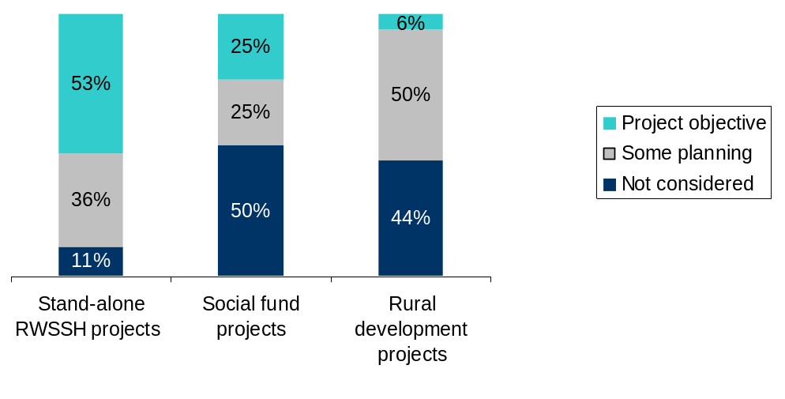
Regionally, the data from sampled projects suggest that RWSSH interventions in East Asia have a clear emphasis on scaling-up, with three-quarters including scalability as primary or secondary project objective (Table 11). Interventions in the South Asia and Latin America region also seem to devote attention achieving results on a larger scale. By contrast, in at least one half of sampled projects in the ECA and MNA regions, scaling up was not at all considered to be a project objective.

Table 11: Extent to which ‘scalability’ considered in project design (% of projects), by region
 | Not at all considered | Desired outcome but no planning | Planned for but not main objective | Main project objective
AFR (n=20) | 40 | 20 | 25 | 15
EAP (n=4) | 0 | 25 | 25 | 50
ECA (n=3) | 67 | 0 | 33 | 0
MNA (n=6) | 50 | 17 | 17 | 34
LAC (n=15) | 33 | 20 | 27 | 40
SA (n=7) | 43 | 0 | 0 | 57

Summary
The still inchoate discussion of scaling up among sector experts provides an opportunity for the Bank to make important contributions to understanding the conditions under which project lending leads to broader impacts and increased access to services among rural communities. Such work might also ultimately enable the development of “scalability” criteria that could be included within project evaluation processes at the Bank with the aim of maximizing impact of RWSSH lending.

3.5 Sanitation and hygiene
Whereas this review was nominally intended to survey Bank experience with water supply, sanitation, and hygiene in rural areas over the past 25 years, in reality this portfolio has been dominated by water (Figure 10). The percentage of Bank-supported RWSSH projects that include sanitation has doubled during the period 1978-2003, but is currently only about 60%. The share of projects that include a hygiene component has remained essentially unchanged at 20%. Across all regions, sanitation components within Bank-supported RWSSH projects receive just three percent of the total project funds on average. Hygiene activities claim less than one percent of lending (Figure 11).

Figure 10: Percentage of Bank-supported RWSSH projects with
sanitation and hygiene components, by time period
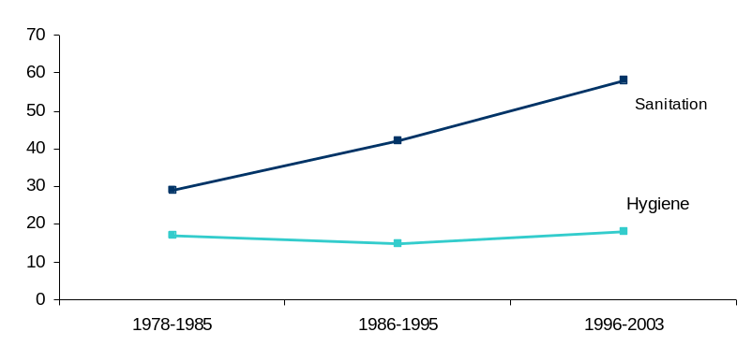

Figure 11: Percentage of RWSSH lending allocated to sanitation & hygiene, by region, 1978 - 2003
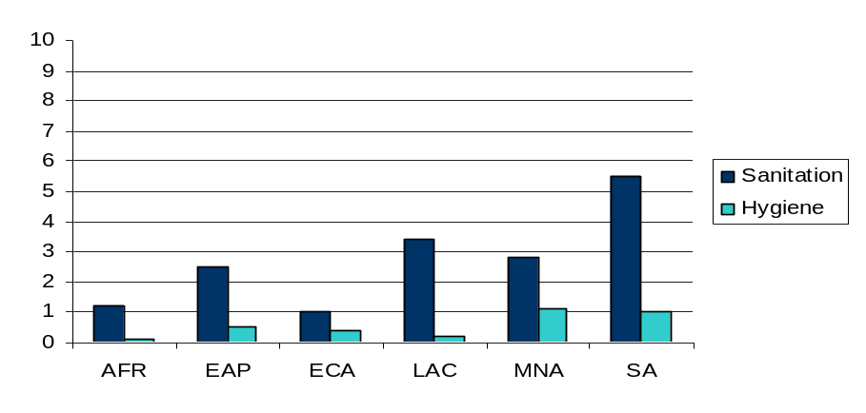
Figure 12 disaggregates these data between dedicated and multi-sector projects and suggests that, since 1986, multi-sector projects have been less likely to include sanitation or hygiene activities within rural water projects as compared to stand-alone projects. Such findings might be further pursued as part of a broader investigation regarding the strengths and shortcomings of different project approaches.

Figure 12: Percentage of stand-alone and multi-sector projects
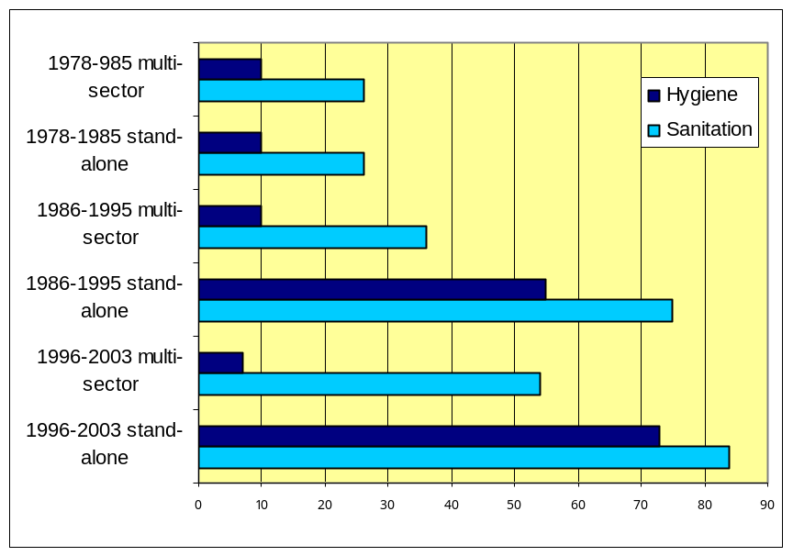with sanitation and hygiene components, by time period

The review did find evidence that the Bank has been willing to work with governments to experiment with alternative approaches to sanitation. These include supplanting central government subsidies with locally administered subsidies, social marketing programs, engagement with NGOs, and promoting household-level investments (Figure 13).

Figure 13: Approaches to sanitation utilized in Bank-supported
RWSSH projects, by time period (percentage of projects)
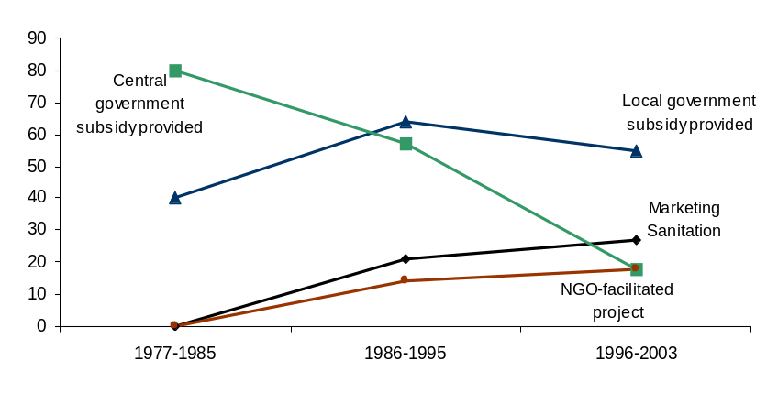

Along with increased diversity in institutional arrangements for sanitation and hygiene, Bank-supported RWSSH projects have also broadened the range of technologies being offered (Figure 14). Review of project-level documents reveals that such diversity increasingly occurs within, not merely among projects, reflecting a greater degree of choice for households and communities.

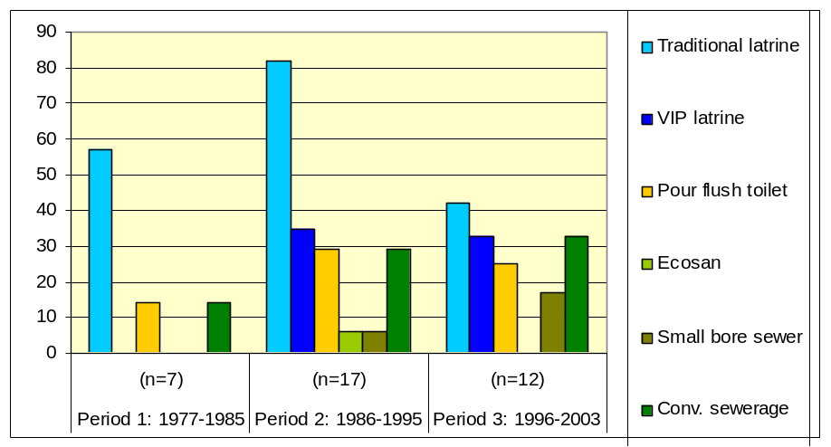Figure 14: Types of sanitation technologies offered (% of projects within time period

4. Conclusions

Lending an average of US$220 million each year during the 25-year period of 1978-2003, the World Bank has been a key actor in rural water supply, sanitation, and hygiene. The wealth of experience gained during this period provides a basis for continuing leadership in the sector, as well as an opportunity to explore critical questions about maximizing both sustainability and impact at scale within RWSSH operations.

The Bank has the potential to accelerate improvements to the quality and impact of its RWSSH portfolio, particularly if it endeavors to:
- Investigate and address factors which may be limiting RWSSH lending and achievement of the MDGs in Africa, East Asia, and Southeast Asia.
- Encourage more rigorous and longer-term sustainability assessments of RWSSH projects that are linked to practice and whose findings are used to shape new programs. Implement related organizational policy changes that promote greater attention to sustainability, such as revising project cycle budgeting so as to allocate more resources toward post-implementation project assessment (as has been done by the German government).
- Move scalability up the agenda, including developing a clear definition and monitoring process. Despite a recognized need to address scalability in the sector, no organization has operationalized the concept (e.g., through the development of indicators).
- Work with partners to optimize their leadership competencies in key areas of the sector, particularly with respect to sanitation and hygiene.

The Bank also has the opportunity to maintain its position as a “thought leader” in RWSSH, and to make major contributions to the understanding of both sustainability and scalability of interventions in the sector, if it is prepared to:
- Undertake a program of rigorous empirical (field-based) studies to examine the long-term sustainability and scale impact of operations and the conditions under which different lending strategies—including stand-alone and multi-sector approaches—are most likely to be successful.
- Modify existing monitoring and evaluation systems to ensure that they generate key information on design inputs, implementation experience, and sustainability and scalability outcomes. Such efforts might entail working with partners to develop cost-effective and practical indicators and guidelines for their use; testing and calibration of such indicators through rigorous field work across a sample of Bank supported projects; and, eventually, revamping monitoring systems across the Bank (including those tracking multi-sector lending) to ensure that data are reported in a consistent, regular, and timely manner.
- Continue strengthening its capacity in the area of rural sanitation and hygiene through sustained support of the recently established Sanitation, Hygiene, and Wastewater Advisory Service. The utility of establishing learning networks with related sectors such as education and health might also be explored.
The Bank has 25 years of experience as the leading international financier of rural water supply, sanitation and hygiene. This review revealed the depth of experience and valuable lessons which have been learned over the years. With some additional research efforts this experience could be converted
Annex 1: The Millennium Development Goals
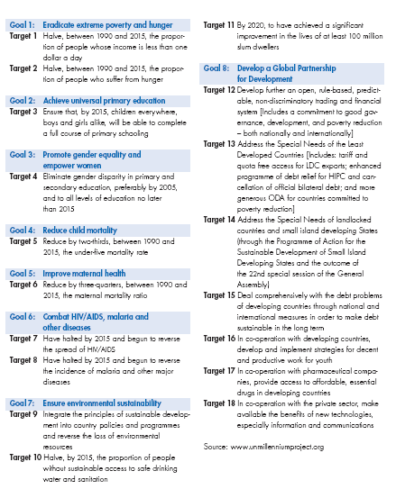

Annex 1: General references

Black, M. (1998), Learning what works: A twenty year retrospective view on international water and sanitation cooperation, UNDP-World Bank, Washington D.C.
Cairncross, S. (1992), Sanitation and Water Supply: practical lessons from the decade, UNDP-World Bank, Washington D.C.
Churchill, A.A. with D. Ferranti, R. Roche, C. Tager, A. Walters and A. Yazer (1987), Rural Water Supply and Sanitation – Time for a Change, World Bank Discussion Papers Nr. 18, World Bank Group, Washington D.C.
Davis, J. and Iyer, P. (2002), Taking Sustainable Rural Water Supply Services to Scale: A Discussion Paper, Bank Netherlands Water Partnership – Water and Sanitation Program, Washington D.C.
DFID (1998), Guidance Manual on Water Supply and Sanitation Programmes, Department for International Development/Water and Environment at London and Loughborough, London.
Hodgkin J. and WASH Project Staff (1994), The Sustainability of Rural Water Supply Projects, WASH Technical Report No. 94.
Mukherjee, N. and van Wijk, C. eds. (2003), Sustainability Planning and Monitoring in Community Water Supply and Sanitation, Water and Sanitation Program/IRC
IRC Thematic Group on Scaling up of community-managed rural water supply; www.irc.nl/scalingup 2003
IRC (2001), From system to service: scaling up community management Report on the conference, 12-13 December, The Hague, The Netherlands, Report, Unpublished document, IRC International Water and Sanitation Centre, Delft, The Netherlands
Rawlings, L.B., Sherburne-Benz, L., and van Domelen, J. (2004), Evaluating Social Funds: A Cross-Country Analysis of Community Investments’, The World Bank, Washington D.C.
Sara, J., Katz, T. (1998), Making Rural Water Supply Sustainable: Report on the Impact of Project Rules, World Bank, Washington D.C.
Water and Sanitation Program – Africa (2002), Water Supply and Sanitation in PRSP Initiatives: A Desk Review of Emerging Experience in Sub-Saharan Africa (SSA).
Water and Sanitation Program – Africa (2004), The Case for Marketing Sanitation.
White, G.F., D.J. Bradley, A.U. White (1972), Drawers of Water – Domestic Water Use in East Africa, University of Chicago Press, Chicago and London.
World Bank (2000), Rural Water Projects: lessons from OED evaluations, Operations Evaluation Department Working Paper Series 21096; World Bank, Washington D.C.
World Bank (2002), Social Funds: Assessing Effectiveness, Operations Evaluation Department; World Bank, Washington D.C.
World Bank (2003), Efficient Sustainable Services for All? An OED Review of the World Bank’s Assistance to Water Supply and Sanitation, Operations Evaluation Department.
World Bank (2004), OED Review of the Poverty Reduction Strategy Process, Operations Evaluation Department, Washington D.C.
World Bank, Sanitation, Health and Hygiene in World Bank Rural Water Supply and Sanitation Projects, Europe and Central Asia Regional Studies Program.
World Bank/BNWP (2002), Rural Water Supply and Sanitation Toolkit for Multi-sector Projects, Rural Water Supply and Sanitation, and Social Funds Thematic Groups.

Annex 2: World Bank project documents reviewed

Arid Lands Resource Management Project, Kenya, 2003, ICR Report No: 27560.
Arid Lands Resource Management Project, Kenya, 1995, SAR Report No: 13692-KE.
Rural Water Supply and Sanitation Project, China, 1992, SAR Report No: 10028-CHA.
Review of the Bank’s Assistance to the Urban Water Supply and Wastewater Sector, China, 2002, Report No: 24979.
Rural Water Supply and Sanitation Project, China, 1999, ICR Report NO: 19475.
Rural Water Supply Project, China, 1994, PPAR Report No: 13281.
Rural Water Supply Project, China, 1992, PCR Report No: 11251.
Rural Water Supply Project, China, 1985, SAR Report No: 5358-CHA.
Rural Water and Sanitation Project, Bolivia, 2002, ICR Report No: 23133.
Rural Water and Sanitation Project, Bolivia, 1995, SAR Report No: 14490-BO.
Lower Shire Valley Agricultural Development Projects, Malawi, 1983, Impact Evaluation Report, Report No: 4850.
Shire Valley Agricultural Consolidation Project, Malawi, 1986, PPAR Report No: 6171.
Shire Valley Agricultural Consolidation Project, Malawi, 1978, SAR Report No: 1945-MAI.
Rural Rehabilitation Project, Mozambique, 2001, ICR Report No: 22446.
Rural Rehabilitation Project, Mozambique, 1993, SAR Report No: 11474-MOZ.
Technical Assistance and Pilot Rural Water Supply and Sanitation Project, Brazil, 1993, PCR Report No:11549.
Technical Assistance and Pilot Rural Water Supply and Sanitation Project, Brazil, 1985, SAR Report No: 5438-BR.
Rural Water Supply Project, Zambia, 1992, PCR Report No: 10723.
Rural Water Supply Project, Zambia, 1983, SAR Report No: 4175-ZA.
Social Investment Project, Guatemala, 1992, SAR Report No: 11060-GU.
Social Investment Project, Guatemala, 1999, ICR Report No: 19459.
Small Rural Operations Project, Senegal, 1980, SAR Report No: 2700a-SE.
Small Rural Operations Project, Senegal, 1995, PPAR Report No: 14765.
Small Rural Operations Project, Senegal, 1991, PCR Report No: 9332.
Rural Poverty Alleviation Project -Bahia, Brazil, 2001, ICR Report No: 23395.
Northeast Rural Poverty Alleviation Program – Rural Poverty Alleviation Project – Bahia, Brazil, 1995, SAR Report No: 14390-BR.
Bihar Plateau Development Project, India, 2001, ICR Report No: 21798.
Bihar Plateau Development Project, India, 1992, SAR Report No: 10974-IN.
Northeast Brazil Ceara Rural Development Project, Brazil, 1977, SAR Report No: 1580a-BR.
Project Performance Audit Report – Brazil: Supporting Rural Development in the Northeast, Ceara Rural Development Project – Ibiapaba, Paraiba Rural Development Project – Brejo, Pernambuco Rural Development Project – Agreste Setentrional, Brazil, 1989, PPAR Report No: 7910.
Ceara Second Rural Development Project, Brazil, 1990, PCR Report No: 8380.
Northeast Brazil Ceara Second Rural Development Project, Brazil, 1980, SAR Report No: 3020a-BR.
Ceara Second Rural Development Project, Brazil, 1992, PPAR Report No: 10636.
Fes-Karia-Tissa Agriculture Project, Morocco, 1992, PCR Report No: 10808.
Fes-Karia-Tissa Agriculture Project, Morocco, 1978, SAR Report No: 2017-MOR.
Fes-Karia-Tissa Agriculture Project, Morocco, 1994, PPAR Report No: 12701.
Kerala Water Supply and Sanitation Project, India, 1998, PPAR Report No: 17922.
Kerala Water Supply and Sanitation Project, India, 1985, SAR Report No: 5397-IN.
Kerala Water Supply and Sanitation Project, India, 1995, ICR Report No: 14783.
Rural Water Supply Project, Burundi, 1985, SAR Report No: 5445-BU.
Water Supply Sector Project, Burundi, 1991, SAR Report No: 9185-BU.
Social Investment Fund, Belize, 2003, ICR Report No: 25398-BZ.
Social Investment Fund, Belize, 1997, PAD Report No: 16310-BEL.
Rural Water Supply Project, Mali, 1983, SAR Report No: 4402-MLI.
Rural Water Supply Project, Mali, 1995, PCR Report No: 15148.
Rural Water Supply Project, Mali, 1997, PPAR Report No: 16511.
Social Action Fund Project, Malawi, 1996, SAR Report No: 15345-MAI.
Social Action Fund Project, Malawi, 2002, ICR Report No: 24017.
Economic and Social Fund Project, Haiti, 1990, SAR Report No: 9058-HA.
Mutara Agricultural and Livestock Development Project – Phase II, Rwanda, 1991, PCR Report No: 9829.
Mutara Agricultural and Livestock Development Project – Phase II, Rwanda, 1979, SAR Report No: 2221-RW.
Third Social Development Fund - Social Investment Fund, Ecuador, 1994, SAR Report No: 12436-EC.
Third Social Development Fund, Ecuador, 2000, ICR Report No: 19997.
NWFP Community Infrastructure and NHA Strengthening Project, Pakistan, 1996, SAR Report No: 15341-PAK.
NWFP Community Infrastructure and NHA Strengthening Project, Pakistan, 2003, ICR Report No: 27496.
Community Action Project, Zimbabwe, 1998, PAD Report No: 17115-ZIM.
Community Action Project, Zimbabwe, 2004, ICR Report No: 28811.
Project to Support Grassroots Initiatives to Fight Hunger and Poverty, Mali, 2004, ICR Report No: 28408.
Project to Support Grassroots Initiatives to Fight Hunger and Poverty, Mali, 1998, SAR Report No: 17342.
Community Reintegration and Rehabilitation Project, Sierra Leone, 2003, ICR Report No: 27263.
Water Supply and Sanitation for Low Income Communities Project, Indonesia, 1993, SAR Report No: 11777.
Water Supply and Sanitation Project for Low-Income Communities, Indonesia, 2001, PPAR Report No: 22395.
Small Towns Water and Sanitation Project, Uganda, 1994, SAR Report No: 12296-UG.
Small Towns Water and Sanitation Project, Uganda, 2003, ICR Report No: 27529.
Water Supply and Sanitation Project for Low Income Communities Project, Indonesia, ICR Report No: 20420.
Tarim Water Supply Project, Yemen, 1990, SAR Report No: 8362-YDR.
Tarim Water Supply Project, Yemen, 1999, ICR Report No: 19946.
Rural Water and Sanitation Project, Morocco, 1997, PAD Report No: 17005-MOR.
Rural Water Supply and Sanitation Project, Morocco, 2003, ICR Report No: 25917.
Pilot Public Health Management Project, Algeria, 1995, PCN Report No: 15219.
Pilot Public Health Management Project, Algeria, 1991, SAR Report No: 8916-AL.
Shaanxi Agricultural Development Project, China, 1989, SAR Report No: 7475-CHA.
Shaanxi Agricultural Development Project, China, 1998, ICR Report No: 18127.
Shaanxi Agricultural Development Project, China, 2000, PPAR Report No: 20683.
Second Water Supply Project, Rwanda, 1987, SAR Report No: 6602-RW.
Second Water Supply Project, Rwanda, 1999, ICR Report No: 19521.
Southern Conveyor Project for Water Resources Development, Cyprus, 1988, SAR Report No: 6649.
Southern Conveyor Project for Water Resources Development, Cyprus, 1997, ICR Report No: 16820.
Emergency Drought Recovery Project, Sudan, 1992, SAR Report No: P-5578.
Emergency Drought Recovery Project, Sudan, 1996, ICR Report No: 15792.
Agricultural Sector Investment Loan, Tunisia, 1994, SAR Report No: 12229.
Agricultural Sector Investment Loan, Tunisia, 2001, ICR Report No: 22291.
Agricultural Sector Investment Loan, Tunisia, 2003, PPAR Report No: 26260.
Village Infrastructure Project, Indonesia, 1995, SAR Report No: 13776.
Village Infrastructure Project, Indonesia, 1999, ICR Report No: 19099.
Village Infrastructure Project, Indonesia, 2000, PPAR Report No: 21546.
Benin Borgou Pilot Rural Support Project, Benin, 1998, PAD Report No: 17654.
Benin Borgou Pilot Rural Support Project, Benin, 2002, ICR Report No: 24797.
Benin Borgou Pilot Rural Support Project, Benin, 2003, PPAR Report No: 26087.
Social Recovery Project, Zambia, 1991, SAR Report No: 9471.
Social Recovery Project, Zambia, 1999, ICR Report No: 18864.
Social Recovery Project, Zambia, 2000, PPAR Report No: 20673.
Second Social Recovery Project, Zambia, 1995, SAR Report No: 14329.
Second Social Recovery Project, Zambia, 2001, ICR Report No: 22047.
Community Development Fund Project, Eritrea, 1996, SAR Report No: 14937.
Community Development Fund Project, Eritrea, 2002, ICR Report No: 22694.
Community Development Fund Project, Eritrea, 2002, PPAR Report No: 24418.
Social Investment Fund Project, Armenia, 1996, SAR Report No: 14655.
Social Investment Fund Project, Armenia, 2001, ICR Report No: 22077.
Social Fund for Development, Yemen, 1997, PAD Report No: 16301.
Social Fund for Development, Yemen, 2003, ICR Report No: 27194.
Third Social Fund, Madagascar, 1999, PAD Report No: 18967.
Third Social Fund, Madagascar, 2003, ICR Report No: 25649.
Northeast Rural Development Program, Sergipe, Rio Grande Do Norte, Bahia and Ceara Projects, Brazil, 1996, ICR Report No: 16191.
Northeast Rural Development Program, Northeast Rural Development II Project, Brazil, 1985, SAR Report No: 5349-BR.
Community Works Project, Albania, 1998, PAD Report No: 18468 ALB.
Community Works Project, Albania, 2002, ICR Report No: 25260.
Second Social Development and Compensation Fund Project, Peru, 2001, ICR Report No: 22019-PE.
Second Social Development and Compensation Fund Project, Peru,, 1996, SAR Report No: 15497-PE.
Third Water Supply and Sanitation Project, Paraguay, 1992, SAR Report No: 10684-PA.
Third Water Supply and Sanitation Project, Paraguay, 1999, ICR Report No: 19180.
Uttar Pradesh and Uttaranchal Rural Water Supply and Environmental Sanitation (SWAJAL) Project, India, 2003, ICR Report No: 27288.
Uttar Pradesh and Uttaranchal Rural Water Supply and Environmental Sanitation (SWAJAL) Project, India, 1996, SAR Report No: 15516-IN.
Rural Water Supply and Sanitation Project, Pakistan, 2001, ICR Report No: 21867.
Rural Water Supply and Sanitation Project, Pakistan, 1991, SAR Report No: 8345-PAK.
Karnataka Rural Water Supply and Environmental Sanitation Project, India, 1993, SAR Report No: 11450-IN.
Karnataka Rural Water Supply and Environmental Sanitation Project, India, 2001, ICR Report No: 22012.
Rural Water Supply and Sanitation Project, Nepal, 1996, SAR Report No: 15232-NEP.
Rural Water Supply and Sanitation Project, Nepal, 2004, ICR Report No: 28523.
Second Rural Development Fund (FSAR) Project, Cameroon, 1985, SAR Report No: 4780-CM.
Second Development Fund Project, Cameroon, 1996, PCR Report No: 15660.
Second Social Investment Fund Project, Nicaragua, 1995, Memorandum and Recommendation of the President of the IDA, Report No: P-6569-NI.
Second Social Investment Fund Project, Nicaragua, 1998, ICR Report No: 18657.
Social Investment Fund II – Rural Water and Sanitation Project, Bolivia, 2002, PPAR Report No: 24158.
Rural Water Supply and Sanitation Project, Benin, 2001, ICR Report No: 22461.
Rural Water Supply and Sanitation Project, Benin, SAR Report No: 12860-BEN.
Second Water Supply Project, Rwanda, 1987, SAR Report No: 6602 RW.
Second Water Supply Project, Rwanda, 1999, ICR Report No: 19521.
Social Investment Fund Project, Honduras, 1991, SAR Report No: 9148-HO.
Social Investment Fund Project, Honduras, 1994, PCR Report No: 13573.
Social Fund Project, Egypt, 1991, SAR Report No: 9561-EGT.
Social Fund Project, Egypt, 1997, ICR Report No: 17248.
Social Fund for Development Project, Yemen, 2003, ICR Report No: 27194.
Social Fund for Development Project, Yemen, 1997, PAD Report No: 16301 YEM.
Rural Sanitation Project, Nicaragua, 1988, PCN Report No: 7527.
Rural Sanitation Project, Nicaragua, 1977, SAR Report No: 1753a-NI.
Rural Water Supply Project, Rural Water Supply and Sanitation Project II-III – Impact Evaluation Report - Community-based Rural Water Systems and the Development of Village Committees, Paraguay, 1998, Operations Evaluation Department, Report No: 17923.

Annex 2: Interviews completed

The authors interviewed a number of task team leaders and other World Bank staff between October 2004 and February 2005, including:
Raja Rehan Arshad
Alexander Bakalian
Caroline van den Berg
Chris Cornelius
Yasser El Gammel
Wambui Gichuri
Midori Makino
Anna Sant Anna
David Steel
Tashi Tenzing
Andrea Vermehren
Richard Verspyk
David Warren

Annex 3: Sample frame

3.A: Known population of stand-alone (“dedicated”) Bank-supported
rural water supply, sanitation, and/or hygiene projects
1. Estimated Population of Stand-alone Rural Water, Sanitation and Hygiene Projects (n=53)
FY78 | LCR | Paraguay | P007867 | Rural Water Project
FY78 | LCR | Nicaragua | P007759 | Rural Sanitation Project
FY80 | SAR | India | P009770 | Rajasthan Water Supply and Sewerage Project
FY81 | LCR | Paraguay | P007874 | Second Rural Water Project
FY82 | MNA | Tunisia | P005648 | National Rural Water Supply Project
FY83 | AFR | Zambia | P003184 | Rural Water Supply Project
FY83 | EAP | Philippines | P004497 | Rural Water Supply Project
FY84 | AFR | Mali | P001715 | Water Supply I
FY84 | MNA | Tunisia | P005659 | Rural Water Supply Project
FY84 | SAR | India | P009827 | Tamil Nadu Water Supply Project
FY85 | EAP | China | P003438 | Rural Water Supply Project
FY85 | LCR | Brazil | P006359 | Rural Water Supply and Sanitation Pilot
FY86 | AFR | Burundi | P000192 | Water Supply II
FY86 | SAR | India | P009858 | Kerala Water supply Project
FY87 | AFR | Rwanda | P002222 | Water Supply II
FY90 | EAP | Philippines | P004561 | Water Supply, Sewerage and Sanitation Project
FY90 | MNA | Yemen, Republic of | P006206 | Tarim Water Project
FY91 | SAR | India | P010369 | Maharashtra Rural Water Supply Project
FY91 | SAR | Pakistan | P010366 | Rural Water Project
FY92 | AFR | Burundi | P000217 | Water Supply Sector Project
FY92 | EAP | China | P003587 | Rural Water Supply and Sanitation Project
FY93 | EAP | Indonesia | P003990 | Indonesia – WSSLIC I
FY93 | LCR | Paraguay | P007920 | Third Rural Water Supply and Sanitation Project
FY93 | SAR | India | P010418 | Karnataka Rural Water Supply and Environmental Sanitation Project
FY93 | SAR | Sri Lanka | P010409 | Community Water Supply and Sanitation Project
FY94 | AFR | Benin | P000121 | Rural Water Supply and Sanitation Project
FY94 | AFR | Ghana | P000924 | Community Water and Sanitation Project
FY94 | AFR | Uganda | P002957 | Small Towns Water and Sanitation Project
FY96 | LCR | Bolivia | P006206 | Rural Water and Sanitation Project
FY96 | LCR | Venezuela | P008224 | Monagas Water Project
FY96 | SAR | India | P010484 | Uttar Pradesh & Uttaranchal Rural Water
FY97 | EAP | China | P003637 | Naitonal Rural Water Supply Project
FY97 | ECA | Turkmenistan | P008867 | Water Supply and Sanitation Project
FY97 | MNA | Yemen, Republic of | P043367 | RY – Taiz Water Project
FY97 | SAR | Nepal | P010516 | Rural Water and Sanitation Project
FY98 | AFR | Madagascar | P001564 | Rural Water Supply and Sanitation Pilot Project
FY98 | ECA | Uzbekistan | P009121 | Rural Water Supply and Health Project
FY98 | LCR | Paraguay | P039983 | 4th Rural Water Supply and Sanitation Project
FY98 | MNA | Morocco | P040566 | Rural Water Supply and Sanitation Project
FY99 | EAP | China | P057352 | 4th Rural Water Supply Project
FY00 | AFR | Ghana | P050616 | Second Community Water and Sanitation Project
FY00 | AFR | Nigeria | P064008 | Small towns Water and Sanitation Program Pilot Project
FY00 | AFR | Rwanda | P045182 | RW- Rural Water Supply and Sanitation Project
FY00 | EAP | Indonesia | P059477 | Indonesia – WSSLIC II
FY01 | LCR | Ecuador | P049924 | EC Rural Water Supply and Sanitation
FY01 | MNA | Yemen, Republic of | P005906 | Rural Water Supply and Sanitation Project
FY01 | SAR | India | P055454 | Kerala Rural Water Supply and Environmental Sanitation Project
FY02 | AFR | Tanzania | P047762 | Rural Water Supply and Sanitation Project
FY02 | ECA | Kyrgyz Republic | P036977 | Rural Water and Sanitation Project
FY02 | LCR | Colombia | P065937 | Water Sector Reform Assistance Project
FY02 | SAR | India | P050653 | Second Karnataka Rural Water Supply and Sanitation Project
FY03 | SAR | Sri Lanka | P058067 | Second Community Water and Sanitation Project
FY03 | LCR | Peru | P065256 | National Rural Water Supply and Sanitation Project

3.B: Known population of multi-sector Bank-supported projects
with rural water supply, sanitation, and/or hygiene components
2. Estimated Population of Multi-sector Rural Water, Sanitation and Hygiene Projects (n=344)
FY78 | AFR | Cameroon | P000340 | ZAPI Integrated Rural Development Project
FY78 | AFR | Cameroon | P000341 | Western Highlands Rural Development Project
FY78 | AFR | Chad | P000493 | Sahelian Zone Project
FY78 | AFR | Malawi | P001604 | Shire Valley Agricultural Consolidation Project
FY78 | AFR | Tanzania | P002712 | Shinyanga Rural Development Project
FY78 | EAP | Korea, Republic of | P004078 | Second Rural Infrastructure Project
FY78 | EAP | Philippines | P004454 | First Rural Infrastructure Project
FY78 | ECA | Cyprus | P008349 | Pitsilia Integrated Rural Development Project
FY78 | LCR | Bolivia | P006130 | Ulla Ulla Development Project
FY78 | LCR | Brazil | P006285 | Paraiba Rural Development Project
FY78 | LCR | Brazil | P006286 | Ceara Rural Development Project
FY78 | LCR | Brazil | P006287 | Bahia Rural Development Project
FY78 | LCR | Colombia | P006751 | Integrated Nutrition Project
FY78 | MNA | Morocco | P005381 | Kes-Faria-Tissa Agriculture Project
FY78 | MNA | Yemen, Republic of | P005768 | Tihama Development Project II
FY78 | MNA | Yemen, Republic of | P005855 | Wadi Tuban Agriculture Development Project
FY78 | SAR | India | P009727 | Andhra Pradesh Fisheries Project
FY79 | LCR | Brazil | P006302 | Water Supply and Sewerage Project
FY79 | MNA | Tunisia | P005632 | Fifth Water Supply Project
FY79 | AFR | Rwanda | P002200 | Second Mutara Agricultural and Livestock Development Project
FY79 | ECA | Greece | P008434 | Integrated Forestry Development Project
FY79 | LCR | Bolivia | P006133 | Omasuyos – Los Andes Rural Development Project
FY79 | LCR | Brazil | P006294 | Sao Francisco II Irrigation Project
FY79 | LCR | Brazil | P006295 | Pernambuco Rural Development Project
FY79 | LCR | Ecuador | P007057 | Tungurahua Rural Development Project
FY79 | MNA | Yemen, Republic of | P005771 | Third Tihama Development Project
FY79 | MNA | Yemen, Republic of | P005858 | Second Fisheries Development Project
FY79 | SAR | Afghanistan | P009316 | Agricultural and Rural Development Project
FY79 | SAR | Nepal | P010134 | Second rural Development –Mahakli Hills- Project
FY79 | SAR | Sri Lanka | P010129 | Kuranagala and Second Rural Development Project
FY80 | LCR | Brazil | P006309 | Third Minas Gerais Water and Sewerage Project
FY80 | AFR | Congo, Dem. Rep. of | P003030 | Smallholder Maize Project
FY80 | AFR | Cote d’Ivoire | P001127 | Northeast Savannah Rural Development Project
FY80 | AFR | Ghana | P000856 | Volta Agricultural Development Project
FY80 | AFR | Kenya | P001270 | Second Integrated Agricultural Development Project
FY80 | AFR | Senegal | P002306 | Small Rural Operations Project
FY80 | AFR | Somalia | P002456 | Bay Region Agricultural Development Project
FY80 | AFR | Sudan | P002578 | New Halfa Irrigation Rehabilitation Project
FY80 | EAP | Indonesia | P003788 | Yogyakarta Rural Development Project
FY80 | EAP | Indonesia | P003791 | Nucleus Estate and Smallholders IV Project
FY80 | EAP | Indonesia | P003792 | Nucleus Estate and Smallholders IV Project
FY80 | EAP | Philippines | P004472 | Samar Island Rural Development Project
FY80 | LCR | Brazil | P006303 | Second Minas Gerais Rural Development Project
FY80 | LCR | Peru | P007964 | Puno Rural Development Project
FY81 | MNA | Morocco | P005396 | Third Water Supply Project
FY81 | AFR | Benin | P000075 | Borgou Province Rural Development Project
FY81 | AFR | Burundi | P000180 | Kirimiro Rural Development Project
FY81 | AFR | Nigeria | P002046 | Kano Agricultural Development Project
FY81 | AFR | Nigeria | P002047 | Bauchi State Agricultural Development Project
FY81 | AFR | Sierra Leone | P002397 | Third Eastern Integrated Agricultural Development Project
FY81 | AFR | Sudan | P002581 | Blue Nile Pump Schemes Rehabilitation Project
FY81 | LCR | Brazil | P006310 | Ceara Second Rural Development Project
FY81 | LCR | Brazil | P006311 | Piaui Rural Development Project
FY81 | LCR | Ecuador | P007062 | Puerto IIa Chone Rural Development Project
FY81 | MNA | Tunisia | P005638 | Northwest Rural Development Project
FY81 | MNA | Yemen, Republic of | P005777 | Second Southern Uplands Rural Development Project
FY81 | SAR | Sri Lanka | P010151 | Second Rural Development Project
FY82 | AFR | Burkina Faso | P000263 | Third Rural Development Fund
FY82 | AFR | Burundi | P000184 | Third Ngozi Integrated Rural Development Project
FY82 | AFR | Madagascar | P001494 | Second Village Livestock and Rural Development Project
FY82 | AFR | Malawi | P001614 | Third National Rural Development Program
FY82 | AFR | Nigeria | P002049 | Sokoto Agricultural Development Project
FY82 | ECA | Portugal | P008638 | Tras-Os-Montes Rural Development Projects
FY82 | ECA | Turkey | P008940 | Erzurum Rural Development Project
FY82 | LCR | Brazil | P006318 | Maranhao Rural Development Project
FY82 | LCR | Brazil | P006320 | Northwest Region Development Program (Phase II) Mato Grosso Rural Development Project
FY82 | LCR | Brazil | P006321 | Amazonas Agricultural Development Projec
FY82 | LCR | Colombia | P006774 | Second Integrated Rural Development Project
FY82 | LCR | Ecuador | P007063 | Esmeraldas Rural Development Project
FY82 | LCR | Mexico | P007567 | Third Integrated Rural Development Project (PIDER III)
FY83 | AFR | Benin | P000082 | Zou Province Rural Development Project
FY83 | AFR | Central African Republic | P000448 | Cotton Area Rural Development Project
FY83 | AFR | Malawi | P001616 | Fourth National Rural Development Project
FY83 | AFR | Sudan | P002587 | Gezira Rehabilitation Project
FY83 | AFR | Togo | P002842 | Second Rural Development Project in Cotton Areas
FY83 | EAP | Sri Lanka | P010186 | Third Rural Development Project
FY83 | LCR | Brazil | P006326 | Second Bahia Rural Development Project
FY83 | LCR | Peru | P007979 | Alto Mayo Rural Development Project
FY83 | MNA | Morocco | P005404 | Oulmes - Rommani Agricultural Development Project
FY84 | MNA | Yemen, Republic of | P005872 | Seiyun Regional Water Supply Project
FY84 | LCR | Haiti | P007289 | Second Rural Development Project in the North
FY84 | MNA | Yemen, Republic of | P005789 | Central Highlands Agricultural Development Project
FY85 | AFR | Cameroon | P000360 | Second Rural Development Fund (FSAR II)
FY85 | AFR | Ethiopia | P000720 | Drought Recovery Program
FY85 | AFR | Somalia | P002464 | Northwest Region Agricultural Development (Phase II) Program
FY85 | AFR | Sudan | P002617 | Drought Recovery Program Project
FY85 | LCR | Brazil | P006345 | Northeast Rural Development Project NRDP Sergipe
FY85 | LCR | Brazil | P006380 | Second North East Rural Development Project -NRDP-
FY85 | MNA | Morocco | P005422 | Health Development Project
FY85 | MNA | Yemen, Republic of | P005794 | Wadi Al Jawf Agricultural Development Project
FY86 | AFR | Nigeria | P002062 | Nigeria - Multi-state Agricultural Development Project
FY86 | EAP | Malaysia | P004274 | Malaysia - Land Settlement Infrastructure Project
FY86 | LCR | Brazil | P006432 | Brazil - Fifth Northeast (Pernambuco) Rural Development Project
FY86 | LCR | Colombia | P006794 | Colombia - Health Services Integration Project
FY87 | AFR | Nigeria | P002086 | Southern Borno Agricultural Development Project
FY87 | LCR | Brazil | P006351 | Third (Bahia) Northeast Rural Development Project
FY87 | LCR | Brazil | P006369 | Fourth (Piaui) Northeast Rural Development Project
FY87 | LCR | Brazil | P006420 | Northeast (Ceara) Rural Development Project
FY87 | LCR | Brazil | P006425 | Northeast Alagoas Rural Development Project
FY87 | LCR | Brazil | P006426 | Northeast (Minas Gerais) Rural Development Project
FY87 | LCR | Brazil | P006433 | Seventh Northeast (Maranhao) Rural Development Project
FY87 | LCR | Brazil | P006445 | Northeast (Paraiba) Rural Development Project
FY87 | SAR | Nepal | P010269 | Third Rural Development Project
FY88 | AFR | Congo, Republic of | P003085 | Third Water Supply Project
FY88 | LCR | Colombia | P006836 | Water Supply and Sewerage Project
FY88 | AFR | Benin | P000090 | Second Borgou Rural Development Project
FY88 | AFR | Lesotho | P001390 | Land Management and Conservation Project
FY88 | AFR | Sudan | P002608 | Southern Kordofan Agricultural Development Project
FY88 | ECA | Cyprus | P008365 | Southern Conveyor Project For Water Resources Development (Phase II)
FY88 | LCR | Bolivia | P006442 | Itaparica Resettlement and Irrigation Project
FY88 | EAP | Sri Lanka | P010307 | Health and Family Planning Project
FY89 | AFR | Nigeria | P002100 | Second Multistate Agricultural Development Project
FY89 | AFR | Nigeria | P002124 | Third Multistate Agricultural Development Project
FY89 | AFR | Sao Taome | P002540 | Multi-sector Project
FY89 | AFR | Somalia | P002494 | Central Rangelands Research and Development Project (Phase II)
FY89 | AFR | Sudan | P002601 | Southern Kassala Agriculture Project
FY89 | EAP | China | P003551 | Shaanxi Agricultural Development Project
FY89 | LCR | Brazil | P006308 | Southern States Water Supply and Sewerage Project
FY90 | AFR | Cote d’Ivoire | P001151 | Water Supply and Sanitation Sector Adjustment Program
FY90 | AFR | Guinea | P001065 | National Rural Infrastructure Project
FY90 | AFR | Malawi | P001642 | Infrastructure Project
FY90 | AFR | Mali | P001744 | Agricultural Sector Adjustment - Investment Project
FY90 | AFR | Somalia | P002466 | Farahaane Irrigation Rehabilitation Project
FY90 | EAP | Lao People's Dem. Rep. | P004195 | Upland Agricultural Development Project
FY90 | LCR | Bolivia | P006182 | Social Investment Fund Project
FY91 | AFR | Sao Taome | P002548 | Multi-sector Project II
FY91 | MNA | Egypt, Arab Republic of | P005158 | Social Fund Project
FY91 | SAR | India | P010362 | Andhra Pradesh Cyclone Emergency Reconstruction Project
FY91 | AFR | Mali | P001727 | Second Health, Population and Rural Water Supply Project
FY91 | AFR | Zambia | P003242 | Social Recovery Project
FY91 | LCR | Argentina | P006028 | Public Enterprise Reform Education Project
FY91 | LCR | Colombia | P006858 | Rural Development Investment Program Project
FY91 | LCR | Haiti | P007321 | Economic and Social Fund Project
FY91 | LCR | Honduras | P007389 | Social Investment Fund Project
FY91 | LCR | Mexico | P007647 | Water Supply and Sanitation Sector Project
FY91 | MNA | Algeria | P004937 | Pilot Public Health Management Project
FY91 | MNA | Jordan | P005317 | Emergency Recovery Project
FY91 | SAR | India | P009958 | Agricultural Development Project (Tamil Nadu)
FY91 | SAR | Sri Lanka | P010368 | Poverty Alleviation Project
FY92 | LCR | Ecuador | P068739 | Second Social Development Health and Nutrition Project
FY92 | AFR | Mozambique | P001781 | Agricultural Services Rehabilitation and Development Project
FY92 | AFR | Nigeria | P002109 | Multi-State Water I
FY92 | AFR | Rwanda | P002261 | Food Security and Social Action Project
FY92 | AFR | Sudan | P002645 | Emergency Drought Recovery Project
FY92 | AFR | Zimbabwe | P003330 | Emergency Drought Recovery Project
FY92 | LCR | Brazil | P006454 | Rondonia Natural Resource Management Project
FY92 | LCR | Brazil | P006505 | Mato Grosso Natural Resource Management Project
FY92 | LCR | Ecuador | P007115 | Rural Development Project
FY92 | LCR | Guyana | P007254 | Health, Nutrition and Sanitation
FY92 | LCR | Honduras | P007394 | Second Social Investment Fund
FY93 | AFR | Kenya | P001369 | Emergency Drought Recovery Project
FY93 | AFR | Mozambique | P001796 | Rural Rehabilitation Project
FY93 | EAP | Indonesia | P003999 | Groundwater Development Project
FY93 | ECA | Albania | P008264 | Rural Poverty Alleviation Project
FY93 | LCR | Bolivia | P006200 | Second Social Investment Fund
FY93 | LCR | Ecuador | P007087 | Second Social Development Fund: Health and Nutrition
FY93 | LCR | Guatemala | P007220 | Social Investment Fund Project
FY93 | LCR | Honduras | P007392 | Honduras - Nutrition and Health Project
FY93 | SAR | India | P010408 | Bihar Plateau Development Project
FY94 | LCR | Ecuador | P007106 | Third Social Development Project
FY94 | AFR | Ghana | P000961 | Agricultural Sector Investment Project
FY94 | EAP | Indonesia | P003937 | Integrated Swamps Development Project
FY94 | EAP | Lao People's Dem. Rep. | P004207 | Luang Namtha Provincial Development Project
FY94 | LCR | Guyana | P007257 | Water Supply Technical Assistance and Maintenance Project
FY94 | LCR | Peru | P008062 | Social Development and Compensation Fund Project
FY94 | MNA | Morocco | P005435 | Fifth Water Supply Project
FY94 | MNA | Tunisia | P005721 | Agricultural Sector Investment Loan
FY94 | MNA | Tunisia | P005733 | Northwest Mountainous Areas Development Project
FY94 | SAR | Pakistan | P010456 | Social Action Program
FY95 | AFR | Chad | P038505 | Supplemental Credit to the Social Development Action Project
FY95 | AFR | Malawi | P001667 | National Water Development Project
FY95 | AFR | Zambia | P003210 | Second Social Recovery Project
FY95 | EAP | Cambodia | P037088 | Social Fund Project
FY95 | EAP | China | P003639 | Southwest Poverty Reduction Program Project
FY95 | EAP | Indonesia | P034891 | Village Infrastructure Project
FY95 | ECA | Albania | P008273 | Rural Development Project
FY95 | LCR | Argentina | P006018 | Second Provincial Development Project
FY95 | LCR | Brazil | P035717 | Rural Poverty Alleviation Project Bahia
FY95 | LCR | Brazil | P038884 | Rural Poverty Alleviation Program Ceara
FY95 | LCR | Brazil | P038885 | Rural Poverty Alleviation Program Sergipe
FY95 | LCR | Mexico | P007702 | Second Decentralization and Regional Development Project
FY95 | LCR | Panama | P007846 | Rural Health Project
FY95 | MNA | Algeria | P038695 | Mascara Emergency Reconstruction Project
FY95 | MNA | Tunisia | P005680 | Water Supply and Sewerage Project
FY95 | SAR | India | P010461 | Second Madras Water Supply Project
FY96 | AFR | Angola | P000061 | Social Action Project
FY96 | AFR | Eritrea | P039264 | Community Development Fund Project
FY96 | AFR | Ethiopia | P000764 | Water Supply Development and Rehabilitation Project
FY96 | AFR | Ethiopia | P000771 | Social Rehabilitation and Development Fund Project
FY96 | AFR | Kenya | P001331 | Arid Lands Resource Management Project
FY96 | AFR | Malawi | P001668 | Social Action Fund
FY96 | EAP | China | P003649 | Shanxi Poverty Alleviation Project
FY96 | MNA | Armenia | P035768 | Social Investment Fund Project
FY96 | LCR | Brazil | P037828 | Parana Rural Poverty Alleviation and Natural Resources Management Project
FY96 | LCR | Honduras | P037709 | Third Social Investment Fund Project
FY96 | LCR | Nicaragua | P038916 | Second Social Investment Fund
FY96 | MNA | Algeria | P004978 | Social Safety Net Support Project
FY96 | MNA | Egypt, Arab Republic of | P043102 | Second Social Fund Project
FY96 | MNA | Morocco | P041303 | Emergency Drought Recovery Project
FY96 | MNA | Yemen, Republic of | P043109 | Public Works Project
FY96 | EAP | Pakistan | P010478 | NWFP Community Infrastructure and National Housing Authority (NHA) Strengthening Project
FY96 | EAP | Pakistan | P010482 | Balochistan Community Irrigation and Agriculture Project
FY97 | MNA | West Bank and Gaza | P047110 | Community Development Project
FY97 | AFR | Ghana | P041150 | Village Infrastructure Project
FY97 | EAP | Indonesia | P040521 | Second Village Infrastructure Project
FY97 | EAP | Philippines | P037079 | Agrarian Reform Communities Development Project
FY97 | LCR | Belize | P039292 | Social Investment Fund Project
FY97 | LCR | Brazil | P038896 | Rural Poverty Alleviation Program (Rio Grande do Norte)
FY97 | LCR | Brazil | P043871 | Northeast Rural Poverty Alleviation Program Piaui
FY97 | LCR | Jamaica | P039029 | Social Investment Fund Project
FY97 | LCR | Panama | P007837 | Social Investment Fund Project
FY97 | LCR | Peru | P040125 | Second Social Development and Compensation Fund Project
FY97 | MNA | Algeria | P043724 | Rural Employment Project
FY97 | MNA | Yemen, Republic of | P041199 | Social Fund for Development Project
FY97 | MNA | Yemen, Republic of | P048522 | Emergency Flood Rehabilitation Project
FY97 | SAR | India | P044449 | Rural Women's Development and Empowerment Project
FY98 | LCR | Guatemala | P049386 | Reconstruction and Local Development Project
FY98 | MNA | Egypt, Arab Republic of | P040858 | Sohag Rural Development Project
FY98 | AFR | Angola | P045644 | Post Conflict Social Reconstruction Project
FY98 | AFR | Benin | P035645 | Social Fund Project
FY98 | AFR | Benin | P057345 | Borgou Pilot Rural Support Project
FY98 | AFR | Comoros | P044824 | Social Fund Project
FY98 | AFR | Mali | P035617 | Project to Support Grassroots Initiatives to Fight Hunger and Poverty
FY98 | AFR | Mozambique | P039015 | National Water Development Project
FY98 | AFR | Senegal | P002365 | Urban Development and Decentralization Program Project
FY98 | AFR | Zimbabwe | P045031 | Community Action
FY98 | EAP | Indonesia | P045337 | Kacamatan Development Fund
FY98 | EAP | Indonesia | P040061 | Bengkulu Regional Development Fund
FY98 | EAP | Philippines | P051386 | SZOPAD Social Fund Project
FY98 | EAP | Philippines | P004595 | Community Based Resources Management Project
FY98 | ECA | Georgia | P039929 | Social Investment Fund Project
FY98 | LCR | Argentina | P049269 | Third Social Protection Project
FY98 | LCR | Brazil | P035728 | Bahia Water Resources Management Project
FY98 | LCR | Brazil | P038895 | Federal Water Resources Management Project
FY98 | LCR | Brazil | P051701 | Northeast Rural Poverty Alleviation Program Maranhao
FY98 | MNA | Egypt, Arab Republic of | P049166 | East Delta Agricultural Services Project
FY98 | EAP | Pakistan | P037835 | Second Social Action Program Project
FY99 | EAP | Philippines | P058842 | Mindanao Rural Development Project
FY99 | ECA | Romania | P049200 | Social Development Fund
FY99 | ECA | Tajikistan | P008860 | Second Poverty Alleviation Project
FY99 | AFR | Ghana | P000970 | Trade and Investment Gateway Project
FY99 | AFR | Guinea | P050732 | Village Communities Support Program
FY99 | AFR | Madagascar | P064305 | Third Social Fund
FY99 | AFR | Malawi | P049599 | Second Social Action Fund Project
FY99 | AFR | Togo | P052263 | Pilot Social Fund
FY99 | EAP | Cambodia | P050601 | Second Social Fund Project
FY99 | EAP | Cambodia | P058841 | Northeast Village Development Project
FY99 | EAP | China | P063123 | Yangtze Flood Emergency Rehabilitation Project
FY99 | EAP | China | P046564 | Gansu and Inner Mongolia Poverty Reduction Project
FY99 | EAP | Lao People's Dem. Rep. | P042237 | Provincial Infrastructure Project
FY99 | EAP | Vietnam | P004845 | Mekong Delta Water Resources Project
FY99 | ECA | Albania | P051309 | Community Works Project
FY99 | ECA | Azerbaijan | P065504 | Pilot Reconstruction Project
FY99 | ECA | Moldova | P044840 | Social Investment Fund Project
FY99 | LCR | Argentina | P006058 | Fourth Social Protection Project
FY99 | LCR | Bolivia | P057030 | Regulatory Reform Sector Adjustment Credit
FY99 | LCR | Guatemala | P040198 | Second Social Investment Fund Project
FY99 | LCR | Guatemala | P049386 | Reconstruction and Local Development Project
FY99 | LCR | Guatemala | P054462 | Land Fund Project
FY99 | LCR | Honduras | P048651 | Fourth Social Investment Fund
FY99 | LCR | Nicaragua | P040197 | Third Social Investment Fund Project
FY99 | MNA | Egypt, Arab Republic of | P040858 | Sohag Rural Development Project
FY99 | MNA | Egypt, Arab Republic of | P052705 | Third Social Fund Project
FY99 | MNA | Morocco | P005519 | Lakhdar Watershed Management Pilot Project
FY99 | SAR | Bangladesh | P050745 | Arsenic Mitigation Water Supply Project
FY99 | SAR | India | P041264 | Integrated Watershed Development Project (Hills II)
FY99 | SAR | Pakistan | P049791 | Poverty Alleviation Fund
FY00 | AFR | Burkina Faso | P035673 | Community-Based Rural Development Project
FY00 | AFR | Angola | P056393 | Second Social Action Fund Project
FY00 | AFR | Burundi | P064510 | Second Social Action Project (BURSAP)
FY00 | AFR | Mali | P041723 | National Rural Infrastructure Program
FY00 | AFR | Senegal | P057996 | National Rural Infrastructure Project
FY00 | AFR | Sierra Leone | P040649 | Community Reintegration and Rehabilitation Project
FY00 | AFR | Zambia | P063584 | Social Investment Fund (ZAMSIF)
FY00 | EAP | Indonesia | P059477 | Second Water Supply and Sanitation for Low Income Communities Project
FY00 | EAP | Philippines | P058842 | Mindanao Rural Development Project
FY00 | ECA | Armenia | P057952 | Second Social Investment Fund Project (SIF II)
FY00 | ECA | Poland | P058202 | Rural Development Project
FY00 | ECA | Tajikistan | P058898 | Rural Infrastructure Rehabilitation Project
FY00 | LCR | Brazil | P006449 | Ceara Integrated Water Resource Management Project
FY00 | LCR | Columbia | P068762 | Community Works and Employment Project
FY00 | LCR | Honduras | P069772 | Supplemental Credit to the Social Investment Fund
FY00 | LCR | St. Lucia | P054939 | Poverty Reduction Fund Project
FY00 | MNA | Tunisia | P035707 | Water Sector Investment Project
FY00 | MNA | Yemen, Republic of | P068830 | Second Social Fund For Development
FY00 | SAR | India | P045049 | Andhra Pradesh District Poverty Initiatives Project
FY00 | SAR | India | P059242 | Madhya Pradesh District Poverty Initiatives Project
FY00 | SAR | Sri Lanka | P058070 | North-East Irrigated Agriculture Project
FY01 | LCR | Ecuador | P039437 | Poverty Reduction & Local Rural Development Project
FY01 | AFR | Burkina Faso | P035673 | Community-Based Rural Development Project
FY01 | AFR | Madagascar | P055166 | Community Development Fund Project
FY01 | AFR | Niger | P061558 | Water Sector Project
FY01 | AFR | Nigeria | P069086 | Community-based Poverty Reduction Project.
FY01 | AFR | Rwanda | P064965 | Rwanda-Rural Sector Support Project
FY01 | AFR | Senegal | P041566 | Social Development Fund Project
FY01 | AFR | Tanzania | P065372 | Social Action Fund
FY01 | EAP | Cambodia | P073310 | Second Social Fund Project
FY01 | EAP | Lao People's Dem. Rep. | P065973 | Agricultural Development Project (Tamil Nadu)
FY01 | EAP | Vietnam | P062748 | Community-Based Rural Development Project
FY01 | ECA | Bosnia-Herzegovina | P070995 | Community Development Project
FY01 | LCR | Belize | P073924 | Supplemental Loan Social Investment Fund
FY01 | LCR | Brazil | P050772 | Land-Based Poverty Alleviation Project
FY01 | LCR | Brazil | P050881 | Rural Poverty Reduction Project - Piaui
FY01 | LCR | Honduras | P064895 | Fifth Social Investment Fund Project
FY01 | LCR | Nicaragua | P064906 | Poverty Reduction and Local Development Project
FY01 | MNA | Lebanon | P071113 | Community Development Project
FY01 | MNA | Morocco | P056978 | Irrigation Based Community Development Project
FY02 | AFR | Eritrea | P044675 | Community Development Program
FY02 | AFR | Niger | P069569 | LKD Public Expenditure Adjustment Credit
FY02 | ECA | Azerbaijan | P055131 | Second Structural Adjustment Credit Project
FY02 | ECA | Romania | P057960 | Rural Development Project (First Phase)
FY02 | ECA | Romania | P068808 | Social Development Fund Program (Phase II)
FY02 | ECA | Ukraine | P069858 | Social Investment Fund
FY02 | LCR | Brazil | P043869 | Santa Catharina Natural Resources Management and Rural Poverty Reduction Project
FY02 | LCR | Brazil | P074085 | Sergipe Rural Poverty Reduction Project
FY02 | LCR | Brazil | P066170 | Rural Poverty Reduction Project -Rio Grande do Norte (02)
FY02 | LCR | Ecuador | P039437 | Poverty Reduction and Local Development Project (PROLOCAL)
FY02 | MNA | Lebanon | P074042 | Ba'albeck Water and Wasterwater Project
FY02 | MNA | Morocco | P073531 | Support for the Social Development Agency Project
FY03 | SAR | Pakistan | P082977 | Poverty Alleviation Fund (02)
FY03 | AFR | Burundi | P081511 | Social Action Program (BURSAP) Supplemental Grant
FY03 | AFR | Ethiopia | P077457 | Ethiopia Social Rehabilitation and Development Fund -Supplemental Credit
FY03 | AFR | Ethiopia | P081773 | Emergency Drought Recovery Project
FY03 | AFR | Malawi | P073309 | Supplemental Malawi NWDP
FY03 | AFR | Malawi | P075911 | Third Social Action Fund
FY03 | AFR | Niger | P065991 | Community Action Program Project
FY03 | AFR | Sierra Leone | P079335 | National Social Action Project
FY03 | AFR | Tanzania | P074072 | Poverty Reduction Support Credit
FY03 | AFR | Uganda | P002952 | Northern Uganda Social Action Fund
FY03 | AFR | Uganda | P073671 | Second Poverty Reduction Support Credit
FY03 | AFR | Uganda | P077477 | Second Local Government Development Project
FY03 | EAP | Cambodia | P071146 | Rural Investment and Local Governance Project
FY03 | EAP | Indonesia | P079156 | Third Kecamatan Development Project
FY03 | EAP | Philippines | P071007 | Second Agrarian Reform Communities Development Project
FY03 | EAP | Philippines | P077012 | Kalahi - CIDDS- Kapitbisig Laban sa Kahirapan-Comprehensive and Integrated Delivery of Social Services
FY03 | ECA | Albania | P077297 | Second Community Works Project
FY03 | ECA | Bulgaria | P069532 | SIEP Social Investment and Employment Promotion Project
FY03 | ECA | Georgia | P074361 | Second Social Investment Fund Project
FY03 | ECA | Moldova | P074469 | Pilot Water Supply and Sanitation Project
FY03 | LCR | Argentina | P073578 | Jefes de Hogar (Heads of Household) Program Project
FY03 | LCR | Guyana | P073851 | GY Poverty Red. Support Credit I (PRSC)
FY03 | LCR | Mexico | P060686 | Municipal Development in Rural Areas
FY03 | SAR | Pakistan | P071454 | AJK Community Infrastructure & Services Project

Annex 4: Stratified sample

Stand-alone (“dedicated”) projects
From a population of an estimated 52 dedicated RWSSH projects from the period 1978 to 2003, 35 had ICRs. From this sub-population of 35 the following 20 dedicated RWSSH projects were sampled, using stratification techniques such that the distribution of sampled projects’ time-period, project size (US$), and region mirrored that of the parent population.
4.A: Sampled stand-alone (“dedicated”) Bank-supported
rural water supply, sanitation, and/or hygiene projects
FY78 | LCR | Nicaragua | P007759 | Rural Water and Sanitation Project
FY83 | AFR | Zambia | P003184 | Rural Water Supply Project
FY84 | AFR | Mali | P001715 | Rural Water Supply Project
FY85 | EAP | China | P003438 | Rural Water Supply Project
FY85 | LCR | Brazil | P006359 | Technical Assistance and Pilot Rural Water Supply
FY86 | AFR | Burundi | P000192 | Rural Water Supply Project
FY86 | SAR | India | P009858 | Kerala Water Supply and Sanitation Project
FY87 | AFR | Rwanda | P002222 | Second Water Supply Project
FY90 | MNA | Yemen | P005884 | Tarim Water Supply Project
FY91 | SAR | Pakistan | P010366 | Rural Water Supply and Sanitation Project
FY92 | EAP | China | P003587 | Rural Water Supply and Sanitation Project
FY93 | EAP | Indonesia | P003990 | WSSLIC I Water Supply and Sanitation for Low Income Countries
FY93 | LCR | Paraguay | P007920 | Third Water Supply and Sanitation Project
FY93 | SAR | India | P010418 | Karnataka Rural Water Supply and Environmental Sanitation Project
FY94 | AFR | Benin | P000121 | Rural Water Supply and Sanitation Project
FY94 | AFR | Uganda | P002957 | Small Towns Water and Sanitation Project
FY96 | LCR | Bolivia | P006206 | Rural Water and Sanitation Project
FY96 | SAR | India | P010484 | Uttar Pradesh/Uttaranchal Rural Water Supply & Sanitation Project
FY97 | SAR | Nepal | P010516 | Rural Water Supply and Sanitation Project
FY98 | MNA | Morocco | P040566 | Rural Water Supply and Sanitation Project

Multi-sector projects
The population of non-dedicated projects containing identifiable RWSSH components for the period 1978-2003 consisted of 345 projects, of which 121 had ‘substantial’ RWSSH components and for which ICRs were available.
These multi-sector projects were sorted into two groups: ‘rural development projects’ and secondly ‘social development’ projects. From each of these two sub-populations 20 projects were sampled by again stratifying according time-period, project size and region, thereby ensuring that the sample would form a close representation of the original population.

4.B: Sampled stand-alone (“dedicated”) Bank-supported
rural water supply, sanitation, and/or hygiene projects

Rural Development Projects with Rural Water, Sanitation and Hygiene Components
FY78 | AFR | Malawi | P001604 | Shire Valley Agricultural Consolidation Project
FY78 | LCR | Brazil | P006286 | Ceara Rural Development Project
FY78 | MNA | Morocco | P005381 | Fes-Karia-Tissa Agriculture Project
FY79 | AFR | Rwanda | P002200 | Second Mutara Agricultural and Livestock Development Project
FY80 | AFR | Senegal | P002306 | Small Rural Operations Project
FY81 | LCR | Brazil | P006310 | Ceara Second Rural Development Project
FY85 | AFR | Cameroon | P000360 | Second Rural Development Project (FSAR II)
FY85 | LCR | Brazil | P006380 | Second North East Rural Development Project
FY88 | ECA | Cyprus | P008365 | Southern Conveyor Project for Water Resources Development
FY89 | EAP | China | P003551 | Shaanxi Agricultural Development Project
FY91 | MNA | Algeria | P004937 | Pilot Public Health Management Project
FY92 | AFR | Sudan | P002645 | Emergency Drought Recovery Project
FY93 | AFR | Mozambique | P001796 | Rural Rehabilitation Project
FY93 | SAR | India | P010408 | Bihar Plateau Development Project
FY94 | MNA | Tunisia | P005721 | Agricultural Sector Investment Loan
FY95 | EAP | Indonesia | P034891 | Village Infrastructure Project
FY95 | LCR | Brazil | P035717 | Rural Poverty Alleviation Project Bahia
FY96 | AFR | Kenya | P001331 | Arid Lands Resource Management Project
FY96 | SAR | Pakistan | P010478 | NWFP Community Infrastructure and National Housing Project
FY98 | AFR | Benin | P057345 | Benin Borgou Pilot Rural Support Project

Social Development Projects with Rural Water, Sanitation and Hygiene Components
FY91 | AFR | Zambia | P003242 | Social Recovery Project
FY91 | LCR | Haiti | P007321 | Economic and Social Fund Project
FY91 | LCR | Honduras | P007389 | Social Investment Fund Project
FY91 | MNA | Egypt | P005158 | Social Fund Project
FY93 | LCR | Guatemala | P007220 | Social Investment Fund Project
FY94 | LCR | Ecuador | P007106 | Third Social Development Fund
FY95 | AFR | Zambia | P003210 | Second Social Recovery Project
FY96 | AFR | Malawi | P001668 | Social Action Fund
FY96 | AFR | Eritrea | P039264 | Community Development Fund Project
FY96 | ECA | Armenia | P035768 | Social Investment Fund Project
FY96 | LCR | Honduras | P037709 | Third Social Investment Fund
FY99 | LCR | Nicaragua | P038916 | Third Social Investment Fund
FY97 | LCR | Belize | P039292 | Social Investment Fund Project
FY97 | LCR | Peru | P040125 | Second Social Development and Compensation Fund Project
FY97 | MNA | Yemen | P041199 | Social Fund for Development Project
FY99 | AFR | Madagascar | P064305 | Third Social Fund
FY99 | ECA | Albania | P051309 | Community Works Project
FY98 | AFR | Mali | P035617 | Project to Support Grassroots Initiatives
FY98 | AFR | Zimbabwe | P045031 | Community Action
FY00 | AFR | Sierra Leone | P040649 | Community Reintegration and Rehabilitation

Annex 4: Population and sample profiles

1. Stand-alone Rural Water Supply and Sanitation Projects (n=35)
 | Population |  | Sample
Regional Distribution | # | % | # | %
AFR | 8 | 22.9% | 6 | 30%
EAP | 5 | 14.3% | 3 | 15%
ECA | 1 | 2.9% | 0 | 0%
LAC | 7 | 20.% | 4 | 20%
MENA | 5 | 14.3% | 2 | 10%
SAR | 9 | 25.7% | 5 | 25%
Time Distribution | # | % | # | %
1978-1987 | 15 | 42.9% | 8 | 40%
1988-1995 | 13 | 37.1% | 8 | 40%
1996-2003 | 7 | 20.0% | 4 | 20%
RWSSH Comp. Distribution | # | % | # | %
< $10 million | 2 | 5.7% | 2 | 10%
$10-$50 million | 20 | 57.1% | 12 | 60%
> $50 million | 13 | 37.1% | 6 | 30%

2. Rural Development (n=84)
 | Population |  | Sample
Regional Distribution | # | % | # | %
AFR | 33 | 39.3% | 8 | 40%
EAP | 10 | 11.9% | 2 | 10%
ECA | 5 | 6.0% | 1 | 5%
LAC | 18 | 21.4% | 4 | 20%
MENA | 12 | 14.3% | 3 | 15%
SAR | 6 | 7.1% | 2 | 10%
Time Distribution | # | % | # | %
1978-1987 | 32 | 38.1% | 8 | 40%
1988-1995 | 39 | 46.4% | 9 | 45%
1996-2003 | 13 | 15.5% | 3 | 15%
RWSSH Comp. Distribution | # | % | # | %
< $10 million | 56 | 66.7% | 13 | 65%
$10-$50 million | 27 | 32.1% | 7 | 35%
> $50 million | 1 | 1.2% | 0 | 0%

3. Social Development (n=37)
 | Population |  | Sample
Regional Distribution | # | % | # | %
AFR | 16 | 43.3% | 8 | 40%
EAP | 1 | 2.7% | 0 | 0%
ECA | 2 | 5.4% | 2 | 10%
LAC | 14 | 37.8% | 8 | 40%
MENA | 4 | 10.8% | 2 | 10%
SA | 0 | 0% | 0 | 0%
Time Distribution | # | % | # | %
1978-1987 | 0 | 0% | 0 | 0%
1988-1995 | 14 | 37.8% | 7 | 35%
1996-2003 | 23 | 62.2% | 13 | 65%
RWSSH Comp. Distribution | # | % | # | %
< $10 million | 28 | 75.7% | 16 | 80%
$10-$50 million | 7 | 18.9% | 3 | 15%
> $50 million | 2 | 5.4% | 1 | 5%

Annex 5: Historical overview of RWSSH at the World Bank

Urban approaches to rural water supply: During the 1960s and 70s investments in water supply (by governments, bi-laterals and international agencies) were concentrated on projects which aimed to bring developing-country services “up” to western standards using conventional technologies. Investments were focused on urban centers and technological development was limited to wastewater treatment and pipe technology. Throughout the 70s however evidence was growing that this approach left many people unserved. Groundbreaking work carried out in Africa showed not only that “new’ systems failed to reach many rural communities it also proved that traditional supplies were becoming increasingly scarce and unreliable in many rural areas.

The decade – new technologies for rural areas: The Mar del Plata Conference in 1978 proved to be a turning point and paved the way for a shift in thinking about rural water supply, sanitation and hygiene. The International Drinking Water Supply and Sanitation Decade (IDWSS), spanning the years from 1981-1990, shone an international spotlight on poor rural and urban communities who remained unserved by conventional water supply projects. The Bank responded in two ways:
- firstly by launching the UNDP-World Bank Water and Sanitation Program which, with Technical Advisory Groups (TAGs) in Africa and Asia, helped to develop, test, demonstrate and scale up the use of new innovative low-cost technologies; and
- secondly by increasing lending to rural water supply, sanitation and hygiene, initially through rural development projects.

The earliest dedicated RWS investments became effective in 1978 (for Paraguay and Nicaragua). The work of the TAG and others in the international community provided the Bank with a range of new technologies and ideas on how to make investments in RWSSH more effective.

A mid-decade review carried out by the Bank in 1987 examined the Bank’s operations up to that year and made a number of recommendations which, if they had been implemented, would have had a significant impact. The primary recommendation, which does seem to have been acted on in part, concerned the fact that most of the lending up to that point had taken place as part of Rural Development operations. The authors concluded that:
“To improve project performance, the Bank should exercise caution about continuing to finance these
services as subcomponents unless there is an adequate policy and institutional framework in place. Without such a framework there is little chance of achieving a substantial rate of return on the component” (p66)

Coincidentally 1987 was also the year that saw the approval of the first Social Development Fund – and multi-sector instrument which aimed to build local capacity through increased decision making and control over investments. Since that time, there has been a dialogue in the Bank which explores whether water and sanitation investments made under Social Development Funds are actually subject to appropriate institutional and financial rules.

The 1987 study, which looked at Bank projects and the literature, drew a number of conclusions about rural water supply and sanitation that remain largely unchallenged today. These included the findings that:
- rural families are willing and able to pay for water supply and sanitation improvements;
- rural water supply and sanitation projects have significant health benefits when disease transmission is stopped through sanitation and improvements to hygiene;
- the public sector is an inefficient provider of services which could better be delivered through local private sector, local authorities and village groups;
- there is a strong need to build institutional capacity so that government becomes responsive to local needs, a change which requires more than “modest reforms”; and
- appropriate use of technologies is essential.

In response, the policy recommendations included:
- development of improved cost sharing approaches;
- development of innovative financing mechanisms;
- increased emphasis on participation and the role of women;
- increased emphasis and support for rural sanitation;
- development of innovative partnerships with the private sector; and
- increased financial support for capacity building and institutional development.

The end of decade review echoed many of these findings and concluded that progress and continuing success depend most on responding to demand. It was acknowledged that, although the shift in technological approaches had been vital, this alone was insufficient to promote sustainable access at scale. What appeared to be needed were new institutional models which supported sustainable investments and effective long-term operation and maintenance. The UNDP-World Bank Water and Sanitation Program began at that time to focus more on institutional development issues while project design shifted focus also.

The 1990s – Demand Responsive Approaches and Community Driven Development: The early 1990s saw the development of a new generation of rural water supply, sanitation and hygiene projects. These projects were subject to rules and institutional approaches which taken together were loosely termed the “demand responsive approach” or “DRA”. While interpretation of DRA has varied the basic approach can be summarized as one which:

“…advocates that to manage water as an economic good, projects should let consumer demand guide key investment decisions. Specifically, projects should adopt clear and transparent rules that allow users to select the level of service, technology and location of facilities that best fit their needs, with a clear understanding of the costs and responsibilities that these options bear.”

A 1997 review of this generation of projects concluded that:
- Demand responsiveness increases sustainability – sustainability is higher in communities where a demand-responsive approach was employed;
- Most projects do not apply their rules related to demand responsiveness consistently among the communities where they work;
- Sustainability is higher when demand is expressed directly by household members, not through traditional leaders of community representatives;
- Training for household members and for water committees improves sustainability by building capacity and commitment;
- A designated community organization is a necessary component of success;
- Inflexibility in technical options and service levels puts systems at risk;
- Accountability and transparency are essential to controlling costs, preventing delays in implementation, and building trust among community members;
- Financial policies must link service level to costs, and must provide incentives for projects to reduce costs; and
- When choices are not linked to prices, households view contributions to projects as a tax rather than an expression of their demand.
The widespread endorsement of the ideas behind DRA is apparent in the terminology of project documents from this time forward, and is also echoed in the literature of the “Community Driven Development” (“CDD”) approach which was developed in the Bank around the same period, for application across all development sectors.

In 2000 an evaluation of the Rural Water Sector for OED acknowledged the challenges inherent in scaling up “DRA-type” projects which emphasize “local involvement in management and design”. The report drew on Implementation Completion Reports (ICRs) of 15 projects closed prior to 2000 and concluded that:
- most projects did not provide sufficient support for long term operation and maintenance (O&M) of schemes - which has proved more challenging for communities than originally thought;
- lack of attention to institutional development has resulted in failures in schemes with the result that governments have had to return to rehabilitate or carry out unscheduled maintenance – this appears to be linked to inadequate cost recovery in many cases; and
- a range of levels of service is essential to ensure a good fit between what is offered and what communities need, want and can manage.

At about the same time, an analysis of social funds suggested that, while water and sanitation components tended to exhibit fairly good poverty-targeting, this varied with the approach (the correlation was better for simple sanitation than sewerage, for example). The analysis also suggested that investments exhibited varying sustainability – but that several common factors could improve this including:
- more formal systems for community-led maintenance;
- more reliance on local governments to support social infrastructure;
- basing investments on users’ willingness to pay; and
- more training in operation and maintenance.
In other words, the performance of water and sanitation investments in social funds was impacted by many of the same constraints exhibited in stand-alone sector projects.

2000 onwards: While the rural water sector had been refining DRA and implementing a host of innovative projects, it became apparent that a significant proportion of lending was still taking place in the context of multi-sector projects. Recognizing this, the Rural Water Supply and Sanitation Thematic Group developed and published a Toolkit for Rural Water Supply and Sanitation in Multi-sector projects in 2002.
Increased emphasis on the use of budgetary support (generally through Poverty Reduction Strategy Credits, mostly focused on Sub-Saharan Africa) also calls into question how rural water supply and sanitation investments can be sustained and access increased at scale outside the ambit of standalone projects. The sector is also increasingly recognizing that hygiene behavior change and building sustained demand for sanitation are both long-term processes and that the private sector has a key role to play in both areas. These conclusions both suggest that “integrated projects” subject to the time-limitations of the Bank’s project cycle may not be the best vehicles for achieving sustained health gains, which require both increased access to water and sanitation, as well as changes in hygienic behaviors.

Pressure is growing to find solutions which are sustainable at scale. With the commitment of the Bank to supporting developing countries achieve the Millennium Development Goals, scaling up of sustainable investments has become even more important.

Annex 6: Timeline of major international conventions and agreements related to rural water supply and sanitation
Date | Events – Issues | Outcomes | Quotes – Remarks
1977 | UN Conference on Water, Mar del Plata  Main issues: assessment of water resources, water use and efficiency | Mar del Plata Action Plan | ‘Relatively little importance has been attached to water resources systematic measurement. The processing and compilation of data have also been seriously neglected.’ (Recommendation A: Assessment of water resources, Mar del Plata Action Plan).
1981-1990 | International Drinking Water and Sanitation Decade |  | ‘The goal of the Decade was that, by the end of 1990, all people should possess and adequate water supply and sullage disposal. This was indeed an ambitious target as it has been estimated that it would have involved the provision of water and sanitation services to over 650,000 people per day for the entire ten day period. Although major efforts were made by government and international organizations to meet this target, it was not achieved.’ (Choguill, C.; Francys, R.; Cotton, A. 1993. Planning for Water and Sanitation.)
1990 | Global Consultation on Safe Water and Sanitation for the 1990s, New Delhi  Main Issues: safe drinking water, environmental sanitation | New Delhi Statement: ‘Some for all rather than more for some’ | ‘Safe water and proper means of waste disposal… must be at the center of integrated water resources management’ (Environment and health, New Delhi Statement)
1992 | International Conference on Water and the Environment, Dublin  Main issues: economic value of water, women, poverty, resolving conflicts, natural disasters, awareness  UN Conference on Environment and Development (UNCED Earth Summit), Rio de Janeiro  Main issues: cooperation and participation, water economics, drinking water and sanitation, human settlements, sustainable development, food production, climate change | Dublin Statement on Water and Sustainable Development  Rio Declaration on Environment and Development  Agenda 21 | Principle 1: ‘Fresh water is a finite and vulnerable resource, essential to sustain life, development and the environment’  Principle 2: ‘Water development and management should be based on a participatory approach, involving users, planners and policy-makers at all levels’  Principle 3: ‘Women play a central part in the provision, management and safeguarding of water’  Principle 4: ‘Water has an economic value in all its competing uses and should be recognized as an economic good’ (Guiding principles. The Dublin Statement on Water and Sustainable Development)  ‘establishing a new and equitable global partnership through the creation of new levels of cooperation among States, key sector societies and people’ (Rio Declaration)  ‘The holistic management of freshwater… and the integration of sector water plans and programs within the framework of national economic and social policy, are of paramount importance for action in the 1990s and beyond.’ (Section 2, Chapter 18, Agenda 21)  The guiding principle in the achievement of Agenda 21 is: ‘community management of services, backed by measures to strengthen local institutions in implementing and sustaining water and sanitation programmes’.
1997 | First World Water Forum, Marrakech  Main issues: water and sanitation, management of shared waters, preserving ecosystems, gender equity, efficient use of water | Marrakech Declaration | ‘to recognize the basic human needs to have access to clean water and sanitation, to establish an effective mechanism for management of shared waters, to support and preserve ecosystems, to encourage the efficient use of water.’ (Marrakech Declaration)
2000 | Second World Water Forum,  The Hague  Main issues: water for people, water for food, water and nature, water in rivers, sovereignty, interbasin transfer, water education | World Water Vision: Making Water Everyone’s Business | - ‘Involve all stakeholders in integrated management;  - Move to full-cost pricing of water services;  - Increase public funding for research and innovation;  - Increase cooperation in international water basins;  - Massively increase investments in water;  (Vision Statement and Key Messages, World Water Vision)
 |  | UN Millennium Declaration | ‘We resolve…to halve, by the year 2015… the proportion of people who are unable to reach of afford safe drinking water.’ (19, UN Millennium Declaration)
2002 | World Summit on Sustainable Development, Rio+10, Johannesburg | Johannesburg Declaration on Sustainable Development | ‘We recognize that poverty eradication, changing consumption and production patterns, and protecting and managing the natural resource base for economic and social development are overarching objectives of, and essential requirements for sustainable development.’ (Para. 11, Declaration of Sustainable Development)  ‘The provision of clean drinking water and adequate sanitation is necessary to protect human health and the environment. In this respect, we agree to halve, by the year 2015, the proportion of people who are unable to reach or to afford safe drinking water (as outlined in Millennium Declaration) and the proportion of people who do not have access to basic sanitation…’ (II.7, Plan of Implementation)
2003 | Third World Water Forum,  Tokyo  Main issues: good governance, capacity building, financing, community-based approaches | Tokyo Declaration | ‘Achieving the target established in the MDGs and that established in the WSSD requires an enormous amount of investment in water supply and sanitation. We call on each country to develop strategies to achieve these objectives. We will redouble our collective efforts to mobilize financial and technical resources, both public and private’.  ‘We will address water supply and sanitation in urban and rural areas in ways suitable for the respective local conditions and management capacities, with a view to achieving short-term improvement of water and sanitation services, as well as cost-effective infrastructure investments and sound management and maintenance over time’. (Para 16., 17, Ministerial Declaration)

Annex 7: The first World Bank-supported

rural water supply and sanitation projects
- Nicaragua ‘Rural Sanitation Project’ – Approved 29-Nov-1977

Objectives and Project Design: The World Bank’s first free-standing rural water project was approved in fiscal 1978, and sought to improve basic sanitation services in three regions of Nicaragua, by providing a fairly integrated program of water supply, latrines, sanitary house improvements, and health education. The basic concept of this project was to provide water in standpipes with hand pumps, using mechanized systems only when no other solution was feasible, and making community involvement and participation the basic condition for project execution. The project was the first Bank operation of its kind in Nicaragua and the capacity of the Borrower to implement the Rural Sanitation Project was overestimated. The project was amended, restructured and reduced in scope. After the restructuring, project execution improved considerably and coordination among institutions was strong.

Development Outcome and Impact: The number of villages attended to was 170 instead of the about 550 envisaged at appraisal, with a corresponding reduction in the number of people who benefited (85%). The project reached the poorer smaller villages with an average population of about 124 inhabitants and provided an integrated sanitation and related health services program. On the other hand, the latrine program exceeded by 84% the appraisal target but no latrines were rehabilitated. The communities were organized and trained to be responsible for their contribution to the project and the operation and maintenance of the facilities.
Village participation and contribution was good, reaching an estimated 20% of the total cost, exceeding the minimum 15% in the appraisal report. The average per capita cost of the water services was US$55 which is relatively low for Latin American standards.

Lessons Learned: More time should have been spent on project preparation, pre-appraisal and restructuring to design a project more adjusted to the capacity of the implementing agency. Bank supervision should have been more frequent than once per year to allow additional time to review progress in the field as well as at the central office. This would have enabled the Bank to help resolve problems at an early stage and provide guidance to the Borrower.

The World Bank Group, (1988). Nicaragua: Rural Sanitation Project – Project Completion Report No. 7527. Washington D.C.

- Paraguay Rural Water Supply Project’ – Approved 13-Dec-1977

Objectives and Project Design: The Rural Water Supply Project, for which Loan 15022-PA was made in December 1977, was the first Bank loan for community water supply in the country. The project was to: (i) improve the level of sanitary services in rural communities in Paraguay; (ii) install piped water supplies and individual waste disposal facilities in 42 communities in three provinces in Paraguay; (iii) provide equipment, technical assistance and training for the National Service of Environmental Sanitation (SENASA), the executing agency; and (iv) establish an educational and promotional program in basic public health in the project area.
Community participation was encouraged by the establishment of a Sanitation Committee (‘Junta’) in each village and a system of reimbursement to SENASA by each Junta covering a deposit against construction costs, O&M expenses, and a renewals provision, all financed by agreed tariffs to consumers.

Development Outcome and Impact: The service levels attained as a result of the project exceeded expectations: 47 communities benefited from the project, compared to the estimated 42, servicing 82,000 people. The juntas are meeting the financial commitments, from tariffs, which appear to be affordable. The technical assistance required by the Bank as a loan condition did much to improve SENASA’s management ability, though accounting was a continuing weak spot. After a major reorganization in 1994, SENASA matured into an effective agency. Because of the attention paid in project planning to community participation, affordable tariffs and financial provision by the juntas towards the costs of operation, maintenance and renewals, the project benefits appear to be sustainable.

Lessons Learned include (a) the importance of ensuring the availability of water sources before initiating subprojects, and of using adequate socio-economic surveys before assessing a rural community’ s ability to contribute towards project costs; and (b) the need to avoid optimism in assessing the time and effort needed to build up an effective institution.

The World Bank Group, (1987). Paraguay: Rural Water Supply Project – Project Performance Audit Report No. 6873. Washington D.C.

Annex 8: The World Bank’s RWSSH assistance program in Paraguay

Summary of the impact evaluation study “Community-based Rural Water Systems and the Development of Village Committees.”
This impact evaluation study tries to assess the impacts of the World Bank’s assistance program on the performance of Paraguay’s rural water sub-sector. The fundamental objective of the projects was to mitigate precarious living and health conditions in rural communities by providing safe water supply and sanitation facilities. The loans have financed the work of the National Environmental Sanitation Service (SENASA) with juntas de saneamiento, nonprofit committees legally constituted to manage water and sanitation within towns and villages of 400 to 4,000 inhabitants. Each Bank loan has followed the same community-based strategic approach, requiring that each participating village operate and maintain its water system.

Achievements, Outcomes and Development Impact. Bank support for the rural water subsector in Paraguay has made a significant difference in the lives of rural families in a large geographic area. These loans have led to the establishment of 275 functioning community-based water, raising the coverage of rural areas from around 1% to about 20% over a 20-year period. SENASA records show that more than 210,000 sanitary units have been constructed in rural areas, not all of which are in the project area or were built with Bank assistance. In addition, SENASA delivered 952 training courses on health and hygiene and on water system management, benefiting approximately 160,000 individuals. SENASA helped create 424 local organizations, all of which will ultimately operate systems that deliver potable water to their communities. The RWS projects have also created employment and leadership opportunities for women in rural villages; improved income distribution and local coordination capacity; reduced disparity between rich and poor in terms of basic household amenities; improved environmental hygiene; strengthened the private sector; and at the household level, produced time and energy savings and productivity gains due to health improvements.

Measurable Impacts:
- An OED review of Ministry of Health data for a 10-year period compared hospital visits for five villages that had received potable water through the project with five others that had not: deaths due to diarrhea were seven times higher in unserved villages.
- Similarly, a study of 150 villages found that over 95 percent of recent (self-reported) stomach distress had occurred in households that had not received potable water through the projects.

Institutional Development and O&M: The institutional development achieved is impressive: the hundreds of juntas that have been established in rural villages are stable and growing; and their members and directors have been trained to operate reasonably complex water delivery systems. Not one junta has ceased to deliver services once its water system became operational.

Threats to Sustainability:
- The greatest immediate threat to sustainability of the committees is excess consumption, commercial use, and misuse of water.
- Of concern in the intermediate term is that tariffs and fees for connection and disconnection do not reflect the true cost of operations in most juntas. Tariffs need to be set at sustainable levels.
- Cost recovery and financial management are also serious issues.
- Weak juntas need additional administrative help over the short term.
- Loan mechanisms should be in place for existing and new juntas to cover water metering

The World Bank Group, (1998). Paraguay: Impact Evaluation Report: Community-based Rural Water Systems and the Development of Village Committees. Rural Water Supply Project (Loan 1502 PA), Rural Water Supply and Sanitation Project II-III (Loans 2014, and 3519 PA). Report No. 17923. Washington D.C.

Annex 9: Summaries of previous reviews of Bank-supported RWSSH projects

1. – Rural Water Supply and Sanitation: Time for a Change – Churchill, A.A. with D. Ferranti, R. Roche, C. Tager, A. Walters and A. Yazer, 1987
This mid-decade review, – the International Water Supply and Sanitation Decade-, carried out by the Bank in 1987 examined the Bank’s operations up to that year, drawing attention to main issues and problems, and formulating policy implications and recommendations concerning the Bank’s ‘Role’ in RWS.

The paper stressed that the design and implementation of replicable programs for rural water and sanitation require four essential policy elements: 1. cost recovery – assumption: rural families are willing and able to pay for water supply and sanitation services; 2. consumer participation – assumption: unless consumers actively participate in the selection of service levels, and in decisions associated with cost recovery, they will not accept ownership; 3. involvement of women; 4. public and private supply of services – assumption: often times, the public sector is an inefficient provider of services, which could better be delivered through local private sector, local authorities and village groups. Regarding the benefits of RWS interventions, the paper emphasized the economic benefits next to the traditionally stressed health benefits. Additionally, concerning institutional development, it concluded there is a strong need to build institutional capacity so that Governments become more responsive to local needs, a change which requires ‘modest reforms’. Finally, it was stressed that appropriate use of technologies is essential. However, given the fact that sanitation services do not appear to be of high priority to most rural dweller, and the public sector can try to stimulate demand, direct investment should be limited to high-priority urban areas.

Based on these findings, the paper included the following recommendations for future Bank policy:
- development of improved cost sharing approaches;
- development of innovative financing mechanisms;
- increased emphasis on the participation and the role of women;
- increase emphasis on the economic benefits of RWS, next to benefits from improved health;
- development of innovative partnerships with the private sector;
- increased financial support for capacity building and institutional development; and
- Bank financing of RWS in the form of subcomponents of rural development projects should be continued only in those cases where there exists an adequate policy framework.

Churchill, A.A. with D. Ferranti, R. Roche, C. Tager, A. Walters and A. Yazer, (1987). Rural Water Supply and Sanitation: Time for a Change. The World Bank Group, Washington D.C.

2. – Sanitation and Water Supply: Practical Lessons for the Decade – Cairncross, S., 1992
This review provides an analysis of experience gained during the International Drinking Water Supply and Sanitation Decade's effort to provide low-cost waste disposal facilities to poor communities in developing countries. The principal lesson is that progress and continuing success depend most on responding to consumer demand. It was acknowledged that, although the shift in technological approaches had been vital, alone this was insufficient to promote sustainable access at scale. What appeared to be needed were new institutional models which supported sustainable investments and effective long-term operation and maintenance by emphasizing consumer demand.

Government departments and agencies typically have little experience with the techniques of marketing, and donor agencies may have little patience with the time and effort required to achieve success. Community contact and consumer education are essential. It is useful to begin promotion and education efforts with an established cadre of community workers and to build the program on the sanitation solutions the target community has used in the past, aiming for sustained growth rather than rapid coverage.

Important linkages with housing, water supply, drainage, solid waste disposal, and land tenure must be considered in planning and executing a program. Equally important, interactions and complementarily with water supply and health education can significantly increase the total benefit to a community. Equipment choice, installation, financing, maintenance strategies, and cost recovery are important considerations that must be dealt with afresh in each locality. It is important to test several options and approaches in the communities where they will be used. It is also vital to offer consumers a range of choices and allow them to choose the one they prefer and are willing to pay for.

Cairncross, S. (1992) Sanitation and Water Supply: Practical Lessons from the Decade World Bank Water and Sanitation Discussion Paper Series Number 9. The World Bank Group, Washington D.C.
3. – Learning What Works: A 20 Year Retrospective View on International Water and Sanitation Cooperation – Black, M., 1998
This comprehensive review of developments which have guided thinking and action in the water sector, since the UNDP- World Bank Water and Sanitation Program’s inception in 1978, analyzes how the program and the sector have been affected by, and responded to, these developments. The report begins with a historical introduction and is then divided in three main sections, each covering a phase of the 20-year period, while focusing on the period’s main project activities, principal lessons and its respective evolution in international thinking.

- Part I: “The Appropriate Technology Phase, 1978-1988” – looks at the Program’s first decade of activity. Key issues are urban sanitation and community water supplies, and program activities included the low-cost water supply and sanitation project, and ‘the handpumps project’. The key lesson learned during this phase was that identifying low-cost hardware solutions was only the first step and that these approaches take time to prevail. Moreover, there was the growing recognition that a system consisting of various separate installations required a very different structure of operational management than one typically undertaken. Communities would have to take on some measure of responsibility and therefore would have to feel a strong sense of ownership of services.
- Part II: “From ‘Hardware’ to ‘Software’, 1988-1994” – discusses the shift in emphasis from appropriate technologies to a greater concern with institutional and service management issues. During this period, the Program focus was on sustainability, community participation and the role of women, and institution-building and human resources development. Activities included the ‘International Training Network’ (ITN), ‘Scaling up’, demonstration projects, the promotion of participation, etc. Main lessons learned recognized the extreme complexity of creating functional systems of community management for water and sanitation.
- Part III: “Promoting the New Agenda, 1994-1998” – traces the further evolution of the Program’s scope and agenda. It looks at capacity building, the growing urban sanitary crisis, and the shift towards a more demand-responsive approach to service provision. Program activities were concerned with learning, urban sanitation, and demand responsiveness on a global scale.

Black, M. (1998). Learning What Works: A 20 Year Retrospective View on International Water and Sanitation Cooperation. UNDP-World Bank Water and Sanitation Program, Washington D.C.

4. – Sanitation, Health and Hygiene in World Bank Rural Water Supply and Sanitation Projects – Europe and Central Asia Regional Studies Program,
The review was carried out by the ECA Regional Studies program for the express purpose of making RWSS projects more health-results oriented. The authors of the study reviewed professional literature on best practices and lessons learned in RWSS and all available reports on RWSS projects or project components. They interviewed Bank TTLs on the current status of activities in implementation as well as internationally recognized experts outside the Bank. Finally, fieldwork was conducted to assess the performance of the hygiene, sanitation, and health component of a RWSS project in implementation (the Ghana RWSS).
The key findings of the review are listed below:
- Examples of completed WB RWSS projects with documented health impacts are very rare. Most projects report improved health as an impact but very few have baseline information sufficient to make this claim.
- Non-water sector projects with RWSS components are often well placed to implement the hygiene, sanitation, and health promotion activities that would enhance the benefits of the water supply investment. They tend to adopt approaches to project design and implementation that differ from RWSS projects.
- Most of the RWSS projects in implementation with hygiene, sanitation, and health components include the key ingredients for success with the exception of a well-defined monitoring and evaluation program.
- Participation of beneficiaries and stakeholders and use of the demand responsive approach have been increasing in the World Bank RWSS projects.
- Bank-wide, it is very rare for policy issues or training related to strengthening of the public health policies, institutions, and staff to be included in RWSS projects.

The study’s recommendations focus on improving hygiene, sanitation, and health aspects of RWSS.
1. The first recommendation is directed to operational staff at the Bank; if health benefits are an objective of a RWSS project or component, included hygiene, sanitation and health interventions.
2. The second recommendation, also directed to operations staff, underlines the importance of monitoring and evaluation: when the project gets underway, immediately set up a monitoring and evaluation program.
3. The third recommendation is addressed to the Bank as an institution: require that all projects with investments in RWS and a goal of improved health, include hygiene, sanitation, & health interventions.

Klees, R. with J. Godinho, M. Lawson-Doe, S. Adulin (?). Sanitation, Health and Hygiene in World Bank rural Water Supply and Sanitation Projects. Europe and Central Asia Regional Studies Program, The World Bank Group, Washington D.C.

5. – Rural Water Projects. Lessons from OED Evaluations – Parker, R. and Skytta, T., 2000

The review was carried out by the ECA Regional Studies program for the express purpose of making RWSS projects more health-results oriented. The authors of the study reviewed professional literature on best practices and lessons learned in RWSS and all available reports on RWSS projects or project components. They interviewed Bank TTLs on the current status of activities in implementation as well as internationally recognized experts outside the Bank. Finally, fieldwork was conducted to assess the performance of the hygiene, sanitation, and health component of a RWSS project in implementation (the Ghana RWSS).
The key findings of the review are listed below:
- Examples of completed WB RWSS projects with documented health impacts are very rare. Most projects report improved health as an impact but very few have baseline information sufficient to make this claim.
- Non-water sector projects with RWSS components are often well placed to implement the hygiene, sanitation, and health promotion activities that would enhance the benefits of the water supply investment. They tend to adopt approaches to project design and implementation that differ from RWSS projects.
- Most of the RWSS projects in implementation with hygiene, sanitation, and health components include the key ingredients for success with the exception of a well-defined monitoring and evaluation program.
- Participation of beneficiaries and stakeholders and use of the demand responsive approach have been increasing in the World Bank RWSS projects.
- Bank-wide, it is very rare for policy issues or training related to strengthening of the public health policies, institutions, and staff to be included in RWSS projects.

The study’s recommendations focus on improving hygiene, sanitation, and health aspects of RWSS.
1. The first recommendation is directed to operational staff at the Bank; if health benefits are an objective of a RWSS project or component, included hygiene, sanitation and health interventions.
2. The second recommendation, also directed to operations staff, underlines the importance of monitoring and evaluation: when the project gets underway, immediately set up a monitoring and evaluation program.
3. The third recommendation is addressed to the Bank as an institution: require that all projects with investments in RWS and a goal of improved health, include hygiene, sanitation, & health interventions.

Klees, R. with J. Godinho, M. Lawson-Doe, S. Adulin (?). Sanitation, Health and Hygiene in World Bank rural Water Supply and Sanitation Projects. Europe and Central Asia Regional Studies Program, The World Bank Group, Washington D.C.
6. – Efficient Sustainable Services for All? An OED Review of the World Bank’s Assistance to Water Supply and Sanitation – OED, 2003
Objectives of the Study – Study Scope and Methods. This Operations Evaluation Department (OED) study, which is primarily a desk review, updates the findings of the 1992 OED review of the Water Supply and Sanitation (WSS) sector. It is based on an analysis of existing OED databases, data generated by OED project performance assessment reports (PPARs), and data obtained through electronic mail surveys. The evaluation is divided into four main areas, and the first area of the review is the most applicable to the RWS, namely the portfolio review. The portfolio review comprises 304 water supply and sanitation projects of which 142 dedicated and 162 non-dedicated, representing the totality of projects approved in the 1990-2001 period.

Internal consistency of dedicated projects. It is reasonable to expect consistency between stated objectives, loan components, and loan conditionality. However, the analysis indicated that such internal consistency is not always the case: objectives are often quite general and lack legal covenants to underpin project implementation.
Policy consistency between dedicated and non-dedicated projects. Policy consistency between dedicated and non-dedicated projects is similarly lacking. For example, private sector participation with regulation seems to be pursued only under dedicated projects. Likewise, policy and strategy reform ranks considerably higher among the objectives, components, and conditionality for dedicated projects. The reason could be that non-dedicated projects covers a number of sectors and each sector may receive less attention than it would in stand-alone projects. Assuming the trend towards a growing share of non-dedicated sector lending continues, the challenge of ensuring policy consistency across the entire water supply and sanitation sector will intensify

Evaluation of Sector Objectives:
1. ‘Providing Service-For-All’. The overarching sector objective is to provide ‘service-for-all’ and is practically a universal component of both dedicated and non-dedicated projects. It is less often listed as an objective, showing up in only about one-quarter of either category of projects.
2. ‘Providing Sustainable Service’. A number of objectives aim at ensuring sustainable and safe services. Four of the six most frequent –project- objectives contribute to improving sustainability: institutional development, better cost recovery, private sector participation, and regulatory reform. A clear distinction emerges between dedicated and non-dedicated projects, where dedicated projects pay greater attention to those aspects that underpin sustainability.

3. ‘Providing Efficient Service’ Service efficiency matters since lower costs facilitate sustainability when beneficiaries pay tariffs to pay for costs. However, higher efficiency does not appear among the six most important project objectives.

Project Performance – Ratings of OED
Dedicated projects: The OED outcome ratings for closed projects show an increase from satisfactory ratings of 58% in the 80s to 64% in the 1990s. Project ambitions/complexity have increased over time and it has become more difficult for projects to achieve satisfactory outcome ratings. The OED ratings of institutional development impact have stabilized. Additionally, 40% of the projects have a sustainability rating of ‘likely’ approximately 25% have an ‘unlikely’ rating, and the remaining 35% having ‘uncertain’ or ‘not rated’ sustainability. Sustainability is undoubtedly the most difficult aspect to rate in a consistent fashion, and is also the most difficult to use in comparisons with corresponding ratings for other sectors.

Non-dedicated projects: The corresponding ratings of outcome, IDI, and sustainability are not readily available for WSS investments financed under non-dedicated projects because ratings are not provided for individual components under multi-sector projects. Nevertheless, a sample of 41 non-dedicated projects was selected for textual analysis to infer ratings –results only indicative-. 46% of non-dedicated projects would have an outcome rating of ‘satisfactory’, compared to 60% for dedicated projects. Further, only 7% for non-dedicated projects were rated ‘substantial’ for IDI compared to 32% of the dedicated projects. Finally, 24% of the non-dedicated projects were rated as having a ‘likely’ sustainability, compared to 40% of the dedicated projects. The difference in ratings could be explained by the fact that dedicated projects include objectives such as cost-recovery, policy reform, private sector participation, and regulatory reform more frequently than non-dedicated projects do.

OED, (2003). Efficient, Sustainable Services for All? An OED Review of the World Bank’s Assistance to Water Supply and Sanitation, The World Bank Group, Washington D.C.
7. – Evaluating Social Funds: A Cross-Country Analysis of Community Investments – Rawlings, L.B., with L. Sherburne-Benz, J. van Domelen, 2003
The study seeks to answer four questions that summarize the fundamental issues in the international debate about the capacity of social funds (SFs) to improve beneficiaries' living conditions: Do SFs reach poor areas and households? Do SFs deliver sustainable investments? Do SFs affect living standards? How cost-efficient are SFs compared with other delivery mechanisms? The evaluation assesses subprojects identified and implemented between 1993-1999, a period when longer-term objectives began to supplant the funds' original emergency mandates.

Impact Evaluation Results: Water and Sanitation. Social fund investments in water have….
- increased access to water, raising coverage and reducing time and distance to the nearest water source
- resulting in positive, significant changes in health outcomes in three of the four cases studies, including < 5 child mortality impacts. (Bolivia: impact on diarrhea; impact on < 5 child mortality (reduction 40% - 105 to 61/1000) – (Peru: deaths children < 5 were 33/1000 for SF households versus 60/1000 in control group )

Social fund investments in sewerage have…
- increased access to sanitation, although connection rates remain low
- resulted in positive impacts on health outcomes (diarrhea) in one of the two cases studied

Social fund investments in latrines have…
- increased access to sanitation and resulted in positive health impacts in one of the two cases

Conclusions and Recommendations
Key design issues for social funds
- social funds will need to define more closely their poverty targeting expectations
- building in mechanisms for community participation and management have large pay-offs
- moving from emergency to longer-term requires continued adjustment of procedures and criteria
Recommendations for evaluations
- evaluations should be carried out across public sector programs to assess comparative effectiveness
- impact evaluations should be but one evaluation component
Lessons of the role of social funds within poverty alleviation strategies
- social funds have met the broad objectives they were designed to address
- the imitations of social funds are also clear – they cannot substitute for effective sector policies and cannot fulfill all the investment financing needs of all poor communities

Rawlings, L. with L. Sherburne-Benz, J. van Domelen (2003). Evaluating Social Funds: A Cross Country Analysis of Community Investments.

The Millennium Development Goals (MDGs) for water supply and sanitation, adopted by the Millennium Summit and the World Summit, are to halve the proportion of people without sustainable access to safe drinking water by 2015 and without access to basic sanitation by 2025. A list of all the MDGs is provided in Annex 1.
A full listing of the World Bank’s stand-alone and multi-sector rural water supply and sanitation projects is provided in Annex 3.
Unless otherwise indicated, all monetary figures in the review are presented in 2003 US$s.
The research team was managed by Param Iyer, Senior Water and Sanitation Specialist, EWD, and consisted of Elif Yavuz, Consultant, EWD; Barbara Evans, Water and Sanitation Consultant; Jason Cardosi, Consultant, EWD; and Jennifer Davis, Consultant. The team would particularly like to thank the operational task team members and leaders who contributed their time in interviews and discussions during the course of this preliminary review. A partial list of individuals interviewed for the Review is provided in Annex 2.
Efforts were made to identify all Bank lending in support of projects with a RWSSH components; however, given limitations of project information available (particularly with respect to multi-sector initiative), it is almost certain that the Bank’s RWSSH portfolio during the period 1978-2003 includes a greater number of projects than the 397 identified for this review.
Summaries of the major earlier RWSSH reviews carried out by the Bank are presented in Annex 9.
Parker, R. and Skytta T. (2000), Rural Water Projects. Lessons from OED Evaluations.
Katz, T., Sara, J. (1998), Making Rural Water Supply Sustainable: Report on the Impact of Project Rules
United Nations Millennium Project Task Force on Water and Sanitation. 2005. Health, Dignity, and Development: What Will It Take? Achieving the Millennium Development Goals. Stockholm: Stockholm International Water Institute and the United Nations.
Note that investment data represent total RWSSH lending, whereas coverage data are for rural water supply alone. Investments in sanitation and hygiene constitute a negligible % of the total. A similar analysis for sanitation investments alone (from all ODA) showed as similar skewing of investment priorities
Allocation of WB RWSSH lending to Europe and Central Asia was <5% in each of the three time periods.
World Bank (2003). Efficient, Sustainable Services for All? An OED Review of the World Bank’s Assistance to Water Supply and Sanitation. Washington, DC: Operations and Evaluation Department.
In this and all tables and graphs, n represents the number of projects in the full or stratified sample for which data were available regarding the topic under analysis.
See, for example, J. Sara and T. Katz (1998), “Making Rural Water Supply Sustainable: Report on the Impact of Project Rules,” World Bank Water & Sanitation Program.
The OED department regularly undertakes Project Performance Audits, which include both a review of ICRs and, most importantly, fieldwork conducted by OED. Such audits are completed for approximately 25 percent of the Bank’s lending operations.
Davis, J., and P. Iyer. 2003. Scaling up sustainable rural water supply services: A discussion paper. Washington, DC: The World Bank-Netherlands Water Partnership.
Of course the impact of a given amount of spending on water supply, sanitation, or hygiene is likely to be quite different; there is no a priori expectation as to what the ideal allocation of RWSSH funding among these components might be. At the same time, in a qualitative sense the Bank’s funding for sanitation and hygiene appears very limited, given that (a) a substantially larger number of people lack access to sanitation services as compared to water supply, and (b) consensus is mounting that hygiene programs are central for maximizing the impacts of sanitation infrastructure.
PAD: Project Appraisal Document, SAR: Staff Appraisal Document, ICR: Implementation Completion Report, PCR: Project Completion Report, PPAR: Project Performance Audit Report.
Defined as projects in which the proportion of total lending allocated to RWSSH amounted to at least 5% of the total IBRD/IDA commitment.
White, G.F., D.J. Bradley, A.U. White (1972) Drawers of Water – Domestic Water Use in East Africa University of Chicago Press, Chicago and London
Churchill, A.A. with D. Ferranti, R.Roche, C.Tager, A.Walters and A.Yazer (1987) Rural Water Supply and Sanitation – Time for a Change World Bank Discussion Papers Nr 18.
See for example the World Bank/ BNWP (2002) Rural Water Supply and Sanitation Toolkit for Multi-sector Projects Rural Water Supply and Sanitation, and Social Funds Thematic Groups
Cairncross, S. (1992) Sanitation and Water Supply: Practical Lessons from the Decade World Bank Water and Sanitation Discussion Paper Series Number 9. Other literature of the time echoed this finding and also emphasized the importance of investing in human capital and the need for gendered approaches in the sector. The new developments are usually dated from the Dublin conference in 1990 which emphasized for the first time that water was both a social and an economic good to be managed at the lowest appropriate level.
Katz, T. and J. Sara (1997) Making Rural Water Supply Sustainable: Recommendations from a Global Study UNDP-World Bank Water and Sanitation Program
Katz, T. and J. Sara ibid.
Parker, R. and T. Skytta (2000) Rural Water Projects – Lessons from OED Evaluations OED Working Paper Series Nr. 3
Rawlings, L., L. Sherburne-Benz, J. Van Domelen (2004) Evaluating Social Funds – A cross Country Analysis of Community Investments World Bank Regional and Sector Studies
World Bank/ BNWP (2002) Rural Water Supply and Sanitation Toolkit for Multi-sector Projects Rural Water Supply and Sanitation, and Social Funds Thematic Groups
A 2001 review of Poverty Reduction Strategy Papers (a requirement as a precursor to PRSCs) in the poorest countries of Africa found that while sanitation and water were often cited as a pressing need at the community level, they failed to be addressed in final budgetary recommendations at national level (Water and Sanitation Program – Africa (2002) Water Supply and Sanitation in PRSP Initiatives: A Desk Review of Emerging Experience in Sub-Saharan Africa (SSA)) Watsan staff acknowledge the challenges of linking sector reform to budgetary support but new approaches are now being developed. A companion piece to this research will explore best-practice in this important area. For a more general analysis of the experience of Poverty Reduction Strategy Papers see OED (2004) OED Review of the Poverty Reduction Strategy Process.
See for example WSP (2004) The Case for Marketing Sanitation Water and Sanitation Program – Africa Field note and the Handwashing Initiative.

