Republic of Uzbekistan
RP1696 V2 REV

Project «Construction of new electrified railway Angren-Pap»

World Bank
SJSRWC «UzbekistonTemirYullari»

RESETTLEMENT ACTION PLAN

Tashkent 2014

CONTENTS
CONTENTS 2
ABBREVIATIONS 3
GLOSSARY 4
EXECUTIVE SUMMARY 7
INTRODUCTION 10
CHAPTER I: INFORMATION ABOUT PROJECT 11
1.1 General provisions 11
1.2 Project description 11
CHAPTER II: POTENTIAL IMPACTS 14
2.1 PLANNING ACTIVITY UPON THE PROJECT 14
2.2 RAP COMPONENTS 14
2.3 MEASURES APPLIED TO MINIMIZE RESETTLEMENT AND ACQUISITION OF LAND 16
CHAPTER III: THE MAIN PRINCIPLES AND OBJECTIVES OF THE RESETTLEMENT ACTION PLAN 17
3.1 PRINCIPLES AND OBJECTIVES OF INVOLUNTARY RESETLLEMENT POLICY 17
3.2 OBJECTIVES OF INVOLUNTARY RESETTLEMENT POLICY 17
CHAPTER IV: RESULTS OF THE CENSUS OF THE ASSETS of the PROJECT AFFECTED PEOPLE 19
4.1 CENSUS OF THE ASSETS of the PROJECT AFFECTED PEOPLE 19
4.2 THE METHODOLOGY OF VALUATION 20
CHAPTER V: Socio-economic profile of the affected households 22
5.1 Affected Population 22
5.2 Affected structures 24
CHAPTER VI: right for compensations and help 26
6.1 category of persons subject to involuntary resettlement 26
CHAPTER VII: LIVELIHOOD RESTORATION AND REHABILITATION 34
CHAPTER VIII: INSTITUTIONAL FRAMEWORK 35
8.1 GOVERNMENTAL ORGANIZATIONS AND STRUCTURES RESPONSIBLE FOR RESETTLEMENT ISSUES 35
8.2 LEGAL ACTS REGULATING INSTITUTIONS WHICH ARE RESPONSIBLE FOR THE RESETTLEMENT IMPLEMENTATION 35
CHAPTER IX: PUBLIC CONSULTATIONS 38
9.1 PUBLIC MEETINGS AND CONSULTATIONS 38
9.2 DISCLOSURE OF INFORMATION 41
CHAPTER X: procedures of consideration and redressing of grievances 42
10.1 Mechanism for redressing of grievance 42
CHAPTER XI RESETTLEMENT SITES 45
CHAPTER XII: EXPENSES AND BUDGET 46
CHAPTER XIII: IMPLEMENTATION SCHEDULE 48
CHAPTER XIV: MONITORING AND EVALUATION (M&E) 50
ANNEX I PHOTOS OF PUBLIC MEETING AND CONSULTATIONS IN PROJECT RAIONS 52
ANNEX II SOCIAL AND ECONOMIC SITUATION in projectzone 56

ABBREVIATIONS
AP | Affected Person
GRP | Gross Regional Product
IFI | International Financial Institutions
LARF | Land Acquisition and Resettlement Framework
LARS | Land Acquisition and Resettlement Survey
LF | Leasehold Farm
NGO | Non-Governmental Organization
OP | Operational Policy
PAP | Project Affected Persons
PIB | Public Information Booklet
PIU | Project Implementation Unit
PMC | Project Management Consultant
RAP | Resettlement Action Plan
RPF | Resettlement Policy Framework
ROW | Right of Way
TOR | Terms of Reference
RUz | Republic of Uzbekistan
SJSRWC «UTY» | SJSRWC «Uzbekiston TemirYullari»
UZS | Uzbek Sum
WB | World Bank
WE-WC | Western Europe Western China

GLOSSARY
 | Lease of land |  | Time, compensated possession and use of the land plot on the basis of the lease contract.
 | Affected Persons |  | People, Households, or Legal Entities affected by the project related changes in use of land, water, natural resources, or income losses.
 | Cadastral Service |  | State committee of the Republic of Uzbekistan for land resources, geodesy, cartography and state cadastre
 | Compensation |  | Payment in cash or in kind to which the Affected Persons are entitled in order to replace land or other assets taken for project use.
 | Cut-off-date |  | Date after which people will NOT be considered eligible for compensation, i.e., they are not included in the list of PAPs as defined by the census.
 | Entitlement |  | Entitlement means the range of measures comprising compensation in cash or in kind, relocation cost, income rehabilitation assistance, transfer assistance, income substitution, and business restoration which are due to PAPs, depending on the type, degree and nature of their losses, to restore their social and economic base.
 | Dekhkan |  | Dekhkan farm consists of homestead lands, allotted to heads of families under inheritable life tenure, producing and selling agricultural products on the basis of the labour of family members.
 | Tomorka (dekhkan land plot) |  | Household garden plot up to 0.25 ha
 | Household |  | Household means all persons living and eating together as a single-family unit and eating from the same kitchen whether or not related to each other. The census used this definition, and the data generated by the census forms the basis for identifying a household unit.
 | Income restoration |  | Income Restoration means re-establishing productivity and Livelihoods of PAPs.
 | Involuntary Resettlement |  | Any resettlement, which does not involve willingness of the persons being adversely affected, but are forced through an instrument of law.
 | Land acquisition |  | Land Acquisition means the process whereby a person is compelled by a public agency to alienate all or part of the land she/he owns or possesses, to the ownership and possession of that agency, for public purposes in return for fair compensation.
 | Construction documents |  | Construction documentation is a ground for issuance of permits for the construction. Construction documentation defines scope, design and technical specifications, cost of construction, reconstruction and rehabilitation as well as improvements of buildings, structures and other facilities.
Replacement cost (assets) |  | For houses and other structures, it is the market cost of the materials to build a replacement structure with an area and quality similar to or better than those of the affected structure, or to repair a partially affected structure, plus the cost of transporting building materials to the construction site, plus the cost of any labor and contractors’ fees, plus the cost of any registration and transfer taxes. In determining the replacement cost, depreciation of the asset and the value of salvage materials are not taken into account, nor is the value of benefits to be derived from the project deducted from the valuation of an affected asset.
Replacement cost (land) |  | Replacement cost for land is the pre-project or pre-displacement, whichever is higher, market value of land of equal productive potential or use located in the vicinity of the affected land, plus the cost of preparing the land to levels similar to those of the affected land, plus the cost of any registration and transfer taxes
 | Rehabilitation |  | Assistance provided to the affected persons to supplement their income losses in order to improve, or at least achieve full restoration of their pre-project living standards and quality of life.
 | Vulnerable groups |  | Socially vulnerable groups, citizens, families who have low income and accumulated wealth. Mainly, they are elderly people, disabled people, large families and single-parent families as well as families with incomes below the living wage.
 | Makhalla |  | Organization of the community type at local level, officially recognized in Uzbekistan, serving as interface between the government and the community and responsible for provision with the means of social support and cultural interaction of its members.Chairmen of makhalla are elected by local gatherings.
 | Farmer |  | A farmer of land on which crop production is undertaken for commercial or similar purposes. This excludes dekhkan farms, which for this definition are considered to engage in crop production for domestic and private use.
 | Khokimiyat |  | Public authority in places, carrying out interaction between local communities and the government at regional and national levels.Possesses the highest administrative and legal authority over the local population living in the territory within the jurisdiction.

As a result of construction of new electrified railway and involuntary land acquisition, the cost of compensation payments constitutes :

Cost of project-affected households: UZS 2 985 399 983
or
US$ 1 247 817 *

Cost of trees (fruit): UZS 1 116 681 287
or
US$ 466 742 *

M&E US$ 170 000
Total: UZS 4 919 017 397
or
US$ 2 056 014 *

* The rate of the Central bank (CB) of the Republic of Uzbekistan
(as for November 11, 2014)
US$ 1 (USD) = 2392.50 Uzbek Sums (UZS)
1 UZS = 0,0004179USD

EXECUTIVE SUMMARY
This report describes the principles and procedures which will be observed during the resettlement of the households affected by the project “Construction of new electrified railway Angren-Pap”. The main objective of the report is to give the total number of the affected households, define their losses as the result of project implementation as well as amount of compensation to replace the cost of the affected assets.
This report is prepared on the base of the results of the conducted census of the housedolds in the territory affected by the project. As the result 106 affected households whose lands will be acquired will be affected by the project.
The RAP is based on assessed impacts on land and property. Compensation rates and quantities incorporate a factor of safety to ensure that adequate provision will enable AHHs to achieve equal or better incomes and living standards after the project.
The Project construction would entail acquisition of 14.68 ha. Of this, 4.5 ha is individually held land (residential structures) and 8.63 ha are farmlands. 1.55 ha are state reserve land will be acquired upon the project.
According to the conducted census project will affect 56 residential structures with homestead land plots and 50 farmers. These 50 farmers fall under full acquisition of lands as the result of construction of the railway, i.e. extension and reconstruction of electric power station «Obi-Khayot 220 /110/10 kilovolt» in Namangan region, Pap raion and transfer of electric networks «220 kilovolt» «L-25-0-2» and «L-S-O» as well as works on input-output into “Sardala” station of air-line «L-25-0-2», and construction of new electric networks Obi-KhayotPap as a result of new electric networks at 110 kilovolt “ Obi-Khayot- Kushminor”.
The social and economic profile of the affected households showed that 42% of the heads of households depend on white-collar jobs, 31% rely on agriculture and 15% rely on the private sector as their main economic activity. By prior estimates resettlement activity will have no households that will suffer negative impacts on their livelihoods.
According to the results of the census upon this RAP preparation 4 HH of the 106 affected households comprised of vulnerable households. These households comprised of the following categories: disable person (invalid, third category of invalidity with the right of work), low-income household and woman headed households (female-headed households with fewer than 2 adult income-earners).
The entitlement matrix provides for measures for mitigating the impact on the vulnerable AHs. The vulnerable AHs will be entitled to special assistance over and above the compensation for affected assets in order to ensure that they are able to restore or improve their pre-project standard of living. The vulnerable households will be provided with additional conditions to reduce their expenses to get the working place, medical point, educational institution (school/ college etc.), local authorities as well as adequate quality of social and public infrastructure (gas, water, electricity etc.). These measures are prepared during the discussions with the vulnerable affected households and representatives of makhalla and local khokimiyat of the project area. No losses of livelihood as a result of displacement have been identified. However, should any be identified during implementation the following measures would be put in place to mitigate the impacts. These measures are provided in order to improve the living conditions of vulnerable affected households in compliance with Ertitlement Matrix.
- The land -based assistance includes re-establishing gardens and subsistence agricultural practices, provision of training on better agriculture practices, enhancement of agricultural productivity, support for equipment’s and linkages with various agriculture development programs of the government;
- The non-land based assistance focuses on reducing the dependence on subsistence agriculture by training and collaboration for community development activities to benefit the broader community as well as skill inventory of the existing skills of the affected households, the market survey of new vocations and skills in demand. In line with this, vocational skill trainings will be provided to members of affected/displaced HHs.
- Employment: Vulnerable households will have benefit for employment in project-related jobs, self-employment and wage employment assistance; Provision of training and professional development or retraining. Provisional of financial support and allowance for persons who are for the first time seeking for work as well as persons interested to resume their work after a long break; Additional guarantees are provided by creation of additional workplaces, the specialized enterprises, including the enterprises for work of disabled people, organization of special programs of training, establishment in the enterprises of the minimum quantity of workplaces for employment etc. Provision of state social insurance.
- Safety net programs for the affected HH may include additional assistance from the local authorities such as social benefits (cash income according to the welfare system); provision of foodstuff (oil, flour, meal etc), provision of poultry or cattle, fodder, medicaments etc. Assistance in transportation, construction, celebration and other activity;
- For losses related to inability to plant (due to informal notification of pending project) the allowance equal to the net profit from annual harvesting (including summer and winter crops).

The PIU (Project Implementation Unit) has prepared comprehensive list of households affected by construction activities in order to carry out legitimate resettlement and compensation activities. Lists of affected persons were prepared together with the raion cadastral services and representative of SJSRC – Azizbek Rasulov responsible for resettlement issues. All farmers and households were notified of the project and its possible effect (acquisition of land and resettlement). The comprehensive Resettlement Action Plan (RAP) was developed.
The assessment of PAP assets is an estimate and carried out by average cost of the assets in Akhangaran and Pap raions.
The total value of the affected assets as the result of construction of railway (56 residential households) according to the market value calculation is preliminary and amounts about 2 981 336 178 UZS or US$ 1 246 118 at the exchange rate of the Central Bank (CB) of the Republic of Uzbekistan as for November 11, 2014.
The value of agricultural trees (fruit trees) is 1 116 681 287 UZS or US$ 466 742.
The total value of the affected farms and households with their land plots / gardens as the result extension and reconstruction of electric power station «Obi-Khayot 220 /110/10 kilovolt» in Namangan region, Pap raion is preliminary and amounts 4 063 805 UZS or US$ 1698.60 at the exchange rate of the Central Bank (CB) of the Republic of Uzbekistan as for November 11, 2014.
Total preliminary budget for the resettlement is 4 919 017 397 UZS or US$ 2 056 014 including all contingencies. The budget is calculated preliminary and will be updated after the final version of the Feasibility Study.
Information on planned construction of railway and its location was presented to all the stakeholders and institutions on conducted consultations and public meetings in project area.
The cut-off date is October 16 -17, 2014. Persons who settled or placed any other tangible or intangible property other on the affected area after the cut-off date is considered in this case, are not entitled to compensation form of resettlement assistance upon the Project.
The official cut-off date is Ocotber – 16-17, 2014. However, some farmers were informally informed of the pending project and land acquisition in May 2014. Income impacts and mitigation measures due to loss of cropping for these farmers are included in the entitlement matrix.
The detailed information on Legal Framework and Discrepancies between the WB policy and legislation of the Republic of Uzbekistan is described in RPF which was prepared simultaneously with thei RAP.
Conclusion
As a whole, project implementation and its goals in project raions will provide a huge benefit for this region. The increase in mobility of people, goods and services will lead to the increase in capacity for achievement of fast economic development. It will create new opportunities for employment, and fast access to regional institutions for rural settlements away from the road.
Despite the fact that there are clear advantages of the project implementation, some disadvantages still exist. The project works will have adverse socio-economic effects on people living in the project area. Persons affected by the project may partially or entirely lose their houses, land plots, sources of income and business due to involuntary resettlement and land acquisition.

INTRODUCTION
The following report introduces data of the Resettlement Action Plan (RAP) prepared for «Construction of new electrified railway Angren-Pap» Project.
The government of the Republic of Uzbekistan obtained a credit of the World Bank (WB) to fund «Construction of new electrified railway Angren-Pap» Project. The project provides commissioning of the electrified railway through the territory of Tashkent and Namangan regions. The region of Fergana Valley plays the important role in economic, social, foreign policy life of the whole Uzbekistan.
Implementation of this project will raise not only the efficiency of cooperation of economic entities of national economy, but also the external economic role of our government. New railroad will serve as the shortest railway (passing other states), connecting inexhaustible economic resources of Fergana Valley to the main industrial and economic centers of the Republic of Uzbekistan. This construction will bring huge benefit for this region. The increase in mobility of people, goods and services will lead to the increase in capacity for achievement of fast economic development. It will create new opportunities for employment, fast access to regional institutions for rural settlements away from the road.
Despite the fact that there are clear advantages of the project implementation, some disadvantages still exist. The project works will have adverse socio-economic effects on people living in the project area. Persons affected by the project may partially or entirely lose their houses, land plots, sources of income and business due to involuntary resettlement and land acquisition. So, the RAP that corresponds to the WB Operation Policy (OP) 4.12 “Involuntary Resettlement” is developed in order to minimize the impact of resettlement.
According to the preliminary data, the RAP was prepared on the basis of the socio-economic information on project area, primary evaluation of the property as well as consultations and meetings with stakeholders. The RAP describes the number of households who have their land plots within the planned location of railway line; provides estimates of losses of these households; determines principles and legal basis of compensations for damages due to project implementation, including temporary losses; reveals mechanism of compensation procedures; and provides monitoring arrangement and grievance redress.

CHAPTER I: INFORMATION ABOUT PROJECT
  - General provisions
The President and the Government of the Republic of Uzbekistan give the priority to strategically important state project “Construction of New Electrified Railway Angren-Pap”.
In compliance with the Decree of the President of the Republic of Uzbekistan No.PP-1985 dated June 18, 2013 “On measures for the organization of construction of the electrified railway “Angren-Pap”, for completion of formation of unique network of railroads of the Republic of Uzbekistan, creation of new international transit railway corridor “China-Central Asia-Europe”, and also provision of favorable conditions for further complex economic and social development of the regions of Fergana Valley the following sources of the project financing are determined:
- own and attracted funds of SJSRWC “UzbekistonTemirYullari” allocated for acquisition of construction machinery, equipment, materials and payment of construction and assembly works, and also other expenses related to the project implementation;
- funds of the centralized investments annually provided within the State budget of the Republic of Uzbekistan for 2013-2016;
- concessional long-term foreign credits attracted for financing of objects of electrification of railway, its equipping with alarm and communication systems, and also procurement of cars and mechanisms for operation. World Bank was invited for this purpose;
- credits of the Fund for reconstruction and development of the Republic of Uzbekistan provided by SJSRWC “UzbekistonTemirYullari” for financing of payment of the import equipment and components, carrying out assessment, maintenance and construction supervision, other currency expenses within the project implementation, and also equipment procurement for equipping of the contract construction organizations.
- Also, the loan agreement is signed with Export-import Bank of China for co-financing of the contract on construction of railway tunnel within the line construction
  - Project description
World Bank renders assistance to the Republic of Uzbekistan in preparation and implementation of strategically important project “Construction of new electrified railway “Angren-Pap”. The objective of this project is achieved by the construction and electrification of the railway between Fergana Valley and the central part of Uzbekistan. The project provides commissioning of the electrified railway through the territory of Tashkent and Namangan regions. The region of Fergana Valley plays the important role in economic, social, foreign policy life of the whole Uzbekistan.
Implementation of this project will raise not only the efficiency of cooperation of economic entities of national economy, but also the external economic role of our government. New railroad will serve as the shortest railway (passing other states), connecting inexhaustible economic resources of Fergana Valley to the main industrial and economic centers of the Republic of Uzbekistan. This construction will bring huge benefit for this region. The increase in mobility of people, goods and services will lead to the increase in capacity for achievement of fast economic development. It will create new opportunities for employment, fast access to regional institutions for rural settlements away from the road.
The route of the railway goes through the territories of various land tenure and land users, partially involving the territories of settlements. Settlements are located mainly at inflows of the Akhangaran river. The largest of them are Chinar, Terkakyrildy, Tangatapdy, Chetsu, Koksaray, Mashinatop, Beshkul, Sardala. Existence of the highway A-373 and settlements causes certain difficulties in arrangement of the railway route in quite narrow valley of the Akhangaran river with observance of standard sanitary gap to the housing estate. Under such circumstances, construction of new way of 124 km involves monetary expenses from testing of the soil and new geodetic works prior to preparation of detailed and ecological developments; determination of requirements for land acquisition and movement; consultation of local official and other interested persons on provision of assistance; and also planning and implementation of logistics of transportation of workers, machinery and materials to many remote areas.
The route of the designed railway is conditionally divided into two parts: Tashkent and Namangan regions:
Tashkent region  (Akhangaran raion) | In the territory of the Tashkent region from Angren station the route passes along the coal mine “Angren” of 8.4 km long through other lands not used in agriculture (84 hectares). Further throughout 7 km the route passes through the territory of Akhangaran forestry (70 hectares) of which 20 hectares is forest and 50 hectares – other lands not used in agriculture. Further throughout 19.8 km the route passes through “Chatkal” lands territory (198 hectares) out of which 190 hectares are pastures, 8 hectares – other lands not used in agriculture.
Namangan region  (Pap raion) | In the territory of Namangan region the route passes through the territory of Abu Ali Ibn Sino lands (5 km). Lands are represented with the pastures (50 hectares). Further throughout 23.5 km the route passes through “Chadak” lands territory. Lands are represented with the pastures (212 hectares) and other lands (23 hectares) not used in agriculture. Then the route passes through “Vodiy” lands territory (20.5 km). Lands are represented with the irrigated lands – 18.8 hectares, pastures – 168 hectares, roads, sprinklers – 0.4 hectares, homestead lands – 0.8 hectares, other lands not used in agriculture – 17 hectares. Further the route passes through “M’ashal” lands territory (9 km). Lands are represented with the irrigated lands – 84.21 hectares, roads, sprinklers – 2.6 hectares, homestead lands – 3.45 hectares. Further the route passes through “Mirsultanova” lands territory (4.2 km). Lands are represented with irrigated lands – 41.5 hectares, roads, sprinklers – 0.9 hectares. Further the route passes through “Dustlik” lands territory (1.0 km). Lands are represented with irrigated lands – 10.23 hectares, roads, sprinklers – 0.27 hectares.

Total extent of the route (without tunnel) makes 98.4 km, total area of acquired lands – 985.2 hectares, of them 154.74 hectares – irrigated lands, 20 hectares – woodland and forest plantations, 620 hectares – pastures, 4.17 hectares – road, sprinklers, 4.25 hectares – homestead lands and 182 hectares – other lands not used in agriculture.
This RAP will cover 106 affected households (56 residential structures with homestead land plots and 50 farmers). These 50 farmers fall under full acquisition of lands as the result of construction of the railway, i.e. extension and reconstruction of electric power station «Obi-Khayot 220 /110/10 kilovolt» in Namangan region, Pap raion and transfer of electric networks «220 kilovolt» «L-25-0-2» and «L-S-O» as well as works on input-output into “Sardala” station of air-line «L-25-0-2», and construction of new electric networks Obi-KhayotPap as a result of new electric networks at 110 kilovolt “ Obi-Khayot- Kushminor”.
The Project construction upon this RAP would entail acquisition of 14.68 ha. Of this, 4.5 ha is individually held land (residential struxtures) and 8.63 ha are farmlands. 1.55 ha are state reserve land will be acquired by the project.
In view of the performed tasks and logic of project implementation, and also the current legislation, the main stages of the project and their duration are determined:
- Phase 1: Pre-investment researches and costs.
This project stage consists of:
- – PFS stage;
- – Organization and conducting of tender, conclusion of contracts;
- – FS stage;
- – WD stage;
During this stage the RPF, the RAP for known land acquisition, and the Resettlement Audit and Social Action Plan for resettlement that has already been undertaken have been prepared. Also during this stage, the RAP and the Social Action Plan will be implemented.
Total duration of pre-investment phase makes up to 12 months: from PFS stage to FS stage. WD stage, in view of rather big duration of investment phase, is set during the whole period of project implementation.
At tender stage it is supposed to use services of the international consulting company for carrying out the tender for involvement of general contractor. Tender for construction, as well as procurement of import and local raw materials and the equipment will be carried out in the process of project implementation.
- Phase 2: Capital investment expenses.
This stage envisages fulfilment of capital investment costs in form of:
- – Construction and assembly works.
- – Purchase, installation and commissioning of equipment.
Total duration of the second stage is up to 20 months.
The project has five components, the first two of which have the greatest impact on social and surrounding environment. Additional stage of the project includes institutional development. This component includes rendering of consulting services, technical training, equipping, as well as training for strengthening of internal management and activities of the Committee, in particular, improvements of planning of railway sector, programming, financing from the budget, performance of security actions and improvement of efficiency of road maintenance practice. Technical assistance will be provided for preparation of the Plan for improvement of road safety and Action Plan for development of road services along the Corridor.

CHAPTER II: POTENTIAL IMPACTS
  - PLANNING ACTIVITY UPON THE PROJECT
According to the Feasibility Study future trends of increase of traffic flow and incomes as the result of project implementation were studied and assessed. Project incomes form from freight transport (goods transportation) and passenger traffic (carriage of passengers) via new Electrified railway Angren-Pap.
During implementation of the similar projects growth of passenger traffic (carriage of passengers) falls on second – third years. According to the Feasibility Study of this project 2019 year is a starting year for beginning of carriage of passengers.
Project implementation will allow increasing the capacity of manufacturing enterprises. As the result it will increase the volume of transporting goods. The full productive capacity of manufacturing enterprises upon the project implementation is expected to be reached not later than 2020. Consequently, pre-laid volume of cargo in 2020 will amount to 16.36 million tons. Taking into account the forecast of cargo transportation and carriage load / capacity number of import is calculated on the base of part of carriage and rate /tariff on carriage of cargo. This forms the income of the enterprise.
Rates / tariffs depend on the type of cargo and the categories of traffic (local, export / import, transit). Due to the fact that some categories of goods missing their type of transport (local or export / import), they are considered as “local”.
Passenger traffic depends on the railway capacity. The calculated capacity of passenger traffic is 611 740.0 people. Profitable rate adopted in accordance with production and economic indicators in the amount of 75.679 UZS / p-km.
Thus, when the railway line reach its full capacity (21 trains per day) it is expected to implement the volume of cargo traffic at16.36 million tons per year and passenger traffic in the volume of 611.74 thousand passengers per year, which will receive the income in the amount of 188 071.9 thousand dollars in equivalent at current prices.
  - RAP COMPONENTS
Project will require acquisition of land for the construction of railway (98.4 km) with total area 985.2 ha. During project design and development it was determined that involuntary resettlement of persons living within the project area would be an inevitable measure. Thus, the PIU (Project Implementation Unit) has prepared comprehensive list of households affected by construction activities in order to carry out resettlement and compensation activities.
All farmers and households were notified of the project and its possible effect (land acquisition). The comprehensive Resettlement Action Plan (RAP) was elaborated for the project as well.
The implementation of the RAP includes the following steps:
- Collection of basic data which are necessary for preparation of the RAP:
- Overall census of landowners and their family members (temporarily or permanently living on land plots);
- Overall inventory of affected assets like e.g. land, infrastructure, crops and trees;
- Collection of data on income and sources of livelihood at the household level;
- Calculation of losses for each household;
- Analysis of laws describing the valuation, land acquisition;
- Analysis of valuation, allotment and acquisition of land standard procedures;
- Documentation describing measures minimizing acquisition of land/resettlement procedures; and
- Final results of compensation for damages to affected persons.
- Elaboration of the layout of affected property, houses and other constructions, also trees and vegetation;
- Identification and determination of alternatives that minimize land acquisition, resettlement and relocation procedures before Project implementation;
- Planning and realization of a consultative program that involves beneficiaries in elaboration of conceptual models, planning, realization and assistance;
- Preparation of the resettlement strategy;
- Description of rights for each affected person and determination that resettlement implementation will be based on special regulations of the RAP. Description of valuation methods for affected constructions, land, trees and other assets, and preparation of legislation principles, such as redress of grievances and appeal mechanisms;
- Preparation of the RAP authorization and its entitlement matrix;
- Realization of meetings for RAP implementation, including project implementation agencies, nongovernmental organizations (makhalla, women committe etc.) and other appropriate organizations;
- Calculation of budget for implementation of the RAP, including administration costs, consulting services, equipment expenditures and compensation of losses such as land, houses, trees and other properties;
- Definition of alternative options in order to avoid any delay in Project implementation;
- Grievance redress mechanism;
- Monitoring arrangements.
Thus, Project implementation will require involuntary resettlement which will result in relocation or loss of assets or access to assets and whether or not the affected persons must move to another location. These problems will be settled according to the state safety measures and the World Bank’s policy on Involuntary Resettlement (OP 4.12), including situations when private property (houses, gardens, plots, facilities and structures) can be lost as a result of railway construction. However, the most part of the people living in the project zone, will receive obvious benefit from project implementation. The project implementation stipulates additional assistance to vulnerable households affected by the resettlement activity. RAP will cover detailed description of direct social and economic impacts that are caused by the involuntary taking of land and negative impact on the households’ assets as well as adverse impacts on the livelihoods of the displaced persons.
Local authorities will study the measures to minimize the negative affect of positional problems by conducting the activity on lowering of losses of resettlement and land acquisition in accordance with legislative of RUz and the World Bank’s operational policy on involuntary resettlement. However, mostly people living in the project area will gain from the project implementation.

  - MEASURES APPLIED TO MINIMIZE RESETTLEMENT AND ACQUISITION OF LAND
Efforts were made to minimize adverse effects of the project in order to prepare the RAP in compliance with the WB Involuntary Resettlement requirements. Thus, the following measures were applied:
- All possible project land alternatives, especially non-agricultural land, badlands and agricultural land of poor quality were explored for construction purpose;
- To minimize cases to avoid land acquisition within the agricultural land the necessity of maximal conservation of extremely precious fertile land, architectural and in-farm territory organization; advancement and conservation of the ecological system; preservation of soil against erosion and swamping was taken into consideration;
- The selection of land plots was based on the principle to minimize or avoid unreasonable demolition of houses and constructions, particularly dwelling houses, and avoid inconveniences for water, pipeline and network exploitation
- It was determined presence of buildings and constructions, houses, including illegally constructed, underground pipelines and networks, composition of agricultural land;
- It was determined the amount of losses on owners, users and tenants of land due to acquisition (buyout) of their land;
- It was determined the necessity and ways of recultivation of the affected land (for use in agricultural, forestry, fishery or other purposes); and
- It was determined the order of acquisition of land belonging to owners, users and tenants.

CHAPTER III: THE MAIN PRINCIPLES AND OBJECTIVES OF THE RESETTLEMENT ACTION PLAN
  - PRINCIPLES AND OBJECTIVES OF INVOLUNTARY RESETLLEMENT POLICY
According to the document of Operational Policy of the World Bank No. 4.12 (OP 4.12) on involuntary resettlement, in the course of development of project activities by "Uzdaverloyikha" institute, all measures were taken for reduction of resettlement and minimizing of temporary use and acquisition of valuable lands by attentive examination of implementation options and the provided procedures of monitoring during construction stages.
According to the project design, Project will require certain amount of land for permanent occupation and demolition of houses, commercial facilities and existing infrastructure; also some temporary occupation of land may take place. As there is a probability of an adverse impact on people, the report on RPF corresponding to OP 4.12 on Involuntary Resettlement which includes both issues of involuntary resettlement, and the ones connected with acquisition of lands was prepared. In addition this Resettlement Action Plan (RAP) has been prepared to mitigate impacts on sites already identified for acquisition.
Project implementation should be carried out according to the following principles:
- It is necessary to minimize performance of works on railway construction which may cause the necessity of involuntary resettlement; when carrying out construction and rehabilitation works damage to houses and objects of infrastructure should be minimized;
- Due to careful selection of necessary plots all the best should be done to minimize acquisition of productive and private lands and to avoid acquisition of lands where people live and carry out business activity;
- During designing acquisition of lands on permanent basis should be minimized;
- Temporary negative impact on lands should be minimized by accurate implementation of construction/rehabilitation works; it is necessary to take additional measures on informing of households to minimize damage to available crops / fruits;
- It is necessary to make all efforts to use more public lands for construction of new railway "Angren-Pap", and also to the most limit construction and repair works in irrigated plots. In case it appears impossible to avoid works in the territory of irrigated plots outside the settlements, damage to fields, crops and plantings should be compensated;
- The amount of compensations to households for the damage caused to crops and trees, will be determined basing on replacement cost;
- Households should have an opportunity to raise complaints in regards to the compensation process;
- Implementation of the RAP will be traced by carrying out internal monitoring – by PIU.
- Compensations will be paid in full to the affected parties prior to any displacement.
- Affected persons will be assisted in their efforts to improve their livelihoods and standards of living or at least restore them, in real terms, to pre-displacement levels or levels prevailing prior to the project (whichever is higher) if should any be identified during project implementation.
  - OBJECTIVES OF INVOLUNTARY RESETTLEMENT POLICY
The main objectives of resettlement policy are:
  - To provide implementation of recommendations and principles when carrying out construction, rehabilitation and repair (recovery) works of the objects affected by the project;
  - To provide direction in efforts to assist the restoration of livelihoods;
  - To provide basis for consultations with the relevant involved parties;
  - To allow the affected groups of population to receive and deepen knowledge of their rights and duties;
  - To give opportunity to the affected groups of population to declare claims to the relevant instances; and
  - To envisage measures for monitoring of restoration process of damages and losses.

CHAPTER IV: RESULTS OF THE CENSUS OF THE ASSETS of the PROJECT AFFECTED PEOPLE
  - CENSUS OF THE ASSETS of the PROJECT AFFECTED PEOPLE
Census and assessment of PAP assets located in the territory of project area (zone of the construction and land acquisition upon construction of railway and extension and reconstruction of electric power station 220 / 110 / 10 kilovolt «Obi-Khayot»,) was carried out by two independent appraisal companies:
- Tashkent region, Akhangaran raion – «HISOB VA BIYNES BAHOLASH» Ltd, registered at the following address: room 402, 16A Amir Temur str., Mirobad district, Tashkent city and having a license # 207183965 as for 05.08.2014 for the right to exercise the assessment. The appraiser Pavlovna Irina, who carried out assessment of affected assets, has the certificate #0181 for the right to exercise assessment issued by the State Property Committee of the Republic of Uzbekistan as for 22.07.2013;
- Namangan region, Pap raion - «KONS INVETTAR BAHO» Ltd registered at the following address: 1, Diyor str., Chust city, Namangan region and having a license # 20636983707 as for 28.04.2009 for the right to exercise the assessment. The appraisers who carried out assessment of affected assets are Boimatov Shukhratjon, who has the certificate #0225 for the right to exercise assessment issued by the State Property Committee of the Republic of Uzbekistan as for 24.12.2013 and Fuzalov Maksudjon who has the certificate #0566 for the right to exercise assessment issued by the State Property Committee of the Republic of Uzbekistan as for 08.08.2011;
A detailed inventory of assets of project-affected households and the calculation of their losses (constructions, trees, crops and etc.) has been prepared.
Currently the assessment of PAP assets has been carried out for only for 30% of the affected households. The planned period of completing the evaluating process of the affected households is the end of the January 2015.
For the present according to the preliminary data (November 2014), assessment identified 106 targets, including 56 residential strictures with homestead land plots and 50 farmers. These 50 farmers fall under full acquisition of lands as the result of construction of the railway, i.e. extension and reconstruction of electric power station «Obi-Khayot 220 /110/10 kilovolt» in Namangan region, Pap raion and transfer of electric networks «220 kilovolt» «L-25-0-2» and «L-S-O» as well as works on input-output into “Sardala” station of air-line «L-25-0-2», and construction of new electric networks Obi-KhayotPap as a result of new electric networks at 110 kilovolt “ Obi-Khayot- Kushminor”.
Preliminary total value of compensation of the assets affected by the construction of new electrified railway (56 residential households), according to the market value calculation will make about UZS2 981 336 178 or US$1 246 118 at the exchange rate of the Central Bank of the Republic of Uzbekistan as for November 11, 2014.
The total value of compensation of the homestead land plots and farmlands affected by the extension and reconstruction of electric power station 220 / 110 / 10 kilovolt «Obi-Khayot» in Namangan region, Pap raion is preliminary and amounts about UZS4 063 805 or US$1698,6.
The value of agricultural trees (fruit trees) is 1 116 681 287 UZS or US$466 742.

Assessment was carried out by appraiser on the basis of the market value by means of application of a cost-based price
Socio-economic information on project raions is described in Annex IV.
  - THE METHODOLOGY OF VALUATION
Acquisition of land and involuntary resettlement of persons affected by the project, as well as compensation of their exempt assets (granting the housing of equal worth or money equivalent for the seized property cost) will be considered within the project implementation. So, the valuation of losses was held in order to calculate the approximate amount of losses that households of project raions will suffer due to their involuntary resettlement.
Consequently, with the aim of developing of the appropriate RAP, assessment of the property market value was held. During the evaluation process the assessor adhered to the concepts and methods of the National Standards for Property Assessment (NSPA) adopted on 14.06.2006 by the resolution of the State Property Committee and developed on the basis of the law of the Ruz “On valuation activity”.
In accordance with the NSPA №2 “Market value as the base for assessment”, the market value is calculated by application of the evaluation methods and procedures which reveal the sort of the property and conditions for its selling in the open market. The most commonly used ways of the market value calculation are the sales comparative approach, the capitalization-of-income method or the discounted cash flow technique and the cost plus method.
As provided by NSPA #10 “Appraisal value of the fixed property”, the selection of established methods within the bounds of each approach to the assessment is conducted by the assessor in accordance with the purpose of assessment, specificity and development perspectives of the evaluated object, as well of the restrictive conditions, information database availability and completeness.
Calculation of garden value was implemented in accordance with the Collector №4 of the “Aggregative indexes of the replacement values” and on the basis of the replacement value of one tree (in Uzbek sums). Diameter of the tree, its replacement value, inflation index and reappraisal coefficient was taken into consideration as well.
The appraiser made a revision of the appraisal objects and its inspection in order to collect all necessary data on its features and actual condition of development. Thereby it was determined:
- The type of basic engineering structures;
- The sort of basic construction materials;
- Geometry features;
- Actual state of engineering structures and engineering equipment
Besides that, photographing and other necessary actions for the object identification were made. Also, the object identification implemented by the appraiser on the basis of the documentation provided by the owner of the object as follows:
      - State Registration Certificate for the building;
      - Cadastral documents.
In case of availability of construction documents, the verification of actual design concepts, used construction materials and volumes of civil and erection works were implemented.
If construction documents were absent, the geometry features of the evaluation object were determined by means of physical measuring.
The factual condition of construction elements, engineering systems and equipment was defined by visual inspection.

CHAPTER V: Socio-economic profile of the affected households
Socioeconomic survey was conducted during the preparation of the draft RAP. The data collected by the survey and its findings were reported for the entire Project area. The following socioeconomic analysis refers to the entire affected population living along the Project road.
The socio economic analysis of the affected households is based on a sample survey undertaken in October 2014. In addition to the demographic and social data collected during the census survey, socio-economic information was collected from affected persons through a structured socio-economic questionnaire. At the time of the census survey, which preceded preliminary design, 106 households were identified as potentially affected.
All the affected households are ready to resettle and need to be paid the compensation.

5.1 Affected Population
In all, 106 households will be affected by the Resettlement Site development requiring relocation. The average household size is 5 members per household. Most of heads of households are Uzbek (85%).
Table 1 Population by gender
Raion | Affected houholds | Affected persons | Male | Female | Average household size
Pap | 73 | 327 | 95 | 9 | 4,5
Akhangaran | 33 | 201 | 95 | 9 | 6,1
Total | 106 | 528 | 104* |  | 5,0
* 2 Aaffected households are reserve lands/ owner is khokimiyat
Sources of income
About 42% of the surveyed heads of households depend on white-collar jobs, such as work in the Government sector. Agriculture is the main economic activities for 31% of the affected households. 15% are stated that private sector (private enterprise and small business) is their main economic activity. Approximately 7% of the surveyed households are retired people.
Table 2 Sources of income of households’ head
Main Source of Income | No. of affected households | %
Government employees | 44 | 42%
Private sector (private enterprise and small business) | 16 | 15%
Agriculture (heads of farm, farm-worker) | 32 | 31%
Student | 0 | 0%
Unemployed | 5 | 5%
Retired | 7 | 7%
Total | 104* | 100%
* 2 Aaffected households are reserve lands/ owner is khokimiyat
Household income
Govermental sector is the highest contributor to the annual income of the affected households. The survey data shows the average income of the households. As can be seen in table below, the average income for a household in Pap raion is US$ 762 per month per family. Average daily income for each person of affected households is US$170 per month or US$6 per day.
In Akhangaran raion the average income for a household is US$ 624 per month per family. Average daily income for each person of affected households is US$103 per month or US$3 per day.
All the affected households are above the poverty line.
Table 3 Household income, UZS
Raion | Affected HHs | Affected persons | Income for per family |  |  | Income for each person
Raion | Affected HHs | Affected persons | Min | Average | Max | Min | Average | Max
Pap | 73 | 327 | 1 200 000 | 1 822 220 | 7 000 000 | 267 890 | 406 795 | 1 562 691
Akhangaran | 33 | 201 | 1 100 000 | 1 494 030 | 8 000 000 | 180 597 | 245 289 | 1 313 433
TOTAL | 106 | 528 | 1 100 000 | 1 820 000 | 8 000 000 | 220 000 | 364 000 | 1 600 000

Vulnerability Status of the affected households.
Based on the census data, it was noted that 4 HH of the 106 affected households comprised of vulnerable households. In other words, these households comprised of the follwong categories:
Number of the AHHs | Vulnerability category
2 AHHs | Disable person (invalid, third category of invalidity with the right of work);
1 AHHs | Low-income household
1 AHHs | Woman headed households(female-headed households with fewer than 2 adult income-earners),

The poverty criteria based on income for Uzbekistan is equivalent to US$ based on Resolution # 165 of Cabinet of Ministers of Uzbekistan (as for 07.06.2012) and calculated as 1.5 times minimum salary wage per person in the family, less than US$ 45 per capita per month. Due to US$ exchange rate fluctuations this data is subject for fluctuations accordingly, but minimum flat rate is accepted as US$ 1.65.
However, the entitlement matrix provides for measures for mitigating the impact on the vulnerable AHs. The vulnerable AHs will be entitled to special assistance over and above the compensation for affected assets in order to ensure that they are able to restore or improve their pre-project standard of living.
Impact on Income and livelihood.
According to the results of census all the affected households will lose their households and homestead land plots (56 residental households) and partially the farm land plots (50 farmer and dekhan farms). No one of the affected households will loss their source of income and need to restore their livelihood. They will lose only small part for their land plots and will be provided with the land plot of equal productivity as well as paid the compensation for the lost crops, harvest and trees according to the Entitlement Matrix. Some farmers may have suffered a loss of income during the project preparation period because they did not plant when they were informally notified of the pending project and land acquisition (May 2014).
The mitigation measures for these losses are in the entitlement matrix.

5.2 Affected structures
The land acquisition will affect a number of residential buildings (dwelling houses, homestead land plots, sheds, stalls, baths, verandah and other building attachments and structures) and agricultural lands (farmer and dekhkan lands). The total area required to be acquired by the project is 14.68 ha.
All the residential households are in private property (owners). Farmer and dekhan lands are rent (leaseholders).
Table 4 Category of the affected structures
Raion | Category |  | Type of ownership |  | Total land acquired (ha)
Raion | Residental | Agricultural | Owner | Rent | Temprory | Permanent
Pap | 23 | 50 | 23 | 48 | 0 | 12.04
Akhangaran | 33 | 0 | 33 | 0 | 0 | 2.64
TOTAL | 56 | 50 | 56 | 48* | 0 | 14.68
* 2 Aaffected households are reserve lands/ owner is khokimiyat
As presented in table below project implementation will affect 56 residental strctures (dwelling house and homestead land plot) and 50 Land plot/fields and two plots belonging to the khokimiyat (reserve land).
Table 5 Affected structures
Item | Pap raion | Akhangaran raion | Total
Dwelling house and homestead land plot | 23 | 33 | 56
Land plot / homestead land plot | 0 | 0 | 0
Land plot / field | 50 | 0 | 50
 | 73 | 33 | 106
TOTAL | 106

In total, project implementation will affect 267 structures locate at the site of residential house, including 81 dwelling houses (some of the households have two or three houses in the affected area), 47 sheds, 49 cowshed /stall / hen houses, 34 verandah, 23 kitchens, 30 baths and 3 water pumps. The main construction materials are baked brick and concret / forced concrete. Clay and sand are used mostly for sheds, cowshed /stall / hen houses.
About 80% of the affected structures of households have been assessed by the AHHs’ owners as excellent and good.
Table 6 Number of the affected structures
Item | Pap raion | Akhangaran raion | Total
Dwelling house | 19 | 28 | 81
Shed |  |  | 47
cowshed /stall / hen house | 22 | 27 | 49
Verandah | 15 | 19 | 34
Kitchen | 12 | 11 | 23
Bath | 14 | 16 | 30
Water-pump | 1 | 2 | 3
TOTAL | 119 | 148 | 267
Garden / homestead land plot | 21 | 29 | 50

CHAPTER VI: right for compensations and help
  - category of persons subject to involuntary resettlement
All land users who get under project impact, irrespective of the property right to lands, are determined as persons suffering from negative impact, and have the right for compensation (or alternative forms of help). Persons subject to involuntary resettlement refer to the following categories:
- owners of land who lose all or part of their land, building or property owned by them;
- persons who are not owners of land or the property, however livelihood funds of which directly depend on the land or property, but this land or property is necessary for project implementation (for example, private land plots);
- owners of land in use.
Categories of users of land plots in Uzbekistan subject to compensation of losses in view of land alienation are determined in the Land Code:
- Legal entities having land plots on the right of permanent ownership, use, terminal (temporary) use, rent and property according to the order established by the law;
- Natural persons having land plots on the right of lifelong inheritable ownership, permanent use, terminal (temporary) use, rent and property according to the order established by the law.
Therefore, all persons referred to these categories on the basis of the appropriate legal documents, are legal owners of the property owned by them, are protected by the law of the Republic of Uzbekistan and have the right to apply for compensation for loss of this property in the order established by the law. In addition, persons not having legal rights and claims concerning the land plots occupied to them will also receive compensation such as help to a new residence instead of compensation for the land plots withdrawn from them, and resettlement assistance, for achievement of the objectives (including assistance to restore livelihoods ).
Consultant prepared matrix (provided below) of losses during project implementation by each category of objects:

Table 7 Entitlement matrix
Losses | Application | Determination of owner | Compensation policy |  | Implementation issues
Agricultural lands | Loss of land regardless of impact degree | Lessee / leaseholder | a) Compensation “land for land” is being provided to all households (including farmers).  Affected persons to be provided opportunity to harvest standing crop prior to land acquisition. If not, compensation for standing crop to be provided.  AND  For lost agricultural crops:Monetary compensation is based on market replacement cost by providing compensation for loss of the right of land use, equal to 4 years of average net profit for the last 3 years (the affected annual crops)  For fruit trees: Monetary compensation is based on market replacement cost by providing compensation for loss harvest equal to 4 years of average net profit for the last 3 years (the affected tree) and full replacement cost of the tree.  b) Not covered plots of affected arable land will be also compensated if after impact they are unsuitable for use. |  | а) Payment of compensations will be carried out on the basis of full replacement cost of affected assets in local markets for the actual moment of compensation, taking into account inflation and market fluctuation in prices in the real estate sphere, including all payments taxes and fees related to it.  b) Commissions consisting of representatives of khokimiyats, departments of cadastral service and other departmental structures on selection of the similar (equivalent) land plots of the equal value / productivity, of comparable location and additional agricultural means (or compensation for provision of similar means) will be created.
Agricultural lands | Additional provision in case of strong impact (loss of more than 10% of production capacities) | Lessee / leaseholder | - Allowance equal to the net profit from annual harvesting (including summer and winter crops) in addition to the provision the land plot and compensation for crops / trees.  - In case the PAP is unable to harvest the crop prior to land acquisition additional compensation for standing crop will be is paid for the seasonal harvest losses.
Agricultural lands | Where there is no crop on agricultural land or in the case of the land intended for residential buildings (owner does not depend on agriculture) | Lessee / leaseholder | In this case single additional allowance in amount of the 3-month income (average income of affected household per the last 3 months) will be paid to the owner
Loss of residential structures of the households | Losses of the inhabited structures, adjacent to the territory and the objects located in this territory | Owners of houses/ householders | a) Full compensation of the inhabited structures (full replacement cost of affected assets in local markets), adjacent territories and objects in this territory;  Calculation of compensation is based on the results of the market estimation of cost of the specified objects, including all the related payments  b) Compensation for moving;  d) Rental allowance for temporary accommodation (rental allowance sufficient to get accommodation equivalent to their current homes) in the form of 1 to 24 months rent in cash for those who plan to construct a new house themselves). |  | a) Payment of compensations will be carried out on the basis of full replacement cost of affected assets in local markets for the actual moment of compensation payment, taking into account inflation and market fluctuation in prices in the real estate sphere, including all payments related to it;  b) The commissions consisting of representatives of khokimiyats, departments of cadastral service and other departmental structures on selection of the similar (equivalent) land plots and inhabited structures will be created. Valuation will be undertaken by an appraisal company, which is non-governmental and independent.  - The rental allowance will be provided for the period up to 24 months. The household can rent the house in the relocation area or area of the current residence. The rent will be sufficient to get accommodation equivalent to their current homes. During this period household will construct the new house.
Loss of commercial, business and industrial objects | Losses of the industrial structures, adjacent to the territory and the objects located in this territory | The owner and employees of commercial, business and industrial activity or those who works in this sphere | a) Full compensation of the structures, adjacent territories and objects at replacement cost of affected assets in local markets, including all payments related to it, including compensation of losses for 2 years based on average annual profit.  b) Compensation for movement | a) Khokimiyats of the respective raions will notify and consult with the owners of residential, production and other buildings, structures and plantings on the made decision in writing for the signature not later than in six months prior to demolition, attaching to the notice copies of the relevant decisions on withdrawal of the land plot, demolition of residential, production and other buildings, structures and plantings located in the land plot. Withdrawal of the land plots and the real estate in them will be made only after receiving of compensation by these subjects.
Vulnerable Affected Households |  | Low income households, female-headed households with fewer than 2 adult income-earners, the elderly headed HHs with unemployed family members and disabled) | - Inclusion in existing safety net programs to ensure the continuation, or increase, of previous income.  - One-time additional allowance equivalent to their 3-month average household.  - Priority for employment in project-related jobs, training opportunities, self-employment and wage employment assistance.  - Livelihood restoration measures such as training to ensure that continuation, or increase, or previous income (if required). (More detailed measures are described below in Section Livelihood restoration and rehabilitation).
Rehabilitation and reclamation of the affected land | Agricultural lands, orchard, state reserve lands, pastures and other classified as agricultural land | The state (Special account of rational/regional Department for Land Use and State Cadastre of Goscomzemgeodezcadastre).  The calculated compensations are for the affected lands that remain under the state owned (ex. Reserve lands, greeneries along roads/highways, orchards, agricultural lands, pastures, and other classified as agricultural lands). | Compensations are to be paid to rehabilitate lands through irrigation and agro-irrigation activities in order to maintain the fertility/productivity of existing lands in accordance with the unit rate  Calculations of compensations are done according to the Cabinet of MinistersDecree # 146.In case of absence of such value category of agricultural land such as pasture, reserve land and others will be calculated by application of special unit rate set by this Decree.  The compensations are paid to the local Hokimiyats and relevant agencies that are responsible to rehabilitate and develop affected land.  All losses to economic trees, crops, pasture land, and/or other economic activities will be compensated based on the entitlement matrix.
Loss of livelihood | Farmers that lost a season of planting due to restrictions on planting  In case if households are identified during project implementation as losing livelihoods as a result of the project. |  | - Allowance equal to the net profit from annual harvesting (including summer and winter crops) in addition to the provision of the land plot and compensation for crops / trees.  Livelihood restoration measures such as :  - The land -based assistance includes re-establishing gardens and subsistence agricultural practices, provision of training on better agriculture practices, enhancement of agricultural productivity, support for equipment’s and linkages with various agriculture development programs of the government;  - The non-land based assistance focuses on reducing the dependence on subsistence agriculture by training and collaboration for community development activities to benefit the broader community as well as skill inventory of the existing skills of the affected households, the market survey of new vocations and skills in demand. In line with this, vocational skill trainings will be provided to members of affected/displaced HHs.  - Employment: In additional to cash assistance, affected households/persons will get preferences for employment. Vulnerable households will have benefit for employment in project-related jobs, self-employment and wage employment assistance; Employment in the Resettlement Site construction will be an added source of income in the livelihood restoration processes. Human development measures: Provision of training and professional development or retraining. Provisional of financial support and allowance for persons who are for the first time seeking for work as well as persons interested to resume their work after a long break; Additional guarantees are provided by creation of additional workplaces, the specialized enterprises, including the enterprises for work of disabled people, organization of special programs of training, establishment in the enterprises of the minimum quantity of workplaces for employment etc. Provision of state social insurance.  - Safety net programs for the affected HH may include additional assistance from the local authorities such as social benefits (cash income according to the welfare system); provision of foodstuff (oil, flour, meal etc), provision of poultry or cattle, fodder, medicaments etc. Assistance in transportation, construction, celebration and other activity;
Loss of services (utilities such as electricity, gas, etc.) | Households relocated to the new communities | Local authorities / State Unitary Enterprise Housing and Communal Services (gas, electricity, water supply etc.) | The State Unitary Enterprise Housing and Communal Services enterprises under its control are the suppliers of public utilities, together with the self-funding enterprise, operating at district and city levels as well as local authorties (khokimiyats) will:  - assess the needs and develop facilities (gas, electricity, water supply etc.) as well as provide enhancement of carrying capacity of common civic amenities/utilities of new communities;  - Provide investment in the new area to improve health, education, and other public services;  - Conduct afforestation in the new area.  Utilities will be provided in temporary and permanent housing prior to relocation of affected persons.

CHAPTER VII: LIVELIHOOD RESTORATION AND REHABILITATION
No losses of livelihood as a result of displacement have been identified, however, should any be identified during implementation measures will be put in place to mitigate the impacts. This section summarizes the approach to livelihood restoration.
The livelihood restoration and rehabilitation plan includes efforts to assist displaced persons to restore livelihoods at par or better than pre-project conditions when their livelihoods are adversely affected by the project.
The following measures will be provided to the affected households as special assistance over and above the compensation for affected assets in order to ensure that they are able to restore or improve their pre-project standard of living. Thus, these measures are provided in order to improve the living conditions of vulnerable affected households in compliance with Ertitlement Matrix
- The land -based assistance would include re-establishing gardens and subsistence agricultural practices, provision of training on better agriculture practices, enhancement of agricultural productivity, support for equipment’s and linkages with various agriculture development programs of the government;
- The non-land based assistance would reduce the dependence on subsistence agriculture by training and collaboration for community development activities to benefit the broader community as well as skill inventory of the existing skills of the affected households, the market survey of new vocations and skills in demand. In line with this, vocational skill trainings will be provided to members of affected/displaced HHs.
- Employment: Affected households/persons would get preferences for employment. Vulnerable households would have benefit for employment in project-related jobs, self-employment and wage employment assistance; Employment in the Resettlement Site construction would be an added source of income in the livelihood restoration processes. Human development measures: Provision of training and professional development or retraining. Provisional of financial support and allowance for persons who are for the first time seeking for work as well as persons interested to resume their work after a long break; Additional guarantees would be provided by creation of additional workplaces, the specialized enterprises, including the enterprises for work of disabled people, organization of special programs of training, establishment in the enterprises of the minimum quantity of workplaces for employment etc. Provision of state social insurance.
- Safety net programs for the affected HH would include additional assistance from the local authorities such as social benefits (cash income according to the welfare system); provision of foodstuff (oil, flour, meal etc), provision of poultry or cattle, fodder, medicaments etc. Assistance in transportation, construction, celebration and other activity;
- Allowance equal to the net profit from annual harvesting (including summer and winter crops).
The vulnerable households will be provided with additional conditions to reduce their expenses to get the working place, medical point, educational institution (school/ college etc.), local authorities as well as adequate quality of social and public infrastructure (gas, water, electricity etc.).

CHAPTER VIII: INSTITUTIONAL FRAMEWORK
  - GOVERNMENTAL ORGANIZATIONS AND STRUCTURES RESPONSIBLE FOR RESETTLEMENT ISSUES
According to the legislation of the RUz, the following governmental organizations and structures are responsible for the resettlement implementation:
- Regional and raion khokimiyats;
- Regional Committee on land acquisition;
- Regional department of the State Committee of the Republic of Uzbekistan on Land Resources, Geodesy, Cartography and State Cadastre;
- Regional valuation committee;
- Regional department of the State Committee of the Republic of Uzbekistan for Nature Protection;
- Regional sanitary-and-epidemiologic services;
- Regional fire inspection agency
These institutions have all appropriate opportunities and authorities to implement measures on resettlement and compensation of losses issues as well as restoration and rehabilitation of the livelihood. Project implementation will not require any activity to improvement their institutional potential.
Apart from governmental organizations and structures, non-governmental organizations (NGO) and makhalla can be involved in resettlement procedures in order to ensure guarantees of rights and interests of displaced persons and implementation of measures on rehabilitation of the livelihood.
  - LEGAL ACTS REGULATING INSTITUTIONS WHICH ARE RESPONSIBLE FOR THE RESETTLEMENT IMPLEMENTATION
Procedures, functions and authorities of organizations which are responsible for implementation of acquisition of land for non-agricultural purposes are determined by the RCM of the Ruz #146 as for 25.05.2011 “On measures of improvement of the order of land acquisition for town planning and non-agricultural purposes”.
The architecture and construction of the region (city) department:
- Prepare an offer on allocation of a land plot with indication its total area, situation of buildings and constructions, location of pipelines and networks;
- Prepare documents on allocation of a land plot (layout of a land plot, draft of the general layout of arbitrary scale, photographs (15x20) of a land plot coupled with surrounding objects);
- co-ordinate documents on sitting and conditions of acquisition of a land plot with legal entities or individuals whose land plots are seized, with superior authorized bodies whose land plots are seized, with the land resources and state cadastre, nature protection, state sanitary and fire inspection committees, if a land plot located at irrigated areas then with agricultural and water resources committees;
- Prepare:
- documents on allocation of the object, the map with borders of a land plot, reports of organizations where documents on sitting are matched, the list of displaced persons with indication of people who would like to obtain new land plots or apartments, the list of houses and constructions that should be demolished;
- the act determining other losses of owners, users and tenants of land plots and damages of the agricultural and forestry production (if it is required);
- the act of the technical inspection of a land plot if it is seized from the forestry production land ownership (if it is required);
- The report of the State Committee of the Republic of Uzbekistan for Nature Protection;
- The report on compliance of sitting with land laws prepared by the land resources and state cadastre of the region (town) department;
- Documents on matching of documentation with legal entities and individuals whose land plots should be seized. Monitor the construction project sequence;
- Prepare documents on acquisition of a land plot on a contractual basis with the legal entity or individual;
- Implement drawing borders of a land plot;
- Prepare documents on the right to use land plots.
State Committee for Architecture and Construction (regional / raion department) co-ordinates documents on site location.
The State Committee of the Republic of Uzbekistan on Land Resources, Geodesy, Cartography and State Cadastre:
- Calculate cost of works on allocation of land plots, preparation of documents on sitting and acquisition of land plots;
- Calculate the extent of damages of owners, users and tenants of land plots and losses of agricultural and forestry production;
- Implement programs and measures to improve soil fertility, rational and effective usage and protection of land.
The Committee on acquisition of regional land plots:
- Consider documents on sitting;
- Draw up a report that includes the following points:
- The list of members of a committee taking part in the meeting;
- Information on presence or absence of buildings and constructions, irrigation and drainage networks, pipelines and network systems, permanent planting;
- Calculation of damages of owners, users and tenants of land plots and losses of agricultural and forestry production (if it is required);
- Description of a land plot;
- Determination of growth class of agricultural land in accordance with it owners, users and tenants;
- Information on provision of individuals with land plots for building houses and other constructions within the resettlement bounds;
- Conditions of allocation of land plots according to the nature protection and cultural heritage requirements;
- Land reclamation issues;
- Removal of fertile soil (if it is required);
- Other issues at option of the committee members;
- Committee report.
Consider documents on acquisition of a land plot.
Regional (municipal) khokims:
- Ratify sitting for designing;
- Make a decision on acquisition of a land plot with indication:
a. to whom, for what purposes and what terms (if acquisition of land is temporary, a particular term is indicated) a land plot is seized and also name of owners, users and tenants whose land plots are seized;
b. total area of allocated land plots according to its owners, users and tenants and also quality (growth class) of seized agricultural acres;
c. the amount of losses that should be compensated to owners, users and tenants of land plots (if it is required);
d. the amount of losses of the agricultural and forestry production (if it is required);
e. necessity of reclamation of a land plot, the order of its return to owners, users and tenants whose land plots were seized;
f. necessity of removing of fertile soil;
g. water protection, ecological, fireproof, sanitary and other requirements.
- Ratify the layout of land plots’ borders;
- Development and implementation the programs on livelihood enhancement.

The Council of Ministers of the Republic of Uzbekistan ratifies the decision of the regional (municipal) khokim on acquisition of a land plot.
Independent valuation committee calculates losses of land owners and users and losses of the agricultural and forestry productiondue to acquisition of land for governmental and public needs.
State Committee of the Republic of Uzbekistan for Nature Protection: 1) holds ecological assessment expertise of adverse effects from launching objects or introducing technologies 2) ratifies object’s location that have adverse effects on soil fertility; 3) elaborates land protection measures in case of necessity to allocate, design, construct and start-up new or reconstructed objects, constructions and also necessity to introduce new technologies that have adverse effects on the land fertility.
Thus, the major part of the acquisition and allocation of a land plot procedures is implemented by the architecture and construction of the region (town) department, “Uzdaverloyiha” subdivisions and land management services according to the “one window” principle.

CHAPTER IX: PUBLIC CONSULTATIONS
  - PUBLIC MEETINGS AND CONSULTATIONS
Beginning from July, 2013 just before geodetic works and during Project preparation representatives of PIU carried out number of preliminary consultations with persons affected by the project, and informed them on the project, the necessary rights and other issues, concerning them. Within these activities announcements, brochures containing relevant information were distributed.
A number of outreach efforts have been undertaken to inform potential affected households of the project and its impacts. Some households that participated in consultations have subsequently not been affected by the project due to changes in the design of the alignment.
Public meetings with more detailed information and discussion of issues of concern to the affected households, were held in the period of October 2014 in the Pap and Akhangaran raions. Representatives of relevant state organizations, khokimiyats, makhalla committees, cadastral service and other local authorities, and also the persons, affected by the project implementation took part in these consultations. In addition, some households that participated in the consultations were already subject to involuntary resettlement (this is further discussed in a separate Resettlement Audit).
Key issues agreed with all participants of public consultations. A copy of each RAP will be available on web site of the Ministry and will be publicly available in local offices of the Road Fund in each project raion.
Information about venue, number of meetings, dates of consultations and participants are summarized in the table below:
Table 8 Information of public meetings and consultations
Date | Venue |  | Number of meetings | Participants
Date | raion | RAC / makhalla | Number of meetings | Participants
October 16, 2014 | Pap raion | Chodak RAC (Gulistan, Chodak) | 1 | 58
October 16, 2014 | Pap raion | Raion khokimiat (Gurumsaroy, Mirsultonov, Dustlik, Voddiy) | 1 | 58
October 16, 2014 | Pap raion | Raion khokimiat (Gurumsaroy, Mirsultonov, Dustlik, Voddiy) | 2 | 25
October 17, 2014 | Akhangaran raion | Raion khokimiat at Saridala | 1 | 40
 |  |  | 4 | 123 persons
As a result of the held consultations the population affected by the project, was informed and consulted on all important issues on resettlement and payments of compensation, the order of conducting of all activities, property evaluation, terms of payments of compensation and provision (if necessary) of the land plots, terms of activity on alienation of lands and other issues. Key questions and answers are presented in table below

Table 9 Key issues studied during public meetings and consultations
Question | Answer | Note
Has it already been determined that the railway line would be constructed in this territory? | Yes, the appropriate government decree and the relevant decrees of district and regional khokimiathave been issued. | This question was asked by almost all participants of the consultations / public meetings
When will acquisition of land start? | Acquisition of land will be updated after preparation the final design of the project | This question was asked by almost all participants of the consultations / public meetings. Interest in this question is caused by concern of people on further actions after land acquisition and seizure of their property.
What compensation will be provided to the farmers? | Compensation will be paid according to the actions described in RAP based on conducted assessment of the assets of the affected objects. Principle of compensation is based in the following:  Land for land, agricultural losses -compensation equals to 4 years of average net profit for the last 3 years (the affected annual crops) | Farmers were interested in this questions as they loss their farmlands / fields as the result of reconstruction and extension of electric power station 220 /110/10 kilovolt , «Obi-Khayot» and construction of electric line and networks 110 kilovolt “Obi-KhayotKushminor”.
Who will conduct assessment of the affected assets? | Compensation will be calculated by independent appraisal company which will base on replacement of the affected property cost in local markets. | All households were interested in these questions. During consultation it was explained that HHs can choose the independent appraisal company themselves or go to the law (court action) in case of dissatisfaction.
Can the AHHs receive the compensation in cash? | No, compensation will be paid into personal account of AHHs (plastic card) according stated market value of the compensation. | Despite the fact that the more convenient option of receiving compensation is compensation in cash, payment by plastic cards has no restrictions in buying needed goods / construction materials for the restoration of the seized property.
When should we leave from the affected lands? | After receiving full amount of the compensation and payments (if entitled to them and after agreement letter | All households were interested in this question.
What compensation will be provided to the farmers / leasers? | Annual net income of the yield | Farmers were interested in this questions as they loss their farmlands / fields as the result of reconstruction and extension of electric power station 220 /110/10 kilovolt , «Obi-Khayot» and construction of electric line and networks 110 kilovolt “Obi-KhayotKushminor”.
If construction of the railway affect the gardens /orchards will the losses also be compensated? | Yes, all types of households, affected by the project, including illegal households, will be compensated. | All households whose homestead land plot / gardens affected by the project and should be acquired were interested in this question.
If I build a new temporary building for my own purposes in the next month, will they be compensated as well? | No, they will not be compensated as any type of changes in constructions, trees etc. Affected by the project will be compensated only if they constructed before cut-off date. | Interest of this question is caused by that period of design and construction can take several months / years. During this period household can construct any support structures and facilities in its territory (shed, etc.)
Will someone inform us if there is come changes in design of the railway? | Yes, local khokimiyats, makhalla will be informed on the final detailed project design. You can obtain any required information from them. | All households were interested in this question.
What if we waive the land for land compensation? | In this case, you should provide PIU and khokimiyat with the confirmation letter of waive the land for land compensation. This letter should be signed only by the household affected by the project. | All households were interested in this question.
Are we going to continue to pay the taxes for our land plot affected by the project? | No, land plot which affected by the project will be excluded from land balance of the household and you will not pay any taxes for that land plot | All households were interested in this question.
When will construction start? | According to the schedule, it should start after the approval of the final version of the Feasibility Study up to July 1, 2015. | In accordance with the decree of the President of the Republic of Uzbekistan # PP-1985 as for June 18, 2013, in exceptional cases, it is allowed to carry out the construction of a new line in conjunction with the design and development work and design estimates up to July 1, 2015.
Can we take any advantages of employment on the new railway station? | Yes, Resettlement Action Plan will include the priority of employment of the affected HHs during construction of the railway. | Project implementation on construction a new railway line will create new employment opportunities for the whole rural settlements located in the side of the road as well as provide quick access to regional institutions.
Will we still be entitled to receive compensation if we have no official cadastral documents for our land? | Yes, but in order to be eligible for compensation affected HHs should legalize his rights for the land plot. All costs associated with registration will be covered by the EA | However, in case if there are any additional taxes, affected HH pay these expenditures from its own sources.
Can we receive land for land compensation? | Yes, in this case the land will be provided in the nearby area | Compensation “land for land” is being provided to all households

The mechanism for complaints was also explained in details during the consultations. After consultation affected households further appealed to Khokimiyat, makhalla and PIU to clarify questions, situations and explanations necessary action which they are interested in.
In order to provide convenience to the people affected by the project, the consultant and moderator of public meetings visited the place of settlement of displaced persons to consult them on the site.
Khokimiat representatives and other local authorities were directly involved in the conduct the consultations. They informed the affected people that they will also be assisted by the local authorities in the provision of some building materials, including sand, cement, bricks.
According to the results of public consultation minutes of meetings were drawn up. Photos o the conducted public consultations are presented in the Annex.

  - DISCLOSURE OF INFORMATION
As noted above, consultations have been undertaken as part of the preparation of the RAP. Ongoing consultations will be undertaken for all affected HHs (including households, farms) and relevant government organizations during the November –December 2014 (preliminary period). Organized meeting will gather all stakeholders to explain and answer all raised, unresolved or existing questions. Information sheet in the local language (Uzbek, Russian, Tajik and other languages that may be used by the affected population) will be distributed to all households, the relevant agencies and organizations during the meeting. Information sheet will describe the information about the project and the need for land for the project implementation as well as the matrix of payments and grievance redress mechanism.

CHAPTER X: procedures of consideration and redressing of grievances
  - Mechanism for redressing of grievance
Withdrawal of lands and involuntary resettlement of citizens is difficult process which in addition can be accompanied by judicial proceedings in view of complaints concerning compensation payments, as well as non-fulfilment of other obligations on assistance to citizens in resettlement issues. On the basis of the existing practice of development of the similar mechanism in the similar projects providing involuntary resettlement, the approximate grievance procedure was developed. This mechanism provides for the appeal of any actions and decisions violating the rights and freedoms of citizens affected by the project.
As it was discussed above, laws of the Republic of Uzbekistan and various regulations determine the procedures of allotment of land and the amount of compensation payments in view of withdrawal of the land plots, and also are directed on avoidance of the possible conflicts and violations of the rights of land users. These procedures provide for participation of all land users and members of their families in decision-making process on the choice of the new land plot and on the rate of losses and the suffered damage in connection with implementation of the project. In cases when the persons having legal rights for withdrawn property, do not agree with the decisions of the organizations or establishments on compensation, or with other decisions, they have the right to submit the preliminary claims to local authorities (45ational or regional khokimiyats).
Process of redressing of grievances at non-agreement with certain amount of losses and losses of agricultural production:
- The affected persons will submit their complaints to the chairman of makhalla committee or to PIU (the responsible person for resettlement) which will register these complaints and will try to resolve them. If the complaint is not solved within one week, it goes to national/regional level. Initiative groups under makhalla committees consisting of representatives of farms and households, taking active part in consideration of issues on involuntary resettlement and compensations within the project will also be created.
- Bodies responsible for resettlement (makhalla committees and PIU) should have stitched journals for complaints registration. The submitted complaints should be considered within 21 working days. Also PIU representative is obliged to look through the journals for complaints registration of the makhalla committees every 14 calendar days.
- All possible measures for solution of the arisen problem will be taken in rational khokimiyat within the powers of the rational khokim. If within two weeks the solution is not found, the complaint is transferred to the commission on consideration of issues of provision (acquisition) of the land plots.
- The authorized person of the commission receives the complaint, registers it and tries to find the solution.
- If there is no decision within two weeks, the complaint is brought into the Supreme court of the Republic of Uzbekistan and is resolved according to the legislation of the Republic of Uzbekistan taking into account the agreements between Government of Uzbekistan and the World Bank. In these cases the state law will prevail as long as it is aligned with the World Bank policy OP 4.12
Reports and settlement of disputes are subject to the subsequent control by the group on monitoring and evaluation and khokimiyat
The grievance redress mechanism for the affected persons in the resettlement upon “Construction of new electrified railway line Angren-Pap” Project must be:
- transparent and meet the principles of legislation of the Republic of Uzbekistan and the World Bank Operational Policy;
- carefully studied by the representative, where the complaint was submitted and, if necessary, the defendant may request the necessary documents and take other measures to address the issue;
- the relevant response should be prepared on each written complaint in writing on the outcome of proposals, applications and complaints , with their denial, specify the reasons to explain the procedure of appeal;
- justified decision on the proposals, statements and complaints, and the timely and correct implementation of these decisions on the side of the defendants.
The figures below present the main stakeholders responsible for the resettlement policy upon “Construction of new electrified railway line Angren-Pap” Project:
Tashkent region, Akhangaranraion
KhokimofAkhangaranraion
Akhangaran raion department on land recourses and cadastre
KhokimiyatofAkhangaranraion
If you problem if not solved as required
Resettlement specialist of SJSRWC «Uzbekiston Temir Yullari»
Consultant on resettlement at "ALMAR CONSULTING" LLC

PIU of "Construction of new electrified railway line Angren-Pap" Project

Namangan region, Pap raion
KhokimofPapraion
Pap raion department on land recourses and cadastre
KhokimiyatofPapraion

If you problem if not solved as required

Resettlement specialist of SJSRWC «Uzbekiston Temir Yullari»

Consultanton resettlement at "ALMAR CONSULTING" LLC
PIU of "Construction of new electrified railway line Angren-Pap" Project

CHAPTER XI RESETTLEMENT SITES
During the relocation / resettlement of affected households the following resettlement sites will be provided to them as for settling:
- Uvak, CercaKirili and MarkaziKurgon communities in Akhangaran raion; These communities are new created and residential buildings /dwelling houses are planned to be constructed in this territory. During the construction adequate connection of HH to public services and infrastructures will provided for the constructed houses. These communities are constructed as neighbouring communities to the affected communities.
- Chodak, Kushminor, Khonobod, Guliston communities in Pap raion. The affected bouseholds will be resettled inside the affected communitiy. They do not need to relocate to the neighbouring communities.
The relocation sites are not far from the original sites with the same climate and land productivity. In case if the land productivity is poor than the households have in his original site the compenastion to rehabilitate/ improve the land productivity will be provided im compliance with Entitlement Matrix (for households rely on agriculture).
All the resettled households will obtaine the more comfortable living conditions, especially:
- Availability of basic public utilities (gas, power, water) as well as infrastructure and social objects (school, kindergarten, medical points and policlinics). Now social and health objects (such as school and medical points are located at the distance not less than 3-5 km from the affected households. After resettling the same objects will be located not more than 0.7-2 km from their houses;
- Availability of main high road which allow saving time to get somewhere. There will no need to spend time to get the high road.
- Availability of high quality of access roads. They are asphalted roads. Now households do not have asphalted roads near their houses that make difficulties to get the houses in autumn-winter period. The roads inside of the communities will be asphalted as well.
Thus, the living conditions of the resettled households are better than they had before.
Local authorities will assist in provision of legal title for the PAPs.
There will no any potential for conflict between the host populations and the incoming populations because on the following reasons:
- The communities for resettlement in Akhangaran raion are new created and residential buildings /dwelling houses are planned to be constructed in this territory;
- The affected bouseholds in Pap raion will be resettled inside the affected communitiy.
All the resettlement sites are state land and were not acquired.

CHAPTER XII: EXPENSES AND BUDGET
According to the existing practice, the resettlement budget should include all supposed expenses related to acquisition of land, displacement and restoration of income, administration costs, external control, and also contingencies.
Despite the fact that the evaluation process on assessment the affected asstets is preliminary (see Chapter 4), it is already known that compensation for damages of assets, assistance payments and also preparation and granting of land with appropriate infrastructure for displaced persons are stipulated by the WB operational policy, besides these measures should applied before displacement.
Taking into account all above presented information, the appraisal companies that carried out assessment of the value of the affected assets in Akhangaranraion in Tashkent region and Pap raion in Namangan region were engaged.
For the present it is possible to calculate the approximate cost of withdrawn property as at this stage there is no final approved version of the feasibility study of the project. Specified cost indicator will be available only at the stage of preparation of a final version of design.
So, detailed information of forthcoming expenditures oriented on payment of compensation and other costs is presented in following table:
Table 10 Estimated costs of the land acquisition and resettlement issues*
Item of expenses | Amount | Total, UZS | Total, US$
Compensation for the PAP assets | 56 | 2 981 336 178 | 1 246 118
Compensation for the farmlands and homestead land plots | 50 | 4 063 805 | 1698,6
Sub-total | 106 HHs | 2 985 399 983 | 1 247 817
Compensation for trees (fruit) | 24 750 trees | 1 116 681 287 | 466 742
Sub-total | 106 HHs | 1 116 681 287 | 466 742
Contingencies (10%) |  | 410 208 127 | 171 456
M&E |  | 406 725 000 | 170 000
GRAND TOTAL |  | 4 919 017 397 | 2 056 014
GRAND TOTAL |  | UZS | US$
*Calculation of budget is preliminary and may be revised in compliance with changes in compensation amount. Currently the assessment of PAP asstes is carried out only for 30% of the affected households. The planned period of completing the evaluating process of the affected households is the end of the January 2015. Thus, the budget will be revised when the appraisal is completed.
Total resettlement budget is UZS 4 919 017 397 or US$ 2 056 014 at the exchange rate of the Central bank (CB) of the Republic of Uzbekistan as for November 11, 2014.
All the mentioned costs will be re-estimated taking into account the rate of inflation as well as possible additional expenses (such as preparation of the resettlement sites) and fluctuations of market conditions.
As regards acquisition of land and other assets, it can be implemented just after payment of compensations and provision of new land plots and providing assistance payments to displaced people.
All the expenses upon the resettlement actions will be covered by local authorities (khokimiyats) by funds of the state budget of RUz. The Ministry of Finance is responsible for the distribution and transferring the funds from the state budget to the local authorities in time. In their turns, local authorities will provide the affected households with the required amount of evaluated compensation.

CHAPTER XIII: IMPLEMENTATION SCHEDULE
This section includes a detailed, time bound, implementation schedule for all key land acquisition and resettlement activities.
A timeline for RAP preparation, implementation and post implementation is summarized in Table below:
Table 11 RAP Implementation schedule
Step | Action | Responsibility | Timing
A) | COMPLETING THE RAP PREPARATION
 | Disclosure of RAP through public consultation | Resettlement Consultant | November –December 2014
 | Final verification survey / determination of plots requirements of APs | Resettlement Consultant | November –December 2014
 | Follow-up surveys and disclosure/consultations on  compensation policy | Resettlement Consultant | December 2014
 | Identification of required land plot for residential replacement | District Land Acquisition and Valuation Committee, Khokiniyats, and Resettlement Consultant PIU | January - February 2014
 | Compensation rates updates | Resettlement Consultant | January - February 2014
B) | RAP IMPLEMENTATION
 | Preparation of new resettlement sites / relocation sites | District Land Acquisition and Valuation Committee, Mahalla, Khokiniyats, Farmers Association and Resettlement Consultant PIU | December – Februrary 2015
 | Distribution of Relocation Notices to AH | District Land Acquisition and Valuation Committee, Mahalla, Khokiniyats, Farmers Association and Resettlement Consultant PIU | February – March 2015
 | Preparation of plan for payment of each affected asset | District Land Acquisition, and Resettlement Committee Khokiniyats, and Resettlement Consultant PIU | February – March 2015
 | Payment of compensation according to the Entitlement Matrix. | District Land Accusation and Valuation Committee, Khokiniyats, and Resettlement Consultant PIU | March 2015
 | Public consultation and information sharing on RAP activities | District Land Acquisition and Valuation Committee, Khokiniyats, and Resettlement Consultant PIU | Ongoing
 | Detailed schedule for compensation action plan | District Land Acquisition and Valuation Committee, Khokiniyats, and Resettlement Consultant PIU | February - April 2015
 | Disbursement of compensation payments for physical structures of AHH | UTY | February - April 2015
 | Disbursement of compensation payments for agricultural crops and trees | UTY | February - April 2015
 | Demolition and Relocation of Affected Structures/Assets (After compensation paid and temporary place to live is provided) | UTY Contractor | May 2015
 | Reinstallation of public utilities | District Land Acquisition and Valuation Committee, Khokiniyats, and Resettlement Consultant PIU, UTY Contractor | April –May 2015
 | No objection notice from WB if RAP implementation found to be satisfactory | WB | June 2015
 | Notice to proceed for civil works is issued | WB / UTY | June 2015
C) | POST-IMPLEMENTATION TASKS
 | Independent evaluation of RAP | Independent Monitoring | To be confirmed
D) | ITERATIVE TASKS
 | Internal monitoring. Semi-annual reporting to WB | Resettlement Consultant PIU | Semi-annual 2015-2016

CHAPTER XIV: MONITORING AND EVALUATION (M&E)
Effective monitoring and evaluation both during the project implementation and long term after project completion is a vital part of the overall project cycle; without M&E the lessons necessary to ensure continued improvements in performance will not be learned and applied.
Initiative groups consisting of the representatives of leasehold farms and households to take active part in consideration of resettlement and compensation issues within the project allowing external monitoring will be established under makhalla committees.
M&E is proposed to be carried out by international consultant and national consultant in joint venture, working with M&E specialists of the PIU.
Thus, in accordance with ToR, a specialist responsible for supervising the resettlement process will be assigned and will cooperate with the PIU consultants. All these measures will allow achieving the objectives of training national consultants and staff according to the requirements for M&E of a large internationally funded project and introduce exact M&E techniques in the PIU structure.
The main objectives of the monitoring and evaluation (M&E) component of the project are to:
- Provide independent and continuous feed back to the implementing agencies on the project's performance and progress in implementation;
- Monitor and provide feedback on the success in meeting the project objectives, and assess its physical, agricultural, social, financial/ fiscal, and economic impact;
- Monitor and evaluate the effectiveness of redress mechanism and number of appeals placed, improvement the continuous feedback;
- Socio-economic monitoring: case studies, using baseline information for comparing displaced persons socio-economic conditions, evacuation, demolition, salvaging materials, community relationships, dates for consultations, and; and
- Impact evaluation monitoring: Income standards restored/improved, and socio-economic conditions of the displaced persons.
At the start of their involvement, the M&E consultants will draw up and agree with the PIU a program of regular data collection and surveys.
In consultation with the PIU, the M&E consultants will establish the appropriate M&E procedures targeted on key project input, output and impact indicators to be agreed with the government and the World Bank. The component would include, but not be limited to, the following activities:
- Physical implementation progress in the field as compared with the prepared implementation schedule/ work schedule in the contractors’ contracts;
- Financial management within the project, costs, expenditures, payments to the contractors, and loan disbursements;
- Works completed under various contracts, such as completion of new canals, rehabilitation of roads, ariks etc;
- Feedback to the implementing agencies, the Government of Uzbekistan and the Bank, on project implementation progress;
- Feedback to the implementing agencies, in particular identifying lessons to be learned;
- Development and utilization of geographical and management information systems to monitor project implementation and operational performance;
- On-the-job-training to PIU counterpart staff and national consultants, with the objective that such staff become knowledgeable in the survey and evaluation techniques.
Monitoring will be conducted during two years on continuing basis. The budget for M&E is US$170 000 and included into the preliminary resettlement budget. The report will be prepared on the results of M&E for six months.

ANNEX I PHOTOS OF PUBLIC MEETING AND CONSULTATIONS IN PROJECT RAIONS
Tashkentregion
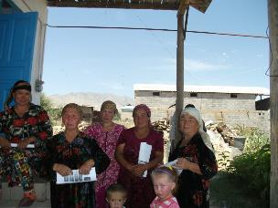 | 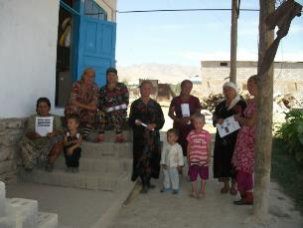
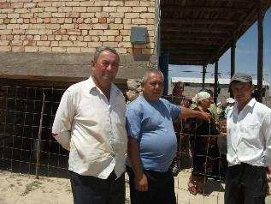 | 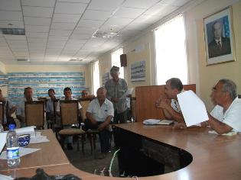
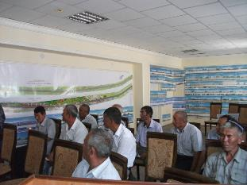 | 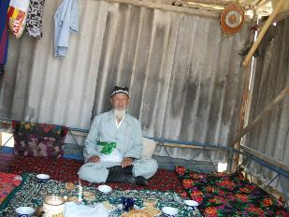

Namangan region, Pap rayon
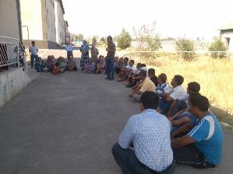 | 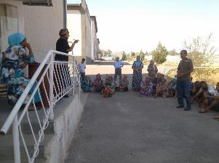
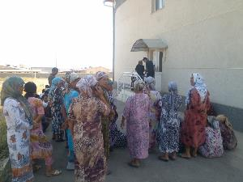 | 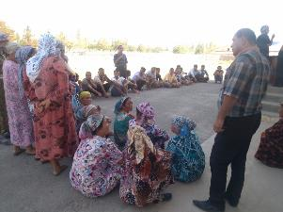
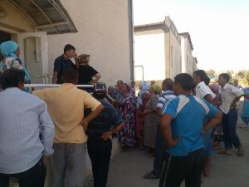 | 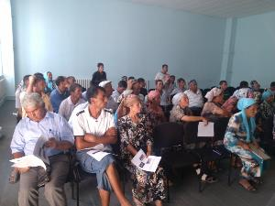
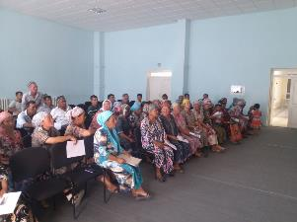 | 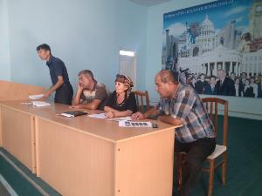

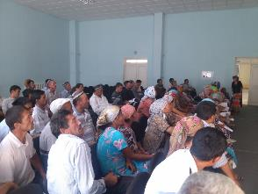 | 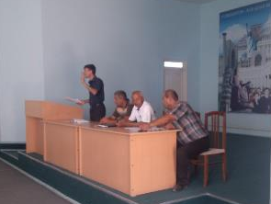
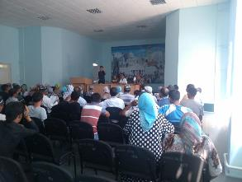 | 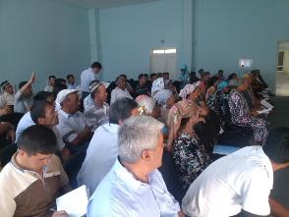
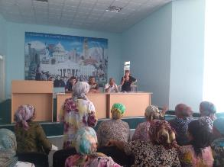 | 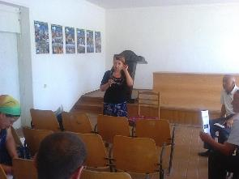
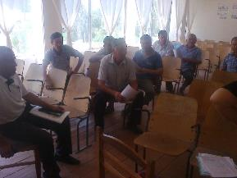 | 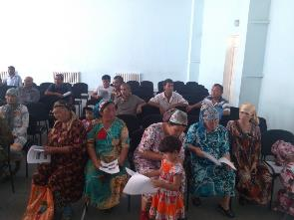

ANNEX II SOCIAL AND ECONOMIC SITUATION in projectzone

TASHKENT REGION, AKHANGARAN RAION
- Demographic characteristics
Population of the Tashkent region as of January 1, 2014 makes 2 733.6 thousand people (without Tashkent city). Population density – 171.1 people per 1 sq.km. The region is on the fourth place by the population in the republic. Population of the Tashkent region makes 9.0% of the population of the republic.
The largest cities are Almalyk, Angren, Akhangaran, Bekabad, Chirchik, Yangiyul.
Diagram 1 National structure of the population of the Tashkent region in 2013, %
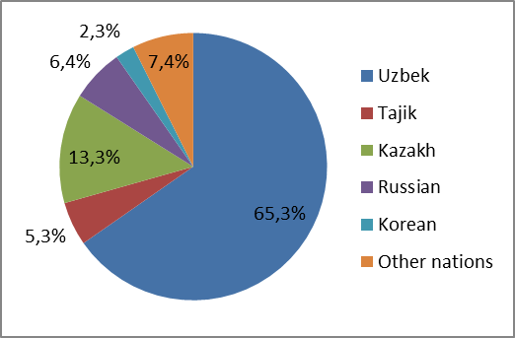 | National structure of the population of the Tashkent region is shown on the Diagram below: the main share of the population is Uzbeks (65.3%). Among representatives of other nations Kyrgyz, Uyghurs, Tatars, Ukrainians, other representatives of more than 80 nations and nationalities live in the Tashkent region.
Source: State Statistics Committee of the Republic of Uzbekistan, Khokimiyat of the Tashkent region
Diagram 2 National structure of the population of Akhangaranraion in 2013, %
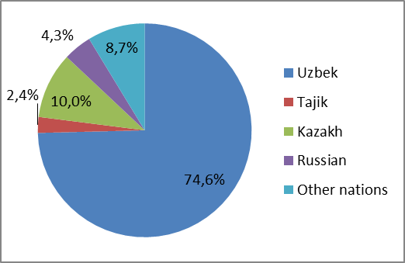 | Population of Akhangaranraion for January 1, 2014 made 124.4 thousand people. The share of the population of this raion makes 4,5% of the total population in the Tashkent region.  By national structure the prevailing share of the population of Akhangaranraion is Uzbeks – 74.6%.
Source: State Statistics Committee of the Republic of Uzbekistan, Khokimiyat of the Tashkent region

Table 1 Coefficient of population movement in the Tashkent region in 2012-2013, per 1000 people
 | Birth rate |  | Mortality |  | Maternal mortality, people |  | Infant mortality, till 1 year old |  | Nativity growth
 | 2012 | 2013 | 2012 | 2013 | 2012 | 2013 | 2012 | 2013 | 2012 | 2013
Tashkent region | 19,7 | 20,4 | 6,0 | 5,8 | 11 | 4 | 8,6 | 9,7 | 13,7 | 14,6
Akhangaranraion | 19,6 | 20,0 | 6,2 | 6,0 | 1 | 0 | 6,2 | 8,7 | 13,4 | 14,0
Source: State Statistics Committee of the Republic of Uzbekistan, Khokimiyat of the Tashkent region
Tashkent region, including Akhangaranraion, is characterized by positive indices of natural population growth. Along with the positive natural growth of the population in the project zone during 2012-2013 birth rate in the project zone increases against decrease in mortality rates. It allows to speak about increase in life expectancy among the population.
Migration indices in the Tashkent region and Akhangaranraionare given in the table below.
Table 2 Indices of population migration in the Tashkent region in 2012-2013, people
 | Number of arrived |  | Number of left |  | Migration balance
 | 2012 | 2013 | 2012 | 2013 | 2012 | 2013
Tashkent region | 22 322 | 17 653 | 34 479 | 26 767 | -12 157 | -9 114
Akhangaranraion | 1 037 | 916 | 1 280 | 1 200 | -243 | -284
Source: State Statistics Committee of the Republic of Uzbekistan, Khokimiyat of the Tashkent region
Taking into account the indices of population migration reflected in the table above, in the Tashkent region, including in Akhangaranraion, negative dynamics of migration is noted. The number of left population in this raion exceeds the number of arriving population. It is caused by the fact that the most part of the leaving population moves to the boundaries of Tashkent city.
- Social and economic development
Diagram 3 Share of Tashkent region in different sectors of economic development of the republic in 2013, %
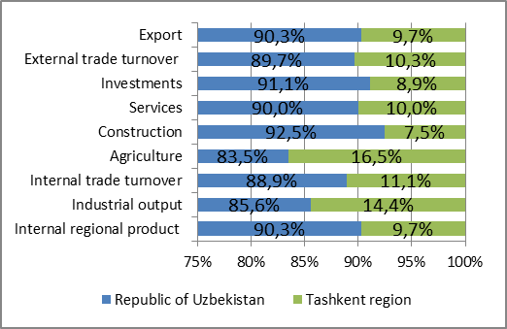 | Tashkent region is large industrial region of the republic and takes the leading place in various sectors of economic development of the republic.  In particular, about 9.7% of internal regional product (IRP), 14.4% of industrial output, 8.9% of the republican amount of investments, 16.5% of the output of agricultural sector, 11.1% of internal trade turnover and 10.0% of services, as well as 10.3% of external trade turnover and 9.7% of export fell on this region in 2013.
Source: State Statistics Committee of the Republic of Uzbekistan, Khokimiyat of the Tashkent region
Diagram 4 Share of IRP in the Tashkent region in 2013, %
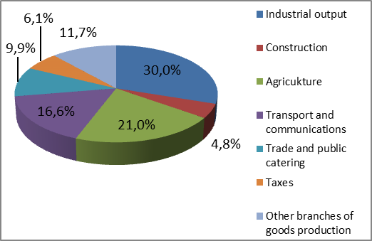 | The volume of internal regional product (IRP) of the Tashkent region increased by 7.8% and made 11 669.6 billion sums in 2013 in comparison with 2012 (9 518.9 billion sums). The volume of industrial output made 30.0%, agriculture – 21.0%, construction – 4.8%, trade and public catering – 9.9%, transport and communications – 16.6%, other branches of goods production – 11.7%, taxes – 6.1% of total amount of IRP. The share of small business makes 55.3%, the share of services – 37.9% of total amount of IRP.
Source: State Statistics Committee of the Republic of Uzbekistan, Khokimiyat of the Tashkent region
Diagram 5 IRP per capita in 2013 in the Tashkent region in the breakdown by large sectors of economy, in average, thousand sums
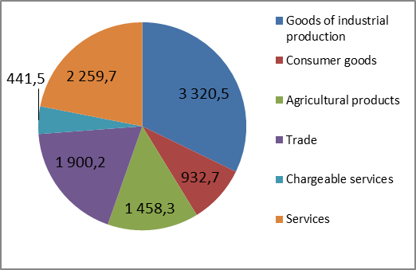 | IRP per capita of the region made 4304.6 thousand sums. Diagram below shows IRP per capita in the breakdown by large sectors of economy. The biggest share is the share of goods of industrial production which makes about 3 320.5 thousand sums per capita. The volume of agricultural products and the volume of retail trade per capita in the region are twice less than the volume of industrial goods production. The volume of provided services per capita makes 2 259.7 thousand sums per capita.
Source: State Statistics Committee of the Republic of Uzbekistan, Khokimiyat of the Tashkent region
Diagram 6 IRP per capita in 2013 in Akhangaranraion in the breakdown by large sectors of economy, in average, thousand sums
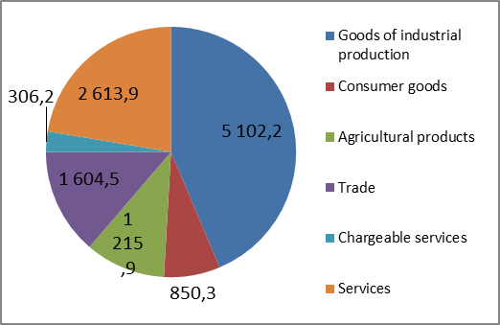 | In Akhangaranraion also the biggest share is the share of goods of industrial production which makes about 5 102.2 thousand people. The volume of services per capita makes 2 613.9 thousand sums per capita which makes practically a half of the volume of goods of industrial production in the raion. The region makes 20% of total industrial output produced in the republic, 45% of electric power, 98% of coal, 43% of cement, 100% of metal roll, the main part of non-ferrous metals. 87 large, out of them 51 enterprises for production of consumer goods work in the region.
Source: State Statistics Committee of the Republic of Uzbekistan, Khokimiyat of the Tashkent region
Diagram 7 Industrial production by the sectors of economy in the Tashkent region in 2013, %
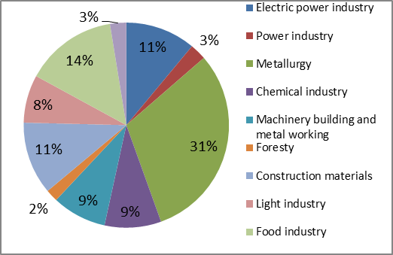 | The volume of industrial production by the region made 9001.2 billion sums in 2013 or in comparison with 2012 increased by 11.6%. Industrial production by the sectors of economy is presented in the diagram.  The leading industries of the region are: metallurgy (31% of total volume of industrial production), food (14%), power industry (11%), production of construction materials (11%), machinery building and metal working (9%), chemical industry (9%) and light industry (8%).
Source: State Statistics Committee of the Republic of Uzbekistan, Khokimiyat of the Tashkent region
- Development of agrarian sector
Agriculture is one of the main components of the economy of the region. The main resources of agricultural production are plant growing products - grain, raw cotton, vegetables, fruits and berries, grapes; livestock production - big and small cattle, goats, pigs, poultry, fishery.
Six raions of the region (Akhangaran, Bostanlyk, Zangiata, Kibray, Parkent, Yangiyul) specialize on production of fruits and vegetables, other raions are engaged in cultivation of cotton and grain. Crops of cotton and wheat occupy three quarters of fertile lands.
The region is one of the ancient centers of wine growing and winemaking of the republic. The main objective of agriculture of the region is cultivation of fresh fruits and grapes, providing city and industrial centers with them, grapes processing in existing wine stations, as well as export of fresh fruits and grapes out of the republic.
Diagram 8 Agricultural lands in the Tashkent region, thousand hectares
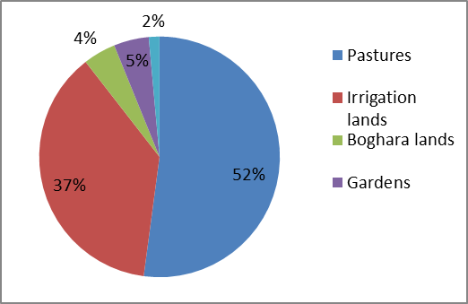 | Agricultural lands of the region made 816.4 thousand hectares, of them 425.4 thousand hectares are pastures, 305.1 thousand hectares - irrigation lands, 35.7 thousand hectares – boghara lands, 38.5 thousand hectares - gardens, vineyards – 11.7 thousand hectares. Therefore, half of all agricultural lands are occupied with the pastures, a third is irrigation lands.
Source: State Statistics Committee of the Republic of Uzbekistan, Khokimiyat of the Tashkent region
Diagram 9 Agricultural lands in Akhangaranraion, thousand hectares
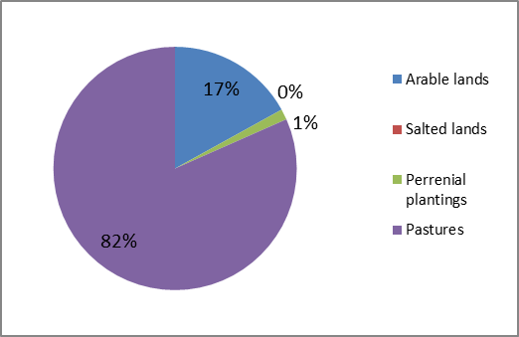 | Agricultural lands in Akhangaranraion make about 185.5 thousand hectares, including arable lands – 31.5 thousand hectares, salted - 0,004 hectares, (0,002%), perrenial plantings – 2.6 thousand hectares, deposits, pastures - 151.5 thousand hectares. Therefore, almost all agricultural lands consist of pastures, and only 17% are arable lands.  Besides that in the raion houses and personal land plots occupy 2.4 thousand hectares, highways – 0.1 thousand hectares, forests – 38.8 thousand hectares, objects of social value and streets – 1.8, other lands (the rivers, hills, industrial zones, transmission lines) – 90.3 thousand hectares.
Source: State Statistics Committee of the Republic of Uzbekistan, Khokimiyat of the Tashkent region
Diagram 10 IRP in agrarian sector of the Tashkent region in 2013, %
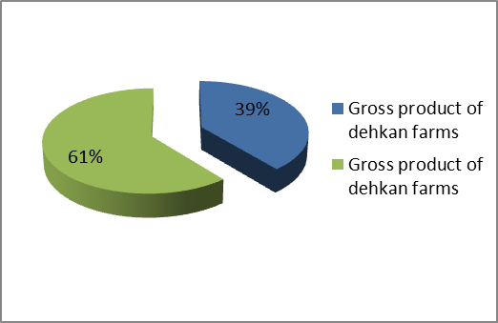 | In 2013 the gross product in agrarian sector in the Tashkent region made 2 451.0 billion sums and in comparison with 2012 increased by 5.9%.  The gross product of dehkan farms made 955.9 billion sums and in comparison with the last year increased by 5.3% and 39% of the total volume of agricultural production.  The gross livestock product made 1 495.1 billion sums or in comparison with the last year increased by 6.4%, and 61% of the total volume of production.
Source: State Statistics Committee of the Republic of Uzbekistan, Khokimiyat of the Tashkent region
6 192 leasehold farms operate in the region. Leasehold farms are engaged in production of plant growing - raw cotton, ear grain, fruits, grapes, melons, cocoons. Also there are 418.0 thousand dehkan farms in the region.
In 2013 the gross product in agrarian sector in Akhangaranraion made 149.7 billion sums and in comparison with 2012 increased by 6.5%. 427 leasehold farms (6% of total amount of leasehold farms operating in the region) operate in the raion. Leasehold farms are engaged in production of plant growing - raw cotton, ear grain, fruits, grapes, melons, cocoons. Also there are 18.5 thousand dehkan farms (4% of total amount of dehkan farms) in the region.
Diagram 11 Leasehold and dehkan farms in the Tashkent region in 2013
Leasehold farms | Dehkan farms
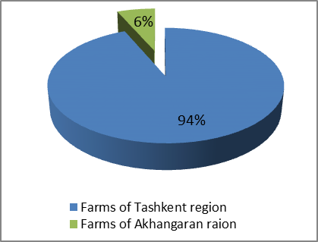 | 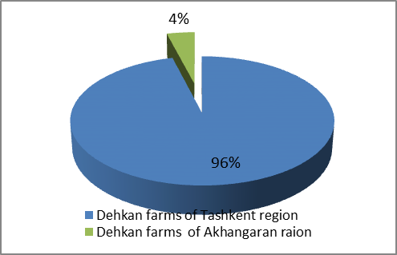
Source: State Statistics Committee of the Republic of Uzbekistan, Khokimiyat of the Tashkent region
Leasehold and Dehkan farms produced 166.0 thousand tons of meat, 568.0 thousand tons of milk, 871.0 million pieces of eggs, 255.4 tons of raw cotton, 627.2 thousand tons of grain, 268.8 thousand tons of potato, 1299.1 thousand tons of vegetables, 102.0 thousand tons of melons, 140.1 thousand tons of fruits, 115.5 thousand tons of grapes.
On the basis of the above-mentioned resources in the region ginning and cotton-processing branches, textile and clothing industry, food industry, including meat - dairy, oil milling and fats, flour-grinding and cereals, wine-making, canning, confectionery and others got development.
- Population employment
Total population size in the Tashkent region in 2013 made 2 726.1 thousand people. Out of the total number of population 58% of the population is able to work. 82% of able to work population are economically active. 96% of able to work population are engaged in economy. 4% of economically active population are unemployed, half of which applied to the employment agency and 95% were recognized as unemployed.
Able to work population also makes 58% of total population size in Akhangaranraion. Number of economically active and employed population of the raion is insignificantly higher than in the Tashkent region as a whole which makes 86% and 99% of able to work population. Accordingly the rate of unemployed population half of which also addressed to the employment bodies is lower and 99% were recognized as unemployed.

Table 3 Employment rates of the population in the Tashkent region in 2013, thousand people
Name | Tashkent region |  | Akhangaranraion
Name | Amount | % |  | Amount
Population size | 2726,1 | 100% | 124,4 | 100%
Able to work population | 1585,0 | 58% | 71,8 | 58%
Economically active population | 1291,8 | 82% | 62,1 | 86%
Employed population | 1244,9 | 96% | 61,8 | 99%
Unemployed | 46,8 | 4% | 2,3 | 1%
Addressed to the employment agencies | 24,3 | 52% | 1,2 | 53%
Recognized as unemployed | 23,2 | 95% | 0,3 | 99%
Source: State Statistics Committee of the Republic of Uzbekistan, Khokimiyat of the Tashkent region
Diagram 12 Population employment by big sectors of economy in the Tashkent region in 2013, %
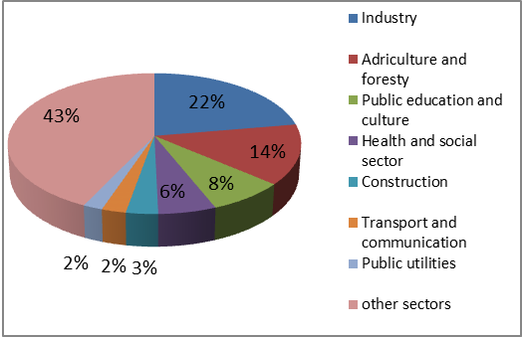 | Employment by large sectors of economy is given on the diagram below: about one fifth of total economically employed population is engaged in the industry. Every seventh person of economically employed population is engaged in agriculture. Almost half of economically employed population is engaged in other (smaller) sectors of economy.  About 3% are engaged in construction, in the sphere of transport and communication – 2% of economically employed population.
Source: State Statistics Committee of the Republic of Uzbekistan, Khokimiyat of the Tashkent region
Diagram 13 Spheres of creation of new work places in the Tashkent region in 2013, %
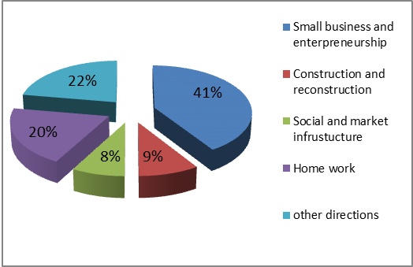 | There were about 12.4 thousand vacant workplaces and about 87.4 thousand workplaces were created in the Tashkent region in 2013. In Akhangaranraion in 2013 there were 180 vacant workplaces (1.5% of total amount of vacant workplaces in the region) and 4.6 thousand places were created (about 5.2% of total number of the created workplaces in the region).  Diagram below shows sectors of economy in which new workplaces in the Tashkent region and Akhangaranraionwere created.
Source: State Statistics Committee of the Republic of Uzbekistan, Khokimiyat of the Tashkent region

Diagram 14 Spheres of creation of new workplaces in Akhangaranraion in 2013, %
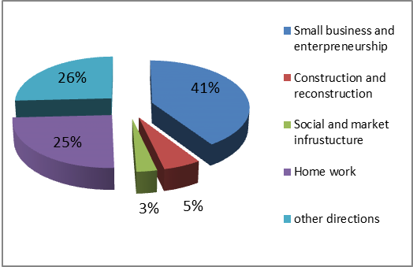 | The biggest share of newly created workplaces in the Tashkent region and Akhangaranraion is the share of small business and enterpreneurship. About 20-25% of newly created workplaces fall on home work and other directions. In the sphere of construction and reconstruction construction and reconstruction about 5-9% of total workplaces are created.
Source: State Statistics Committee of the Republic of Uzbekistan, Khokimiyat of the Tashkent region
- Transport infrastructure and communications
Railway traffic center connecting Uzbekistan with the republics of Central Asia and the states of Eastern Europe passes through the territory of the region. Length of railways makes 249.0 km. Total length of highways of the region - 3960 km (taking into account international highways), including regional and local – 2324 km.
Main highways: The big Uzbekistan highway and the road connecting Tashkent with Fergana Valley, construction of the transnational highway "Great Silk Road" on the route Tashkent – Andijan – Osh - Kashgar through the pass Kamchik / Kuramin ridge / to the Osh city of the Republic of Kyrgyzstan and Sintszyano - Uygur autonomous region of China is carried out.
Construction project of new electrified railway Angren Pap which will create additional infrastructure for foreign and domestic investments is developed; it will serve for development of small and private business in the region, lead to the solution of strategic tasks on integration into the world transport system and improvement of transport infrastructure of the region.
Telecommunication, mail service, telephone communication (including cellular), special communication, government currier operate in the Tashkent region.

NAMANGAN REGION, PAP RAION
- Demographical caracteristics
Diagram 15 National structure of the population in Namangan region in 2013, %
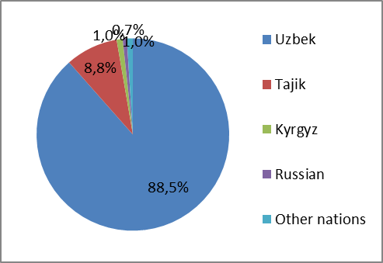 | Population of Namangan region made 2 448.4 thousand people in 2013. Population density makes 292.8 people per 1 sq.km. The region takes the fourth place in the republic by the population.  Representatives of over 20 nationalities live in Namangan region. In relation to the total number of the population Uzbeks make 88.4%, Tajiks – 8.8%, Russian – 0.7%, Kyrgyz – 1.0%, other nationalities – 1.0%. The national structure of Namangan region is given in the diagram:
Source: State Statistics Committee of the Republic of Uzbekistan, Khokimiyat of Namangan region
Diagram 16 National structure of the population of Pap raion in 2013, %
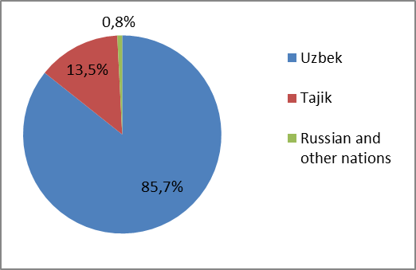 | Population of Pap raion made 197.6 thousand people in 2013. The share of the population of this raion makes 8.0% of the total number of the population in the Namangan region. The share of urban population in the raion makes 22.5%, population of rural areas – 77.5%. Population density made 67.2 people per 1 sq.km.In Pap raion Uzbeks make 85.7%, Tajiks (the second locals) – 13.5%, Russian and other nations make 0.8% of the total number of the population of the raion. In total in the structure of the population men make 48.8% and women - 51.2%.
Source: State Statistics Committee of the Republic of Uzbekistan, Khokimiyat of Namangan region
Table 4 Coefficient of population migration in Namangan region in 2012-2013, people
 | Birth rate |  | Mortality rate |  | Natality
 | 2012 | 2013 | 2012 | 2013 | 2012 | 2013
Namangan region | 50,6 | 56,8 | 11,6 | 11,4 | 39,0 | 45,4
Source: State Statistics Committee of the Republic of Uzbekistan, Khokimiyat of Namangan region
Namangan region is characterized by positive indices of natural growth of the population (natality). Along with the positive natural growth of the population in the project zone during 2012-2013 birth rate in project zone increases against decrease in mortality rates. It allows to speak about increase in life expectancy among the population.
Table below shows migration indices in the Tashkent region and Akhangaranraion.
Table 5 Indices of population migration in the Tashkent region in 2012-2013
 | Number of arrived |  | Number of left |  | Migration balance
 | 2012 | 2013 | 2012 | 2013 | 2012 | 2013
Namangan region | 4245 | 4938 | 5144 | 5065 | -899 | -127
Source: State Statistics Committee of the Republic of Uzbekistan, Khokimiyat of Namangan region
Taking into account indices of population migration shown in the table above, in Namangan region, negative dynamics of migration is noted. Number of left population in this raion exceeds the number of arriving population.
- Social and economic development
As a result of realization of the main directions of social and economic development of Uzbekistan in 2012-2013, by the end of 2012 sustainable growth in all spheres of economy was provided in Namangan region. During 2012-2013 the volume of IRP increased by 10%, in comparison with the last year, growth of industrial production made +14.9%, agricultural production - +7%, construction works - +10.2%, retail trade turnover - +16.6% and the volume of paid services - +16.8%.
Diagram 17 Structure of IRP of Namangan region in 2013, %
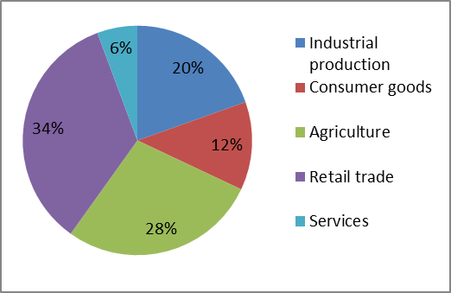 | In total amount of IRP the volume of industrial production made 20.0%, agriculture – 28.0%, consumer goods – 12%, retail trade – 34% and 6% - services.  Total number of enterprises in Namangan region, operating in 2013, made 2 887 units. Concerning indices of number of enterprises in 2012 this index grew by 24.7% which made +571 units.
Source: State Statistics Committee of the Republic of Uzbekistan, Khokimiyat of Namangan region

Diagram 18 Production volume in Namangan region in 2013, %
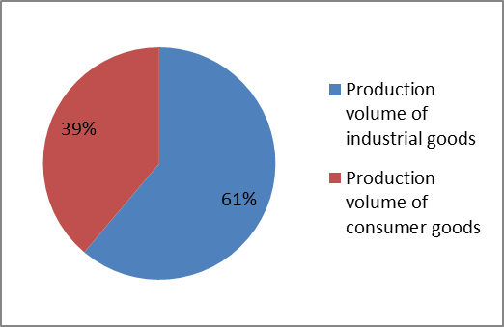 | During 2013 the industrial enterprises of the region produced industrial goods for the amount of 1 289.3 billion sums and consumer goods for the amount of 819.2 billion sums. Growth made 14.9% and 13.1% respectively. Production volume of local industries goods made 487.7 billion sums and their share in total production made 39%. The annual growth in comparison with the previous year made +16.7%.
Source: State Statistics Committee of the Republic of Uzbekistan, Khokimiyat of Namangan region
Measures on programs of development of production sectors, first of all light industry are taken for ensuring economic stability in the region. In particular, in 2013 volume of production in metallurgical industry increased and made - +9.9%, in the sphere of light industry growth made - +16.7%, in food industry - +14.1%. The shares of light and food industry in the volume of production are 38.0% and 31.0% accordingly.
The amount of industrial production per capita and production of consumer goods per capita makes 334.5 thousand sums (+20,3% of growth).
Industry – is one of the main factors in the economy of Pap raion. Raion has 4 big and 91 small enterprises, the annual growth of income (2012-2013) - +55.4%. The volume of products at big enterprises makes +40.8%; in microfirms – 90.0%; in small enterprises by 5.1 times, in minor enterprises about 10-12% a year.
- Agriculture
In 2013 total amount of agricultural products of the region made 1 836.4 billion sums which provided growth rate by +7%. Farmers fulfilled the plan on agricultural production by +5.9%, dehkan farms by +7.3%.
For the present there are 5 699 leasehold farms being allocated 264.6 thousand hectares of lands in the region. 82.9 thousand employees work in these farms. Also, there are 450 219 dehkan farms and 358 of them have legal status in the region.
The share of leasehold farms in total volume of agricultural production of the region made 30.3%, dehkan farms – 68.9%
In 2013, livestock made 557 thousand heads (gworth +2.5%), including cows – 196.4 thousand heads (+2.7%), sheep – 647.7 thousand heads (+3.1%), hens – 2293.8 thousand heads (+12.8%) and horses – 6.4 thousand heads (+0.9%).
Grain growing, rice growing, vitivulture and fruits, melons and vegetable growing, animal husbandry are the leading branches of agriculture in Pap raion. There are more than 641 leasehold and 35 560 dehkan farms, out of them 40 legal dehkan farms operate in the raion.
- Small business
Shares of small business in regional gross product made 79.0% in 2013. By the end of 2012 only 23 716 subjects of small business were registered (except leasehold farms). During 2012-2013 this index increased by +3.3%.
Diagram 19 Share of small business in several sectors of economy in 2013, %
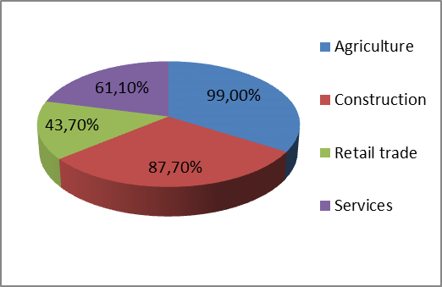 | If in 2012 subjects of small business produced goods for the sum of 409 billion sums, in 2013 this index made 576.5 billion sums. Growth of small business on production of industrial goods from 39.0% to 46.6% is noted in the region.  In 2013 21856 new workplaces were created by the subjects of small business, and employment in the sphere of small business reached 675.4 thousand people.
Source: State Statistics Committee of the Republic of Uzbekistan, Khokimiyat of Namangan region
- Social sphere
By 2013 number of population in the region reached 2 448.4 thousand people. Number of manpower reached 1469.5 thousand people (60% of the total number of population of the region).
For the purpose of creation of new workplaces and employment of the population in 2013 75 109 new workplaces were created. 61 324 vacant workplaces in villages were created. The most part of the created workplaces, i.e. 43.6% were created on the basis of development of private business (32 774 places).
24 291 places were created on the basis of creation of firms and micro firms, on the basis of creation of objects of production, modernization and development of firms 5 090 places were created, private business 8383 places were created, spheres of households 28 855 places were created, development of leashold farms 2286 places were created, development of production, social and trade infrastructure, improvement of makhallas 4 993 places were created, on the basis of restoration of idle firms 1 211 new workplaces were created.

10% is included for contingencies. These expenses are applicable to those exceptional cases if Project affected people refuse the offer of the land plot for a number of reasons, or if notification is not provided in time and leads to relative losses of crops and other cases. Total amount of the compensation is preliminary and may have some amendments.
Two households
The poverty line is taken as: monthly per capita income is less than the equivalent of UZS 161.452 (approximately US$2.26 per capita per day), which is close to the internationally accepted income poverty line of US$1.65 per capita, per day.
This category of invalidity is assigned for those people who have diseases which allow working.
To calculate the required amount of the compensation based on average monthly income of this household it will be taken into account the monthly income of the household per the last three month (but not more than 1.5 times the minimal wage in the Republic for each working family member). In case the average income of the affected household is less than 1.5 times the minimal wage in the Republic for each working family member, the compensation will be paid based on 1.5 times the minimal wage in the Republic for each working family member. The 3-month income is calculated based on provisions stated in Cabinet Minister ‘decree #165, average aggregate income of affected household.
Decree of the Cabinet of Ministers N 97 as for 29.05.2006 on Order of compensations payment to citizens and legal entities in view of the land plots acquisition for state and public needs. Decision on the period on rental allowance will be made by Commissions consisting of representatives of khokimiyats, departments of cadastral service and other departmental structures on the base of actual period of rent of temporary accommodation.
In case of unemployed APs, necessary required paper from local Labour authorities.
It should be noted that there is only one unit of the school, medical point, policlinic in the community. However it is better condition for the affected households as they have before the relocation. It is caused by the following reason: not every community has its own school, medical point, and policlinic. Some times people have to go to the neibouring community to get education, medical assiatnce etc.
Unemployed are people officially registered as unemployed in the appropriated population employment agencies.

