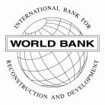
INTERNATIONAL BANK FOR RECONSTRUCTION AND DEVELOPMENT
85037
BOARD OF GOVERNORS

Resolution No. 202

Number of Elected Executive Directors

RESOLVED:

THAT at the Regular Election of Executive Directors to be held during the 1964 Annual Meeting of the Board of Governors, there shall be elected 15 Executive Directors.

(Adopted on May 18, 1964)

