China: Fujian Fishing Ports Project
E4347 V2 REV

ENVIRONMENTAL ASSESSMENT
Executive Summary

Fujian Provincial Department of Ocean and Fisheries
Fujian Provincial Environmental Science Institute

October 2013
TABLE OF CONTENTS
1. Introduction - 2 -
2. Project Description - 4 -
3. EA REGULATORY AND LEGAL FRAMEWORK 8
4. ANALYSIS OF ALTERNATIVES 11
4.1 With/Without Project 11
4.2 Port Layout Options 12
4.3 Construction Methods of Breakwater 13
5. ENVIRONMENTAL BASELINES 14
5.1 Natural Environment 14
5.2 Socio-economic Context 15
5.3 Regional Environmental Planning 16
5.4 Environmentally and Socially Sensitive Sites 19
5.5 Ambient Environmental Quality 23
6. ASSESSMENT OF IMPACTS AND MITIGATION MEASURES - 26 -
6.1 Impacts during Construction Stage - 26 -
6.1.1 Impacts on Marine Ecology - 26 -
6.1.2 Impacts on Fuying Island Marine Protection Area and Pollicipes mitella Species - 29 -
6.1.3 Impacts on Fuyao Islands Marine Protection Area - 30 -
6.1.4 Land Acquisition, Resettlement and Aquaculture Livelihood - 30 -
6.1.5 Impacts on Communities - 31 -
6.1.6 Impacts on Physical Cultural Resources - 32 -
6.1.7 Impacts on Scenic Area - 32 -
6.1.8 Navigation and Safety - 33 -
6.1.9 Terrestrial Ecology - 33 -
6.1.10 Management of Construction Ship Waste - 34 -
6.2 Impacts during Operation Stage - 34 -
6.2.1 Hydrodynamics and Siltation - 34 -
6.2.2 Waste Management - 35 -
6.2.3 Odor Control - 35 -
6.2.4 Dongchong Peninsula Scenic Area - 36 -
6.2.5 Fuying Island Marine Protection Area - 36 -
6.2.6 Safety and Emergency Response - 36 -
6.2.7 Oil Spill Risks and Emergency Response - 37 -
6.2.8 Cumulative Impacts - 38 -
7. PUBLIC CONSULTATION AND DISCLOSURE - 41 -
8. ENVIRONMENTAL MANAGEMENT PLAN (EMP) - 43 -
8.1 Roles and Responsibilities - 43 -
8.2 Management Plans - 45 -
8.3 Management of Contractors - 45 -
8.4 EMP Budget - 46 -

Introduction

This document summarizes the environmental impact assessment (EIA) process of the Fujian Fishing Port Project. It highlights the key environmental and social safeguards issues related to the project construction and operation, describes the main findings and conclusion of impact assessment, and summarizes main mitigation measures to avoid, minimize, mitigate and compensate adverse impacts.

The project is located in Xiapu County, Ningde City of Fujian Province in the southeast coast of China. Fujian, with total sea area of 136,000km², has the second longest coastal line among other provinces in China, which makes offshore fishery and aquaculture a major industry for the province. Xiapu County is one of the ten key fishery counties of Fujian, with fishery industry accounting for 75% of agricultural GDP.

The coastal areas of Fujian are frequently stricken by typhoon disasters. Meanwhile, this is further aggravated by the global climate change which has evidently caused more frequent extreme climate events. In recent years, with social and economic development and wealth accumulation, the economic losses incurred by typhoon disasters have been rising constantly, thus threatening the sustainable development of society and economy. Lack of fishing ports that provide adequate sheltered waters is the main reason for the loss of fishing boats and human casualties. In order to reduce the vulnerability of the fishing communities to extreme weather events in Fujian Province, the project will support the construction of six fishing ports in Xiapu County of Fujian, including ports of Sansha, Luxia, Fenghuo, Beishuang, Wenao and Dajing. The locations of the proposed fishing ports are shown inFigure 1-1. In addition, the project will also support the construction of a Training Center in the existing campus of Fujian Provincial Ocean Technology College in Fuhzou, capital city of Fujian Province.

The main project activities include construction of breakwaters, docks, seawalls, access roads and land reclamation. Based on requirements of both Chinese environmental assessment laws/regulations and the World Bank’s OP 4.01 Environmental Assessment, the proposed project is classified as Category A. The following safeguards policies are triggered: (1) OP4.01 Environmental Assessment; (2) OP4.04 Natural Habitats; (3) OP4.11 Physical Cultural Resources; and (4) OP4.12 Involuntary Resettlement.

A full EIA report and a stand-alone EMPfor ports construction and an EMP for the Fisherman Training Center building were prepared by Fujian Provincial Environmental Science Institute, with comments and guidance from the World Bank task team. The preparation of EIA and EMPs followed the relevant laws and regulations of China, World Bank safeguards policies, as well as EHS guidelines. The final EIA/EMPs were submitted to the Bank in October 2013, and found inconformity with World Bank policies. These documents have been locally disclosedon September 30 on internetwith announcement on newspaper, and also have been disclosed in the World Bank InfoShopon November 11, 2013.

This document is prepared based on conclusions and recommendations of Environmental Impact Assessment (EIA), Environmental Management Plan (EMP) and Resettlement Action Plan (RAP). In summary, the EIA has thoroughly assessed potential environmental and social impacts related to construction and operation of fishing ports, as well as cumulative impacts from other activities and induced port/township development in the project area. Adequate mitigation measures have been developed in the EMPs to avoid, minimize, mitigate and compensate the social and environmental impacts.

As concluded from these documents, the project:
- incorporated effective analysis of alternatives and engineering measures to maximize project benefits and minimize significant negative impacts;
- will not significantly degrade or convert critical natural habitats;
- will results in limited loss of intertidal zone habitat (less than 0.1% of intertidal zone area of Xiapu county);
- will not adversely affect physical cultural resources;
- will not adversely affect ethnic minorities;
- will have minimized the need for resettlement and will provide adequate and just compensation and income restoration for affected peoples;
- includes a management plan for addressing environmental and social issues during construction and operation of the project; and
- includes a habitat offset program of man-madereef deployment
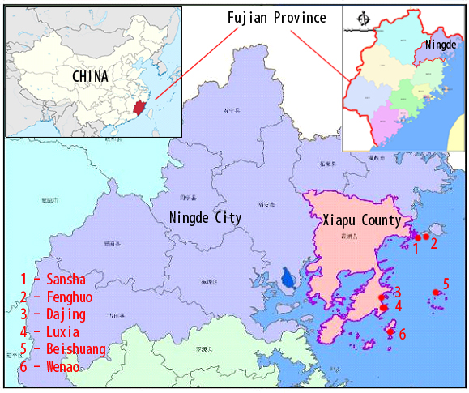

Figure 1-1 Locations of Proposed Fishing Ports

Project Description

The overall project development objective (PDO) is to reduce the vulnerability of the fishing communities to extreme weather events in Fujian Province. The project includes four components:

- Component 1:Expansion and upgrading of six fishing port facilities in Xiapu County of Fujian Province, including such as breakwaters, docks, bank protection, land reclamation, buildings, trestle bridges, and access roads to the ports. These six ports are: Sansha (Central port), Luxia (Class I port), Fenghuo (class II port), Beishuang (class II port), Dajing (class II port) and Wen’ao (class II port);
- Component 2: Upgrading of early warning and response systems, including: (i) upgrading Fujian Provincial Central Ocean and Fishing Vessels Management Information System Platform; (ii) installing a dedicated connection between the Provincial Center and the Plow Satellite Operations Service Center, to enable direct connection with the Plow Satellite communication and positioning system; (iii) upgrading and improving the user friendliness of the interface between the Provincial Center, cities, counties, and Class I fishing ports and the Plow Satellite services.
- Component 3:Establishing a Training Center(a 6-story building with a constructed area of 6000 m²), to provide necessary professional training, including fishery production, boat maintenance and operation, and risk mitigation, to reduce vulnerability of fishermen;
- Component 4: Project management and implementation support.

Among these four components, Component 2 and Component 4 support technical assistance and capacity building activities that have no environmental and social safeguards issues. Only Component 1 and Component 3 will support physical construction activities.

The Training Center building supported by Component 3 is located within the existing campus of Fujian Ocean Technology College in Fuzhou City, of which the environmental impacts is rather limited and can be readily handled with good construction management. A simple EMP with generic Environmental Code of Practice (ECOPs) has been prepared for this building.

The main environmental and social safeguards issues are related to expansion and upgrading of six fishing port facilities under Component 1. These ports are:
- Sansha Central Fishing Port
- LuxiaClass I Fishing Port
- FenghuoClass II Fishing Port
- BeishuangClass II Fishing Port
- Wen'aoClass II Fishing Port
- DajingClass II Fishing Port

The detailed project contents of these six ports include:

Table 2-1 Project Contents of Six Fishing Ports Expansion and Upgrading
Fishing Ports | Sansha | Luxia | Fenghuo | Beishuang | Dajing | Wen'ao
Grade* | Central Port | Class-1 Port | Class-2 Port | Class-2 Port | Class-2 Port | Class-2 Port
Breakwaters | South: 750m;  West: 545m | Outer: 600m;  Inner-A:380m,  Inner-B: 680m  Inner-C: 600m | 200m | / | / | East: 75m; South: 370m
Docks | 1×300m | 2×74m | 1×35m | / | 1×65m | /
Trestle bridges | 80m | / | / | / | / | /
Seawall | / | Seawall #1: 1,186 m; seawall #2: 2,413 m | / | 85m | 1,065m | /
Land reclamation | 33.8 ha** | 7.4593ha | / | 8,200 m² | 3,715 m² | /
Buildings | Administration and fishermen shelter building: 2,500m² | Administration and fishermen shelter building: 2,500m² | Administration building, 500m² | Administration building, 500m² | Administration building, 500m² | Administration building, 500m²
Access roads | Use existing access roads | 7m-wide, 2,413m-long new access road to dock, to be built along inner side of seawall #2 | 2, 260m-long, 3m-wide new access road | Use existing access road | 285m-long, 4m-wide new access road to dock; pavement of 1,300m existing road | Use existing access roads
Sheltered water area | 420,000 m2 | 940,000 m2 | 308,000m2 | Land based shelter | 59,000m2 | 41,300m2
* Classification of fishing by Ministry of Agriculture:
- Central fishing port: can provide berthing, shelter and supplies for over 800 large, medium-sized and small fishing vessels; water and land area is over 400,000 m² and 200,000 m²respectively;coordinated development with small towns.
- Class-1 fishing port: can provide berthing, shelter and supplies for over 600 large, medium-sized and small fishing vessels; water and land area is over 300,000 m² and 100,000 m² respectively.
- Class-2 fishing port: mainly provides berthing, shelter and supply services to local fishing vessels.
- Class-3 fishing port: can only provide berthing and supply services to local fishing vessels.
Central and Class-1 ports may have auxiliary facilities for processing, storage and distribution of fish, while Class-2 and Class-3 ports only have the functions of fish unloading and transshipment.
**The World Bank financed activity in Shansha is the expansion of domestically funded Phase I of SanshaCentralFishing Port which includes a plan of land reclamation of 33.8ha. The World Bank funded expansion activity will generate dredged materials from breakwater construction, which will be reused as backfilling material for the land reclamation.

All these six fishing ports are located within the administrative boundary of Xiapu County: Sansha Port is located in the water area in the south of Sansha Town; Luxia Port is located in the water area in the south of Luxia Village, Changchun Town; Fenghuo Port is located in the water area in the east side of Fenghuo Island in Sansha Town; Beishuang Port is located in the water area in the south of Beishuang Village on Beishuang Island; Wen'ao Port is located in the water area in the south of Wen'ao Village on Fuying Island; and Dajing Port is located in the east of Gangli Village, a natural village of Dajing Village, Changchun Town. The locations of the fishing ports are shown in Figure 2-1, and project contents of each port are illustrated in Figure 2-2.

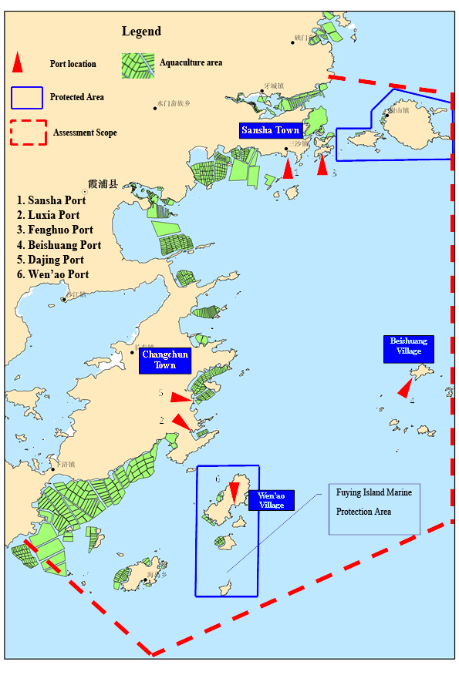

Figure 2-1 Expansion and Upgrading of Fishing Ports in Xiapu County
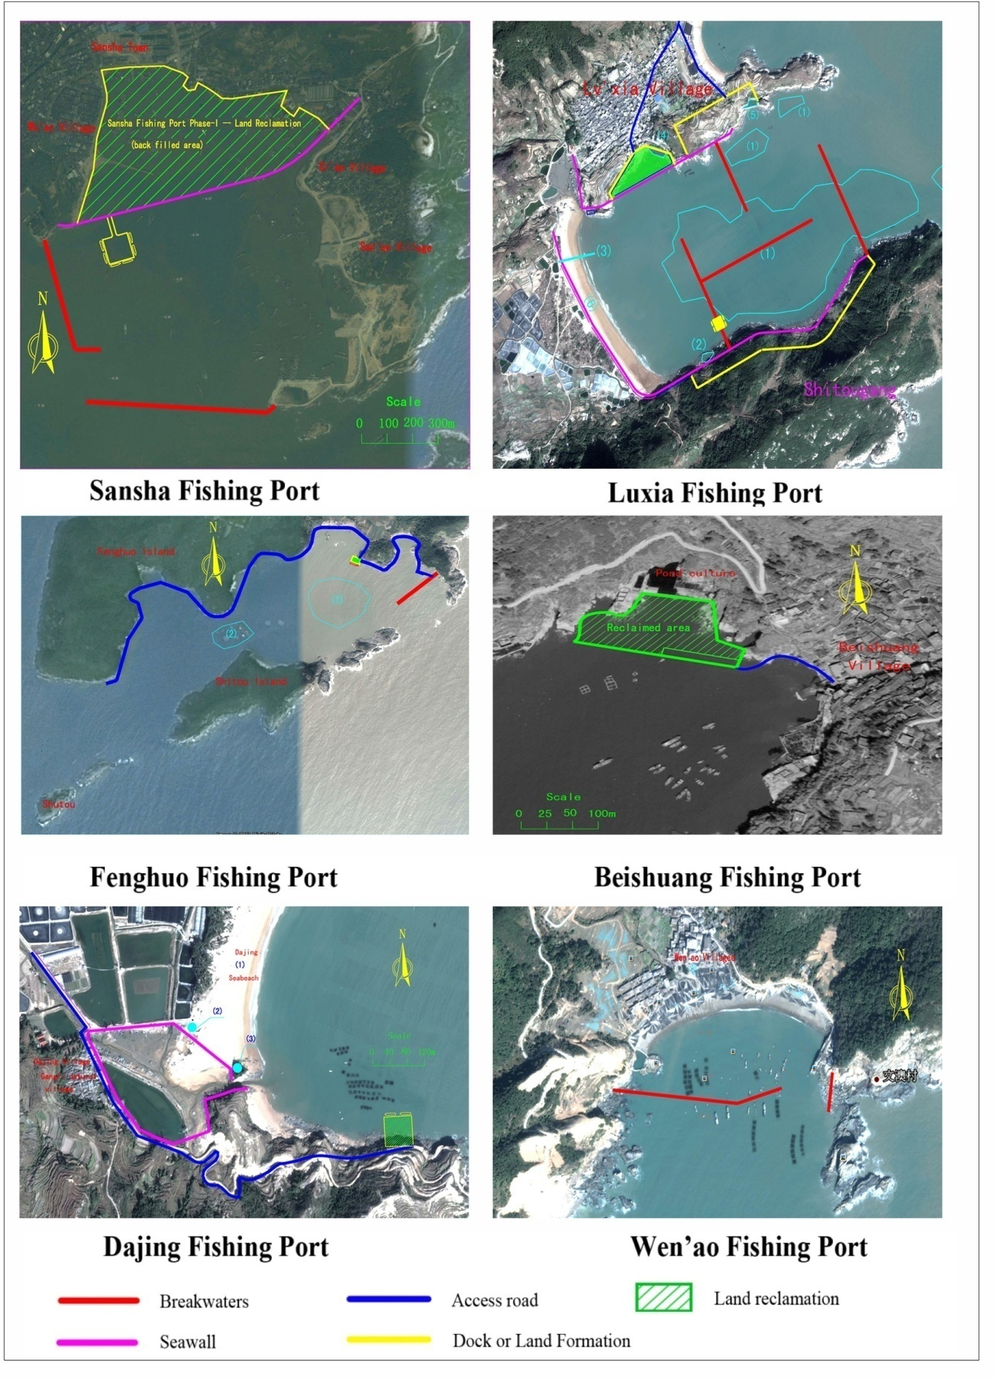

Figure 2-2 Project Contents of Fishing Port Expansion and Upgrading

EA REGULATORY AND LEGAL FRAMEWORK

The Environmental Assessment (EA) was conducted in accordance with Chinese environmental assessment laws/regulations and the World Bank safeguards policies. Compliance with Chinese domestic regulations and World Bank policy requirements are summarized in this chapter.

World Bank Safeguard Policy Requirements

Of the ten safeguards policies, the following are triggered: 1) OP4.01 Environmental Assessment; and 2) OP4.04 Natural Habitats; 3) OP/BP4.12Involuntary Resettlement; 4) OP/BP4.11 Physical Cultural Resources. Compliance with these policies, and the World Bank’s disclosure of information policy, is summarized in Table 3-1 and 3-2.

Table 3-1Compliance with World Bank Safeguards Policies
Safeguard Policies | Trigger | Actions
Environmental Assessment  (OP/BP 4.01) | Yes | - Category A project.  - Full EIA and EMP have been prepared.  - Consultation conducted as part of EIA process
Natural Habitats  (OP/BP 4.04) | Yes | - Ecological survey conducted as part of EIA  - Mitigation measures developed to mitigate impacts  - Ecological compensation and habitat offset program developed in EMP
Involuntary Resettlement  (OP/BP 4.12) | Yes | - Resettlement is applicable and a Resettlement Action Plan has been prepared.
OP/BP4.11 Physical Cultural Resources | Yes | - Two cultural resources sites (a tomb and a temple) identified in Dajing port area, and measures to avoid impact in EMP  - Chance-find procedure has been developed in EMP
OP/BP4.36 Forest | No | The project will not finance activities that would involve significant conversion or degradation of critical forest areas or related critical natural habitats as defined under the policy.
OP/BP4.09 Pest Management | No | The project will not procure any pesticides nor will an increased use of pesticides result from the project. No action is required under the policy.
OP/BP4.37 Dam Safety | No | The project area does not include any dams.
OP/BP4.10 Indigenous Peoples | No | There are no indigenous peoples live in project-located area, no impact on the indigenous peoples.
OP/BP7.50 Projects on International Waterways | No | The project doesn’t include any international waterways.
OP/BP7.60 Projects in Disputed Areas | No | The project area does not include any disputed areas.

The World Bank Group Environmental, Health and Safety Guidelines (WGB EHS Guidelines) also apply to the project, including the General Guidelines and specific Guidelines for Ports, Harbor and Terminals. The project Environmental Management Plan includes the mitigation measures that are fully in compliance with the general principles and measures in the General Guidelines (especially related to Construction management), as these general requirement in the Guidelines is equally required in Chinese laws, regulations, guidelines and construction management norms. The EHS Guidelines for Ports, Harbor and Terminals is intended for “commercial ports, harbors and terminals for cargo and passengers transfer”. However, its measures, where applicable, is included in the EMP as well, as illustrated in the following table:

Table 3-2 Compliance with WBG EHS Guidelines for Ports, Harbor and Terminals
EHS Guidelines | EIA /EMP Compliance
Guidelines on Dredged Materials Management, including requirements on dredge planning, dredging, and disposal of dredged materials. | The project doesn’t need to dredge any navigation channel. Excavation is needed for Sansha breakwater due to very thick silts. Limited dredging of dock basin for Sansha, Lvxia and Dajing is needed as well. There is no need for maintenance dredging. The dredging techniques, quality of dredged materials, disposal approach comply with the EHS guidelines.
Guidelines on air emissions from vessels. | Emissions from fish boats are limited compared to large cargo vessels. The ambient air quality is very good. The project will not result in increased air emissions.
Guidelines on wastewaters from port, drainage and vessels | Collection and treatment of boat wastewater, port wastewater and runoff have been considered in the EIA and EMP. Compliance with the guidelines and international convention of MARPOL.
Guidelines on wastes from vessels and ports | Collection and disposal of wastes have been considered in the EIA and EMP. Compliance with the guidelines and international convention of MARPOL.
Guidelines on protection of biodiversity | Survey and assessment of marine ecology conducted. Impacts on natural habitats are very limited. Offset plan is included in the EMP.
Occupational Health and Safety | These measures equal to national requirements and included in EMP.

Domestic Laws and Regulations

The EIA is prepared fully in compliance with China national laws, regulations, guidelines and procedures. Compliance with key Chinese national laws and regulations are summarized in Table 3-3.

Table 3-3 Compliance with China Domestic Laws and Regulations
China Laws and Regulations | Project Compliance
Environmental Protection Law | - EIA prepared to address potential impact on ocean, with necessary mitigation measures developed..
Marine Environmental Protection Law | - EA covers dredging, blasting, disposal of dredging materials (as backfilling material for Phase I of Sansha Fishing Port), waste management, oil spill risks, ecological protection and compensation.  - Dredged material reused by Phase I of Sansha Port construction  - Oil spill risk emergency response plan prepared  - Ecological compensation plan prepared
Management Regulations for Sea Waters Use | - Sea waters use has been approved from relevant ocean authority
Environmental Impact Assessment Law | - Full EA prepared by the certified EIA consultant and Project proponent, reviewed and approved by Fujian Provincial Department of Ocean and Fisheries and Fujian Provincial Environmental Protection Department.  - Two rounds of public participation conducted in surrounding villages/towns, and info disclosure through Mingdong Daily, Xiapu Government website and EA consultant website.
Notice on Strengthening EIA Management for Construction Projects Funded by Loans from International Financial Institutions | - EIA and EMP are prepared in compliance with World Bank safeguards policies.
Fishery Law | - EMP incorporates measures to minimize impacts on fishery resources resulted from underwater blasting and construction. Affected aquaculture will be relocated before construction
Water and Soil ConservationLaw | - Water conservation and soil erosion control plan has been prepared and approved by relevant authority.
Marine Traffic Safety Law | - EA considers safety operation zone for construction activities.
Navigation Safety Regulations for Above- and Under Water Activities | - Construction shall start after approved by relevant authorities.
Administrative Regulations for Marine Pollution Prevention from Marine Engineering | - Land reclamation using dredged materials covered by the EA. No natural spawning ground, breeding ground and feeding ground will be occupied.  - Quality of the dredged/filling material complies with environmental criteria  - EMP incorporates mitigation measures for blasting
Administrative Regulations for Marine Pollution Prevention from Ship Wastes | - Ship wastewater and solid wastes must be received and treated by port facilities.
Technical Regulations for Impact Assessment of Construction Projects on Marine Living Resources | - EA assessed impacts on marine living resources resulted in dredging, blasting and disposal of dredged materials  - EA evaluated the economics value of potential losses  - An ecological compensation plan to deploy artificial reef prepared and budgeted.

ANALYSIS OF ALTERNATIVES

With/Without Project

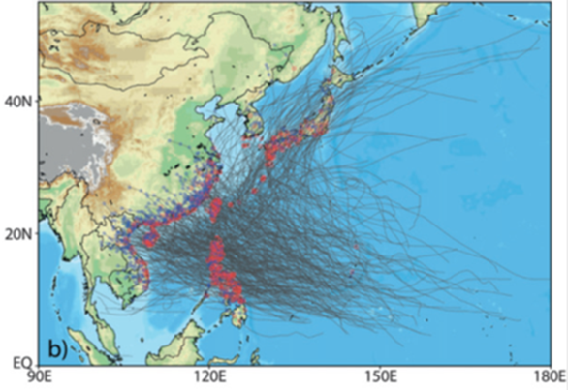Fujian is close to the source of typhoons and is one of the provinces heavily affected by typhoon disaster. According to the data of Fujian Provincial Meteorological Center, during 1980-2012, there are total 140 typhoons affecting and landing in Fujian, including 49 landing typhoons (1.48 per year on average), and 91 affecting typhoons (2.76 per year on average). For the recent 6 years (2007-2012), 26 typhoons affect or land on Fujian, including 10 landing typhoons, 1.67 per year on average, and 16 influential typhoons, 2.67 per year on average. With global climate change, there is evident increasing frequency of extreme climate events (including typhoons) in recent years.
Figure 4-1 Typhoon tracks affecting Fujian (1950-2010)

Fishery sector is one of the pillar industries in Xiapu County of Fujian Province. Among 14 towns in the county, there are 10 coastal towns with 260,000 people engaged in fishing and more than 18450 fishing boats. During typhoon, the fishing boats and recreational fishing boats need to enter ports for shelter, and it's a great challenge for the sheltering capacity of fishing ports.

Along the coastal line of Xiapu, there is no large-sized typhoon shelter (with the sheltered area over 300,000m² for the fishing boats). By the end of 2013, there are only three major typhoon shelters in this region for fishing boats, i.e. Tian'ao Port Area of Sansha Fishing Port, Shihu Fishing PortandSimenqiao Fishing Port. Besides these three major shelter areas, there are several small-sized typhoon shelters of different areas for the fishing boats of local villages. Such small typhoon shelters are all using natural bay areas with limited facilities and low capacitywhichcould only be supplement for sheltering of the fishing boats.

The current shelter ports can only provide partial coverage.For the six project ports, about 70% of the larger fishing boats (over 20HP) have to sail to other ports during typhoon periodwhere there is effective sheltered water area. Small boats, especially those aquaculture fishing boats are unable to sail long distance and have to stay at local ports. Due to shortage of sheltering capacity, every severe typhoon will cause damage or sinking of fishing boats and human casualties. It is estimated that, during 2009~2012, the numbers of fishing boats in Xiapu County sunk and damaged by typhoonsreached55 and 264 respectively, resulting in catching lossofRMB 200.77 million and the aquaculture lossofRMB 61.46 million. Besides the damage/loss of property and casualties, the other major impact of typhoon is the time, fuel and living cost for the fishing boats to sail to other shelter ports outside Xiapucounty. For instance, during typhoon periods, nearly one thousand fishing boats have to go to Shacheng Port (34km to Sansha, the nearest typhoon shelter to Xiapu) which could barely accommodate so many.

Fishing boats are generally small in tonnage and weak in the capacity to resist wind and waves. During typhoon, for no place for shelter, some fishing boats had to anchor close to the small natural bay with less safety factor (Figure 4-2). In this case, the fishing boats may be confronted with the risk of being capsized in the wind. If the port has poor sheltering capacity, the boats (even rest in port) could also get anchor dragging or collision and suffer great losses.
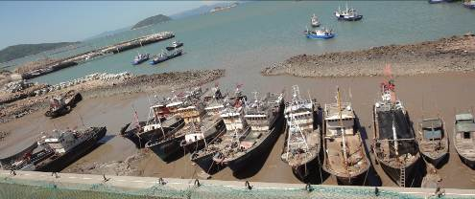
Figure 4-2 Fishing boats anchor in simple port
Therefore, it is critical to expand and upgrade the fishing ports, construct breakwaters and increase sheltered water areas, to minimize life and property loss of the fishing communities in Xiapu.The proposed expansion and upgrading of six ports can provide full coverage of all boats of the local community.“Without Project” scenario is not a viable option.

Port Layout Options

The layout of the breakwater and the other infrastructure is determined mainly by the features of the bays where the fishing ports are located through the mathematical modeling of tides and waves. Besides meeting the demand of typhoon shelter, it should avoid port siltation, minimize involuntary resettlement, avoid sensitive environmental receptors, and ensure the flow direction and velocity not to change significantly at the entrance and ensure the boats navigation safety.Based on these considerations, the feasibility study and the EIA reportsconsideredthree layout options for each port, and conducted comprehensive comparison in terms of technology, economic, social and environmental impact and navigation safety concerns based on which an overall optimal option was selected. (A sample of port layout options for Sansha Fishing Port is provided as an illustration).
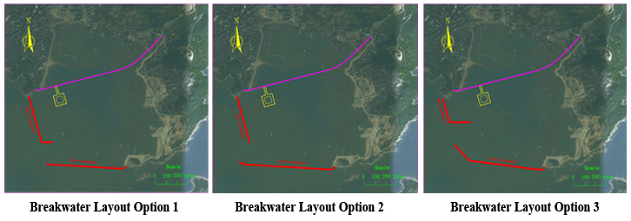
Figure 4-3 Illustration of Port Layout Options (Sansha Port)

Construction Methods of Breakwater

Construction of breakwater is the main content of the proposed fishing port project. The construction techniques for breakwater include packing sediment by dumping stones, packing sediment by blasting, dumpingstonesafter the excavation of foundation bed, etc. An overall comparison of these three methods was assessed and summarized in Table 4-1, and appropriate methods were selected for different fishing ports with due consideration of environmental and social impacts.
Table 4-1 Alternative Analysis of Construction Techniques
Construction  Techniques | Packing Sediment by Dumping Stones | Packing Sediment by Blasting | Dumping after the Excavation
Scope of Application | Sediment not exceeding 4m in thickness | Sediment 4~12m in thickness | Sediment exceeding 12m in thickness
Construction complexity | Simple | Complex | Moderate
Engineering Cost | Relatively Low | Average | High
Environmental Impacts | Causing the suspended solids to exceed the standard in short term with a small quantity of ecological loss | Causing the suspended solids to exceed the standard in short term with a greater quantity of ecological loss | Causing the suspended solids to exceed the standard in short term with a small quantity of ecological loss
Social Impact | Less impact on aqua-cultivation and no impact on fishermen's houses | Great impact on aqua-cultivation and fishermen's houses | Less impact on aqua-cultivation and no impact on fishermen's houses
Based on the comparison:
- The packing sediment by throwing stones has the lowest engineering cost and less environmental and social impacts, it is planned to be used for the Fenghuo Fishing Port, Beishuang Fishing Port, Dajing Fishing Port and Wen'ao Fishing Port.
- Sansha Fishing Port has the sediment exceeding 12m in thickness and the technique of packing sediment by throwing stones cannot meet the design requirements. Both blasting and excavation options can be considered. However, Sansha Town has many residents around the port, and the blasting technique has potential of causing damage to the villagers. Therefore, the technique of dump-filling after the excavation of foundation bed with higher engineering cost is selected. The dredged material disposal issue can be solved by reusing it as backfilling material for land reclamation which is planned under the domestically funded Phase I construction of Sansha Fishing Port, thus avoiding pollution from dumping the dredged materials into the ocean or other disposal site to be acquired.
- The packing sediment by blasting is difficult for construction but with moderate engineering cost. It is applicable for thick sediment area in less sensitive environment. Considering the thick sediment at Luxia Fishing Port, this technique is selected for two out of four breakwaters in Luxia port which are relatively far from residential area. Furthermore, the delayed stage-blasting technique is selected with control of the maximum charge for a single stage (less than 100kg) to minimize the impact of blasting wave.

ENVIRONMENTAL BASELINES

Natural Environment

The proposed project is located in the eastern sea area of Xiapu County, Ningde City, Fujian Province. Fujian is located in southeast of China, with Zhejiang in the north, Jiangxi in the west and Guangdong in the south.

Topography

Xiapu County has a land area of 1,590km², featuring with mostly mountain and rolling hills, and little plain area. The total sea waters area of Xiapu County (within 12 nautical miles) is 29,592.6km², of which the total area of intertidal zone is 696km². The total length of coastal line in Xiapu is 404km, the longest among other counties in Fujian, about 1/8 of total coastal line of Fujian province. There are 194 islands in Xiapu, also the most among other counties.

XiapuCounty is located in the fringe of east Asia continent, which belongs to volcanic rock belt of southeast costal region. There is no large regional and active fault found in the area. The proposed fishing ports are located in bay areas with littoral deposition landform. The terrestrial parts of these ports are mostly eroded low hills with mostly bare rocks along the coast, and flat intertidal zone.

Meteorology

The region is subject to sub-tropical marine monsoon climate with abundant precipitation and frequent typhoons. Typhoon mainly occurs in July-September, while it could occur and land in Fujian as early as April and as late as October. Based on statistics, during 1980-2012, there are total 140 typhoons affecting and landing in Fujian, i.e. on average 4.4 per year. The frequency seems increasing along with global climate change which is believed as a main reason for increasing frequency of extreme climate events.

Hydrology and Hydrodynamics

Based on 1995-2010 statistics, the tides in the project belong to irregular semi-diurnal tides. While the tidal current is regular semidiurnal shallow current, with back and forth flow generally parallel with coastal line. The average high tide level is 2.45m (max. 4.37m), and average low tide level is -1.93m (min. -3.74m).

Most of the rivers in Xiapu originate from mountain areas in the northern part, and flows southeast towards the sea. While, there is no terrestrial river flowing into the proposed six fishing ports, i.e. no nutrients and sediments influx into these ports.

Socio-economic Context

Socio-economic statistics

The total population of Xiapu is about 530,000, of which about 50% is fishing population. In 2011, the average GDP per capita is RMB 20,354. The average income for urban and rural population is RMB 18,893 and RMB 8,195 respectively.

Fishing and aquaculture is a major industry for Xiapu County, contributing over 25% of GDP.In 2011, the total marine product in Xiapu was 306,790 t, of which aquaculture product accounting for 67.64%. The main aquaculture productsinclude sea weed and shellfish.

There are total 18,450 fishing boats in Xiapu. Currently, there are 26 fishing ports of carious classes, mostly Class-2 (6) and Class-3 (17) ports.

The proposed six fishing ports are located in Sansha Town (Wu’ao village, Fenghuo village) Port), Changchun Town (Luxiavillageand Dajing village) and Haidao Town (Beishuang village and Wen’ao village). The socio-economic situation of six villages is summarized as follows.
Table 5-1 Socio-economic Situation of Six Villages
Village |  | Wu’ao | Luxia | Fenghuo | Beishuang | Dajing | Wen’ao
Port |  | Sansha | Luxia | Fenghuo | Beishuang | Dajing | Wen’ao
Family |  | 903 | 1379 | 327 | 687 | 2003 | 200
Population |  | 3438 | 4700 | 1127 | 2500 | 7300 | 700
Labor |  | 950 | 3130 | 460 | 1850 | 5400 | 460
Land | Farmland | 188 | 70 | 450 | 100 | 3960 | 200
 | Forestry | / | / | 1260 | / | / | /
 | Waste land | 188 | 110 | 140 | / | / | /
Aquaculture area (mu) |  | / | / | 140 | / | 2000 | 300
Per capita farmland (mu) |  | 0.05 | 0.01 | 0.4 | 0.04 | 0.54 | 0.29
Per capita income in 2012(RMB) |  | 8100 | 7800 | 7620 | 7750 | 8500 | 7200

Based on social assessment, there is no concentrated ethnic minority communities in the project area.

Fishing Ports Development Plan

According to Fujian Fishing Ports Layout and Construction Plan (2009-2018), Fujian will construct and upgrade 167 fishing ports and 16 sheltered anchorage during 2009-2013, and achieve 83% sheltering coverage. It is also planned to construct and upgrade 72 fishing ports during 2014-2018 to provide convenient sheltering coverage of 97% fishing boats in Fujian. The proposed expansion and upgrading of the six fishing ports in Xiapu county are all included in this plan.

RegionalEnvironmental Planning

Fujian Marine Function Zoning Plan (2011-2020)

The Fujian Marine Functional Zoning Plan (2011-2020) has divided the sea area in Fujian Province into 8 types of functional zones, including agriculture and fishery, port navigation, industrial and urban, mineral and resources, tourism and recreation, marine protection area, special use and reserved for other use zone. According to the zoning plan, the proposed Sansha, Fenghuo and Beishuang ports are located in Agriculture and Fishery Zone;Luxia and Dajing ports are in the Reserved Zone; and Wen’ao port is in Protection Zone, i.e. Fuying Island Marine Protection Area (See Figure 5-1).
These fishing ports came into place over a long history. The project will bring about significant social benefits in terms of disaster reduction. Since proposed activities for each fishing port would take less than 10 ha of sea area, which is not anticipated to affect the main marine functions as designated by the function zoning plan. The expansion and upgrading will not change feature of sea waters and will have little impacts on pollicipesmitellaspecieshabitat on the island protection area. Thus, the proposed projects conform to the Fujian Provincial Marine Functional Zoning (2011-2020) and have been approved by marine protection authority.

Fujian Provincial Marine Environmental Protection Plan (2011-2020)

The Fujian Provincial Marine Environmental Protection Plan (2011-2020) classifies the province’s marine waters into 3 general levels based on an assessment of marine ecological sensitivity and significance of marine ecological services, i.e. key protection areas; controlled protection and utilization; and development andsupervisionarea (Table 5-2).

Table 5-2Levels and Types of Marine Environment Classification
Level | Types | Code | Environmental Monitoring & Management
Key Protection Area | Legally protected nature reserve such as marine reserve etc. | 1.1 | Core and buffer zones of nature reserve; forbid all developing activities irrelevant to protect the dominant ecological function
 | Important habitat and ecological functional zone | 1.2 | Area for restricted development; developing activities with insignificant influence on ecological environment are allowed without influence on dominant ecological function.
Controlled Protection & Utilization Area | Fishery zone | 2.1 | Appropriately develop and use following the principle of not influencing the main service function of ecological system based on the planning of marine functional zoning.
 | Tourism zone | 2.2
 | Ecological Channel zone | 2.3
Development &Supervision Area | Monitoring Zone in Cities, Towns, Industries and Ports | 3.1 | Area with intensive developing activities. Monitoring & management shall be attached with great importance to prevent the significant ecological damage and pollution.
 | Ocean disposal zone | 3.2

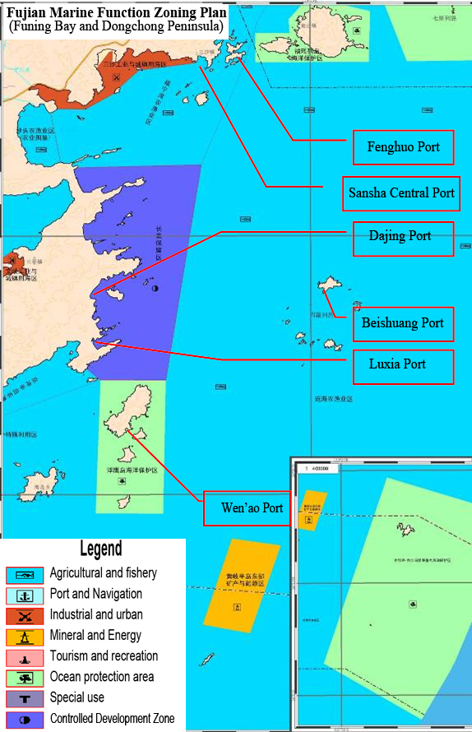
Figure 5-1 Marine Function Zoning in Project Area

Based on this marine protection plan, the sea water classifications for the proposed six fishing ports are as followsTable 5-3and Figure 5-2:

Table 5-3Marine Environmental Protection Classification of Fishing Port Area
Ports | Name | Environmental Protection Requirements
Sansha, Fenghuo,  Luxia,  Beishuang | Fishery Zone | Control pollution from surrounding land area; protect spawning ground, breeding ground and migratory channel; control reclamation scale
Dajing | Tourism Zone | Protect island/rock eco-system; strictly control occupation of coastline, beach and coastal protection forest
Wen’ao | Important habitat and ecological functional zone | Protect island eco-system, pollicipesmitella species and its eco-system

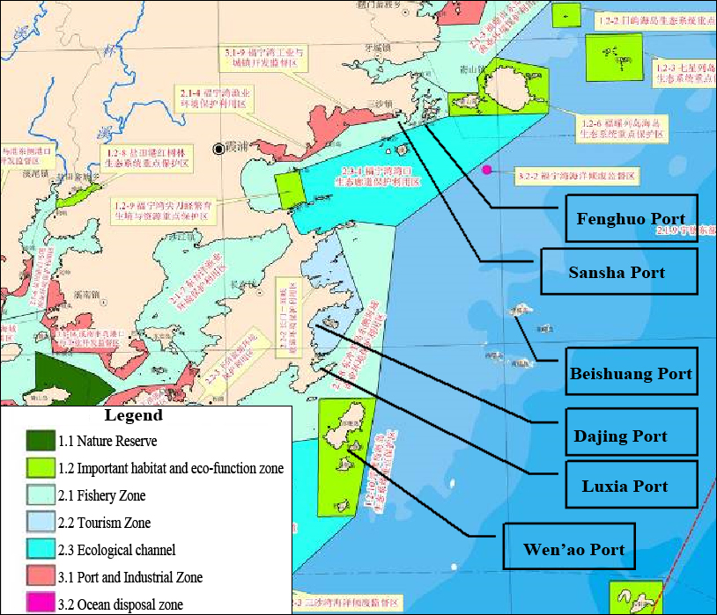
Figure 5-2 Marine Environmental Protection Classification of Fishing Port Area

The proposed Wen’ao Fishing Port is located in theFuying Island Ecological System Protection Zone”. It falls into theprotection category of “important habitat and ecological functional zone” whose specific requirements are “Area for restricted development;developingactivities with insignificantinfluence on ecological environment are allowed without influence on dominant ecological function.”Construction of two breakwaters in Wen’aohas little impact on the dominant ecological function and ecological environment of the island (see section 6.1.2). Other ports also comply with requirement of the environmental protection plan, and will not influence the main service function of eco-system based on the planning of marine functional zoning.

Other environmental and ecological function zoning plans

According to Fujian Provincial Offshore Area Environmental Functional Zoning (Minzhen [2011]No.45), the proposed Sansha Port is located in the “Class 4” zone (navigation, industrial water use and tourism function), and all other 5 ports are located in “Class 2” zone (fishery, aquaculture and navigation function). The proposed ports expansion and upgrading comply with this plan.

InFujian Provincial Ecological Functional Zoning Plan (2010), the proposed Fishing Ports are located in the “3105 Shacheng-Beijiao Ecological Functional Zone for Offshore Sea Fishery”. The main function of this zone is to maintain the fishery ecological environment, biodiversity in islands,coastal and island tourism ecological environment, port and navigation. The proposed ports expansion and upgrading comply with this plan.

Environmentally and Socially Sensitive Sites

Fuying Island Marine Protection Area

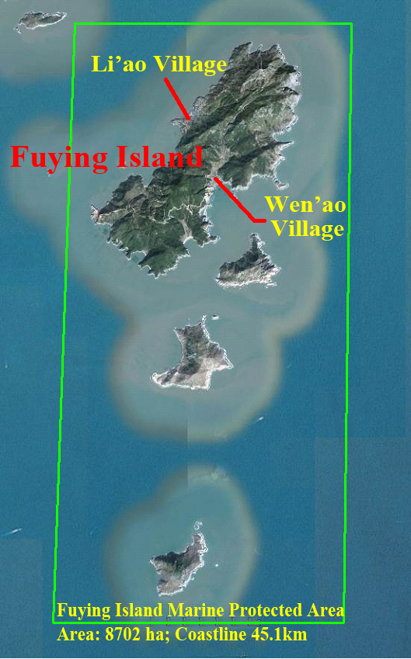The proposed Wen’ao Port is located within Fuying Island Marine Protection Area, whichhasa total area 8,702ha. The main protection objective is “protecting island ecosystem and pollicipesmitellaspecies”.Pollicipesmitella, also called “turtle foot” as it looks like, is a type of sub-tropical/tropical arthropod creature which normally collectively attached to rock cracks at intertidal and supratidal zone for whole life. It is not a threatened, rare or endangered species according to national or international protected species inventory, such as the IUCN Red List. It’s considered high-quality sea food and an income source for local fishing communities. The scope of the Protection Area and habitat of pollicipesmitellaare shown in Figure 5-3 and Figure 5-4.
Figure 5-3 Fuying Island Protected Area

There are two villages in Fuying Island with total population of 1,800 who all make living by fishing. There are also livestock grazing activities in the island with a few hundreds cattle and sheep. The proposedWen’ao Port is located adjunct toWen’ao village which has an population of 700. Location of the villages, existing docks are also shown in Figure 5-3 and 5-4.
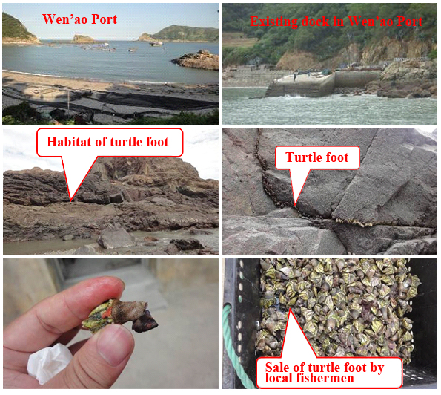
Figure 5-4 Wen’ao Fishing Port and Pollicipesmitella(turtle foot) Species

Dongchong Peninsula Provincial Scenic Area

Dongchong Peninsula Provincial Scenic Area (formerly named as Funing Bay Scenic Area) was established by Fujian Provincial Government in 2007. The Scenic Area covers an area of 187.8km², including marine area of 90.2km², island of 4km² and land area of 93.6km². The area mainly features with sand beach, coastal line and island landscape.

The proposed Luxia Fishing PortandDajing Fishing Port are located within the Scenic Area.
Dajing Beach is 2.3kkm long and 120m wide, located to the northeast of proposed construction site. There is tourism facility at the north end of the beach, and the proposed seawall is at the south end of the beach. The Dajing Port is a closed natural bay currently used as a berthing place for fishing boats. Luxia Beach is 1km long and 110m wide. Though planned as a scenic spot, there is no tourismactivity in Luxia beach as the bay has been traditionally used as fishing port by local community.
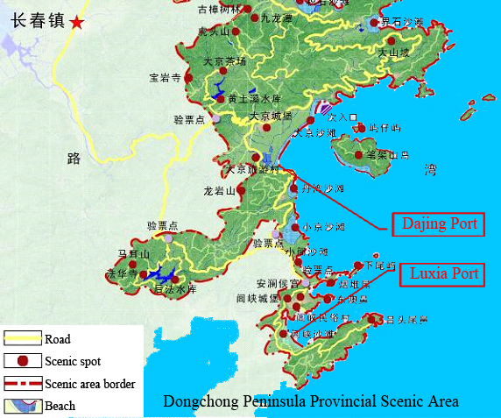

Figure 5-5 Dongchong Peninsula Provincial Scenic Area

Fuyao Islands Marine Protection Area
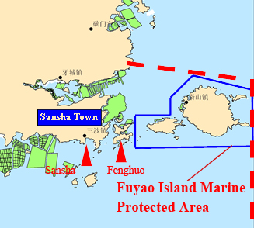
Figure 5-6 Fuyao Islands Marine Protection Area
Within assessment scope, there is the Fuyao Island Marine Protection Area (as shown in Figure 5-6). The FuyaoProtection Area has a total area of 3,807ha. The main management objective is “protecting natural resources, birds and island landscape, strictly follow the requirements of marine special reserve.” In 2012, it is promoted to a national ocean park. The main island (Yushan Island) attracts many tourists every year due to beautiful landscape.

The boundary of the protection area is 1.7km away for the nearest project construction site, i.e. Fenghuo Fishing Port.

Physical Cultural Resources

Following the requirements of Cultural Relics Protection Law of P.R.C. and OP4.11 Physical Cultural Resources, the EIA preparation institution has surveyed within the assessment scope and visited the local authorities for cultural relics protection and villagers around the project-located area, two sites, a Liu’s Tomb and a local temple are found in the vicinity of proposed Dajing Fishing Port.

The spatial relationship of these two sites with the project is shown in Figure 5-7.

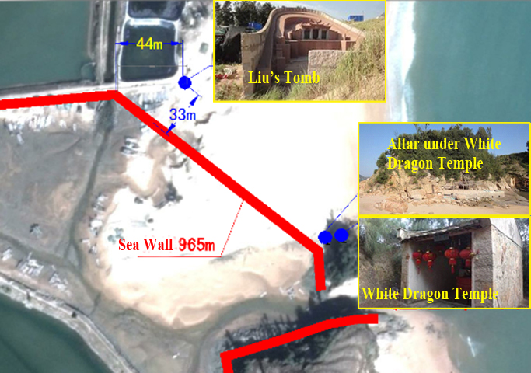
Figure 5-7 Location of Physical Culture Resources Sites in Dajing Port

- Liu’s Tomb was built since 1940 and located in the northeast side of proposed seawall with a distance of 33m. Liu was a villager of Dajing Village. In every Tomb-sweeping Day, the descendants come to sweep tomb and memorize their ancestor.
- White Dragon Temple is a shrine for local village. It was built in 1950 on top of a small hill (about 1200m² weathered rock) at the sea entrance of the Gangli Village.The Palace is a temple style building with an area of 20m², and about 5m above the high tide level. The Palace is a sacred place for local villagers. On every 1st and 15th day of the lunar month or before going fishing on the sea, the fishermen will worship in the White Dragon King’s Palace and pray for safety.

Other social sensitive sites

Others sensitive sites include aquaculture areas in Fenghuo and Luxia port area, water intakes for shrimp and crab ponds in Luxia Port, and villages of the six fishing ports.

A summary of environmental and social sensitive sites are listed in Table 5-4.

Table 5-4Environmental and Social Sensitive Sites in the Project Area
No. | Sea Environment-sensitive Area | Status and Planning Function | Position Relation to Project Construction
1 | Fuying Island Marine Protection Area | Habitat, turtle foot resources | Breakwater dam will occupy 30m wide intertidal rocks
2 | Dongchong Islands Scenic Area – Dajing Beach and Luxia Beach | Landscape and scenic spots | Dajing Port seawall is at south end of Dajing Beach;  Luxia Beach is within Luxia Port area, no construction activity in the beach area
3 | Liu’s Tomb | Liu’s family ancestor tomb, place of family memorial activity | 33m outside the planned seawall
4 | White Dragon Temple | A sacred temple for local fishing community | On top of a small hill above the planned seawall
5 | Aquaculture cultivation area | 15.5ha seaweed in Luxia;  0.3 ha laver in Fenghuo; | Inside the shelter water areas
6 | Water intakes | Water intakes for shrimp/crab ponds in Luxia | At the edge of sand beach
7 | Villages | Si’ao, Fenghuo, Luxia, Dajing, Wen’ao and Beishuang | By the ports

Ambient Environmental Quality

During EA preparation, sampling and tests of water, sediments, biological quality, marine ecology, airquality and noise baseline were conducted to characterize the physical, chemical, biological and ecological conditions of the project area.

Water Quality

Results from 81 sampling pointsshow the over 50% samples have inorganic nitrogen and active phosphate exceeding applicable standards, and certain sampling points are subject to standard-exceedance of pH, dissolved oxygen, COD, lead, zinc and mercury. This is mainly due to the land-based pollution sources, aquaculture activities and pollution of ships. There are also standard-exceeding results of inorganic nitrogen around Protection Areas of Fuying Island and Fuyao Islands.

Sediment

Results from 48 sampling points show overall compliance of sedimentin accordance with national Marine Sediment Quality standards (GB18668-2002). Therefore, for the excavation, dredging and backfill activities in Sansha and Luxia, there is no hazard risks associated with these activities.

Biological Quality

Results from ocean organism sampling from 12 sites show that the compliance of fish species with Non-pollution Marine Product Safety Requirements (GB/T18407-2001). While analysis on clam indicate overall exceedance of Class I standard of national Marine Biological Quality Standard (GB18421-2001).This is mainly due to land-based pollution sources as well as pollutions from ships.

Marine Living Resources

Phytoplankton:During the marine ecological survey, 6 phyla, 51 genera, 127 species of phytoplankton were identified, among whichprorocentrumdonghaiense is the dominant species. The phytoplankton in the project area has relatively good diversity, abundance and homogeneity. The phytoplankton community is relatively stable, with fairly even distribution of species population. Overall, the phytoplankton biodiversity and homogeneity is at the general level of sea area in Fujian Province.

Zooplankton:Marine ecological survey has identified 5 phyla, 45 species of zooplankton in the project area. The project area has less zooplankton species, and general biodiversity index and homogeneity which indicates slight pollution of marine environment. Compared with other nearby bays, the biodiversity and homogeneity value of zooplankton species in project area are lower with greater variation, which indicates unstable structure of zooplankton community. Overall, the zooplankton biomass in Funing Bay was at the general level of sea area in Fujian Province.

Shallow-sea benthic organisms: The marine survey has identified 6 phyla, 28 species of benthic organisms. The density of benthic organisms ranged from 12ind/m² to 136ind/m², averaging at 56ind/m². The biomass of benthic organisms ranged from 1.76-80.48g/m², averaging at 12.83g/m². The types of benthic organism species are relatively less with common diversity index and abundance, high homogeneity, which means the marine ecology was slightly polluted.The benthic organisms’ biomass in FuningBaywasat the general level of offshore Fujian Province. In addition, in the vicinity of project area, no sea grass or kelp beds have been identified.

Benthic organisms in intertidal zone:The survey has identified 10 phyla, 117 species macrobenthos. The density ranges from 24ind - 2,384ind/m², averaging at 512.78ind/m².The biomass ranges from 1.76– 3,872.12g/m², averaging at 490g/m².The types of benthicorganisms species are few with low diversity index and homogeneity, which means the marine ecology was slightly polluted. Compared with similar survey in 2010, there is a trend of intertidal zone benthic organisms species decreasing.

Nektonic organisms: The survey has caught 48 families, 71 species nektonic organisms.The average quantity density of fishery resources ranged greatly in different stations, averaging at 9.8X10⁴ind/km². The diversity and abundance were high while the homogeneity was common. The fishery resources in surveyed sea area were plentiful, varying greatly from different stations. The diversity, abundance and homogeneity of catch collected by stern net are all common. The nektonic organisms in Funing Bay are at the general level of offshore Fujian Province.

Pollicipesmitella (turtle foot): According to the survey carried out during Apr-May 2013, this species is widely distributed in the rock cracks in the intertidal zone, with max. distribution density of 112 ind/m² and wet biomass of 164.48g/m². The total turtle footresources deposits within this reserve are estimated at about 20t.

Waterbirds:The proposed six fishing ports are located in the sea area of Funing Bay. According to Fujian Provincial Costal Wintering Water Birds and Fujian Province Marine Environmental Function Zoning,the key habitats of waterbirdsin the project region are located in Fuyao Islands Marine Protection Area and Qixing Islands Marine Protection Area. The six fishing ports areas are not water birds habitats, as they are being used as fishing ports by local communities. There is no protected water birds species identified during the ecological survey of EA process.

Air quality

Baseline air quality (SO2, NO2, TSP, PM₁₀,) was monitored at selected sampling points in the project area. Overall, the parameters monitored can meet the applicable Air Environmental Quality Standard (GB3095-1996), and the air environment quality in assessed area is generally good.

Acoustic Environmental Quality

Total 30 noise monitoring points (5 for each port) were monitored during EA preparation. The noise level ranges from 50.8dB to 54.7dB in the daytime, and 39.5dB to 44.4dB in the nighttime. All the results conform to the Class 2 standard of Noise Environment Quality Standard (GB3096-2008).

ASSESSMENT OF IMPACTS AND MITIGATION MEASURES

As a natural disaster prevention and relief effort, the project will have significant positive socio-economic benefits by providing sheltering areas for the fishing boats and securing the safety of fishing communities in XiapuCounty. Upon project completion, effective sheltered area of 1,764,000 m² can be realized which can provide shelter for all the fishing boats of the project villages. Most of fishing boats can take shelter from typhoon at nearby fishing ports, which not only secures the safety of human and property, but also results in significant saving of economic cost by avoiding long distance travel to farer ports for shelter.

However, the project construction activities will have adverse environmental and social impacts. Such activities include foundations excavation and construction of breakwaters, land reclamation, port ancillary facility construction, and material borrow and waste disposal, etc. The main environmental and social impacts envisaged include:
- Loss of marine habitat of intertidal and subtidal zones
- Impacts on marine life
- Impacts on hydrodynamic environment and siltation
- Impacts on marine water quality
- Social impacts on aquaculture activities, land acquisition and resettlement
- Impacts on physical cultural resources
- Impacts on navigation safety
- Construction nuisance of noise, dust and waste management, and
- Impacts related to operation, including waste management, navigation safety and cumulative impacts of other development activities

These impacts are carefully assessed in EIA, SA and RAP, and adequate measures have been developed in EMP/RAP. In summary, the project will not have significant adverse impact on marine environment in the project area, will not result in significant degradation or conversion of natural habitat, will not have significant impact on physical cultural resource and scenic/tourism resort. The measures in EMP and RAP can effectively avoid, minimize, mitigate or otherwise compensate the potential environmental and social impacts.

Impacts during Construction Stage

6.1.1 Impacts on Marine Ecology

Based on the environmental impacts scoping and screening, the key impacts on marine ecology during construction stage include: permanent loss of marine habitat due to construction of breakwaters, seawalls and docks and land reclamation; impact of suspended sediments on marine life due to breakwater foundation excavation, construction and land reclamation; damage of marine life due to blasting during construction; potential impacts on Fuying Island Protection Area.

The impact assessment and mitigation measures are summarized as follows:

Permanent lossof marine habitats

The construction of breakwaters and land reclamation will result in 72 ha permanent loss of marine habitat of intertidal and subtidal zones, and an estimate loss of biomass of 18.04t, as shown in Table 6-1.
Table 6-1 Land Reclamation of the Project Ports
Ports | Occupied intertidal zone area (ha) |  |  | Biomass  (g/m²) | Loss  (t)
 | Land Reclamation | Breakwater | Total Sea Area Occupied (ha)
Sansha Central Fishing Port |  | 13.1587 | 13.1587 | 10.93 | 1.438
Luxia Class-1 Fishing Port | 7.4593 | 11.1665 | 18.6258 | 11.96 | 2.228
Fenghuo Class-2 Fishing Port | / | 2.0991 | 2.0991 | 10.04 | 0.211
Beishuang Class-2 Fishing Port | 0.8826 | / | 0.8826 | 1020.6 | 9.008
Wen'ao Class-2 Fishing Port | / | 3.0918 | 3.0918 | 27.15 | 0.839
Dajing Class-2 Fishing Port | 0.3715 | / | 0.3715 | 586.74 | 2.180
Sansha Fishing Port Phase I backfill area | 33.8* |  | 33.8 | Subtidal:5.06  Intertidal:7.6 | 2.14
Total |  |  | 72.0295 |  | 18.04
* A previously approved Sansha Fishing Port Phase I project (under domestic funding) plans to have land reclamation of 33.8ha for port facilities. All the materials from the excavation of breakwaters foundation in Sansha Fishing Port can be reused as backfilling material for land reclamation, thus reducing material borrow demand of the Phase I project.

The area of intertidal zone and subtidal zone to be utilized for construction of fishing ports covers 72 hectares, accounting for 0.1% of total intertidal zone area (696km²) of XiapuCounty,which will potentially result in loss of benthic organisms of about 18 tons.These areas are currently being used as fishing port waters and aquaculture cultivation areas by local villages. According to the ecological survey, the marine life species in the project port areas are all common and widely distributed species in the region, there is no rare or protected oceanic life found in project areas. Therefore, the project construction will not result in significant degradation or conversion of natural habitat, and will not cause decrease of biodiversity in the project area.

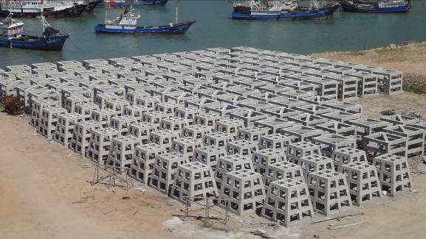The loss of habitat will partially recover through the new rocky slopes of breakwaters which create new intertidal/subtidalhabitat. Furthermore, the project also designs a habitat offset program, by deploying 40ha artificial reef in the project area (near the Dajing Port), to create new habitats for marine life. According to offset plan, the 40ha artificial reef will create 16,000m³of reef volume with large surface area and inner space (See Figure 6-1), which is expected to increase fish harvesting by 160 tons, significantly outweigh the loss of habitats resulting from the project.
Figure 6-1 Concrete Artificial Reef

Impact of suspended sediments on water quality and marine life

Breakwater foundation treatment through excavation and stone dumping will cause diffusion of suspended particles and cause water turbidity impacts on marine life. The scope of diffusion and deposition depends on particle diameter, water depth and velocity of flow. Mathematic model is used to simulate the suspended sediments diffusion scope for all the ports. It is concluded that the dredging operation will cause increase water turbidity (>10mg/l) limited to the vicinity of dredging areas, i.e. 0.098 – 1.56 km² for various ports. Suchimpact is temporary and will soon disappear shortly after construction activities. The analysis of impact on plankton, fish eggs/fry and fish concludes that such temporary turbidity impact will not result in significant loss of marine life in the vicinity of the project area, nor will it degrade or convert the nearby habitat. Within short period of time after completion of construction, quantity and distribution density of species will soon recover.

To minimize such impacts, advanced dredging method and equipment will be adopted to minimize disturbance; apply the GPS, dredge depth indicators to accurately control dredging; strictly follow Dredging Engineering Technical Specifications to avoid spills of dredged materials; avoid dredging at end of spring/early summer season; rationally plan the backfilling to allow adequate sedimentation time; Dredging Management Plan is developed in EMP.

Impact of blasting on marine life

Luxia Fishing Port needs to use blasting method to remove sediment for construction of the Outer Dam and Inner Dam-A. The blasting wave will cause loss and damage of marine life in the vicinity of operation areas. Blast waves from under-water explosion usually spread forward right through fish body since fish body and water have similar density. However, when air cavities exist in fish body, blast waves getting through will result in the avulsion or fragmentation of cavity walls due to air compression. The main reason for death of fish is that explosion causes fish bladders to burst (in terms of fish with air bladders). In addition to fish bladders, other inner organs are also easily damaged. The longer distance from the explosion site, the smaller impact of explosion on fish will be brought. Fish without air bladders have much greater chance of survival under the same conditions.

The EIA assessed the various explosive load options based on actual experiences and guidelines, and estimated the loss of nektonic organisms of 16.19t at an optimum max. load of 100kg explosive charge. While, nektons usually possess strong capability of migration, the project construction will result in the temporary migration of nektons to other sea areas. After the project construction is completed and the marine environment of the project area basically stabilize can the nektonic organisms be moved back to the project area and neighbouring areas. Therefore, the actual loss quantity of nektons will be less than estimated.

During blasting operation, a number of measures will be adopted to minimize the impact on marine life. These include strict control of explosive load, small-load prior blasting to drive away fish, run noisy equipment (e.g. air compressor) to drive away fish before blasting, avoid end of spring and early summer time to minimize the impacts on spawning, etc. With effective implementation of these measures, the potential impact on marine life will be effectively minimized.

6.1.2 Impacts on Fuying Island Marine Protection Area and Pollicipesmitella Species

The proposed Wen'ao Fishing Port is located in Fuying Island Marine Protection Areaaccording to marine function zoning plan. The key environmental protection requirement is "to protect the island ecosystem and Pollicipesmitellacommunity/ecosystem".

According to the ecological survey, the dominant species of benthonic organism in high-tide and low-tideinter-tidal zone are all common species widely distributed in the region. None of them is listed as protected or endangered species defined in List of National Protected Wildlife and IUCN Red List of Threatened Species. Pollicipesmitellais also not a protected species, and is widely distributed in China east and south sea areas. It is a high-class sea food, and thus a valuable economic source of income for local communities.

The key environmental protection objective is to protect the habitat of Pollicipesmitellaspecies on the island. Pollicipesmitellais widely distributed in the rock cracks over mean tide in intertidal zone of Fuying Island. Construction of breakwaters in Wen’ao port will occupy partial high-tidal zone which is the habitat of Pollicipesmitella species. Based on survey, the total length of water front in Fuying Island suitable for Pollicipesmitella habitat is 45,100m long. The construction of breakwaters will occupy 30m wide of rock face. This is less than 0.07% of the total habitat in the island. Therefore, the project will cause little loss of Pollicipesmitellahabitat, and will not result in significant degradation or conversion of natural habitat. It is estimated total Pollicipesmitellaresources in island is about 20t (about 99.24-164.48 g/m² wet weight), while the max loss of Pollicipesmitelladue to 30 breakwater construction is 1.6kg (or RMB 160 yuan at current price).

The construction of breakwaters needs 250,000m³ stone materials. Since the island is far away from mainland, shipping of stone material from outside is prohibitively expensive. Two borrow sites are selected in the island near the port area, with a total area of 1.7ha (0.15% of island area). Based on field investigation and remote sensing image interpretation, the two sites are adjacent to existing village and subject to disturbance of intensive human activities, the surface vegetation of the sites is mainly planted horsetail beefwood, which is not protected species, neither virgin forest. These sites are well above the high-tide zone, and no habitat of Pollicipesmitellaspecies. Therefore, material borrowing will not have major impact on natural ecological system in the island, and have no impact on the main projection objective of the Fuying Island Marine Protection Area.

Consultation with relevant authority has been conducted during EA preparation and approval document for Wen’ao Fishing Port expansion and upgrading has been approved by Ningde Municipal Ocean and Fishery Bureau.

6.1.3 Impacts on Fuyao Islands Marine Protection Area

As described in Chapter 5, the Fuyao Islands Marine Protection Area (shown in Figure 5-6) is to the east of Fenghuo Port. The main management objective is “protecting natural resources, birds and island landscape, strictly follow the requirements of marine special reserve.” The distance of Fuyao Islands Marine Protection Area boundary to Fenghuo Port is 1.7km. The potential impact will be water turbidity caused by suspended sediment diffusion by breakwater construction. Based on modelling, the suspended sediment increase of Fenghuo Port is within 1km of construction site, therefore, have no impact on Fuyao Islands Marine Protection Area.

6.1.4 Land Acquisition, Resettlement and Aquaculture Livelihood

The project has no household relocation but only acquisition for 207 mu land (13.8ha),276 mu aquaculture ocean area. The project will also result in demolition of 3120m² non-residential buildings of 4 entities, and acquisition of 276mu aquaculture cultivation areas. There are total 274 affected people in 6 villages. Following World Bank safeguards policies OP4.12, detailed survey of land acquisition and resettlement, consultation with project-affected people were conducted during project preparation. A Resettlement Action Plan (RAP) has been developed during project preparation which identifies the scope of impacts, develops compensation measures and mechanisms, grievance procedures, institutional arrangement, capacity building, monitoring and reporting procedures.

Currently, there are aquaculture cultivation activities in the project areas of Fenghuo Port and Luxia Port.

In Fenghuo Port, there are 0.3 hectare of nori cultivation area and 15 small yellow croaker cultivation cages. These properties have been compensated in 2010 for a planned relocation to outside the port area in 2014. By the time that proposed Fenghuo Fishing Port construction in 2017, there will be no aquaculture activities with in the area of influence.

In Luxia Port, there is 15.5 ha seaweed cultivation area within the planned shelter waters. These will be relocated under the project, and full compensation is provided. (See details in RAP).

There are also two water intakes at the coastal line of Luxia Port which supply water for a shrimp pond and a crab pond in land area of west and south of the port. These two water intake pump water through 10-15m deep wellsat the edge of the sand beach. Based on modelling calculation of suspended sediment (SS) diffusion, the construction of breakwaters will not cause suspended sediment over 10mg/l at the west water intake location, and will cause a slightly higher than 10mg/l at the south intake location. Modelling results also indicate that such suspended sediment is temporary, and will clear away the next day. While, since the water intake pumps water from underground where 10-15m sand beach is a natural filter for the sea water, the slight increase of suspend sediment will not have adverse impact on the water quality pumped out of the well (Figure 6-2).

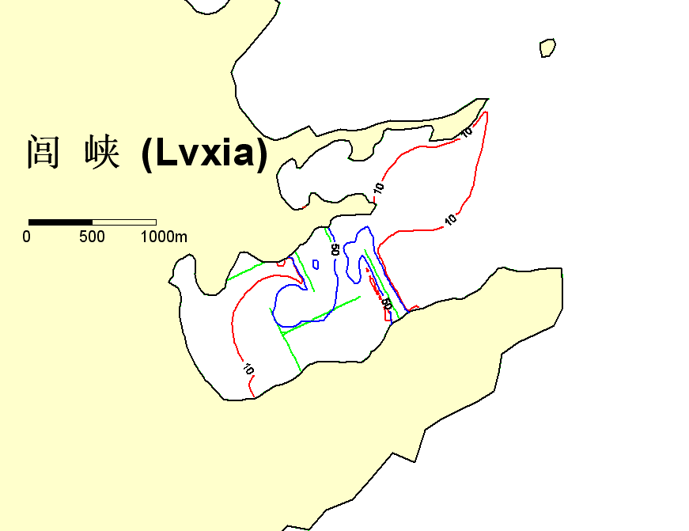To further minimize the potential impact of water quality for the shrimp/crab ponds, coordination with the ponds owners will be carried out by the project owner to schedule the water taking after 12 hours of breakwater construction activity.
West intake
South intake
Figure 6-2 SS Impact from Breakwater Construction

6.1.5 Impacts on Communities

Since all project ports are the existing fishing ports surrounded by local communities, the construction of breakwaters, material hauling, blasting and seawall construction will have disturbance impact on the daily life of these communities, including nuisance of noise and dust, traffic disturbance and safety. There is also potential community impact of influx of construction workers into the project sites, which is considered limited given the fact that at peak construction sea, at most 50-100 workers will be needed.Overall, these impacts are manageable through good environmental management practice during construction.

In Luxia Port, blasting will be used for 2 breakwaters construction. Following the safety distance requirement of the national Safety Guidelines for Blasting (GB 6722-2011), when single load quantity of explosive is 100 kg, safety distance of brick buildings is 83m. The blasting point of breakwater in Luxiaisover 200 m away from LuxiaVillage. Therefore, the seismic wave from underwater blasting in Luxia Fishing Port will not cause major impact on Luxia Village.

Blasting in quarry sites may also have impacts on nearby villages. Following the national Safety Guidelines for Blasting (GB 6722-2011), a single load of 50kg explosive is selected to ensure 70m safety distance of non-impact on residential houses. The nearest village from quarry site is Beishuang Village for Beishuang Fishing Port, with a distance of 166m. The selected max 50kg load can ensure safety of all communities near the project fishing ports.

According to EIA estimate, the labor force for Sansha and Luxia will be around 100 people respectively, and 50 each for other four ports. Due to small scale of construction force, no workers camp will be constructed. Accommodation of the workers will rely on renting the houses from local community. The community impact from such influx of construction workers is expected to be minimum because of following reason: On one hand, most of the workers are local people with similar cultural and social habits; on the other hand, according to Social Assessment Report, there is no ethnic minority community in the project area, and a few individual ethnic minority households in the project villages (Dajing and Luxia) live a life with no ethnic difference from the rest of the community. Therefore, the influx of construction workers in the project sites will have little social and cultural impacts on the communities. In addition, the renting of local houses and living expenses of these workers will increase the revenue of local communities and thus positively contribute to local economy.

To minimize community impacts, a number of mitigation measures will be carried out during construction, including: education and training of workers on Code of Conducts and local cultures; adoption of low-noise construction equipment and transportation vehicle; schedule construction time to avoid noise disturbance during lunch time; prohibit night-time construction; restrict material hauling vehicle speed; water spraying on access roads to suppress dust; use covered trucks for material transportation; assign cleaning team to keep the access road clean; strictly follow safety procedures defined in Safety Guidelines for Blasting; establish safety perimeter with designated staff; prior notice to communities of blasting operation.

6.1.6 Impacts on Physical Cultural Resources

Two physical cultural resources are identified near Dajing Fishing Port, i.e. Liu’s Tomb and White Dragon Temple (as described in Chapter 5).

Liu’s Tomb.As shown in Figure 5-7, this tomb is 33m outside the planned seawall. The construction of the seawall of Dajing Fishing Port no blasting operation, and the construction of the seawall will not cause any damage to the tomb.

White Dragon Temple. White Dragon Temple is a sacred shrine considered by local community to safeguards their safety of sailing. The temple is on top of a 17m high rock hill, while the seawall connecting to the hill is only 5m high. The construction of seawall will have no impact on the temple. Meanwhile, the simple platform of altar under the hill will be better constructed on top the seawall following villager’s opinion.

During construction, the following measures will be implemented to protect the two physical cultural resource sites: education training be provided to workers on protection of cultural resources and local culture; warning signs and fences will be put on site; no damage of rock and vegetation on the hill is allowed; ensure temporary access to the two sites during construction; properly schedule construction activities to avoid disturbance on sacred ceremonies of local community; chance-find procedures will be strictly followed to ensure proper protection in case of chance-find.

6.1.7 Impacts on Scenic Area

Within Dongchong Peninsula Scenic Area, there are two scenic spots near the project ports, i.e. Dajing Beach in Dajing Port, and Luxia Beach in Luxia Port.

Dajing Beach has an area of 27 ha, 2.3km long and 120m wide. Currently, there is light tourism activity in north part of the beach, and no tourism in the southern part. The DajingPort is located at the south end of Dajing Beach. The port area is a closed bay hiding behind the sandy beach. The proposed seawall construction is within the closed bay area, and not visible from the sea or from the beach. Sand excavated inside the bay is the same sand as outside beach, and will be backfilled outside the seawall. Therefore, construction of Dajing fishing port has visual impact on the Dajing Beach.

Luxia Beach is at the end of Luxia Port, with a total area of 10.4ha. It is 1km long and 110m wide. The proposed breakwater and port construction will not touch the beach part. Currently there is no tourism activity in the Luxia Beach, since the bay is heavily used as fishing port and aquaculture cultivation by local community, and there is no convenient access for outside tourists. The construction of breakwater dikes will not directly affect the sand beach, except visual impact of sea view from the beach. The sheltering function of the port will not affect the beach recreational function since these two scenarios will never overlap.

Consultation with relevant authorities have been conducted during EA preparation, and approval document for expansion and upgrading of Luxia and Dajing ports has been issued by Xiapu County Counstruction Bureau.

6.1.8Navigation and Safety

Dredging and blasting will have disturbance on the normal navigation of the ports, with potential risk of collision and spills. According to project design, blasting in Luxia port will be arranged once every two days, and each time only lasts few minutes. Therefore, the disturbance of navigation is limited.

To mitigate such risk, security watch will be deployed during underwater blasting operation. Restricted area will be established, all boats and personnel are forbidden to enter the restricted area. Prior notification will be made in advance to boats to avoid the area, in particular, the safety of construction personnel, boats berthed at the port area and passing by. The notice will specify the construction period, area and scope, and the relevant precautions in detail, and blasting time, navigation hours and entry/exit arrangements.

6.1.9Terrestrial Ecology

The main terrestrial ecological impact of the project comes from quarries, ancillary facilities construction on land, dismantle of old dike in Dajing Port. The main impact will be soil erosion and loss of surface vegetation.

The proposed quarry sites and port construction areas are normal rock mountains near the ports. They are not classified as any terrestrial nature reserve area. Based on ecological survey during EA preparation, Sansha and Fenghuoports will use existing quarries, while the remaining ports will need to use new borrow sites near the port. The main vegetation in these areas are all common species in the region, and there is no protected or endangered plant species identified in these areas. In summary, the project will have little impact on terrestrial ecology, will not result in loss of terrestrial biodiversity and ecological integrity of the project area.

According to project design, all top soil will be reserved for greening upon project completion. Material from old dike dismantling in Dajing will be reused for bank protection works. All dredged material from Sansha port will be reused as backfilling material for land reclamation planned under the Sansha Fishing Port –Phase I project. No waste spoil material is generated by the projectthat requires separate disposal site.

To minimize terrestrial ecological impacts, a Soil Erosion Control Plan has been developed as part of the EA preparation, which includes a set of comprehensive engineering, plantation and temporary mitigation measures, e.g. interception drainage ditch (9.6km), settling tanks, preservation of top soil, planation of 10654 trees, seed broadcasting of 12ha, and temporary retaining/interception measuresetc.

6.1.10Management of Construction Ship Waste

During dredging and blasting operation, there will be small amount of wastewater and solid waste generated from the operation ships, which may have adverse impact on the water quality and ecological environment of the Bay. According to Management Regulations on Preventing Vessels from Polluting Marine Environment, Fujian Marine Environmental Protection Regulations and other relevant laws and regulations, construction vessels must be equipped with oil-contaminated water storage tanks (or containers) and for oil polluted water to be received and disposed by receiving organizations authorized by maritime authorities. Discharge of oil-polluted water to the harbor area is prohibited. By unloading the wastewater and solid waste to the central treatment facility in the port, the impact of construction ship waste can be adequately mitigated.

Impacts during Operation Stage

During port operation, the main environmental concerns will include hydrodynamics and siltation changes caused by breakwater construction, wastewater and solid waste from port facilities and fishing boats, navigation safety, oil spill risks and responses, and cumulative environmental impacts from induced port development activities.

6.2.1 Hydrodynamics and Siltation

The construction of breakwater dikes will results in change of hydrodynamic condition and erosion/siltation process of the fishing port areas. To analyze such changes, a dedicated Research Report on Mathematic Model Computation of Hydrodynamic Force of Fishing Port Construction Projectshas been prepared by Hehai University. Computer modelling was used to simulate the hydrodynamic and siltation changes at each of the project port area.

Based on simulation results, it is expected that new breakwaters will cause slight hydrodynamic changes at these port areas, and siltation will start to occur near the dike area and within the sheltered water areas in the port. Siltation intensity is high for the first year, i.e. 0.05 – 0.2m/year, and then will decrease in the coming year until new equilibrium reached in 10-15 years. The computer modelling also simulates the final stable siltation level after 15 years operation. The results confirm that final siltation condition will be not affect the navigation and typhoon sheltering function of the six fishing ports. Therefore, no maintenance dredging is needed for these ports during operation.

6.2.2Waste Management

The major marine environmental impact during operation stage is the waste water and solid waste from the port facilities and fishing boats, including port operation wastewater (e.g. ground washing, fishing process), sewage and oil-containing wastewater from fishing boats.A summary of wastewater generated from six fishing ports are shown in Table 6-2. Wastewater treatment facilities are designed for each port to ensure compliance of discharge with applicable standards.

Table 6-2 Wastewater Amount in Each Fishing Port

Fishing Ports | Total Daily Wastewater Generated (t/d)
Sansha | 894.6 (wastewater from ongoing port development activities included)
Luxia | 746.1
Fenghuo | 5.5
Dajing | 53.88
Beishuang | 5.5
Wen’ao | 5.5

Two fishing ports are selected for detailed impact assessment, i.e. Sansha (classided as Central Port) and Luxia (Class-1 Port) because these two ports are expected to have ancillary facilities for fish processing, storage and distribution, while other four fishing ports (class 2 ports) don’t. Computer modeling results indicate that discharge of treated wastewater will not result in non-compliance of water quality in the port areas. In fact, wastewater treatment facilities constructed under the project will likely reduce the total pollution discharge into the sea compared with the “without project” scenario where such wastewater is discharged into the sea directly.

Solid waste collection facilities will also be established in all the fishing ports to receive/collect solid waste from fishing boats and port area. Disposal of collected wastes will be incorporated into the municipal solid waste disposal system of the local communities.

6.2.3Odor Control

One of the major environmental nuisances during port operation is the odor from fresh and rotten fishing products, as well as odor from wastewater treatment facilities. To minimize such impact, mitigation measures will be carried out, including: reduce scattering and littering of small sea products; timely cleaning of the dock platform; frequent washing of ground and collect wastewater into wastewater treatment facilities; proper cover/sealing of the regulation, hydrolytic acidification and front part of contact oxidation tanks of the wastewater treatment facility; proper sealing of sludge cells etc.

6.2.4Dongchong Peninsula Scenic Area

For Dajing Port, the scenic spot is the Dajing Beach. Currently, there is no tourism development at the southern part of the beach where port is close-by. The port is located the south end of the beach, and is inside a closed bay area behind the high sand beach bank. It is not visible from the beach or from the sea. Therefore, improvement of the existing port area in Dajing will not affect the scenic value of the Dajing Beach.

For Luxia port, the scenic spot is Luxia Beach which is located at the bottom the bay area. Though planned as a scenic spot, there is notourism activity and service facility yet at this beach. Currently, the bay area is being used by local community as a fishing port/ferry dock with existing dock and embankment facilities. The building of breakwater dikes will have aesthetic impact on the sea view from the beach, but will not affect tourism activities on the beach or beach waters. The breakwaters and dock is at least 500m away from the beach, and will not affect the tourism activities at the beach. Water quality modeling results indicate that limited wastewater from port operation will not cause non-compliance of water quality in this area.

6.2.5Fuying Island Marine Protection Area

During operation stage, with two new breakwaters, the Wen’ao Port will continue its current function as shelter and berthing area for fishing boats of Wen’ao village. There is no increase of number of fishing boats and waste discharge compared with current situation, so there is no impact envisaged on the marine eco-system in the project area. There is also no other port activity that will involve any damage of intertidal/supratidal rocks along the island where the Pollicipesmitella (turtle foot) species might exist. Therefore, no adverse impact on the key protected objectives of Fuying Island Marine Protection Area is envisaged during the operation stage at Wen’ao Fishing Port.

6.2.6 Safety and Emergency Response

The construction of breakwaters and relevant port facilities will significantly improve the safety of fishing boats during typhoon period. With effective sheltering area of 1.764million m², the project will be able to provide 100% sheltering coverage for the fishing boats of all the six villages, reduce potential life and property loss and save significant economic and time costs of the fishing communities.

In addition, the project will also upgrade the early warning and response systems in Fujian Province, including: (i) upgrading Fujian Provincial Central Ocean and Fishing Vessels Management Information System Platform; (ii) installing a dedicated connection between the Provincial Center and the Plow Satellite Operations Service Center, to enable direct connection with the Plow Satellite communication and positioning system; (iii) upgrading and improving the user friendliness of the interface between the Provincial Center, cities, counties, and Class I fishing ports and the Plow Satellite services.

In Xiapu County, Xiapu Bureau of Water Resources has established an emergency command system, which can identify locations and communicate with all fishing boats under its administration within the sea areas of XiapuCounty.Xiapu County has also developed a series of emergency response plans, including"Emergency Preparedness Plan for Sheltering Fisheries from Typhoons", "Emergency Preparedness Plan for Disruptive Events", "Emergency Preparedness Plan for the Relief of Fishing Port Safety Accidents", etc.

For the six ports, the Xiapu State Assets Investment Company (XSAIC) will establish three fishing port management companies, i.e. Sansha Fishing Port Management Company (or Sansha Company, in charge of Sansha and Fenghuo ports), Changchun Company (in charge of Luxia and Dajing ports) and Haidao Company (in charge of Wen’ao and Beishuang ports). Management office will be established in each port with dedicated staff, which will be responsible for port facility maintenance, and most importantly, dispatching and guiding the berthing order/locations of fishing boats during typhoon periods. Detailed safety and emergency response plans for these ports will be developed XSAIC and its port management companies during operation stage.

6.2.7Oil Spill Risks and Emergency Response

The EIA assessed the potential environmental risks of oil spill. All the fishing ports are only used by local fishing boats, and there is no hazardous or dangerous goods or petroleum product to be shipped through these ports. Therefore, the main risk is the possible collision of fishing boats which may result in leakage or spill of fuel oil.

Computer modeling was conducted to simulate the fuel oil dispersion under hypothetical fuel spills (full fuel load for largest ship type) for three ports (two major ports of Sansha and Luxia, and Wen’ao port as it is in the Fuying Island Protection Area). Various tidal scenarios were considered for the simulation, and results show that potential oil dispersion scope is 9.651 – 23.514 km², 0.067 – 25.157 km² and 0.19-27.118km² for Sansha, Luxia and Wen’ao ports respectively.

To minimize the fuel oil spill risk, the following measures will be implemented: berthing and anchorage safety rules will be developed by port management companies; safety and spill prevention education and training will be provided to fishing communities; watching and dispatching system will be established; adequate anchorage and anti-collision facilities will be installed; emergency response plan will be developed by port management companies.

Currently, oil spill emergency response is under the responsibility of NingdeMaritimeSafety Administration which has necessary equipment. There are also two private oil spill cleanup companies in Ningde City. NingdeMaritimeSafety Administration has developed Emergency Preparedness Plan of Ningde City for Offshore Search & Rescue and Oil Spill Accidents in 2007, which is aimed to prevent and respond to the possible and ongoing serious or extra-serious oil spill accidents taking place in the sea areas governed by Ningde. It also takes into account the diffusibility and fluidity of oil slick, regionality of impacts and the collaboration with the provincial and adjacent offshore oil spill pollution emergency action systems. The emergency preparedness plan for the oil spill accidents of this project will be incorporated into the offshore oil spill emergency action system of Ningde City.

6.2.8 Cumulative Impacts

The EIA assessed the cumulative impacts with consideration of other major projects in the projects area that are being/will be implemented with timeframe of this project, as well as indirect impact potentially induced by the project. Based on this consideration, such activities will include Sansha Fishing Port Phase I project, and operation and induced development of project ports, and sustainable fishery management. For the six fishing ports under the project, they are dispersed in Xiapu sea areas and far from each other, the construction and operation of these ports will unlikely cause overlapping or cumulative impacts.

The main cumulative impacts envisaged include:
- Marine habitat loss due to land reclamation of Sansha Central Port Phase-I project and this proposed project;
- Combined impacts on port siltation from both this proposed project and Sansha Central Port Phase-I project;
- Water quality impact from the planned Sanshatownshipdevelopment;
- Potential impact of sustainable fishery resources

The Sansha Central Port Phase-I project was planned before this proposed project and has been partially implemented. The remaining will be constructed simultaneously with this project to achieve synergy of disaster preventive measures, dock/port layout, infrastructure compatibility, as well as reuse of dredging materials from breakwater construction. The EIA for Sansha Central Port Phase-I project has been approved by Fujian Provincial Department of Ocean and Fishery in October 2011. A due diligence review of this EIA, including resettlement, has been conducted during this project EIA and RAP preparation, and concluded that potential impacts of Sansha Central Port Phase-I project has been duly assessed, and proper mitigation measures have been developed.

Combined Impacts of Reclamation and Habitat Loss

The Sansha Central Port Phase-I project plans to reclaim a total area of 57.25ha intertidal zone and shallow water area in the Sansha bay for development of docks and ancillary port facilities e.g. fish storage and handling.Of this 57.25 ha reclamation area, 33.8ha will be reclaimed by reusing the dredged materials from the breakwater construction under the World Bank funded project. This arrangement will effectively reduce the potential environmental impacts of disposal of dredged material (whether dumped into ocean or at other disposal area where land need to be acquired), and reduced the demand of earth/stone borrowing by land reclamation planned by Sansha Central Port Phase-I project.

Therefore, the total loss of the coastal habitat due to both projects will be 57.25ha, about 0.08% of total intertidal zone area of Xiapu County. Meanwhile, Sansha bay has been used as a major fishing port for Sansha Township for decades. The occupied coastal water areas have been intensively used by fishing boats and human activities, and are not important natural habitat. Therefore, the total loss of habitat in Sansha bay will not result in significant degradation or conversion of natural habitat is the project area of Xiapu County.

To mitigate such impacts, Xiapu Ocean and Fishery Bureau has implemented a man-made reef deployment project in 2013, by deploying 367 man-made concrete reef blocks. Total deployment area is 259,200 m². It is also planned to use old fishing boats as man-made reef for deployment of another 80,000m². Based on these, Xiapu Ocean and Fishery Bureau plans to establish alga cultivation area of 6.7ha over the man-made reef area, and cultivate benthonic organisms in the area to enhance the habitat quality and increase biodiversity.

Under this proposed project, an additional man-made reef habitat compensation program is planned in the EMP, which will support another 40ha man-made reef area. The budget and implementation is included in the project EMP.

Port Siltation Impact

Upon completion of both Sansha Central Port Phase-I project and this proposed project, the marine hydrodynamics and siltation process will be affected. Such cumulative impacts have been taken into consideration of this EIA where computer modelling is conducted for the scenario of two projects together. The modelling results indicate that an erosion and siltation will reach an equilibrium over 10-15 years, and this will not affect the navigation, sheltering function of the port area, and no maintenance dredging is needed during the operation.

Wastewater from SanshaPort Development

The Sansha Central Port Phase-I project and this proposed project jointly will generate 300d/t wastewater from ground washing, oil-containing wastewater from ships and sewage from ships and port facilities. A wastewater treatment facility has been included in the project design to treat all the wastewater envisaged.

In addition, the EIA also considered the long-term development plan of Sansha Township based on Master Plan of Sansha on Comprehensive Innovation and Construction of Pilot Towns (2010-2030). According to the Master Plan, Sansha Town aims to become a pilot of reform and innovation township by fostering and extending marine product value chain. By 2030, the total population will increase from 34,400 to 100,000. The total wastewater from Sansha Town and port will be 12,000t/d. The Master Plan includes one wastewater treatment plant at the southeast coast of Sansha Town. A computer modelling of combined wastewater discharge from port wastewater treatment facility and township wastewater treatment plant was carried out to simulate the potential water quality impact around the port area. The results indicate that sea water quality around port area will comply with applicable standards.

Potential Impacts on Fishery Resources

Although the project is not supporting any economic or fishing activities directly, the EA included an assessment of potential impacts of increased fishing over time. The Chinese and Fujian province have enacted policies, established institutions and enforced measures to restrictover fishing and help restore fishery resources. China has adopted a limit on the number and capacity of fishing vessels since 1987. The latest ordinance of the Ministry of Agriculture indicates that during the 12th Five-Year Plan (2010-2015), the number and capacity of fishing boats in 2015 should not exceed the number and capacity in 2010. Fujian Province has made continuous efforts and enacted policies to restrict fishing, implement regular moratoriums on fishing, and promote public campaigns. In 2013, the Province has issued a plan to further strengthen its enforcement capacity and curb overfishing by 2020. Given the overall policy environment, existing enforcement capacity and the scope of investments of this project, the impacts on fishery resources are expected to be very limited.

In order to restore and enhance the fishery resources that has been adversely affected by recent overfishing and reclamation activities, Fujian Department of Ocean and Fishery has issued Fujian Provincial Planning on Enhancement Releasing of Living Aquatic Resources(2010-2015), which explicitly specifies species, amount and schedule of fish fry breeding and releasing programs at major sea areas along Fujian coast, including Sansha bay. In Ningde, NingdeOcean and Fishery Bureau and has been implementing breeding and releasing programseven before the provincial plan since 2005, and more than tens of millions fish fries have been released so far.

PUBLIC CONSULTATION AND DISCLOSURE

Two rounds of public consultation have been conducted in July and October 2013 respectively according to the World Bank Environmental Assessment Safeguard Policy OP4.01. A combination of questionnaire surveys and public meetings have been organized in project affected communities, including Changchun Town, Sansha Town, and all the six project port villages. Public concerns have been responded to during consultation and incorporated either in project design or in the EMP.

More than 220 people have been consulted, and 100% support to the project is received. Expectation of early implementation of the project as soon as possible is expressed by the people consulted.

Information disclosure of EA preparation has been carried out through village bulletins, local newspapers (Mingdong Daily) and websites of Xiapu County Government and Fujian Provincial Environmental Science Institute. The full EIA document was disclosed on the website of Xiapu County Government on September 30, 2013, with announcement on Mindong Daily on Sept 20. Meanwhile, the EIA reports are also placed in township/village offices in Changchun Town, Sansha Town, Dajing, Fenghuo, Luxia and Wu’ao since Oct 5, 2013. In addition, the EIA/EMP are also disclosed in InfoShopin???? 2013.

For the purpose of minimizing impacts, communication with project affected people will continue throughout the project.Agrievance procedure will be established, including the following steps:
Stage 1: If the affected person is discontent with the indirect impacts of project construction, he/she can file oral or written complaints to Changchun Township Government, Sansha Township Government, Beishuang Villagers' Committee or Wen'ao Villagers' Committee respectively. The oral complaint shall be handled and recorded by the corresponding township government or villagers' committee, which shall make the handling decision within 2 weeks.
Stage 2: If the affected person is still discontent with the handling decision made in the stage 1, he/she can lodge a complaint to Xiapu County Ocean and Fishery Bureau upon receipt of such decision. The corresponding responsible department shall make the handling decision within 2 weeks.
Stage 3: If the affected person is still unsatisfied with the handling decision made in Stage 2, he/she may bring a case to the civil court according to the Civil Procedure Law upon receipt of such decision.

The grievance procedure shall remain effective during the whole construction period to make sure the affected persons can use it to deal with relevant problems. The aquaculture farm acquisition administration shall properly register and manage the complaint documents and the handling results, and submit such documents to the PMO in written form every month. The PMO will accordingly carry out periodic checks. In order to completely record the complaints of affected persons and the handling status for relevant complaints, the PMO will maintain a form for registering complaints and the handling status thereof.

ENVIRONMENTAL MANAGEMENT PLAN (EMP)

A stand-alone Environmental Management Plan (EMP) has been developed, which specifies environmental management and supervision roles and responsibilities, mitigation measures, environmental monitoring, capacity building programs and EMP budget.

Roles and Responsibilities

The implementation of EMP requires the involvement of multi stakeholders (Figure 8-1), each fulfilling a different but vital role to ensure effective environmental management for the project.

Fujian Department of Ocean and Fisheries
(FPMO)
Xiapu State Owned Assets Investment & Operation Co., Ltd.
Independent Environmental Management Consultant
Environmental Supervision Engineer
Environmental Quality Monitoring Consultant
Contractor, construction site and surroundingEnvironmental Supervision Engineer
environment

Figure 8-1 Environmental Management Structure during Construction

Fujian Provincial Ocean and Fishery Department (FPOFD) will take the overall responsibility for management and coordination of the project implementation. FPOFD has established a Project Management Office (PMO) to manage the project implementation and ensure the overall compliance of EMP.

Xiapu State Assets Investment Company (XSAIC)will be the project owner and implementation entity for the project. It has the overall responsibility to ensure that the project environmental management complies with EMP and relevant legislations, including:
- Supervise the implementation of mitigation measures and other environmental protection measures during project construction, including incorporation of the measures into bidding documents and contracts, organizing training for the contractors, enforce other environmental management programs and conduct periodically inspection of the construction sites.
- Engage environmental monitoring consultant (for example, local Environmental Monitoring Stations) to carry out environmental monitoring in accordance with the project environmental monitoring plan.
- Engage Independent Environmental Consultant to provide technical support including management advice, training, periodical field inspection, and preparation of reports.

XSAIC will designate dedicated environmental staff in charge of overall coordination of EMP implementation.

Contractorsare responsible for taking all efforts to avoid the negative environmental and social impacts, and effectively implement mitigation measures specified in the EMP and contracts to minimize harm and nuisances on the environment and local communities. The Contractors are requested to establish a robust environmental management system that addresses institutional, site-specific measures, monitoring, training and reporting requirements. These requirements are specified in the Environmental Specifications for Contractors chapter of EMP.

Environmental Supervision Engineer (ESE)is an integral part of Project Supervision Company’s function. Each Supervision company will be requested to assign at least one ESE to each contract who will be responsible for: reviewing the Contractor’s Environmental Protection Implementation Plan and Environmental Protection Construction Organization Planin compliance with EMP; carrying out day-to-day site environmental inspection; instructing the Contractor to take corrective actions in case non-compliance; monitoring the performance of the Contractor’s environmental management system; preparing environmental supervision reports; approving invoices or payments with consideration of EMP performance etc.

Independent Environmental Consultant (IEC)will be engaged by XSAIC to provide technical support for environmental protection during the construction period. The IEC is independent of the ESE and Contractors, and will directly report to XSAIC. In particular, the IES will be responsible for: reviewing and auditing in an independent, objective and professional manner in all aspects of the EMP; validating the accuracy of monitoring results, monitoring equipment, monitoring locations, monitoring procedures and locations of sensitive receivers; carry out random site inspection; auditing the EIA recommendations and requirement against the status of implementation of environmental protection measures; reviewing the effectiveness of environmental mitigation measures and project environmental performance;verifying the investigation results of any non-compliance of the environmentalperformance and the effectiveness of corrective measures; providing environmental training to the Contractors, Environmental Supervision Engineers (ESE) and the XSAIC staff prior to and during construction; preparing semi-annual report to the XSAIC, FPCFD and the World Bank.

Environmental Monitoring Station (EMS)will be engaged by XSAIC to monitor the environmental quality in the project area according to the monitoring plan in EMP.

Xiapu Ocean and Fishery Bureau (XOFB) will be the implementing entity for the ecological compensation program. With dedicated fund provided under the project, XOFB will be responsible for the man-made reef deployment program, including: location selection, baseline survey, reef design and deployment, and monitoring and evaluation.

Management Plans

A number of specific management plans have been developed in the EMP, with detailed and site specific mitigation measures, including:
- Project Supervision and Monitoring Plan
- Dredged Material Management Plan
- Contractor Environmental Specifications
- Emergency Response Plan
- Marin Ecology Compensation Plan
- Communication and Stakeholder Engagement Plan, and
- Environmental Training Plan

These plans specify detailed mitigation measures for avoid, minimize, mitigate or compensate the environmental and social impacts. These measures will be incorporated in the bidding documents and contracts to ensure effective implementation.

Management of Contractors

Contractors will be a key component in environmental management, pollution control and impact mitigation during construction. During the construction period, the contractors are mainly responsible for effective implementation of environmental protection and pollution mitigation measures. Therefore, environmental awareness and capacity of contractors are critical for good environmental performance of the project. In order to ensure strong environmental capacity and smooth implementation of environmental protection measures, the following contractor management measures will be implemented:
- During pre-qualification, the environmental management will be included in the authentication clause when the contractor’s qualification is reviewed. Under the same condition, priority shall be given to the bidders who have passed the ISO9000 and ISO14000 authentication;
- In preparation the bidding document, the project owner will ensure mitigation measures included in the EMP are fully incorporated, and require the potential bidders to prepare the bids that fully cover the budgetary estimates for EMP implementation. Therefore, the implementation of the environmental protection measures will become the obligation and responsibility of the successful bidder;
- Every Contractor will be required to provide dedicated environmental staff on each section of the Project. In order to be qualified for the job, the environmental staff will receive an environmental training program prior to construction;
- Prior to construction, the Contractor are required to submit site-specific Environmental Protection Implementation Plan and Environmental Protection Construction Organization Plan for key project activities with potential impacts (if any). The Plans shall be demonstrate compliance with domestic environmental regulations, the mitigation measures specified in the EMP. The plans shall provide details such as commitment to environmental protection by the Contractor’s project management team; methodology of implementing the project EMP; detailed designs and installation of pollution control facilities (e.g. drainage channel, settling tank, etc.); environmental control mechanism; detailed earthworks management plans and site operation plans outlining the measures that are proposed to minimize, mitigate and manage the effects, for the duration of the construction works; and environmental monitoring program during different stages of construction period.
- Prior to the commencement of construction, the Contractor shall receive adequate training on EMP and relevant regulations.

EMP Budget

All mitigation measures have been budgeted and fully incorporated in project costs including monitoring and supervision.

The total investment for environmental protection is RMB23.9million. The detailed EMP budget is shown in Table 8-1.

Table 8-1 Budget for Environmental Management Plan
No. | Mitigation Measures | Budget  (Yuan) | Notes
1 | Ecological compensation program | 5,150,000 | Man-made reef deployment
2 | Environmental management during construction | 300,000 | Wastewater, dust and solid waste management
3 | Environmental management, risk prevention and monitoring | 600,000
4 | Water conservation and soil erosion control | 7,810,000 | Incorporate into soil erosion budget
5 | Pollution control in backfilling area | / | Filtration of coffer dam etc. Included in investment of Sanshan Phase I Project
6 | Environmental Management Consulting During Construction | / | Included in TA
7 | Wastewater water treatment facility | 2,175,000
8 | Solid waste collection and disposal facility | 38,000
9 | Land acquisition, resettlement and relocation of aquaculture facilities | 7,690,100 | Included in RAP
10 | Environmental training | 120,000
11 | Environmental management and monitoring during operation | / | Included in the routine operation cost of ocean and fishery authority
Total |  | 23,883,100

Yellow Sea datum.

