PROJECT INFORMATION DOCUMENT (PID)
88154
APPRAISAL STAGE

Project Name | Partnership for Market Readiness (PMR) in Chile
Region | Latin America and Caribbean
Country | Chile
Sector(s) | General energy sector (100%)
Theme(s) | Climate change (50%), Environmental Policies and Institutions (50%)
Lending Instrument | Investment Project Financing
Project ID | P130378
Borrower(s) | Government of Chile, Agencia de Cooperacion Internacional de Chile
Implementing Agency | Ministry of Energy
Environmental Category | C-Not Required
Date PID Prepared/Updated | 24-April-2014
Estimated Date of Appraisal Completion | 24-April-2014
Estimated Date of Board Approval | N/A
Decision
Other Decision

- Project Context
Country Context
Chile is an upper middle income country with one of the most politically stable systems in Latin America, strong institutions and a solid record of economic growth during the last two and a half decades. Chile’s income per capita was US$14,280 in 2012, the highest among the larger economies of the region. A vibrant private sector, substantial job creation and strong social programs have also led to rising welfare levels and declining poverty rates. Only 14.4 percent (%) of Chileans were under the poverty line in 2011, also one of the lowest rates in the region. In 2010, literacy rate was at 99% and life expectancy at 79 years. As an economy in transition, the Government of Chile has ambitions to achieve a high-income developed status by 2018. It joined the Organization for Economic Co-operation and Development (OECD) in 2010 as a high middle income developing country.

Chile’s economic growth can be attributed to continuity in sound macro policies, an open trade regime, and a business-friendly environment. Growing exports, a result of sustained trade policy framework of low tariffs and trade barriers, the approval of free trade agreements with partners such as the U.S., European Union (EU), China, and Mexico, and a strong business climate environment has sustained the economic growth. Chile’s strong democratic institutions during the past two decades are based on efficient civil service and good governance. This solid institutional platform and above-mentioned fiscal policies has allowed Chile to successfully withstand two large adverse shocks since 2008—the global financial crisis and the devastating earthquake of February 2010.

Chile has a presidential political system with a bicameral legislature. The constitutional presidential term is four years and immediate reelection is not allowed. In the elections held in December 2013, Michelle Bachelet, representing the New Majority Coalition, won by the widest margins in eight decades. She succeeded President Piñera who was elected in a second round run-off in January 2010.

Chile faces two key challenges going forward: declining growth performance and high inequality. Chile's growth has slowed down from an average of 7.6% during the period of 1986-1997 to 5.5% in the period of 2000-2012 (excluding the negative growth in 2009 during the financial crisis). Productivity growth has been trending downward through much of the last decade and overall investment levels have also declined since the late 1990s. The second challenge relates to the need to tackle inequality. While Chile has made substantial progress in reducing poverty, the average income of the richest 20 percent of Chileans was 12 times that of the poorest 20 percent in 2009.

Sectoral and Institutional Context
According to the International Energy Agency (IEA), Chile ranked 61st in the world for per capita Carbon Dioxide (CO2) emissions in 2008, producing 4.35 tons of CO2 per person, slightly above the global average of 4.23 tons of CO2 per person. Nevertheless, the country’s emissions are growing significantly, mainly as a result of its rapid economic growth.

The electricity demand in Chile is projected to double by 2020 due to strong and stable economic growth and demand from services and mining sectors. On a similar trend, Chile’s energy intensity stands at 0.15 tonnes of oil equivalent per US$1000 of GDP, above Latin America and the Caribbean (LAC) regional average of 0.14. This can be explained by the fact that the Chilean economic sectors that contribute most to GDP are energy intensive and as a consequence, there is a strong link between economic growth and energy consumption pattern. As of 2009, 67% of the electricity produced was consumed by industrial users while the residential and commercial sectors accounted for 16% and 15% respectively.

The energy sector is heavily dependent on imported fossil fuels (oil, natural gas and coal), which has resulted in high and volatile electricity prices and raised concern about energy security. The Government’s objectives in the energy sector are as follows:
- Increase and improve the level of energy security to meet the increase in demand associated to the expected economic average annual growth rate of 6% up to 2020.
- Improve current regulations governing access to energy resources, in order to increase investment in renewable energies in Chile.
- Improve information availability and research programs that promote energy efficiency and energy saving projects.
In January 2009, the National Commission for the Environment (CONAMA) presented the National Climate Change Action Plan, for 2008-2012, as a reference framework for climate change impact analysis, vulnerability, adaptation and mitigation. As a new member of the OECD, Chile is adopting a series of OECD policy recommendations including the “Declaration on Green Growth” (2009) and its “Green Growth Strategy” (2011). To this end, Chile’s government has committed to achieving a 20% reduction in GHG emissions below Business as Usual (BAU) by 2020. This has been reflected in statements by President Sebastian Piñera, in 2010, as well as pledges made to the United Nations Framework Convention on Climate Change (UNFCCC). Chile’s Council of Ministers also approved an ongoing National Climate Change Action Plan in 2008, signaling a political will to limit the country’s increase in GHG emissions in a cost-effective manner. Furthermore, in early April 2014, the new government as part of its broad tax reform, has submitted to congress draft legislation that includes, within the proposed green taxes, a carbon tax on large (greater than 50MW) stationary sources in the energy sector.

To meet its climate change mitigation goals, the Chilean Government is keen to explore and study a range of low carbon development instruments, including a carbon footprint web tool, Nationally Appropriate Mitigation Actions (NAMAs), enhancements to the Emissions, Transference and Contaminants Registry (RETC), Emissions Trading Scheme (ETS) and other carbon pricing mechanisms (such as a carbon tax) with possible application in the energy sector. In 2011, the Government embarked on an extensive exercise to prepare long-term mitigation scenarios, known as ‘Mitigation Action Plans & Scenarios (MAPS) Chile’. The main objective of MAPS Chile is to project GHG emissions on a national level for the BAU Scenario and different Mitigation Scenarios, considering a time horizon between 2007 and 2050.

Chile has previously used market-based instruments for the management of natural resources, namely water rights, fisheries, and air quality. For instance, the Water Code of 1981 established a decentralized management system for water allocation in all river basins in the country based on the principle of free trade of water rights. There has been some work assessing the performance of the water markets looking at whether the existing allocations have been reasonably efficient or not. Similarly the Ministry of Health and Ministry of Environment’s RETC collects a range of environmental data.

As the world seeks to continue global GHG mitigation efforts post-2012, countries like Chile are exploring new innovative and cost-effective ways to scale up emission reductions and foster financial flows, including through market based instruments. To support, facilitate and build “readiness” for such instruments, the World Bank established the PMR in 2011. To date, it has received donor pledges totaling about US$125 million to enhance countries’ technical and institutional capacities to develop carbon pricing instruments, including domestic ETS, taxes, and/or scaled-up crediting mechanisms.

- Proposed Development Objective(s)
The objectives of the Project are to provide technical assistance to the Beneficiary in the design and implementation of a Monitoring, Reporting and Verification (MRV) framework and registry, and in the design and preparation of one or more carbon pricing instruments in the energy sector.

- Project Description
The PMR is a grant-based, capacity building multi-donor trust fund that provides funding and technical assistance for the collective innovation and piloting of market-based instruments for greenhouse gas emissions reduction. The PMR brings together thirteen (13) Contributing Participants and seventeen (17) Implementing Country Participants, as well as several other observer organizations, experts and countries. The PMR is country-led. It provides systemic support to enhance the Implementing Country participants’ technical and institutional capacities in order to implement market-based and carbon pricing instruments, such as a domestic ETS, a scaled-up crediting mechanism or a carbon tax. Implementing Country Participants follow a Preparation Phase and an Implementation Phase, for a total period of 4-6 years depending on the circumstances of the specific country and proposed activities: (a) during the Preparation Phase, with the benefit of a US$350,000 preparation grant, each PMR Implementing Country Participant formulates a MRP (Market Readiness Proposal) for consideration and feedback from the Partnership Assembly (PA); (b) the Implementing Country Participant begins the PMR Implementation Phase once the PA allocates Implementation Phase funding for the activities outlined in the MRP.

Chile joined the PMR in May 2011, upon the PA approving its Expression of Interest (EOI) and allocating it $350,000 to prepare its MRP. The Implementing Agency, the MoE, used this funding to organize consultations, meetings, training events and outreach to stakeholders, as well as to establish effective project management capacity. The Ministries of Finance and Environment will assist the MoE in its supervision function as part of a newly created body called the Petit Comité. Additionally, a Steering Committee was established in March 2012, comprising the ministries of Foreign Affairs, Finance, Economy, Agriculture, Mining, Transport & Telecommunications, Energy and Environment.

Chile presented its final MRP at the 5th PA meeting in March 2013. The PA reviewed and endorsed the MRP, awarding it US$3 million in Grant Funding to implement the activities contained within it. The World Bank LAC region provided technical support to the MoE to prepare and complete its MRP and the World Bank’s Carbon Finance Unit (CCGCF) provided secretariat services, technical support and carbon markets and mechanisms expertise. This involved helping to identify areas of PMR support, supervising the execution of the PMR Preparation Phase funding and providing technical support through regular communications with the consortium of local and international MRP consultants.

Chile’s PMR project includes four main components:
Component 1: Regulatory, Economic and Institutional Analyses to assess the viability of one or more carbon pricing instruments for the energy sector -
- Regulatory Analysis for one or more carbon pricing instruments in Chile. This entails review of the current regulatory framework needed for one or more carbon pricing instruments and MRV system, in order to determine what the current laws and regulations allow for and what changes would be necessary to build new capacities.
- Economic Analysis for one or more carbon pricing instruments in Chile. This involves developing both, macro and micro economic analyses of the national situation in order to determine the potential impacts and benefits of one or more carbon pricing instruments in Chile. This research will include modeling that replicates the functioning of the market through a quantitative instrument allowing a visual representation of the aggregate impacts of this market mechanism.
- Institutional Analysis for one or more carbon pricing instruments in Chile. This includes design of an institutional framework that is capable of supporting the implementation of MRV and Registry with their respective compliance systems; that can be utilized at a sectorial level with the capacity to scale up to a national level, at a later date. It also involves exploring the roles, capabilities and needs that existing financial institutions have, regarding oversight of one or more carbon pricing instruments for the energy sector.

Component 2: Design and implementation of MRV framework and Registry system. Given the legal attributes associated with data collection for the RETC as well as its ability to serve as a single platform for emissions reporting, the Chilean Government envisions the PMR to improve and strengthen the reporting and calculation in the specific area of greenhouse gases.
- Design and implementation of an MRV framework. This includes review of the MRV platforms that are used in other countries and the lessons learned in this implementation. It will define the scope and breadth of the MRV framework for the energy sector and lay out the legal and technical design and implementation of a platform that takes into account existing capacities and challenges. Steps to train regulated and regulating entities in MRV and to develop accredited verification entities will also be undertaken. To establish this component, the MoE can seek support from the Chilean Voluntary GHG Reporting Program, which was recently launched and is being developed by the Ministry of Environment.
- Development of a Registry. The main objective of this section is to design and implement an appropriate registry system that can be utilized at a sectorial level (starting with the energy sector), keeping track of all GHG emissions and additionally have all the necessary elements for a potential implementation of national-level emission transaction system. The Government has already begun to build upon these existing RETC systems with the goal of developing a bottom-up GHG emissions registry. The registry will be designed in a two-phase approach:
Phase 1: Enhanced implementation of a bottom-up GHG emissions registry
Phase 2: Design of the emission transaction phase of the registry
Component 3: Communication strategy and stakeholder engagement. This would primarily include development of the most appropriate stakeholder engagement strategy. Their activities will include
      - Development of a strategy for stakeholder engagement. This involves identifying key stakeholders and developing an outreach strategy for the duration of the PMR activities.
      - Public, private and political stakeholder consultation on one or more carbon pricing instruments and MRV registry for the energy sector.
      - Development of a communication strategy, including the preparation of informational tools.
      - Participation in trainings and workshops and country - visits by Chilean officials to understand experiences and lessons on design and operation of one or more carbon pricing instruments in other countries.
      - Other PMR-supported technical assistance and capacity building programs as well as activities from other funding sources will complement this project.

Component 4: Administration of the PMR project. This includes support for -
- The technical execution of Chile’s MRP activities including coordination and technical and policy advice (energy, emissions and carbon markets).
- Administrative support at the Agencia de Cooperacion Internacional de Chile (AGCI) to support disbursement of Chile’s MRP Implementation Funding Grant.

- Financing (in USD Million)
For Loans/Credits/Others | Amount
Borrower/Recipient | 3.00
Financing Gap | 1.38
Total | 4.38

- Implementation
The MoE is the lead implementing agency for the technical execution of the PMR activities and day-to-day supervision of the project. Given its mandate and organizational structure, the MoE is well positioned to implement the technical activities contained in the project and engage various stakeholders in consultations and implementation. AGCI is the lead implementing agency to manage the procurement and financial disbursement of the PMR Activities. A Subsidiary Agreement shall be signed between AGCI and the MoE outlining their respective obligations and arrangements for the project.

Institutional Arrangements

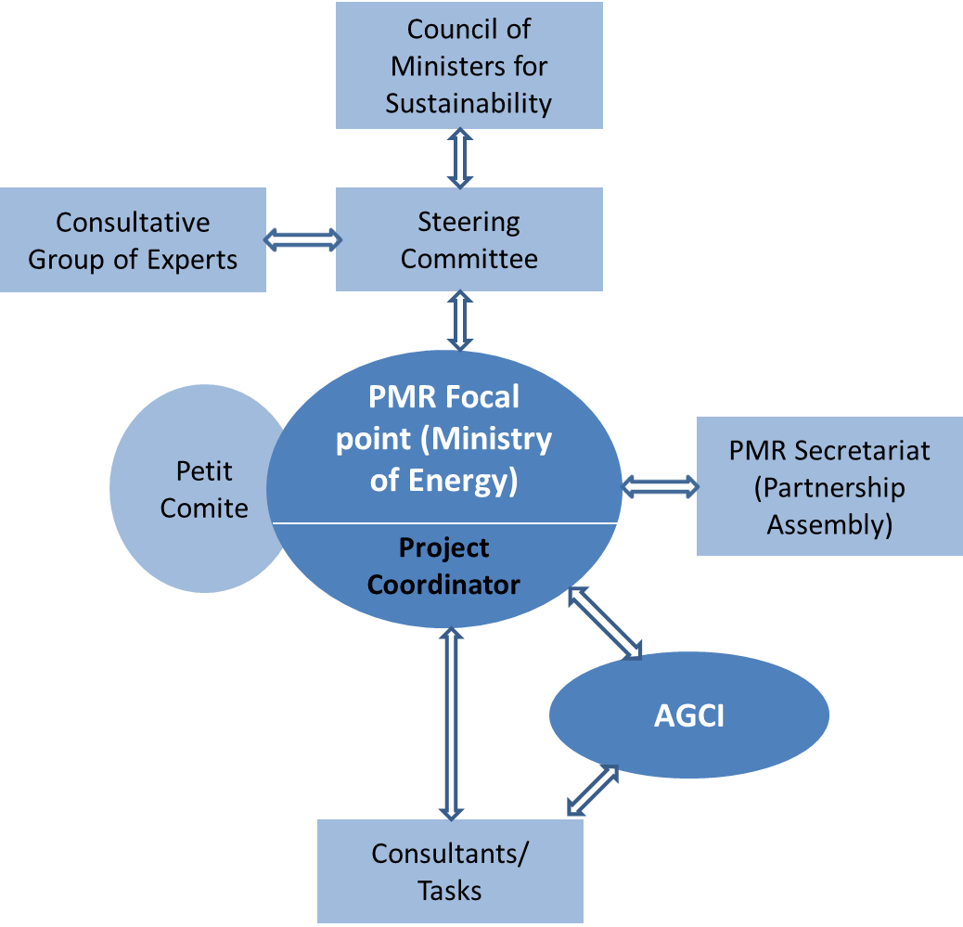

Detailed institutional arrangements envisioned for Chile´s PMR Implementation Phase, as seen from the diagram are:

Focal Point: In this role, the Division of Sustainable Development (DSD) of the MoE is the focal point for the PMR. It will be responsible for the overall day-to-day supervision of the implementation of the PMR tasks. The Focal Point will also coordinate with other participants such as AGCI, Petit Comite, the Steering Committee (SC), the project coordinator, the project consultants, the PMR Secretariat and the World Bank’s Energy Global Practice.

AGCI: AGCI is a decentralized public institution that channels resources for international cooperation to support Chile’s development and carry out cooperation activities with other developing countries. Being familiar with the protocols and procedures of the World Bank, AGCI will undertake the financial and procurement outlays of the project. It will prepare and submit timely disbursement requests to the World Bank, prepare financial reports and coordinate audit reviews by the World Bank.

Petit Comité is a newly created body to assist the MoE in its overall day-to-day supervision function. It comprises of the Ministries of Finance and Environment.

Steering Committee. The SC was established in March 2012 and is headed by the MoE with the participation of the ministries of Agriculture; Economy; Environment; Finance; Foreign Affairs; Mining; and Transportation and Telecommunications. The SC constitutes the primary engagement, collaboration and consultation body in which key Ministries will continue to provide the necessary policy and technical guidance during the implementation of Chile’s PMR and reviewing draft and final reports of the implementation phase studies. If any relevant decision arises during the PMR implementation phase that needs to be addressed at a higher political level, the SC will submit this decision to the Council of Ministers for Sustainability in its role of liaison to the Council.

Council of Ministers for Sustainability, created in 2010 is a multi-sectoral body headed by the Ministry of the Environment and includes the ministries of Agriculture; Finance; Health; Economics; Energy; Public Works; Housing and Urbanism; Transportation and Telecommunications; Mining; and Planning. The Council is in charge of proposing to the President of the Republic policies for the sustainable management and use of natural resources. This body will therefore provide high-level policy guidance to the steps planned under this MRP, especially during development of the roadmap towards a political decision on the implementation of one or more carbon pricing mechanisms and its overall role in Chile’s climate policy.

Consultative Group of Experts (CGE) will be established with the goal of bringing other stakeholders to discuss low carbon development market-based instruments and their suitability and applicability to the Chilean situation. CGE will comprise representatives of industrial associations, research organizations and non-governmental organizations or NGOs. The creation and overall coordination of this group will be done through the Steering Committee.

Project Coordinator (PC): In addition to the supervision role of the PMR Focal Point, a PC will be hired to help with the activities during the PMR implementation phase. The PC will report directly to the PMR Focal Point and its first task will be the development of a work plan for the implementation of the PMR. A thorough and competitive selection process will be established for the choosing of the PC.

Project consultants: The more specific and technical activities will need to be assigned by a public bidding system. The procurement procedures for these assignments will have to comply with the requirements that rule the entity that will administer the PMR Project’s funding. Project consultants will report directly to the PC. A selection process will be established for the appointment of these consultants.

PMR Secretariat and World Bank Energy Global Service: Continuing with its role during the preparation phase, the PMR Secretariat and the World Bank Energy Global Practice will provide technical advice for all the stages of Chile’s PMR project. This assistance will include coordination with the PA, in-country visits, and participation in workshops or training activities and in any other activity related to the PMR in Chile.

- Safeguards Policies that might apply
Safeguard Policies Triggered by the Project | Yes | No | TBD
Environmental Assessment OP/BP 4.01 |  | ✖
Natural Habitats OP/BP 4.04 |  | ✖
Forests OP/BP 4.36 |  | ✖
Pest Management OP 4.09 |  | ✖
Physical Cultural Resources OP/BP 4.11 |  | ✖
Indigenous Peoples OP/BP 4.10 |  | ✖
Involuntary Resettlement OP/BP 4.12 |  | ✖
Safety of Dams OP/BP 4.37 |  | ✖
Projects on International Waterways OP/BP 7.50 |  | ✖
Projects in Disputed Areas OP/BP 7.60 |  | ✖

- Contact point
World Bank
Contact: | Mark Lambrides
Title: | Senior Energy Specialist
Tel: | (202) 458-1654
Email: | mlambrides@worldbank.org
Borrower/Client/Recipient
Name: | Republic of Chile, Agencia de Cooperacion Internacional de Chile
Contact: | Ms. Melissa Sanchez Rabello
Title:
Tel: | +56 (2) 2827 5706
Email: | msanchez@agci.gob.cl
Implementing Agencies
Name: | Republic of Chile, Ministry of Energy
Contact: | Mr. Juan Pedro Searle
Title: | Head of Climate Change Unit Sustainable Development Division, Ministry of Energy
Tel: | +56-562-365-6876
Email: | jsearle@minergia.cl
- For more information contact:
The InfoShop
The World Bank
1818 H Street, NW
Washington, D.C. 20433
Telephone: (202) 458-4500
Fax: (202) 522-1500
Web: http://www.worldbank.org/infoshop

Michelle Bachelet held the President’s office from 2006-2010 as Chile’s first woman President
As stated in the MRP prepared by Chile
President Michelle Bachelet, installed in March 2014
More information is available on the PMR website www.thepmr.org

