Arranging and marking Gelati Monastery - Tsutskhvati cave - Akhalsopeli trail

Environmental and Social Screening Report

March 2018

Sub-Project Description
The Sub-Project (SP) is planned to be implemented in the villages of Tkibuli municipality of Imereti region: Gelati, Kursebi, Tsutskhvati, Manchiori and Akhalsopeli. There is a 21km tourist hiking route on the Okriba-Argveti hill, connecting villages of Gelati and Akhalsopeli. This road represented the section of Skande-Dzevri-Tsutskhvati-Gelati-Kutaisi of the great Silk Road in the past. The hill was lined with roads and paths of various directions that linked two sides of Imereti region – 20 villages of Argveti and Okriba with the shortest passes, that had a great economic and political significance for the region (the livestock-farms were located on the hill, the building materials and firewood were obtained, people used forest products and etc.).
Planning and arrangement of the hiking trail will be carried out within the SP, considering security measures. Implementation of the SP will be in compliance with the decree of the Government of Georgia approving technical regulation for Planning and Marking of Hiking Paths. The sign poles, direction and information boards will be placed along the trail. Four historic and natural monuments (Daviti Cape near village Gelati, Saint George Church on Unagira Mountain, Tsutskhvati cave and Chalastavi church) will be cleaned up and garbage, accumulated throughout years will be removed. The following work are planned within the SP:
- Cleaning up the existing trail;
- Conducting minor earthworks for trail improvement;
- Fencing panoramic viewpoint;
- Cleaning trash at four historical and natural monuments (Saint George’s Church on Unagira Mountain, Chalastavi Church, Tsutskhvati Cave and David’s cape near village Gelati);
- Arranging five tables and 10 benches along the trail;
- Arranging garbage receptacles;
- Arranging simple footbridges, made of rocks on the trail crossed by streams;
- Restoring stairs to Tsutskhvati and Tkibula-Dzevrula caves.
Trail marking works include installation of 125 various signs.
Tkibuli municipality and Tourism Development Center actively supported the project and provided support letters (attachment 1 & 2). They were actively involved in project development and frequently communicated with the applicant organization. Upon completion of works the municipality will cover maintenance costs, including servicing the garbage receptacles and periodic cleaning of the trail.

Environmental Screening and Classification

(A) Impact Identification
Has sub-project a tangible impact on the environment? | The SP construction phase covers three months’ period. The SP will have a small-scale and short-term impact on the environment only in the installation phase, while its long-term impact on the natural environment will be positive.
What are the significant beneficial and adverse environmental effects of the sub-project? | The SP is expected to have positive long-term environmental impact through reducing unorganized movement of tourists and thus decreasing environmental footprint of visitation.  Environmental risk associated with the construction phase is that unless good construction practice is followed, installation of information boards, indicating poles and other activities along the trail may result unnecessary damage of vegetation and littering outside the trail corridor. Works on the trail will not block or disrupt pedestrian movement.
Does the sub-project have any significant potential impact on the local communities? | The long-term social impact of the SP will be beneficial, causing improvement of the social conditions of local population and tourists.  Marking will promote the popularity of several destinations in Imereti and increase tourist flows.  The Gelati-Akhalsopeli pedestrian path will be cleaned. As a result of trail arrangement, tourists will be able to move safely and comfortably.  Significant social impact of SP, such as change of local demographic structure, influx of new settlers, secondary development is not envisaged.
What impact has the sub-project on the human health? | SP will improve safety of hiking path decreasing risk of accidents among tourists.

(B) Impact Mitigation
What alternatives to the sub-project design have been considered and what mitigation measures are proposed? | At the design, a no-project alternative was considered and turned down as the implementation of the SP will help attract both, the local and foreign visitors that will have a positive impact on the social standing of the local population.  Reduction of adverse environmental impact during the construction works will be possible through protecting the following key conditions: fencing the construction site and fixing the relevant signs throughout its perimeter, proper management of waste and selecting less sensitive period for construction works.  In case of chance finds, works will be taken on hold and notification be sent to the Ministry of Culture and Monument Protection of Georgia. Works will resume only upon written consent of the Ministry.  Planned works will not cause cutting of trees and preventive measures will be undertaken to avoid any damage to the nearby standing trees. Large tress on and in the vicinity of the construction activities will be marked and cordoned off with fencing, their root system protected, and any damage to the trees avoided.  During the SP operation phase, the proper management of solid waste generated by the visitors is crucial to prevent littering of the site and area around it. Therefore, waste bins should be installed onsite and properly maintained (timely regular out-transporting of waste).  If before, during or after SP implementation concerned community members have complaints / questions / recommendations, these can be addressed to the sub-grantee, contractor, or Elkana, whose contact information will be made available at the SP site.
Have concerned communities been involved and have their interests and knowledge been adequately taken into consideration in sub-project preparation? | During community mobilization, several priorities were identified, including rehabilitation of village roads, improvement of drinking water system and the arrangement of the hiking trail of Gelati Monastery - Tsutskhvati cave - Akhalsopeli. The latter was prioritized.

(C) CATEGORIZATION AND CONCLUSION
Conclusion of the environmental screening:
- Sub-project is declined □
- Sub-project is accepted ■

- Sub-project is classified
as environmental Category B
and needs EMP ■

- Sub-project is classified
as environmental Category C
and does not need EMP □
Social Screening
Social safeguards screening information |  |  | Yes | No
1 | Is the information related to the affiliation, ownership and land use status of the sub-project site available and verifiable? (The screening cannot be completed until this is available)
2 | Will the sub-project reduce people’s access to their economic resources, such as land, pasture, water, public services, sites of common public use or other resources that they depend on?
3 | Will the sub-project result in resettlement of individuals or families or require the acquisition of land (public or private, temporarily or permanently) for its development?
4 | Will the sub-project result in the temporary or permanent loss of crops, fruit trees and household infrastructure (such as ancillary facilities, fence, canal, granaries, outside toilets and kitchens, etc.)?
If answer to any above question (except question 1) is “Yes”, then OP/BP 4.12 Involuntary Resettlement is applicable and mitigation measures should follow this OP/BP 4.12 and the Resettlement Policy Framework
Cultural resources safeguard screening information |  |  | Yes | No
5 |  | Will the sub-project be implemented in the vicinity of a cultural heritage site?
6 |  | Will the sub-project require excavation near any historical, archaeological or cultural heritage site?

If answer to question 5 is “yes”, then OP/BP 4.11 Physical Cultural Resources is applicable. In this case, sub-project proponent must provide evidence that consultation was held with and an agreement on this sub-project was obtained from an authorized representative of culture and heritage protection authority.
If answer to question 6 is “Yes”, then OP/BP 4.11 Physical Cultural Resources is applicable and possible chance finds must be handled in accordance with OP/BP and relevant procedures provided in this EMF.

Environmental Management Plan

Arranging and marking Gelati Monastery - Tsutskhvati cave - Akhalsopeli trail

PART A: General Project and Site Information
INSTITUTIONAL & ADMINISTRATIVE
Project title | Empowering Poor Communities and Micro-Entrepreneurs in the Georgia Tourism Sector
Sub-Project title | The arrangement of the tourist hiking trail of Gelati Monastery - Tsutskhvati cave - Akhalsopeli water reservoir
Scope of site-specific activity | The following work are planned within the SP:  - Cleaning up the existing trail;  - Conducting minor earthworks for trail improvement;  - Fencing panoramic viewpoint;  - Cleaning trash at four historical and natural monuments (Saint George’s Church on Unagira Mountain, Chalastavi Church, Tsutskhvati Cave and David’s cape near village Gelati);  - Arranging five tables and 10 benches along the trail;  - Arranging garbage receptacles;  - Arranging simple footbridges, made of rocks on the trail crossed by streams;  - Restoring stairs to Tsutskhvati and Tkibula-Dzevrula caves.  - Trail marking works include installation of 125 various signs.
Institutional arrangements (WB) | Task Team Leader:  Sophia Georgieva | Safeguards Specialist:  Darejan Kapanadze, Environment  Rebecca Lacroix and David Jijelava, Social
Implementation arrangements  (Borrower) | Implementing entity:  Biological Farming Association “Elkana” | Works supervisor:  Biological Farming Association “Elkana” | Works contractor:  (tbd)
SITE DESCRIPTION
Who owns the building to be constructed/extended/ reconstructed? | Works are not relates to buildings
Who owns the land allocated for sub-project?  Who uses the land (formal/informal)? | The SP area is the property of Tkibuli municipality.  Due to its poor infrastructure, the area is not used.
Description of physical and natural environment, and of the socio-economic context around the site | The SP area is located in Tkibuli municipality, Imereti Region. The areas around the trail are rich with diverse tourist resources. In addition, this side is distinguished by relatively high level of tourism development in Tkibuli municipality, there are such facilities of tourism infrastructure, such as family hotels and catering facilities;  The sightseeing located on the tourist route are as follows: 1. A site of former village Motsameta, Motsameta monastery complex VII-XI-XIX centuries; 2. The canyon like valley of the river Tskaltsitela - a monument of nature and archeology; 3. The village Gelati - information board; 4. Gelati monastic ensemble XII-XIV centuries; 5. Saint Saba Purified state church - IX-X centuries; 6. Village Godogani; 7. The church of saint Elia the Prophet - IX-X centuries; 8. The church of Mother of God, the source of life - XII centuries; 9. Xenon, the general purpose palace - XII centuries; 10. The church of Savior - XI-XII centuries; 11. The church of Saint Nino; 12. David's cape - Fortress. Early middle century; 13. Monk’s Fortress - Early middle century; 14. The Dokhora ridge; 15. The Eli ridge; 16. The spring "Tsivtkala" – camping place; 17. The village Kursebi – Information board; 18. The village Nagarevi; 19. Lake "Bzarnali"; 20. The monastery of Chalastavi (unconsecrated church) - XVI-XVII centuries; 21. The river Chichura valley; 22. The river Maghara valley; 23. The cave of Tsutskhvati, the monument of nature and archeology; 24. The fortress of Tsutskhvati, middle century; 25. Tsikhe spring; 26. The village Navenakhevi; 27. The village Chalastavi; 28. The village of Tsutskhvati; 29. Unagira pass; 30. The church of St. George Church of Unagira - XII century; 31. The village Upper Simon; 32. The village Separeti; 33. The village Dzevri; 34. The spring "Margaliti"; 35. The cave "Khatshesapari"; 36. The mount of Gumbrala; 37. The Mount of Shindnari; 38. The village Akhalsopeli; 39. The reservoir of Akhalsopeli; 40. The Tsintskili rock; 41. The cave-gap of Tkibula-Dzevrula; 42. The village Manchiori.
Which of the project intervention sites does sub-project related to and how? | The SP is related to the touristic infrastructure rehabilitation in Imereti region through II Regional Development Project, funded by the World Bank and implemented by the Municipal Development Fund of Georgia.
LEGISLATION
National & local legislation & permits that apply to sub-project activity | According to the law of Georgia on Permit on Environmental Impact (2008), the SP does not require preparation of EIA and obtaining of Permit on Environmental Impact.  The SP triggers to the OP/BP 4.01 Environmental Assessment and OP/BP 4.11 Physical Cultural Resources of the World Bank. According to this safeguard policy and the Environmental Management Framework of the Project for Empowering Poor Communities and Micro-Entrepreneurs in the Georgia Tourism Sector, the SP is classified as environmental category B and requires preparation of Environmental Management Plan (EMP).
PUBLIC CONSULTATION
When / where the public consultation process took / will take place | SP-specific draft EMP was made available for village Gelati residents of Tkibuli municipality and discussed in a consultation meeting prior to the tendering of construction works.
ATTACHMENTS
Attachment 1: Support letter from Tkibuli municipality;
Attachment 2: Support letter from Tourism Development Center of Tkibuli municipality;
Attachment 3: SP site plan and photo illustrations;
Attachment 4: Minutes of public consultation meeting on the draft EMP.

PART B: safeguards information
ENVIRONMENTAL /SOCIAL SCREENING
Will the site activity include/involve any of the following? | Activity/Issue | Status | Triggered Actions
 | - Building rehabilitation | [ ] Yes [√] No | See Section A below
 | - New construction | [√] Yes [ ] No | See Section A below
 | - Individual wastewater treatment system | [ ] Yes [√] No | See Section B below
 | - Historic building(s) and districts | [√ ] Yes [ ] No | See Section C below
 | - Acquisition of land | [ ] Yes [√] No | See Section D below
 | - Hazardous or toxic materials | [ ] Yes [√] No | See Section E below
 | - Impacts on forests and/or protected areas | [ ] Yes [√] No | See Section F below
 | - Handling / management of medical waste | [ ] Yes [√] No | See Section G below
 | - Traffic and Pedestrian Safety | [ ] Yes [√] No | See Section H below
PART C: Mitigation measures
ACTIVITY | PARAMETER | MITIGATION MEASURES CHECKLIST
0. General Conditions | Notification and Worker Safety | - The local construction and environment inspectorates and communities have been notified of upcoming activities  - The public has been notified of the works through appropriate notification in the media and/or at publicly accessible sites (including the site of the works)  - All legally required permits have been acquired for construction and/or rehabilitation  - The Contractor formally agrees that all work will be carried out in a safe and disciplined manner designed to minimize impacts on neighboring residents and environment.  - Workers’ PPE will comply with international good practice (always hardhats, as needed masks and safety glasses, harnesses and safety boots)  - Appropriate signposting of the sites will inform workers of key rules and regulations to follow.
A. General Rehabilitation and /or Construction Activities | Air Quality | - During interior demolition debris-chutes shall be used above the first floor  - Demolition debris shall be kept in controlled area and sprayed with water mist to reduce debris dust  - During pneumatic drilling/wall destruction dust shall be suppressed by ongoing water spraying and/or installing dust screen enclosures at site  - The surrounding environment (sidewalks, roads) shall be kept free of debris to minimize dust  - There will be no open burning of construction / waste material at the site  - There will be no excessive idling of construction vehicles at sites
 | Noise | - Construction noise will be limited to restricted times agreed to in the permit  - During operations the engine covers of generators, air compressors and other powered mechanical equipment shall be closed, and equipment placed as far away from residential areas as possible
 | Water Quality | - The site will establish appropriate erosion and sediment control measures such as e.g. hay bales and / or silt fences to prevent sediment from moving off site and causing excessive turbidity in nearby streams and rivers.
 | Waste management | - Waste collection and disposal pathways and sites will be identified for all major waste types expected from demolition and construction activities.  - Mineral construction and demolition wastes will be separated from general refuse, organic, liquid and chemical wastes by on-site sorting and stored in appropriate containers.  - Construction waste will be collected and disposed properly by licensed collectors  - The records of waste disposal will be maintained as proof for proper management as designed.  - Whenever feasible the contractor will reuse and recycle appropriate and viable materials (except asbestos)
B. Individual wastewater treatment system | Water Quality | - The approach to handling sanitary wastes and wastewater from building sites (installation or reconstruction) must be approved by the local authorities  - Before being discharged into receiving waters, effluents from individual wastewater systems must be treated in order to meet the minimal quality criteria set out by national guidelines on effluent quality and wastewater treatment  - Monitoring of new wastewater systems (before/after) will be carried out  - Construction vehicles and machinery will be washed only in designated areas where runoff will not pollute natural surface water bodies.
C. Historic building(s) | Cultural Heritage | - If the building is a designated historic structure, very close to such a structure, or located in a designated historic district, notification shall be made and approvals/permits be obtained from local authorities and all construction activities planned and carried out in line with local and national legislation.  - It shall be ensured that provisions are put in place so that artifacts or other possible “chance finds” encountered in excavation or construction are noted and registered, responsible officials contacted, and works activities delayed or modified to account for such finds.
D. Acquisition of land | Land Acquisition Plan/Framework | - If expropriation of land was not expected but is required, or if loss of access to income of legal or illegal users of land was not expected but may occur, that the Bank’s Task Team Leader shall be immediately consulted.  - The approved Land Acquisition Plan/Framework (if required by the sub-project) will be implemented
E. Toxic Materials | Asbestos management | - If asbestos is located on the sub-project site, it shall be marked clearly as hazardous material  - When possible the asbestos will be appropriately contained and sealed to minimize exposure  - The asbestos prior to removal (if removal is necessary) will be treated with a wetting agent to minimize asbestos dust  - Asbestos will be handled and disposed by skilled & experienced professionals  - If asbestos material is being stored temporarily, the wastes should be securely enclosed inside closed containments and marked appropriately. Security measures will be taken against unauthorized removal from the site.  - The removed asbestos will not be reused
 | Toxic / hazardous waste management | - Temporarily storage on site of all hazardous or toxic substances will be in safe containers labeled with details of composition, properties and handling information  - The containers of hazardous substances shall be placed in an leak-proof container to prevent spillage and leaching  - The wastes shall be transported by specially licensed carriers and disposed in a licensed facility.  - Paints with toxic ingredients or solvents or lead-based paints will not be used
F. Affected forests, wetlands and/or protected areas | Protection | - All recognized natural habitats, wetlands and protected areas in the immediate vicinity of the activity will not be damaged or exploited, all staff will be strictly prohibited from hunting, foraging, logging or other damaging activities.  - A survey and an inventory shall be made of large trees in the vicinity of the construction activity, large trees shall be marked and cordoned off with fencing, their root system protected, and any damage to the trees avoided  - Adjacent wetlands and streams shall be protected from construction site run-off with appropriate erosion and sediment control feature to include by not limited to hay bales and silt fences  - There will be no unlicensed borrow pits, quarries or waste dumps in adjacent areas, especially not in protected areas.
G. Disposal of medical waste | Infrastructure for medical waste management | - In compliance with national regulations the contractor will insure that newly constructed and/or rehabilitated health care facilities include sufficient infrastructure for medical waste handling and disposal; this includes and not limited to:  - Special facilities for segregated healthcare waste (including soiled instruments “sharps”, and human tissue or fluids) from other waste disposal; and  - Appropriate storage facilities for medical waste are in place; and  - If the activity includes facility-based treatment, appropriate disposal options are in place and operational
H Traffic and Pedestrian Safety | Direct or indirect hazards to public traffic and pedestrians by construction  activities | (a) In compliance with national regulations the contractor will insure that the construction site is properly secured and construction related traffic regulated. This includes but is not limited to  - Signposting, warning signs, barriers and traffic diversions: site will be clearly visible and the public warned of all potential hazards  - Traffic management system and staff training, especially for site access and near-site heavy traffic. Provision of safe passages and crossings for pedestrians where construction traffic interferes.  - Adjustment of working hours to local traffic patterns, e.g. avoiding major transport activities during rush hours or times of livestock movement  - Active traffic management by trained and visible staff at the site, if required for safe and convenient passage for the public.  - Ensuring safe and continuous access to office facilities, shops and residences during renovation activities, if the buildings stay open for the public.

PART D: Monitoring Plan
Activity | What  (Is the parameter to be monitored?) | Where  (Is the parameter to be monitored?) | How  (Is the parameter to be monitored?) | When  (Define the frequency / or continuous?) | Why  (Is the parameter being monitored?) | Who  (Is responsible for monitoring?)
Transportation of construction materials and waste movement of construction machinery | Technical condition of vehicles and machinery  Confinement and protection of truck loads with lining  Respect of the established hours and routes of transportation | Construction site | Inspection | Unannounced inspections during work hours and beyond | Limit pollution of soil and air from emissions;  Limit nuisance to local communities from noise and vibration;  Minimize traffic disruption. | Elkana
Earthworks (small scale) | Temporary storage of excavated material in the pre-defined and agreed upon locations;  Backfilling of the excavated material and/or its disposal to the formally designated locations;  In case of chance finds immediate suspension of works, notification of the Ministry of Culture and Monument Protection, and resumption of works exclusively upon formal consent of the Ministry. | Construction site | Inspection | In the course of earth works | Prevent pollution of the construction site and its surroundings with construction waste;  Prevent damage and loss of physical cultural resources | Elkana
Generation of waste from cleaning trash at four historic and natural sites along the trail | Placing collected waste in bags and timely delivery to municipal waste disposal receptacles | Saint George’s Church on Unagira Mountain, Chalastavi Church, Tsutskhvati Cave and David’s cape near village Gelati | Inspection | During trash collection | Prevent open burning of the collected waste;  Prevent dumping of the collected waste in informal dump sites | Elkana
Workers’ health and safety | Provision of uniforms and safety gear to workers;  Ensuring use of the personal protective gear by workers;  Informing of workers and personnel on the personal safety rules and instructions for operating machinery/equipment, and strict compliance with these rules/instructions | Construction site | Inspection | Unannounced inspections in the course of work | Limit occurrence of on-the-job accidents and emergencies | Elkana

Attachment 1: Support letter from Tkibuli Municipality
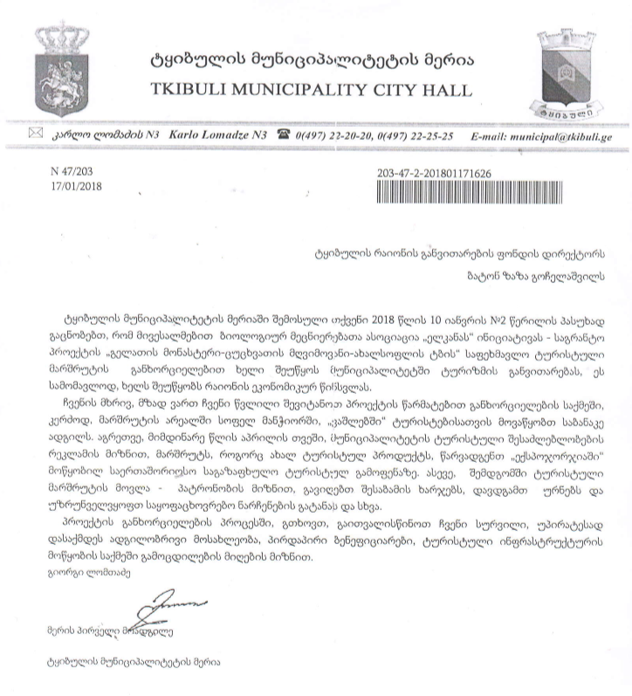

Attachment 2: Support letter from Truism development center of Tkibuli municipality
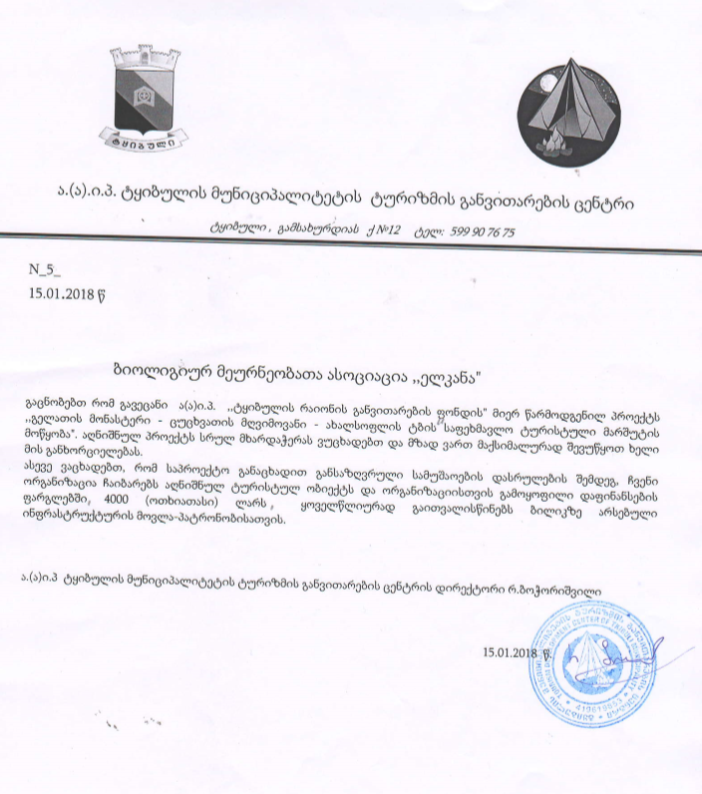

Attachment 3: Sub-Project site plan and photo illustrations
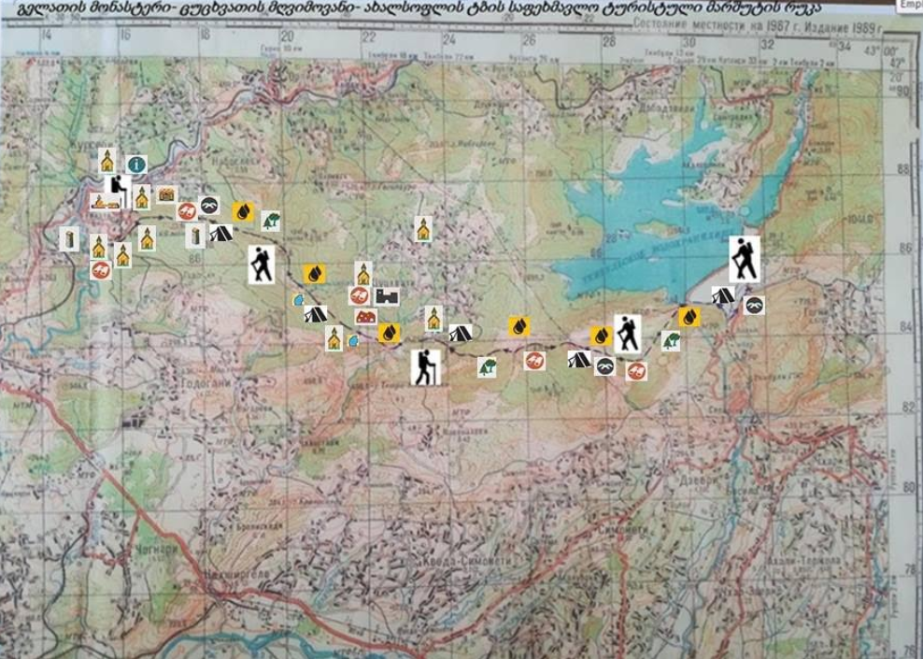
Photography
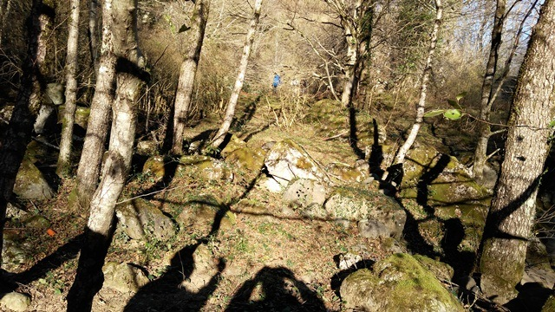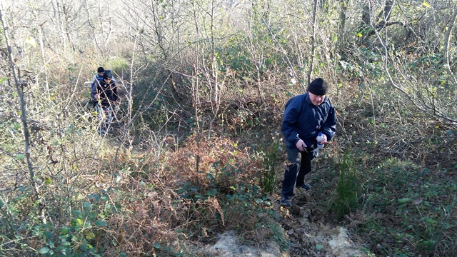
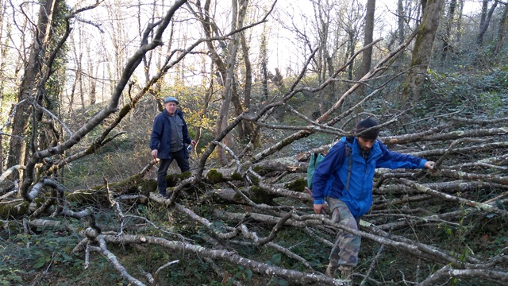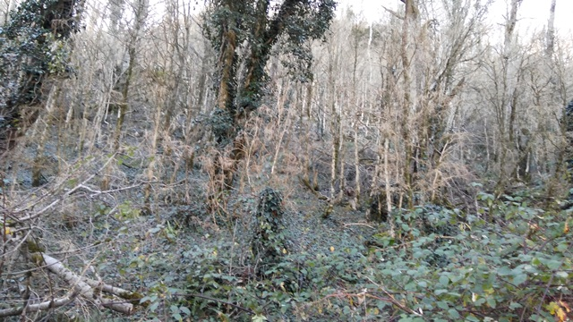
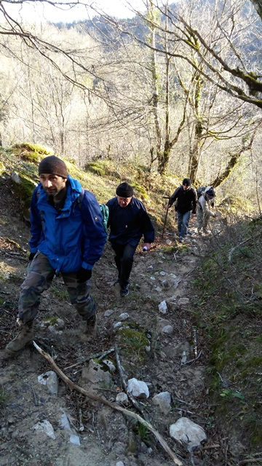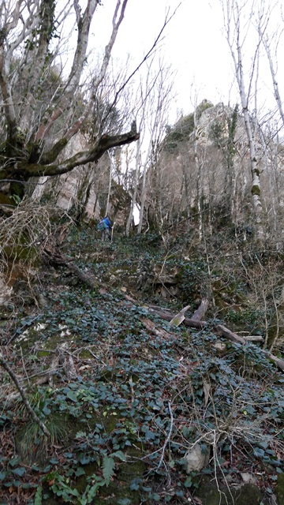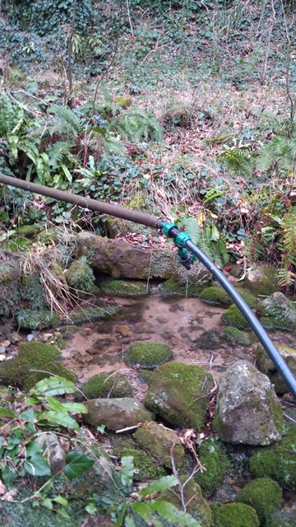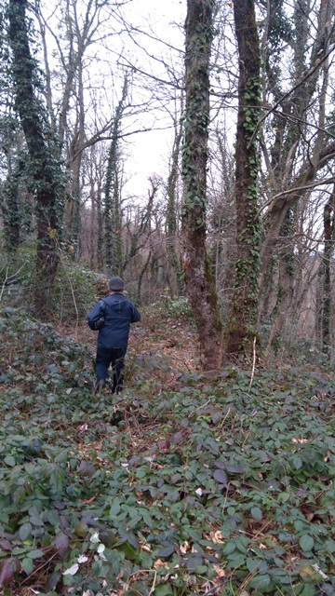
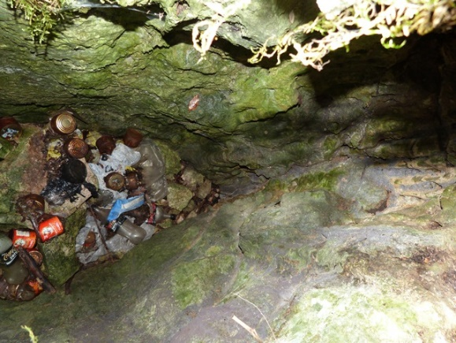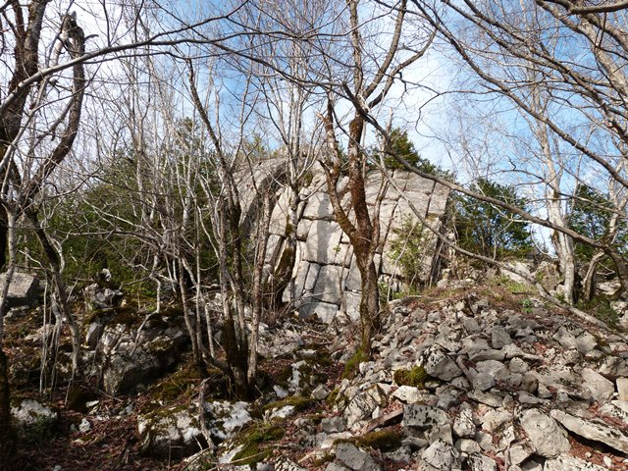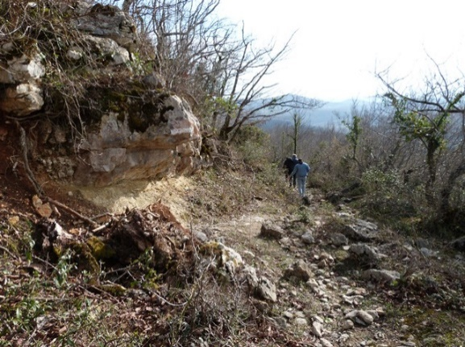
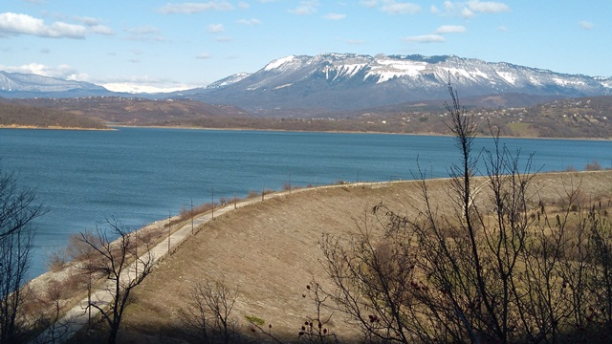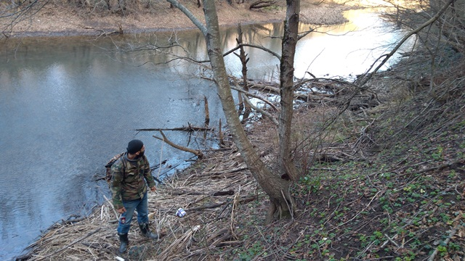
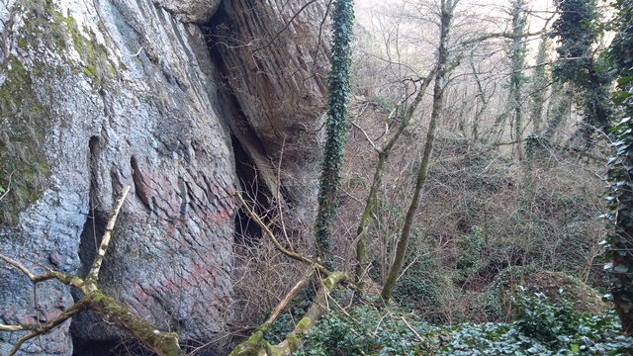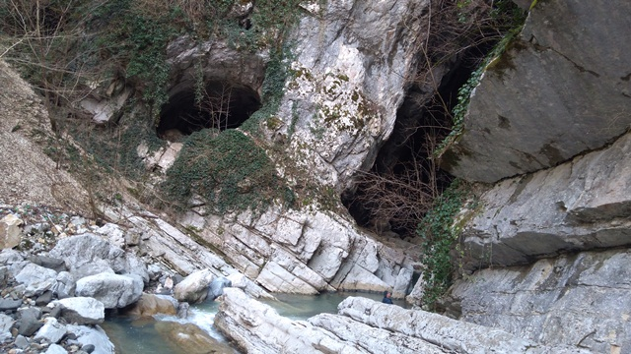
Attachment 4. Minutes of public consultation meeting

Date: March 19, 2018
Venue: Tkibuli Municipality, village Gelati
Donor: Biological Farming Association “Elkana”, through funding from the Japan Social Development Fund and the World Bank
Aim: Consult with the local community on the Draft Environment and Social Management Plan for the sub-project for Arranging and Marking Gelati Monastery - Tsutskhvati Cave - Akhalsopeli Trail

Elkana Project Manager, representative of implementing NGO Tkibuli District Development Fund, local authority representatives and community members attended the meeting. In totally 25 people participated in the gathering, including 16 women.
Tkibuli District Development Fund representatives and Elkana Project Manager presented planned project and activities, as well as the draft Environment Management Plans prepared to mitigate their possible negative impacts on the natural and social environment. After the presentation, meeting participants were given the floor for questions and comments. During the meeting, participants asked the following questions:

Question: Who will be responsible for cleaning and maintaining the trail after the project completion?
Answer: After completion of the project, ownership of trail and respective infrastructure will be transferred to Tkibuli municipality, who will be responsible for maintaining the trail. This will include cleaning of the trail, as well as repairing infrastructure.

Question: How wandering off the trail will be avoided?
Answer: Information signs, explaining directions and distance will be installed according to national standards and will ensure tourists will not wander off the trail. Additionally, in Gelati village tourists can hire local guides, who know the path very well.

Community members were satisfied with the received information and supported implementation of the project.

Signatures of attendees:

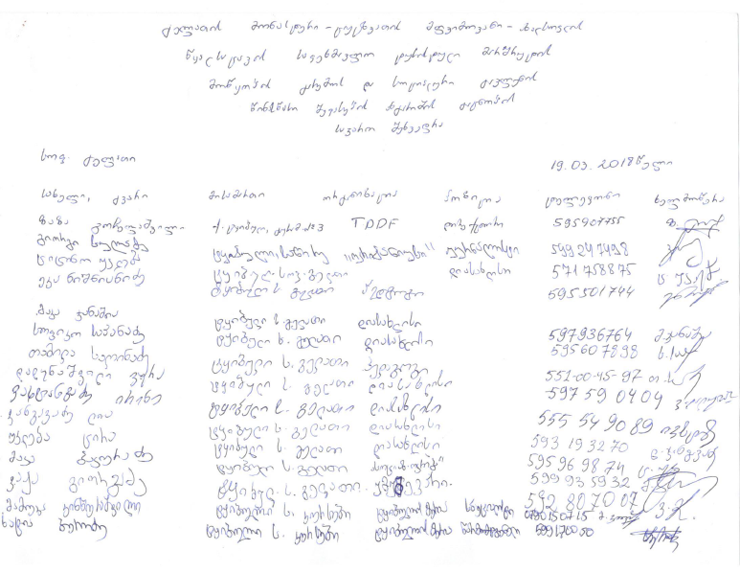
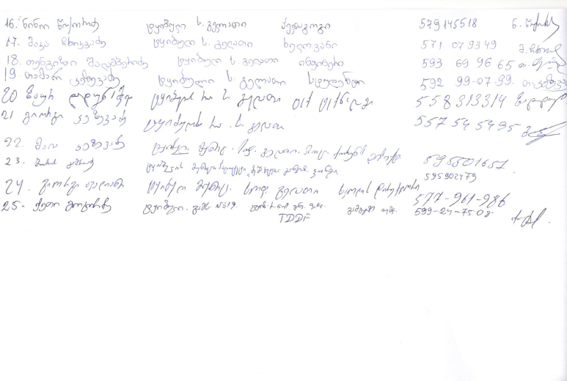

Photo material
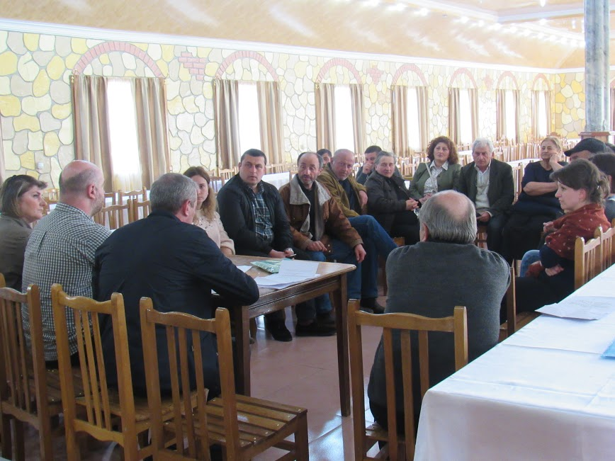
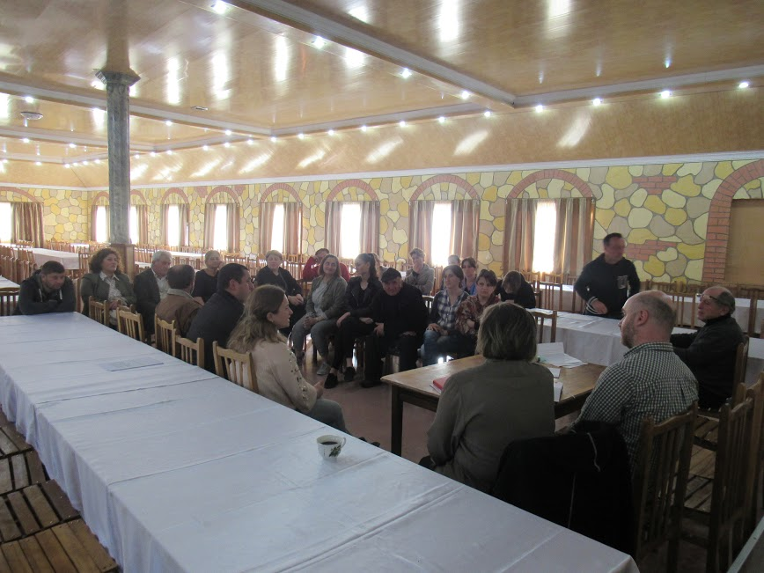
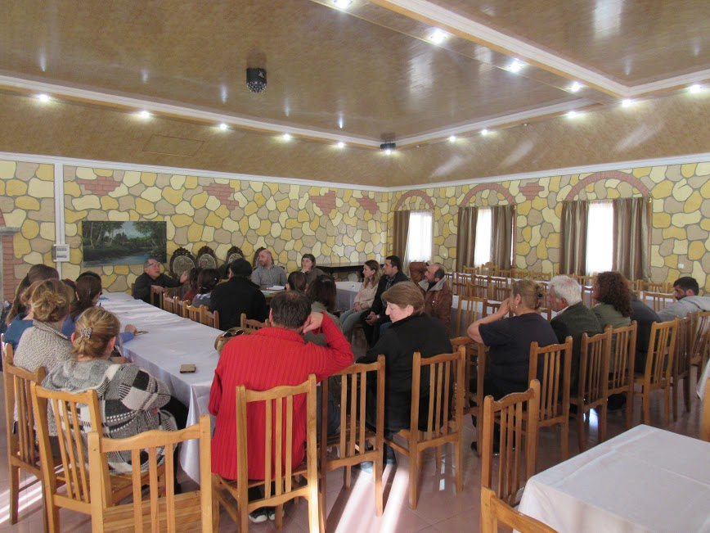

Land acquisitions includes displacement of people, change of livelihood encroachment on private property this is to land that is purchased/transferred and affects people who are living and/or squatters and/or operate a business (kiosks) on land that is being acquired.
Toxic / hazardous material includes but is not limited to asbestos, toxic paints, noxious solvents, removal of lead paint, etc.

