Wading out the Storm[1]

The role of poverty in exposure, vulnerability and resilience to floods in Dar es Salaam

Authors: Alvina Erman, Marguerite Obolensky, Stephane Hallegatte

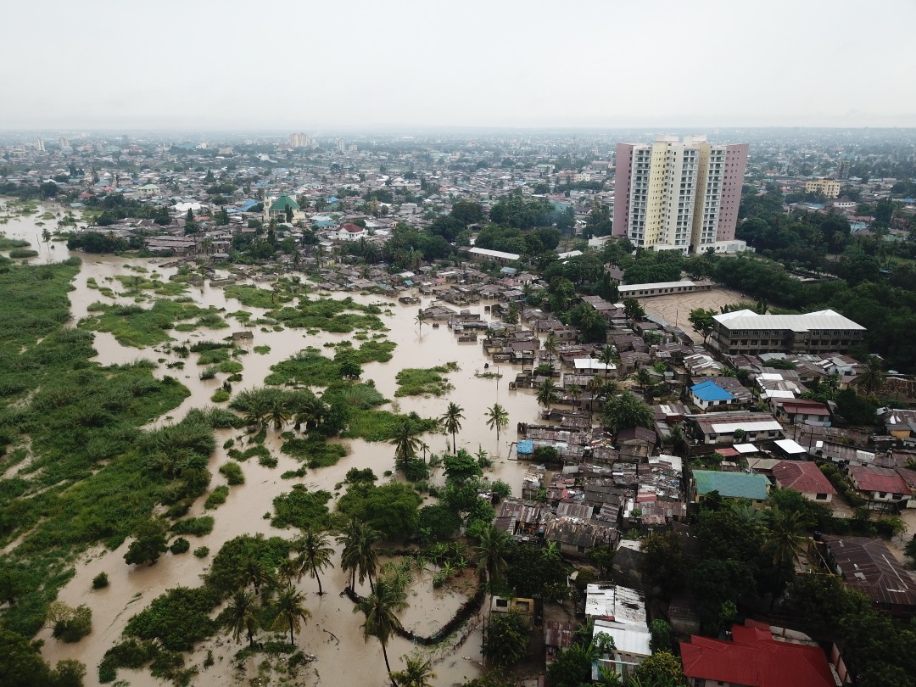

Dar es Salaam is frequently affected by severe flooding causing destruction and impeding daily life of its 4.5 million inhabitants. Recent severe flood events were observed in April 12-18, 2018 and May 5-8, 2019 (pictured above). With a fast-growing population, climate change and sea level rise, the population at risk of flooding is projected to increase. In this context, a better understanding of current flood risks and consequences on the livelihoods and well-being of the population is highly policy relevant.

This note provides new insights into the consequences of floods in Dar es Salaam, based on two rounds of survey conducted as part of the Tanzanian Urban Resilience Program (TURP).[2] The results show that more people than previously thought are exposed to floods in Dar es Salaam and that the poor are disproportionately affected. This note focused in particular on the interplay between poverty and flood risks. It explores first the role of poverty in **exposure** – who is affected by floods? –, then in **vulnerability** – how much do people lose in floods? – and finally in **socioeconomic resilience** – to what extent are the affected people able to cope with and recover from floods in the city of Dar es Salaam?

Exposure - Poor people are more likely to be exposed to flood risk

Exposure to floods is wide-spread in Dar es Salaam —39% of the population or 2 million people— have been impacted either directly or indirectly by floods in the past.[3] The maps below show the share of households reporting being either directly or indirectly affected, by city ward (only wards with 10 or more households included). People that have had their house flooded in the past tend to reside in low-elevation, high population density areas, close to bodies of water. But floods affect much more people by disrupting the city infrastructure, preventing children from going to school and keeping adults from going to work.

Figure 1 - share of affected households by ward, directly (left) or indirectly (right)[4]

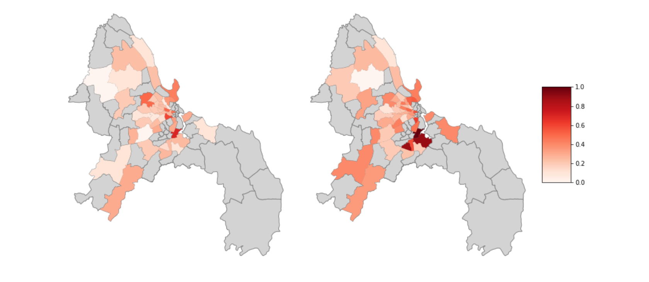

*Note: Data is not representative on a ward level and results are therefore indicative.*

The poor and vulnerable are over-represented among those affected by floods in Dar es Salaam, both directly and indirectly.

* People experiencing direct flood damages (to their house or assets) have per capita expenditures that are 14 percent lower than non-affected people. Households that are living in the flood zone are also significantly more food insecure than the average, and more likely to be female headed. This indicates that vulnerable populations tend to live in high risk areas, either because they settle there, or because they cannot move away when local flood risk increases (for instance because of unplanned urbanization and insufficient drainage).
* People experiencing indirect flood impacts – such as flood-related disease, being unable to go to work, or experiencing water or power outages – are also poorer than the average: their per capita expenditure is 20 percent lower than non-affected households. Higher income acts as a protection against the indirect effects of flooding by, for example, enabling the use of alternative means of transportation when the public transportation system is down.

Figure 2 - Distribution of expenditure proxy (SWIFT) for affected (directly – left and indirectly – right) and non-affected households

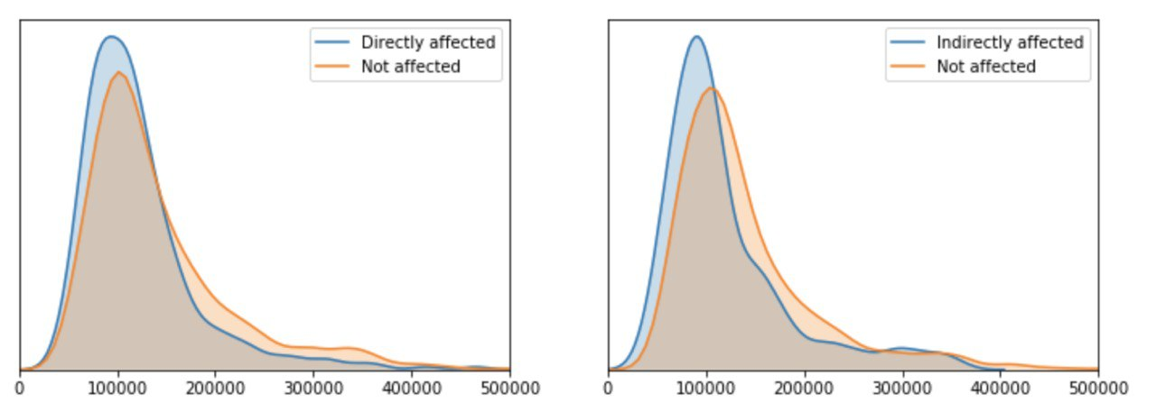

In Dar es Salaam, flood risk and informality go together. Directly affected households are less likely to hold proof of tenure for the dwellings they rent —a sign of informality— and to pay for garbage services —a good proxy for the quality of public services. Households that are indirectly affected also tend to live in areas without access to reliable infrastructure. For example, these households are less likely to have drains outside their dwelling and have access to lower quality water and sanitation services.

There are also some benefits from living in areas prone to floods. For instance, the households that are repeatedly affected by floods live 2.5 times closer to work than non-affected households. And while flood risk does not seem to affect rent values[5], affected households consistently value their own dwelling at about a 30% lower price than non-affected households. These lower prices may provide an incentive for newcomers to settle in flood-prone areas.

In general, people act to protect themselves against floods, both in safer and more flood prone areas. However, the type of actions they take differ. Households in high risk areas are much more likely to take substantive actions such as digging a ditch, putting up sandbags or building a wall around the house. Less elaborate actions – such as removing garbage from the areas surrounding the house and the nearby drainage systems – are more commonly practiced by all households, even in areas that are considered safer.

Vulnerability – Total flood losses at the city level are large

The floods that affected the city of Dar es Salaam in April 2018 cost the population an equivalent of 2 and 4% of the city’s GDP. The assessment is based on results from a phone interview carried out 6 months after the flood with households in the survey.

Table 1 - Breakdown of costs for households in the 2018 flood

|  |  |
| --- | --- |
| **April 2018 flood:** | **Losses** |
| **Direct losses (house repair and asset loss)** | USD 101,480,000* - USD 215,860,000** |
| **Indirect losses (health & labor)** | USD 5,547,000 - USD 11,825,000 |
| **Total losses** | USD 107,027,000 - USD 227,685,000 |
| **% of city GDP** | 2 – 4 percent |
| *assuming households that were not reached in follow up survey were not affected  **assuming households that were not reached in follow up survey were affected in the same way as the ones that were reached | |

It is estimated that the April 2018 flood affected between 900,000 and 1,7 million people in Dar es Salaam, either directly or indirectly. On average, affected households lost 23 percent of annual expenditure – i.e. 84 days of household expenditure. Asset losses alone account at 77 percent of total losses. Housing repairs account for only 17 percent of total losses, even though 21 percent of the city population, experienced water in the house. This is because a significant share (25 percent) of households that had water in the house did not carry out any repairs, either because damages were moderate or because they did not have the resources to pay to repairs.

Health and labor impacts were wide-spread: 18 percent of city population reported health impacts and 26 percent reported having missed days of work. Women were more likely than men to miss work due to the 2018 flood: the average share of women in relation to men who stayed home from work due the 2018 flood is 60 percent. However, the financial value of these indirect losses represents only 5 percent of total flood losses. For instance, costs associated with healthcare are relatively low —110,000 shillings (USD 50) on average —as are the cost for missing days of work for households —averaging 50,000 shillings (USD 22) per household, despite an average of 19 missed days of work.

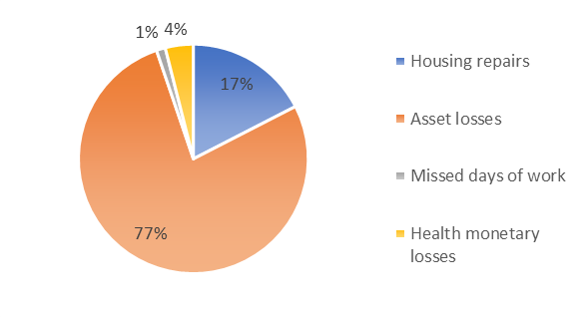

Figure 3 - Type of losses experienced by affected households in 2018 flood

The impact of the flood on well-being is only partially captured by these estimates. Two limits appear particularly important.

* Monetary valuations of flood consequences fail to account for the longer-term impact of the floods, such as the effect on career development of not showing up for work, having the family business damaged or disrupted, or the impact of investment decisions.
* Cost estimates do not capture non-monetary wellbeing impacts, such as health deterioration due to water and sanitation service disruptions or exposure to recurring periods of stress. In focus groups, health impacts were repeatedly reported as the worse consequence of floods according to households.

Looking into total (or average) losses hides important heterogeneity across households. Around 40 percent of affected households lost less than 1 percent of their annual income, while 13 percent of affected households lost more than 50 percent. Surprisingly, poorer people were not the ones who lost the most, not even in relation to their income. One explanation is that poor households have fewer assets and are less likely to be able to afford housing repairs, resulting in a lower monetary value of losses that may not reflect the experience for households. This confirms the importance of considering and incorporating wellbeing impacts into impact assessments of disasters.

Resilience – Access to finance helps households recover

Socioeconomic resilience is defined as the ability of affected households to cope with and recover from the damages from the floods. Almost a third of households that were affected by floods prior to 2018 reported not having recovered from the shock(s). Those households are poorer on average than households that were affected but had recovered and they tend to live in low elevation areas with lower access to services such as electricity and in-house piped water. Noticeably, among the households that did not recover, there are twice as many households that experience floods on an annual basis than among households that recovered. This indicates that some of these households live in a constant state of recovery, with a cumulative effect of regular floods on their poverty and prospect for the future.

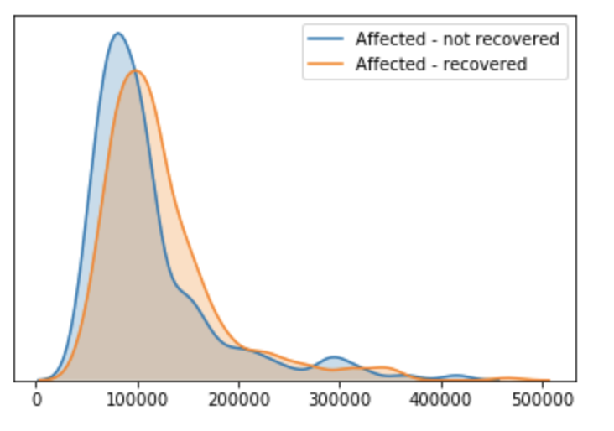

Figure 4 - Distribution of per capita expenditure proxy

Access to (formal and informal) finance and remittances is essential to facilitate recovery. Informal lending and remittances from friends and family, as well as community saving groups[6] —especially the ones that support income generating activities – help people recover. And access to formal bank accounts also makes a difference. While access to formal credit is very limited in Tanzania, it is another critical tool to finance people’s recovery. Finally, insurance that cover flood damages is rare, but is also shown to facilitate recovery.

Female headed households are as likely as men-headed households to have recovered from floods, but they have access to different tools. Male headed households are 9 percent more likely to have access to a formal bank account and are 11.5 percent more likely to practice saving. Female-headed households, on the other hand, are more likely to be engaged in community saving groups than male-headed households.

Conclusion

Flooding is a wide-spread problem in the city of Dar es Salaam and it comes at a large cost for the city. For millions of residents, flood risk is a permanent threat, disturbing daily life, damaging assets and dwelling, and affecting health, work, and education. For the worse affected, floods are a major obstacle to prosperity and well-being. Boosting the resilience of Dar es Salaam households would do much more than making them better able to overcome punctual shocks: it would also enable them to escape poverty, live more decent lives, and thrive.

1. For any questions, please contact Alvina Erman [aerman@worldbank.org](mailto:aerman@worldbank.org)
2. Financed by the Government of the UK’s Department for international Development (DFID).
3. This estimate is based on self-reported exposure to floods (including the 2018 flood) and is computed by applying sample weights, assuming selection strategy was successful in capturing representativeness of flood risk in Dar es Salaam.
4. Masaki peninsula (Msasani) show up as highly exposed to floods despite being a primarily affluent area generally considered safe from floods. 20 households located in informal areas in the southern parts of Masaki were included in the sample and 43% of them reported being flooded.
5. Dysfunctional and informal rental markets may cause rent values to not internalize factors that generally affect price – such as poor access to services and flood risk. In addition, many rental contracts in Dar es Salaam are annual, so the family may be unaware of the flood risk upon moving in.
6. However, households highlighted that community saving groups do not work that well during disasters since the entire neighborhood tend to be affected at the same time putting strains on pooled resources